Module 7 Unit 1 Did you take Amy’s doll? 教学设计
新标准英语一年级起点第七册
- Warm up and lead in
- Sing a song: Did you play football yesterday?
- Watch the CD-ROM and choose,, then learn lost(pot, hot, lot):
What’s the matter? A.Mummy pig lost her hat. B. Mummy pig lost her dog.
- 追问： Did you see the hat? Where?
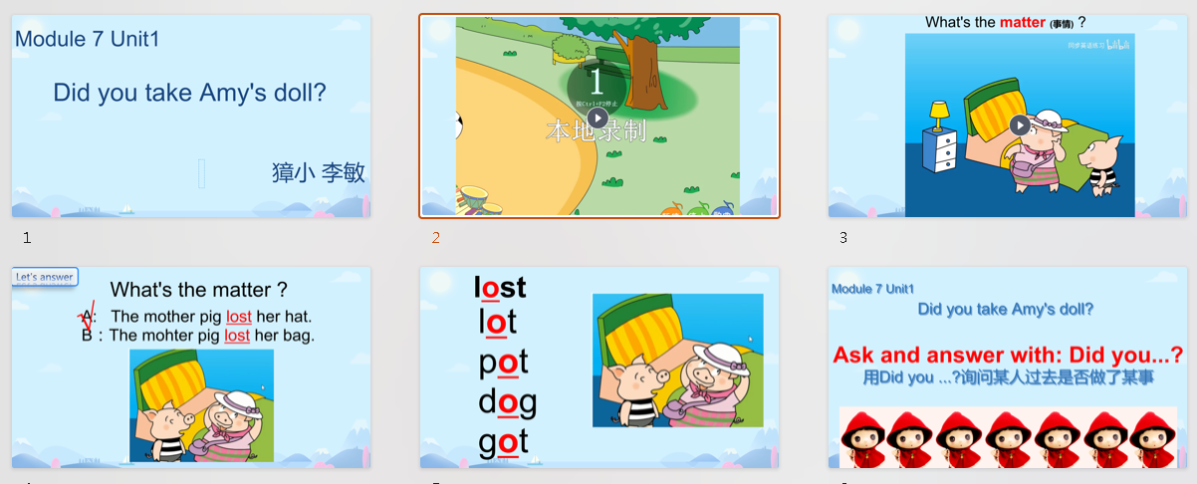

- Task presentation
Today let’s learn Module7 Unit1 Did you take Amy’s doll? 用Did you ...?询问过去的事情。

- Text learning
- Watch Amy’s picture and answer:
What’s the matter? Amy lost her favourite doll. (学doll)
- 追问Who found the doll? (学found-about-shout-out-Little pig found the hat. / Daming/Lingling and Tom found the doll)
- 课文分析Who found Amy’ s doll ? How to find? Where’s the doll? Let’s read and answer：3个Did you ...?句子的重复操练及回答，过程中完善板书
- Point and imitate.
- Read in roles.
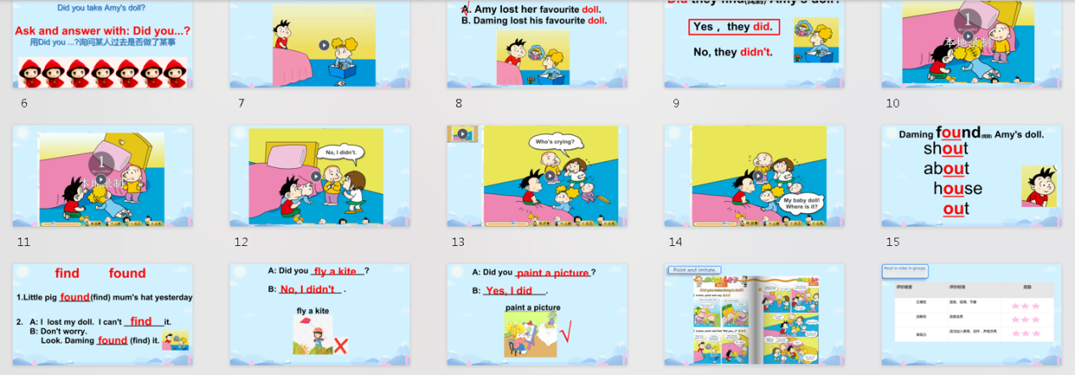

- Practice
功能句配图填空操练
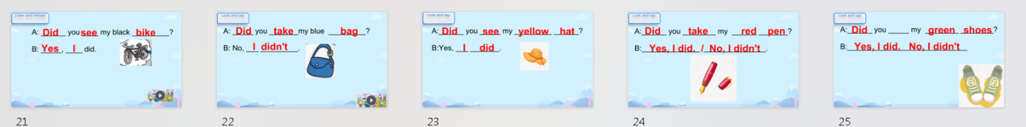

- Production
Guessing game: (遮挡图)生用Did you ...?猜是否做了某事，师提醒其他学生用Yes/No回答
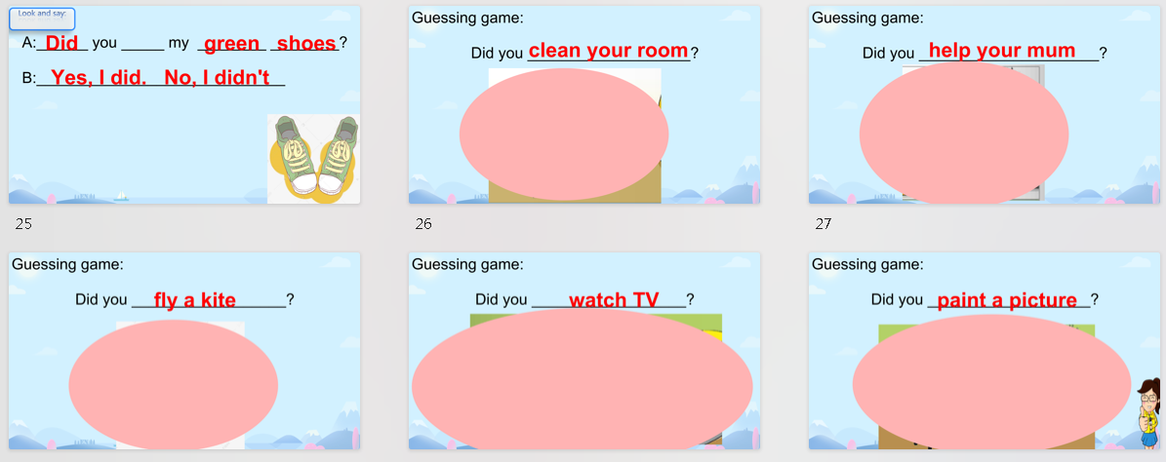

- Task completion
组内参访昨日活动： Did you _______? Yes, I did. No, I didn’t.

- Summary and homework
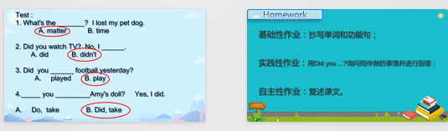

李敏 2023.11.15

