Review Module 6教学设计
教学过程：
Step1. Revision and lead in
- Greeting:
- Sing a song: Tell me about your holiday.
Where did you go ? And what did you do?
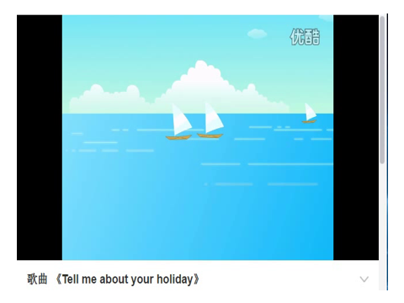
T:I bought you some word cards. Can you read them?
- Fill in the blanks with these words and phrases.
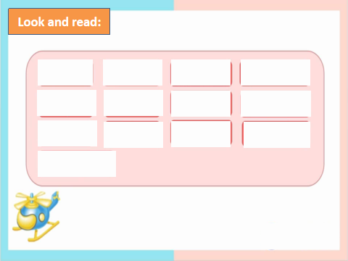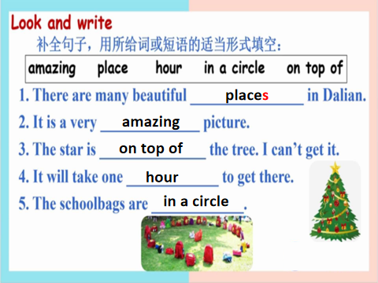
Step2. Task presentation
Task: We’re going to review Module 6 . Review how to talk about your trip experience with the past tense and how to talk about your trip plan with the simple future tense. Today we will have a PK between G1 and G2. Let’s see which group can get the free tickets to travel with me .(说明评价机制)
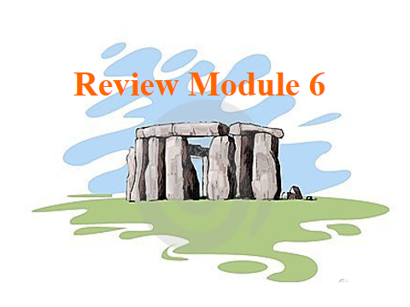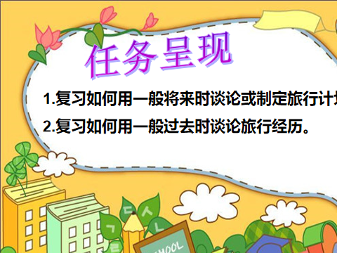
Step3. Practice
T:Last Saturday, Lingling had a lovely day. Do you remember where did she go?
S: She went to Stonehenge.
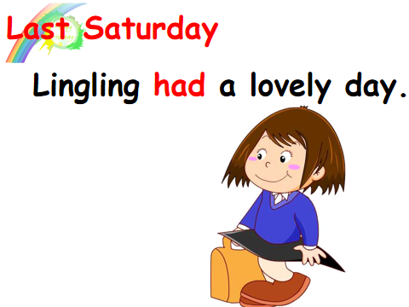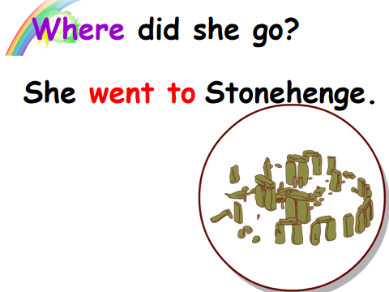
- Now let’s take a look at the Stonehenge. Let’s know more about Stonehenge.
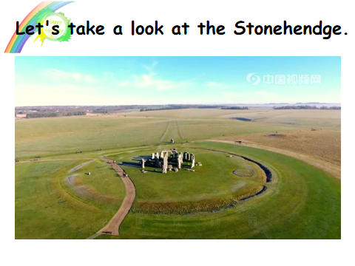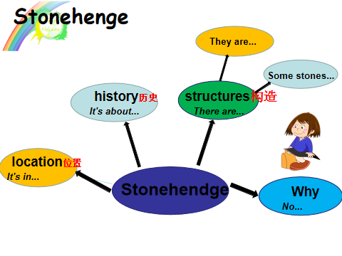
- Ask and answer:What did Lingling do?
S:She took photos./She took a helicopter ride./She wrote a letter to Daming.
- Show Lingling’s letter. Try to read one by one.
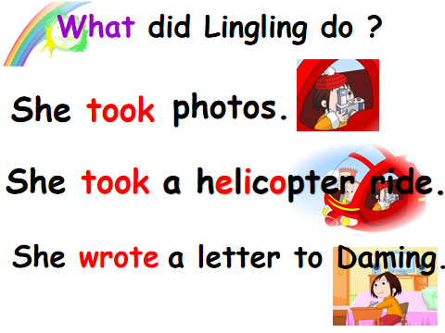
- If you are Daming, you will go to London. Where will you go? Then show Daming’s trip plan. (Ask and answer in pairs)
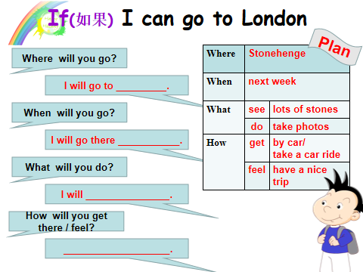
- Read these two parts. What can you find? Then sum up.
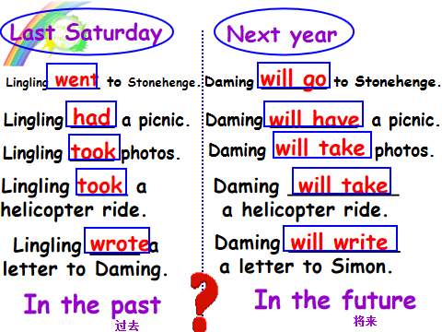

Step4. Production
- Read and choose the right answer.
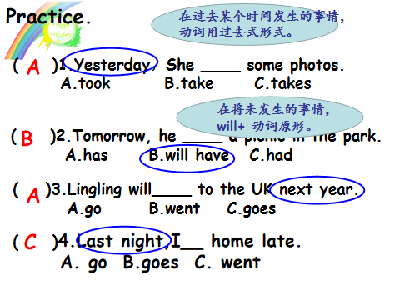
- Play a game: Catch the star.
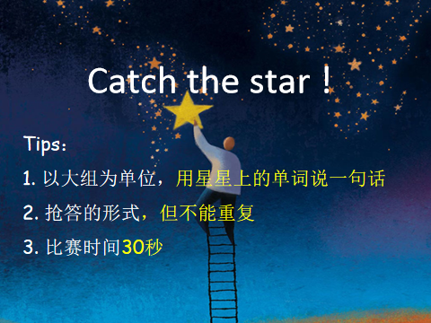
- Enjoy the travel. Then answer the questions. (Show Lisa’s travel experience)
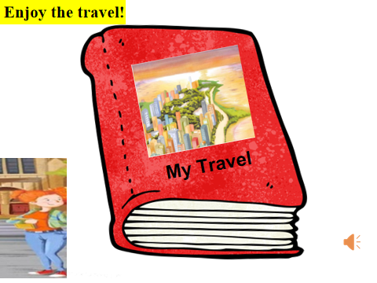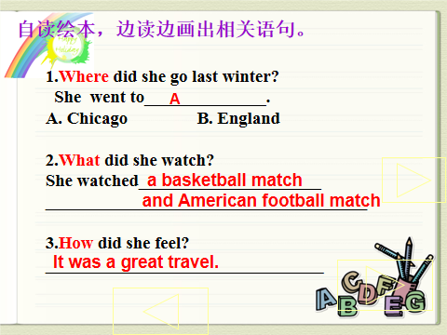
- Lisa’s travel is great! My trip is great too. Let’s read together.
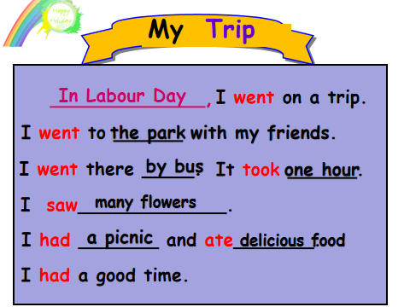
- Recommend a good place for everyone that you think is worth visiting in your group.Then report.
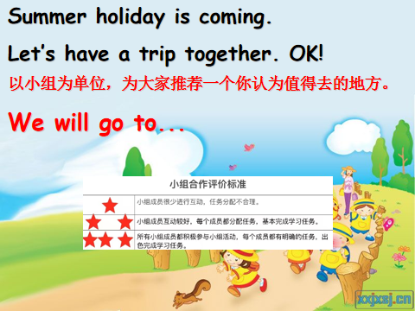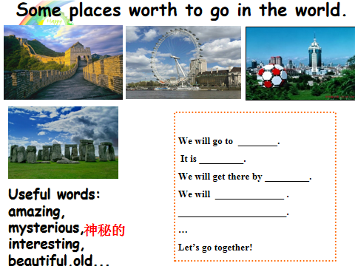
Step5. Task completion
- Writing a letter to tell your friend your trip experience/trip plan. (Choose one to write)
- Show time.
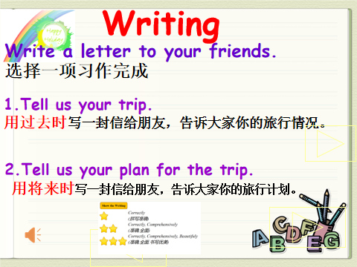
Step6. Summary and homework
- Summary: What have we reviewed today?
- Who is the winner? Let’s have a travel by hot air balloon.
- Homework:
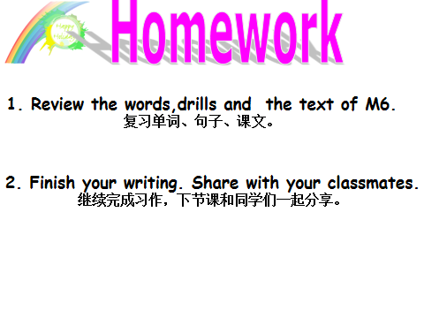

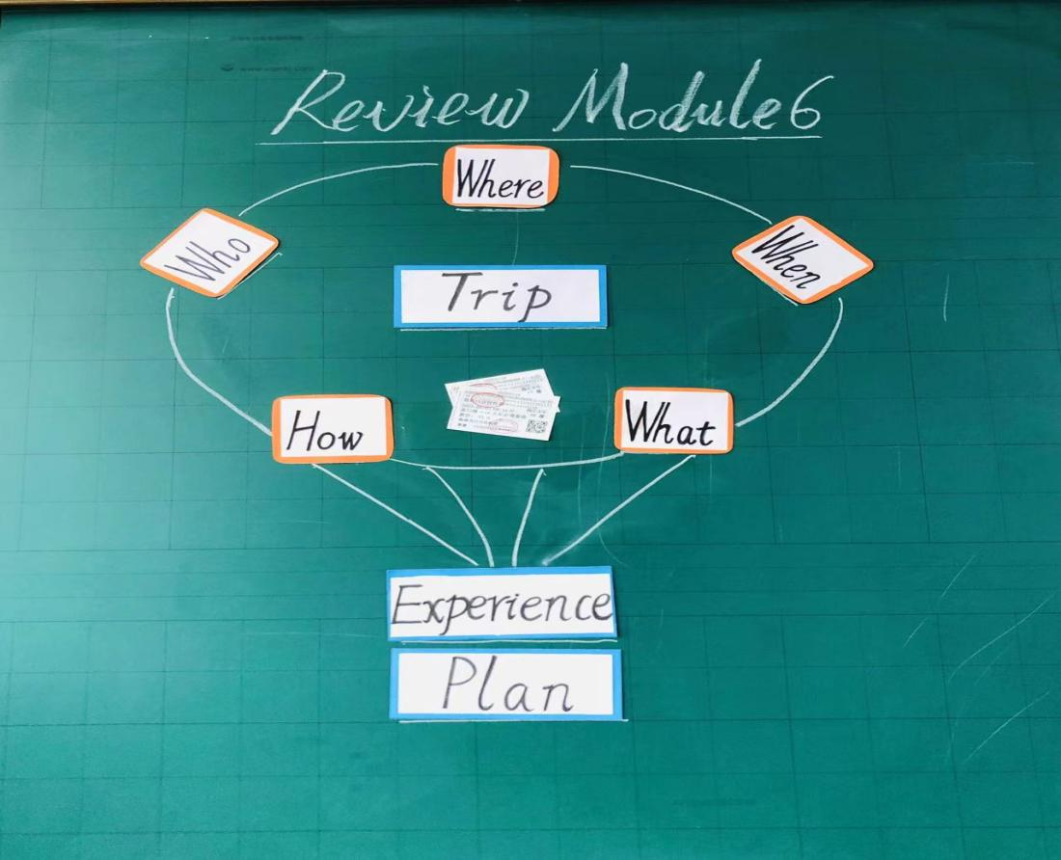
板书：

