新标准英语
一年级起点二年级上册

Review Module 9

广鹿岛镇中心小学

王超

新标准英语一年级起点二年级上册
Review Module 9
教学设计
教材分析
本节课选自外研社出版的《新标准英语》第三册第九模块。运用英语谈论季节与着装以及人们在不同季节的活动。通过活动使学生积极运用所学英语进行表达和交流，相互了解，增进友谊。
模块教学目标
语言知识：
词汇：能听懂会说winter, spring, summer, autumn, wear.
能听懂认读说fly, skating, warm, jacket, sunglasses, cool, sweater, glove, cold, coat.
语法：学习句型It’s spring / summer / autumn / winter. We wear… What does he do in summer? He goes swimming in summer.
复习巩固：Does he…? Yes, he does. / No, he doesn’t.
学习：运用We wear… What does he do in…? 谈论不同季节的着装及活动。
语言技能：
1. 能听懂会说：It’s spring / summer / autumn / winter.
We wear…
What does he do in summer?
He goes swimming in summer.
2. 能理解文本大意，能正确、流利地朗读课文。
3. 能谈论不同季节的着装及活动。
情感态度：在小组合作中能与其他学生积极合作，完成任务。
文化意识：了解世界各地冬季的主要体育运动。
学习策略：积极运用所学英语进行表达和交流，通过词汇联想的方法认知季节及相关活动。

教学重点及难点
掌握单词：
四会winter, spring, summer, autumn, wear.
认读fly, skating, warm, jacket, sunglasses, cool, sweater, glove, cold, coat.
理解并运用重点句型：It’s spring / summer / autumn / winter.
We wear…
What does he do in summer?
He goes swimming in summer.
教学难点:
What does he do? 特殊疑问句的理解和运用。
教学辅助
多媒体课件、教学卡片等

教学过程
Step 1. Revision and lead-in
1.Listen ,sing and do actions .
<Four seasons .>
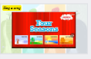
What’s the song about? About season.
Step 2. Task Presentation
- Today’s task is: How to use the season to describe weather , clothes and activity.
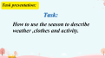

2.In this class, I will divide four teams, spring team, summer team, autumn team and winter team. Let’s see, who’s winner?
3.Today we’re going to review Module 9.(板书)
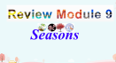

Step 3.Text learning.
1.Listen and answer: How many seasons are there? What are they?
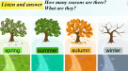

2.Answer: What's the weather like ?
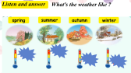

3.Let’s say a chant.快板：
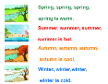
- Let’s play a game!
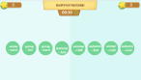

5.What do they wear ? Let’s find it.
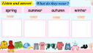

3.Think and answer. Then fill in the blank.
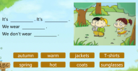

Step 4.Practise.
1.Listen and answer: What do you do in every season?
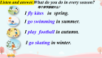
2.Listen and answer.
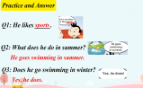
3.Ask and answer.
.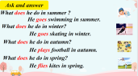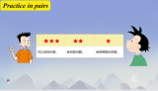
Step5. Task completion
1.Finish the blanks.大家一起完成这个表格，然后让小朋友上前面复述每个季节。
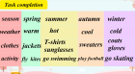
2.Let’s read a book about seasons.
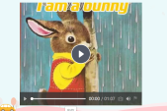
3.情感教育
Seasons are colourful. We should love every season.
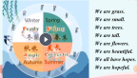

Step6. Summary and homework
1.Let’s summary. What have we learnt?
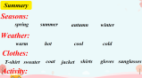
- Take a task paper.
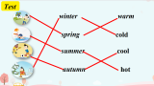

3.Homework
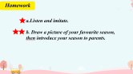
板书
