小学英语一起第九册

Module 2 Unit2
They sell many different things.
教学设计

四块石小学 张力群

小学英语一起第九册
Module 2 Unit2 They sell many different things.教学设计
- 教学目标：
a. 语言功能：描述超市中的商品及其特征。
b. 语言结构：一般现在时。
c. 语言知识目标：1.学生能够会听，说，读，写并会运用本模块单词sell, sometimes。
2. 学生能够理解，运用本模块的目标语句They sell many different things.
d. 语言技能目标：全体学生能够运用功能语句介绍自己喜欢的超市。
e. 情感态度目标：在小组活动中能与其他同学积极交流与合作。
二、教学重、难点：
教学重点：理解重点单词“sell, sometimes”，运用重点单词谈论超市的特征。
教学难点：运用一般现在时描述自己喜欢的超市，并能在真实的语境中运用。
三、学生分析：
五年级学生已经具备一定的英语基础，在以前学习过程中接触过There be 句型，可以较为灵活地使用语言。因此，在教学过程中，结合本课内容，对文本进行深层次的挖掘、拓展延伸，使不同层次的学生，在英语表达方面都有所提高。
- 教学内容：
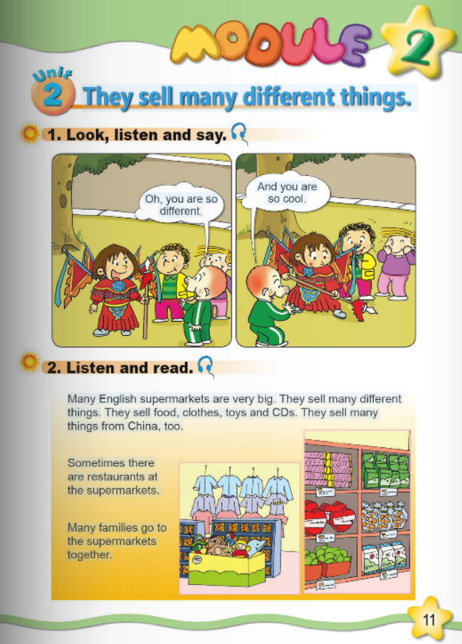
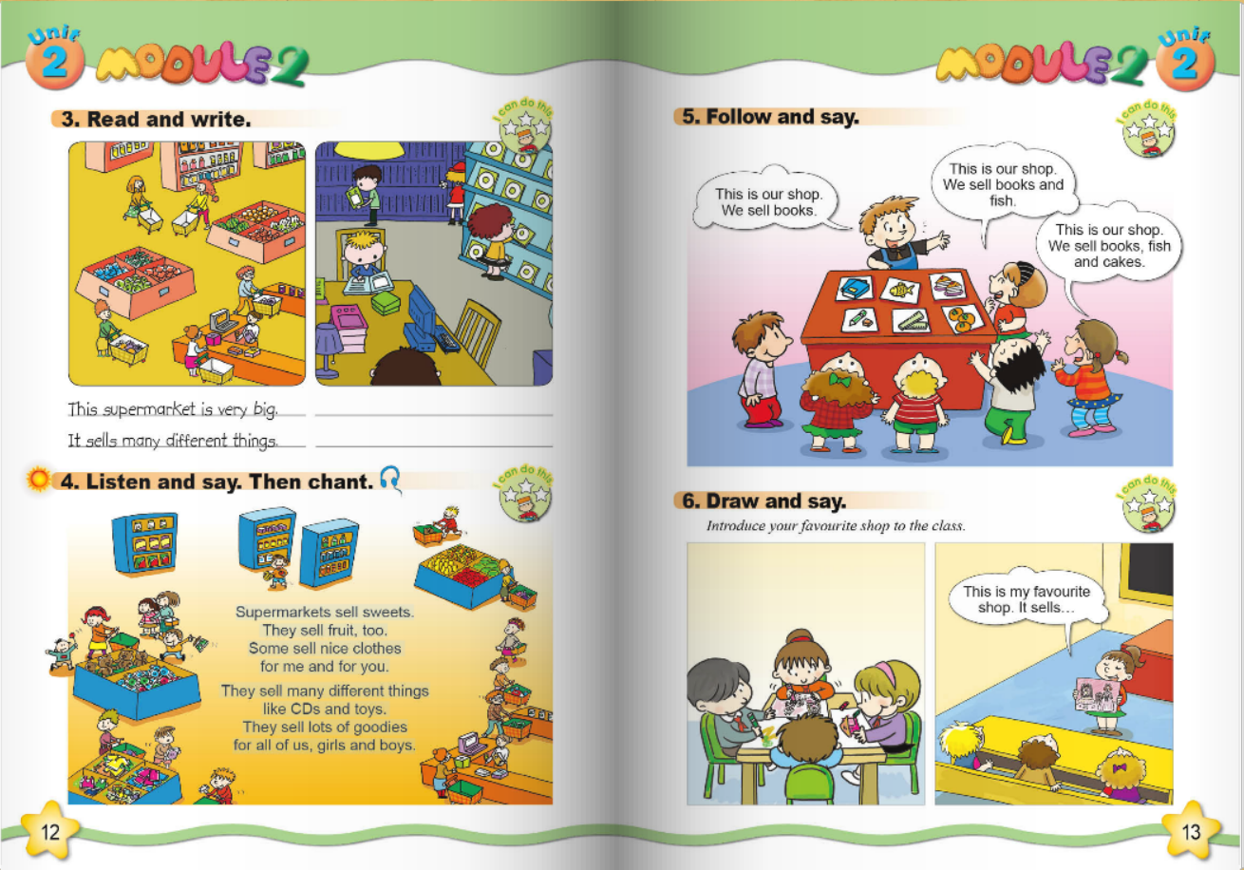

- 教学过程：
Step1. Revision and lead in
- Greeting and enjoy a chant.
T: They sell many different things. Today let’s learn Module 2 Unit2 They sell many different things.
- Watch and answer. What does Lingling look like today?
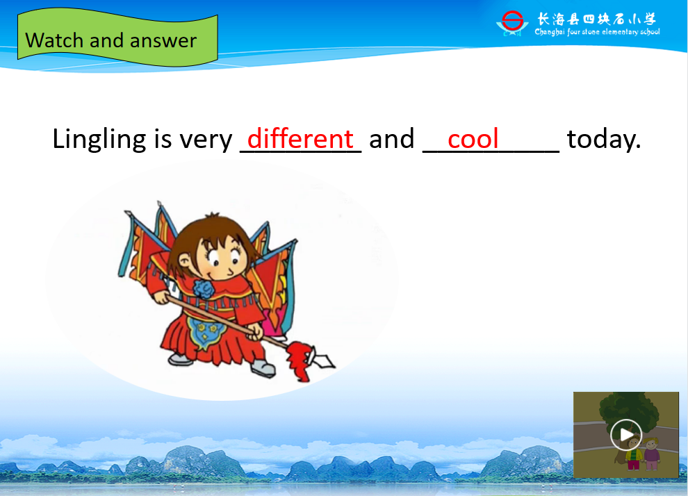

- Free talk
Lingling is playing Beijing Opera. It’s Chinese traditional culture. Chinese culture is going to the world. Long ago, there was a Silk Road. Look, in this picture, we sell... they sell... The Road is very long. But now we have supermarket.
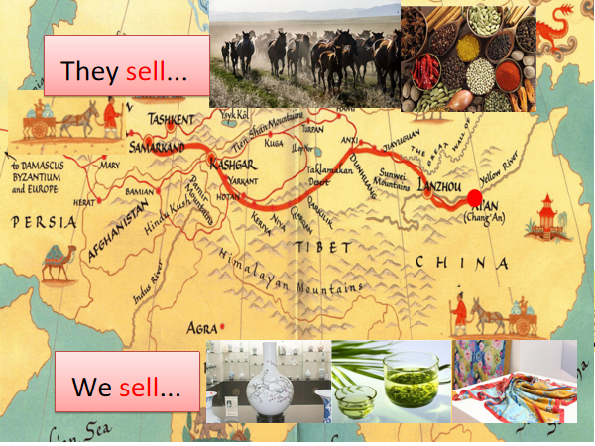
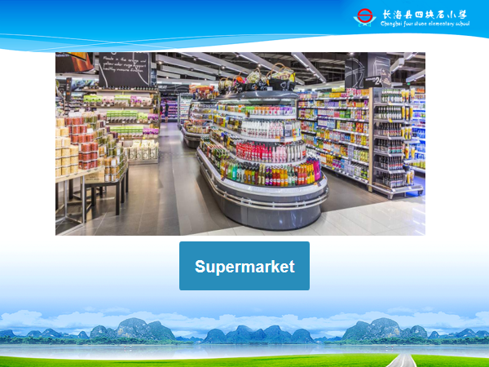

Step2. Task presentation
Task: Today let’s talk about English supermarkets and your favourite supermarkets.
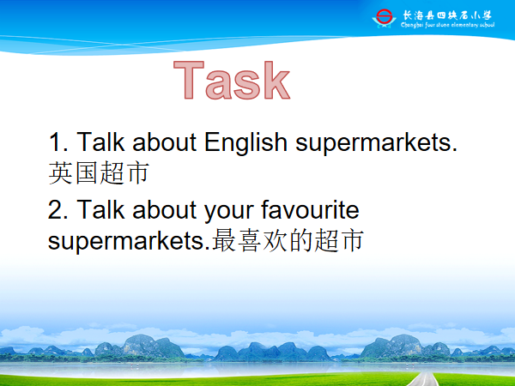

Step3. Text learning
- Watch and answer
Many English supermarket are very_________.
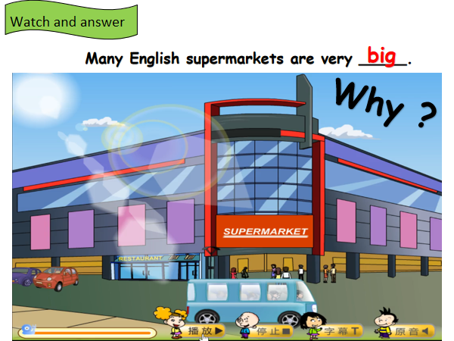

- Read and find. Show three questions.
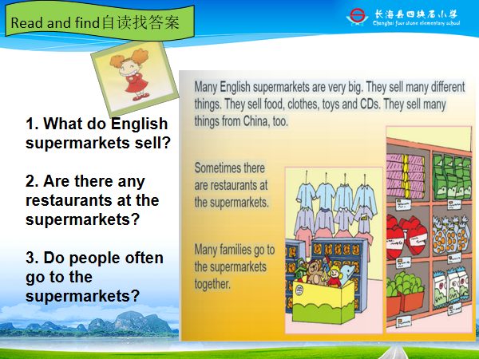

- Answer three questions.
- Teach “sell”. Pay attention to “ell”. Eg, tell, well, smell.
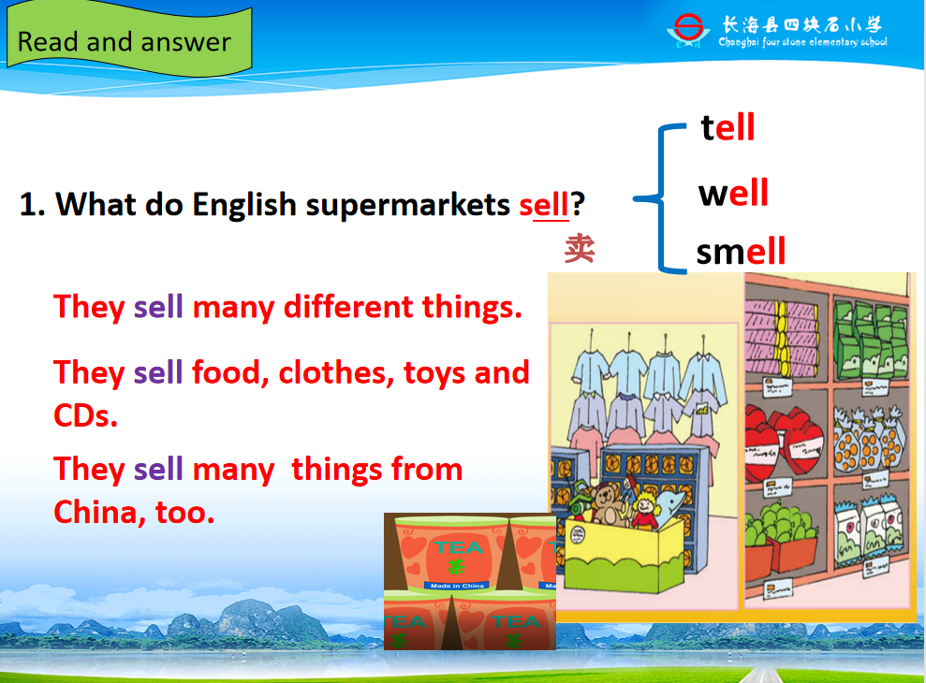

- Explain “sometimes”. It means not often. Eg, Sometimes Lingling visits her friends.

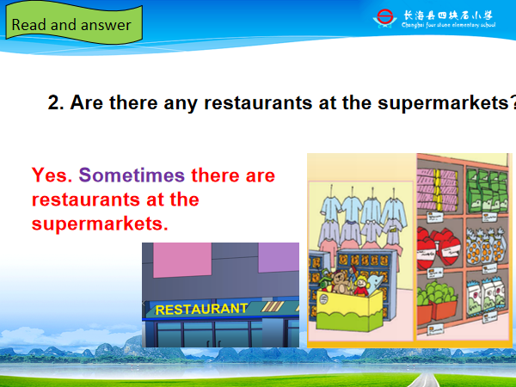
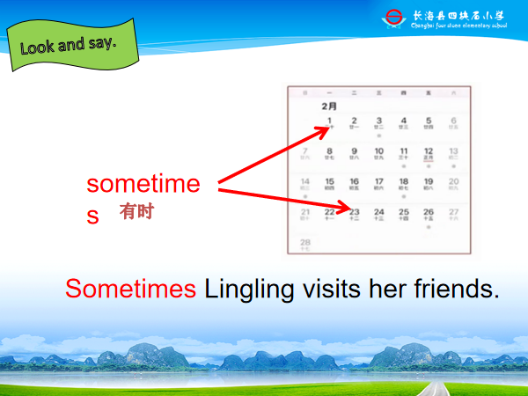

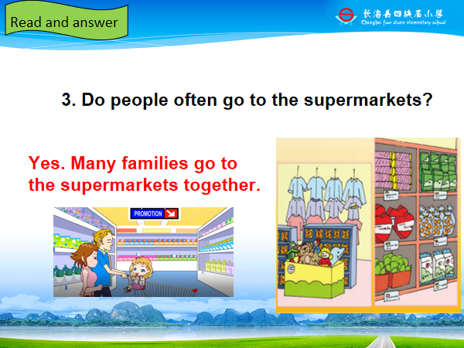

- Listen and repeat.
T: So the supermarket is very big. Do you like them?
- Let’s retell. Retell the text according to the mind map.
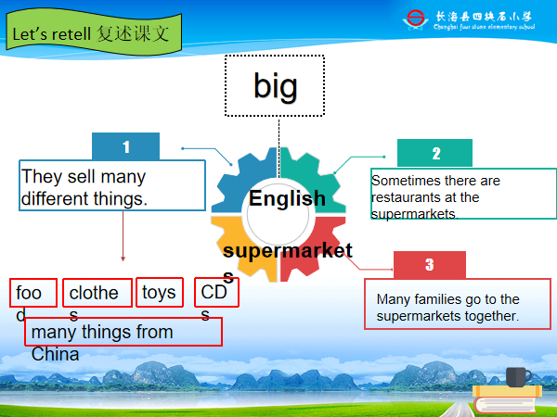
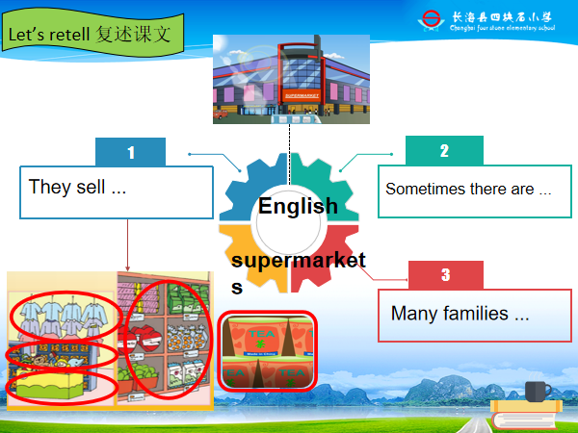

Step4. Practice
- Pair work.
T: What else do they sell? Let’s go. Look and say. They sell...
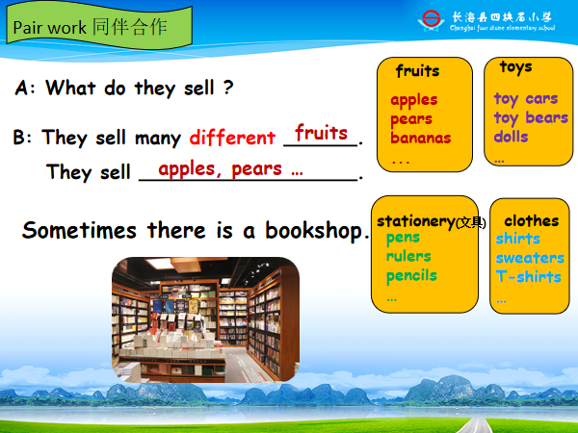
A: What do they sell?
B: They sell many different...They sell...

- Look and say.
T: Sometimes there is bookshop. Look, this bookshop is very big. What does it sell?
S: It sells_______. It ___________. Sometimes it ___________.
T: What do you find? “sell+s”.
T: So the supermarket is big and fantastic.
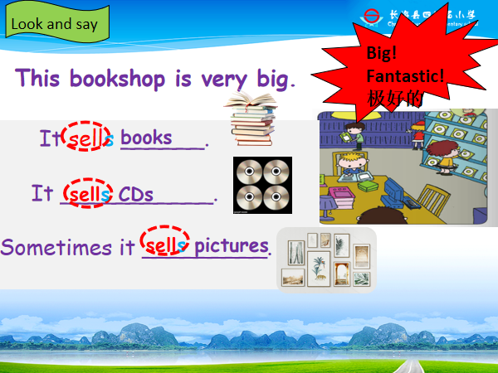

Step5. Task completion
- Watch the vedio. Know about the changes of the market.
T: Shopping becomes more and more easy and convenient.
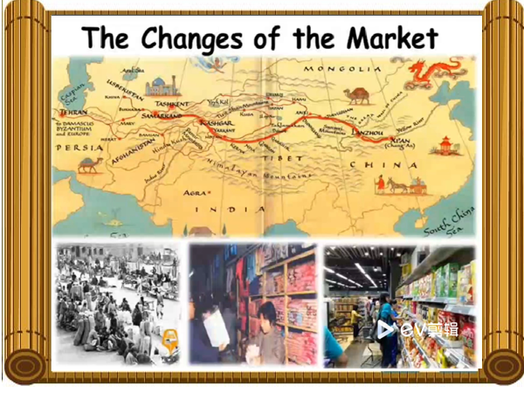
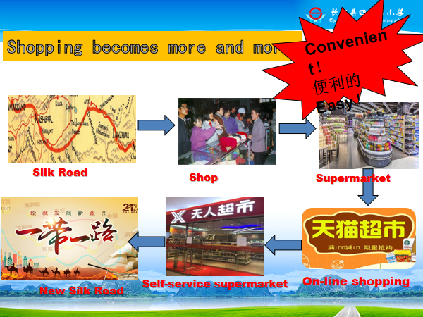

- Talk about favourite supermarket.
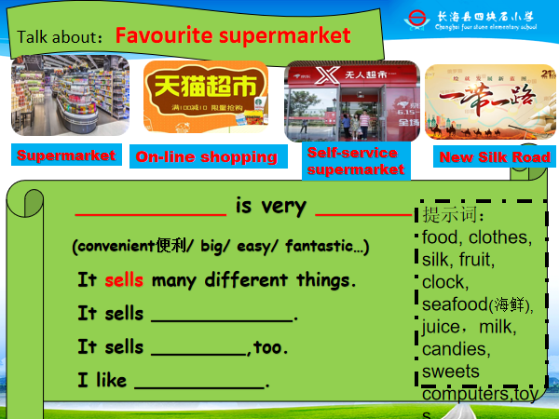

Step6. Summary and homework
- Summary: What have we learned today?
- Have a test.
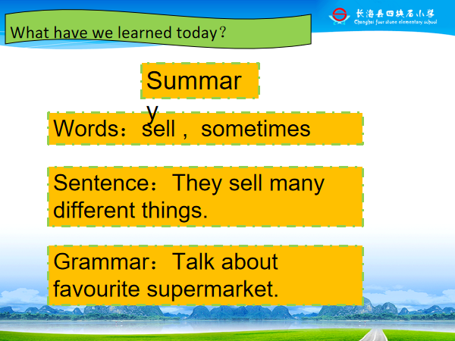
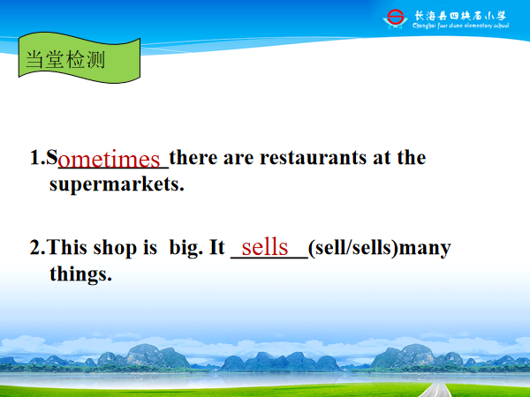

- Homework:


