**Shopping with Dad**

大长山岛镇中心小学 王钟慧

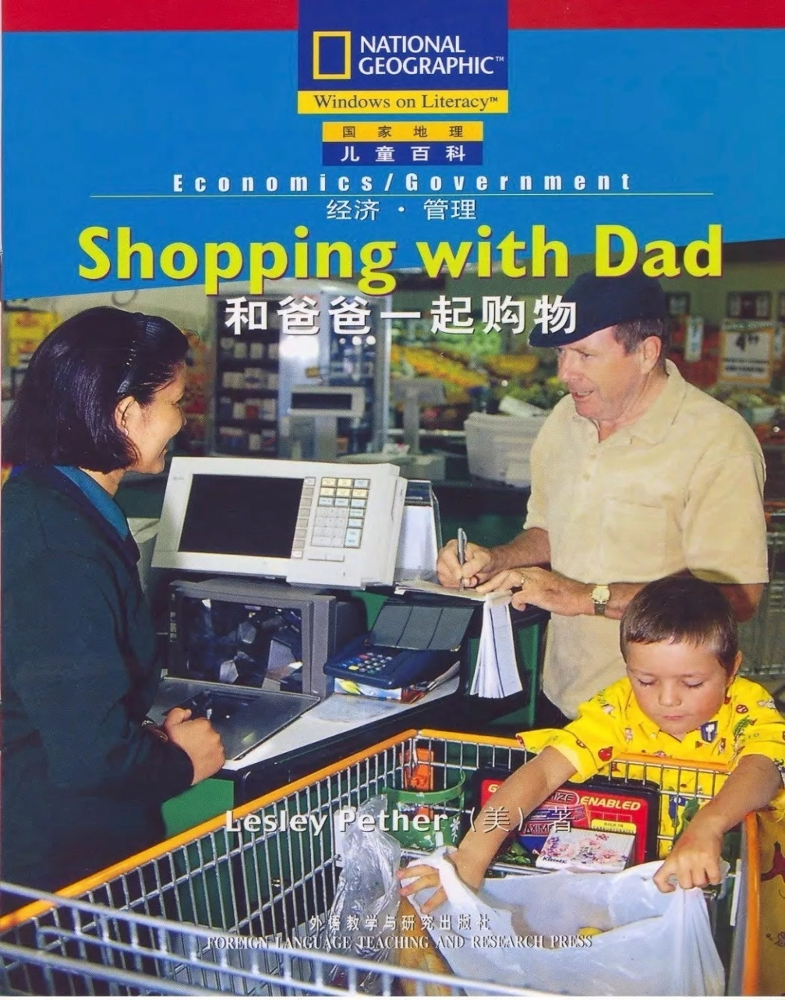

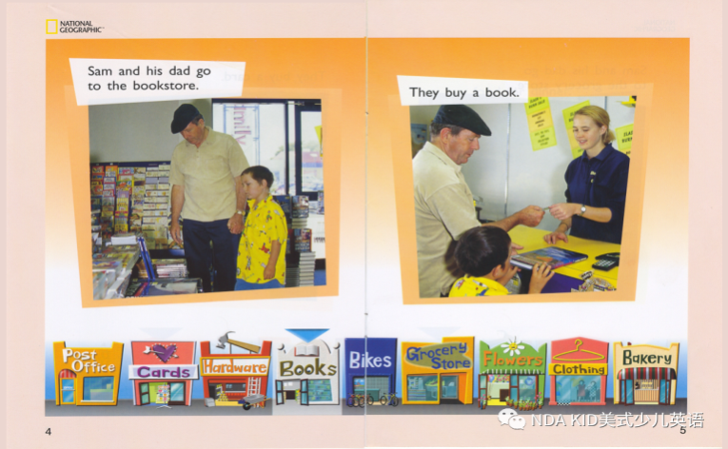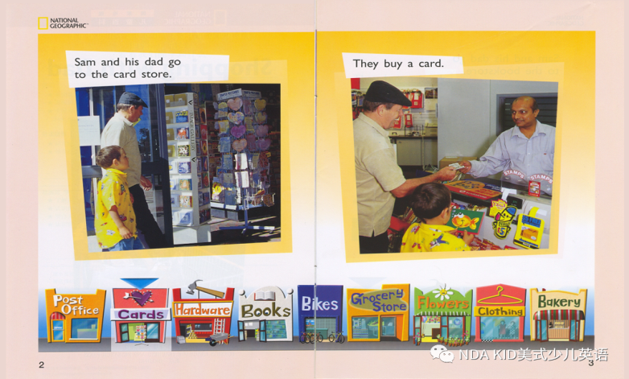

**Sam and his dad go to the card store. Sam and his dad go to the bookstore. They**

**They buy a card. It’s cheap. It costs 1 dollar. buy a book. It’s interesting .It costs 5 dollars.**

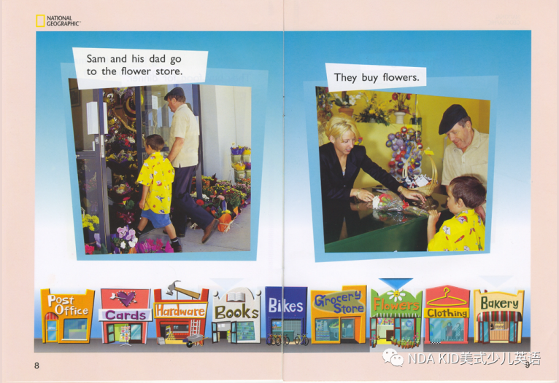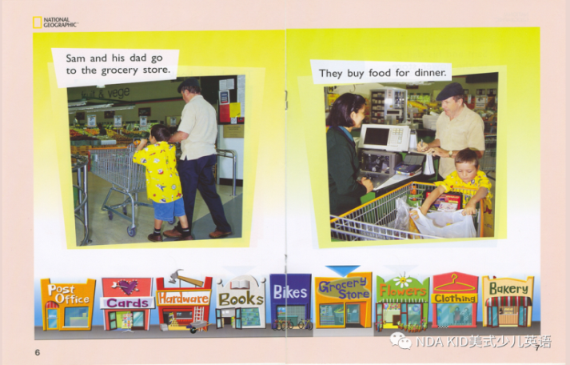

**Sam and his dad go to the grocery store. Sam and his dad go to the flower store.**

**They buy food for dinner. It’s delicious. They buy flowers. They are beautiful, but**

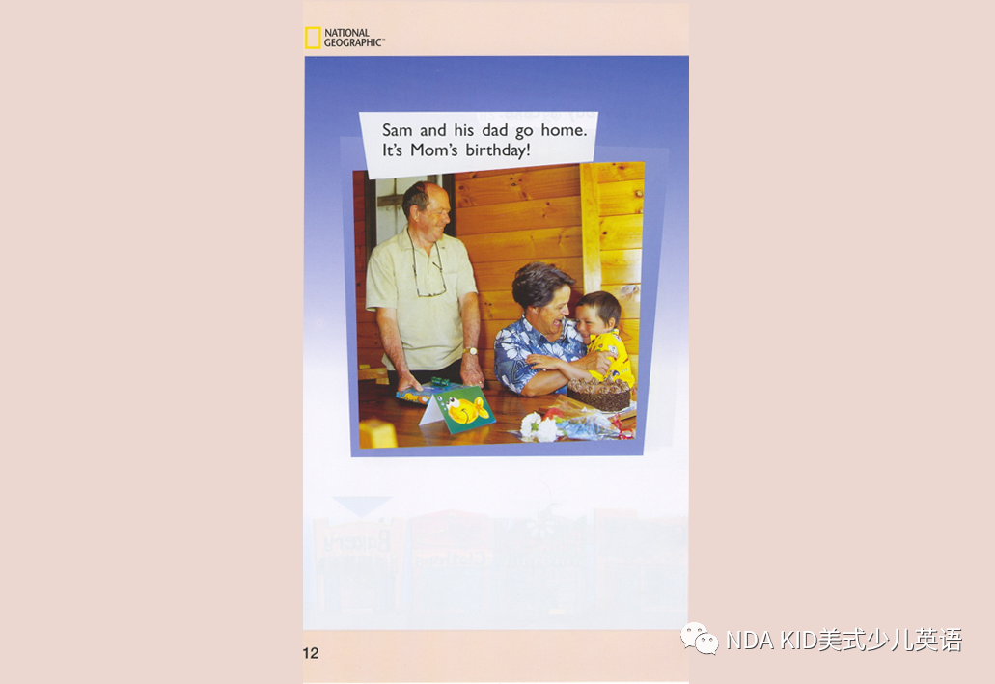**It costs 119 dollars. they are expensive. It costs 49 dollars.**

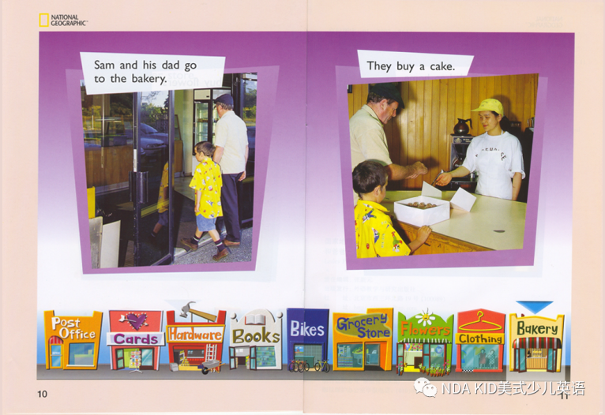

**Sam and his dad go to the bakery. Sam and his dad go home.**

**They buy a cake. The cake is delicious. It's Mom's birthday!**