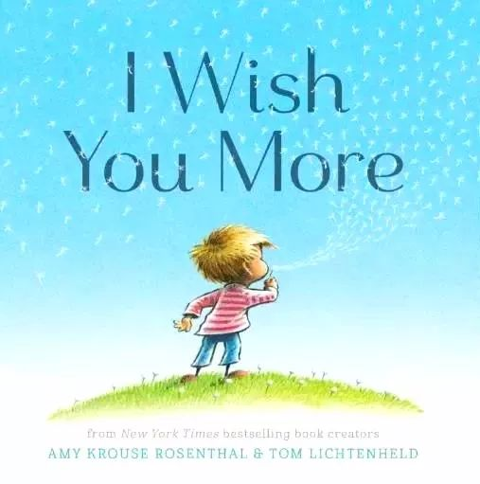

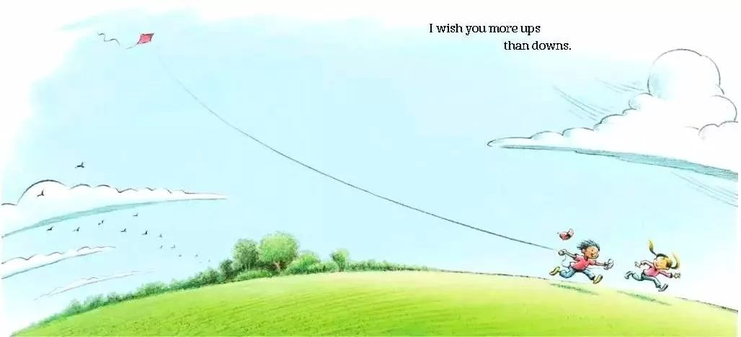



I wish you more ups than downs.
愿你大起胜大落。

I wish you more give than take.
愿你给予赛收获。

I wish you more tippy-toes than deep.
愿你硅步成千里。


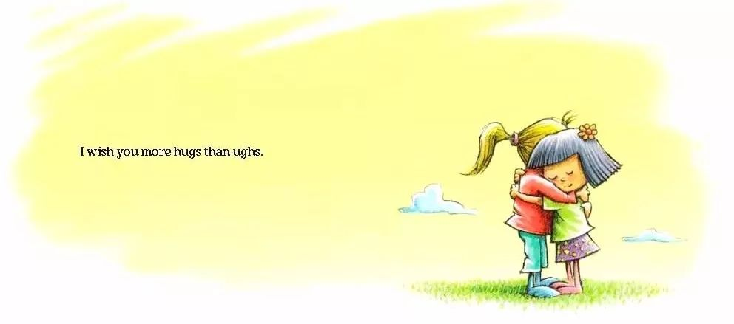
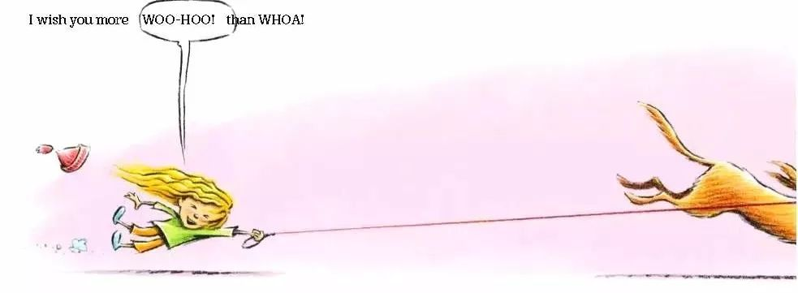

I wish you more we than me.
愿你大我赢小我。

I wish you more hugs than ughs.
愿你包容胜刻薄。

I wish you more WOO-HOO! than WHOA!
愿你兴奋多失落！

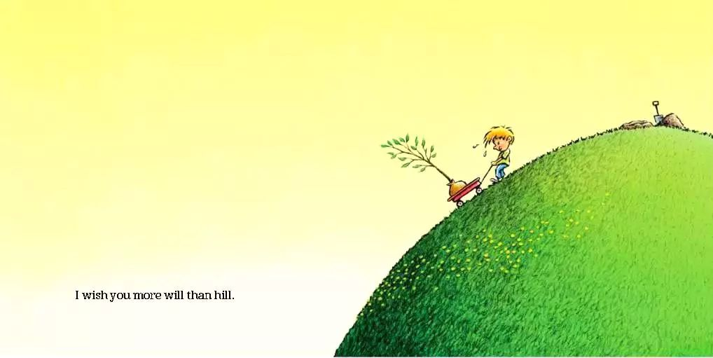

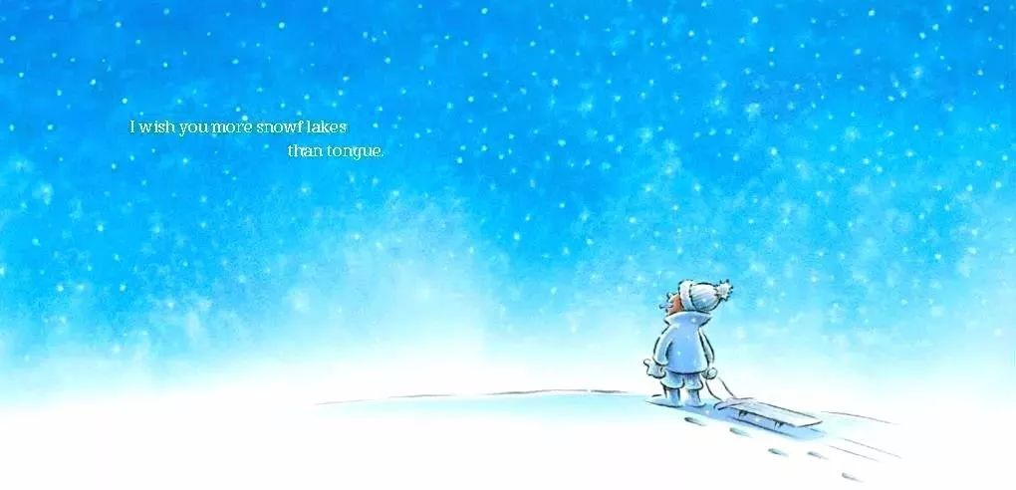

I wish you more will than hill.
办法总比困难多。

I wish you more can than knot.
人人都能靠自我。

I wish you more snowflakes than tongue.
愿你所想能拥有。

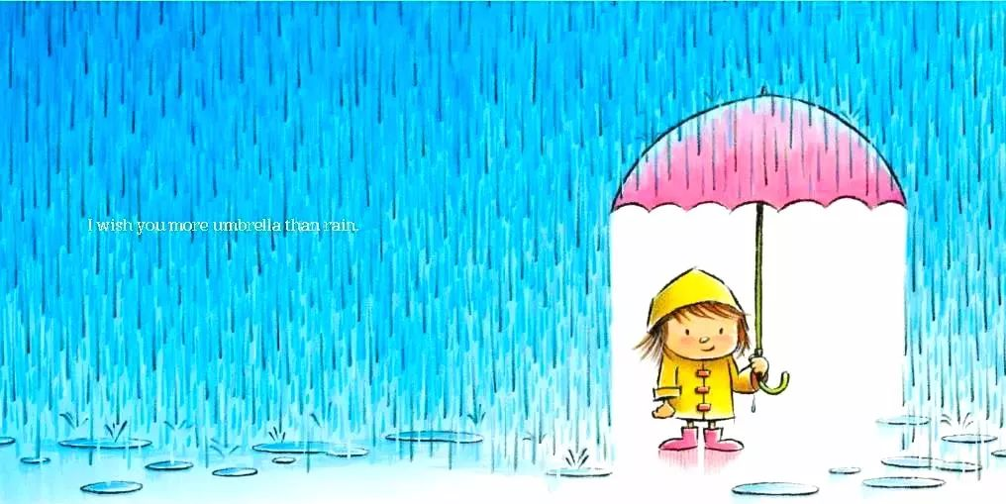

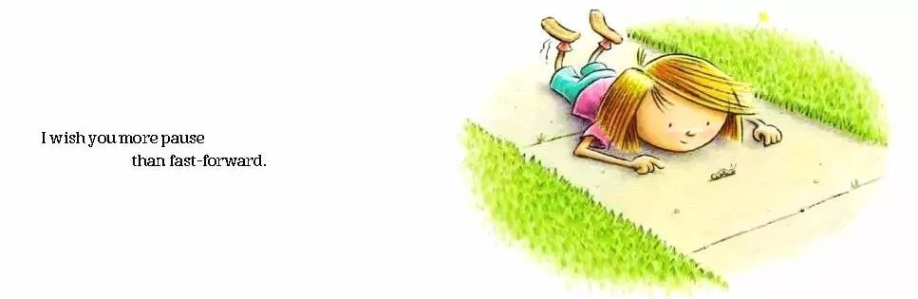

I wish you more bubbles than bath.
愿你生活乐趣多。

I wish you more pause than fast-forward.
愿你旅途有收获。

I wish you more umbrella than rain.
愿你风雨能度过。

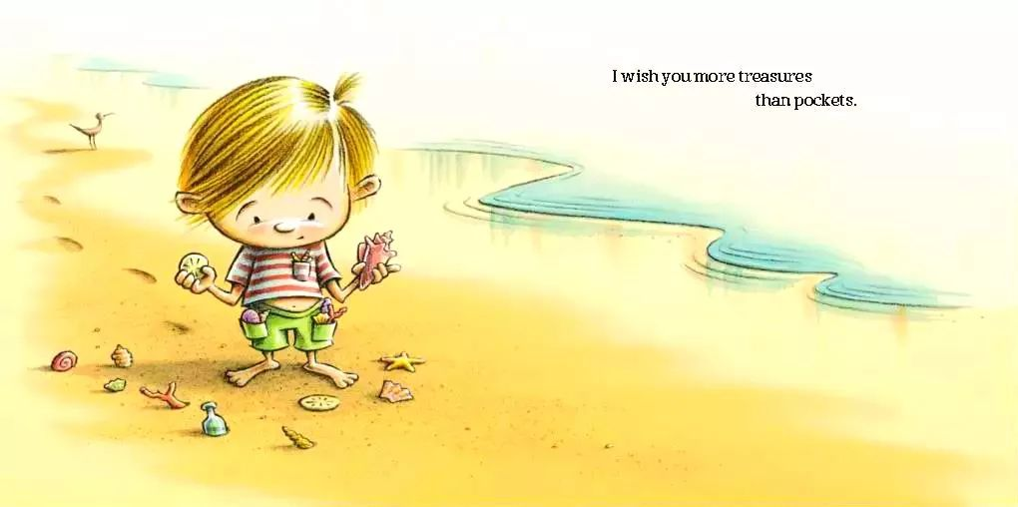

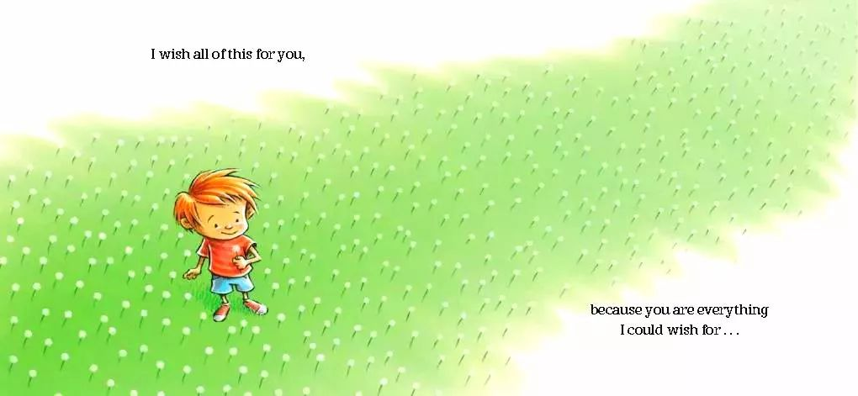
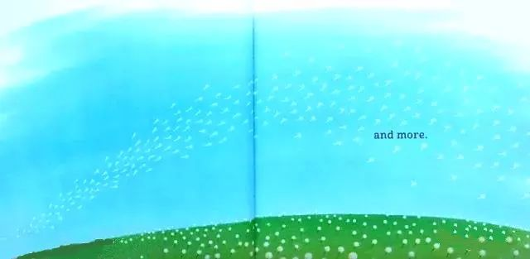
I wish you more treasures than pockets.
珍宝总把口袋没。

I wish you more stories than stars.
故事要比星星多。

I wish all of this for you.
愿这一切都属于你。
because you are everything I could wish for…
因为我希望为你送上祝福......

and more.
还有更多的祝福。

