**What will you do on holiday?**

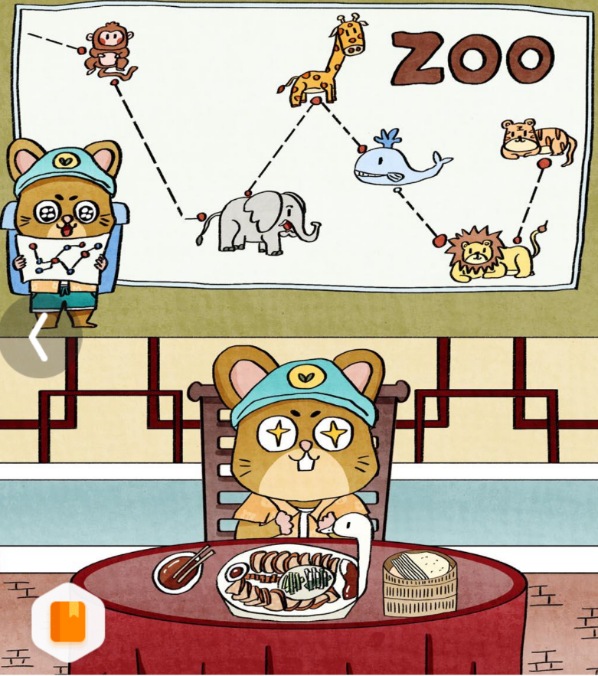

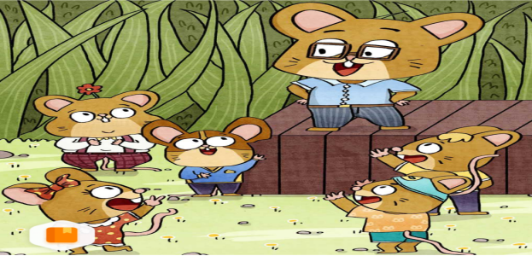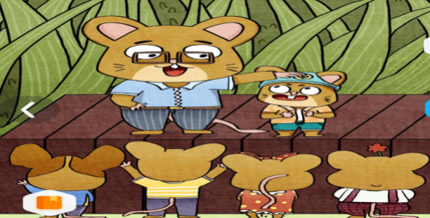

Where will you go in your holiday?

I will go to Beijing.

We will have a long holiday.

What will you do?

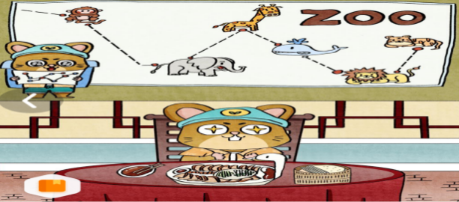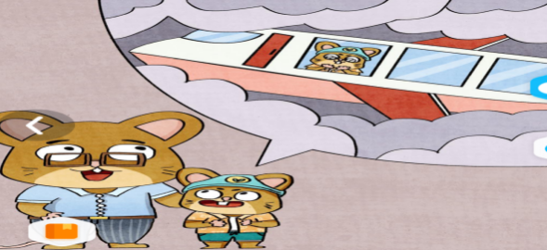

Will you go to Beijing by plane?

Yes.It’s fast.

I will visit Beijing Zoo.

I will taste Roast Duck.

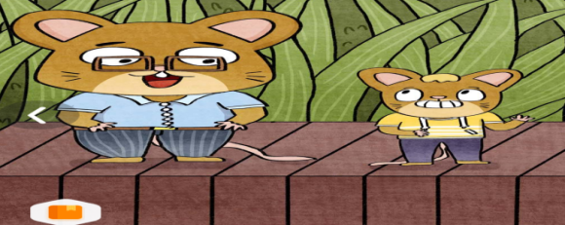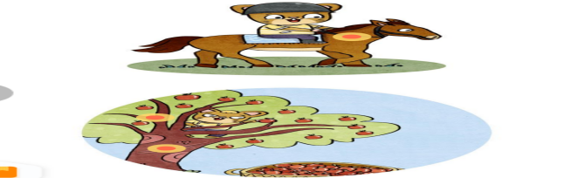

What about you?

I will go to Uncle’s farm.

I will ride a horse.

I will pick apples.

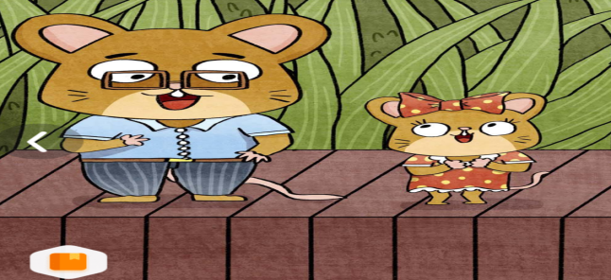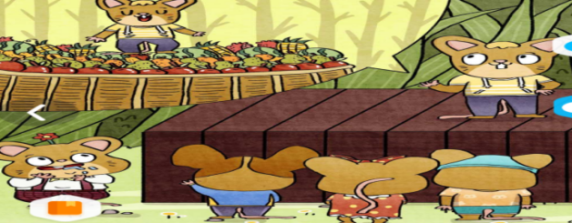

Will you take some apples back?

Yes.I will bring some fruit to all of you.

We will have a wonderful holiday.