Maps
大长山岛镇中心小学 骆文芳

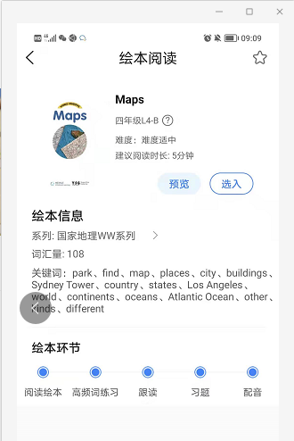

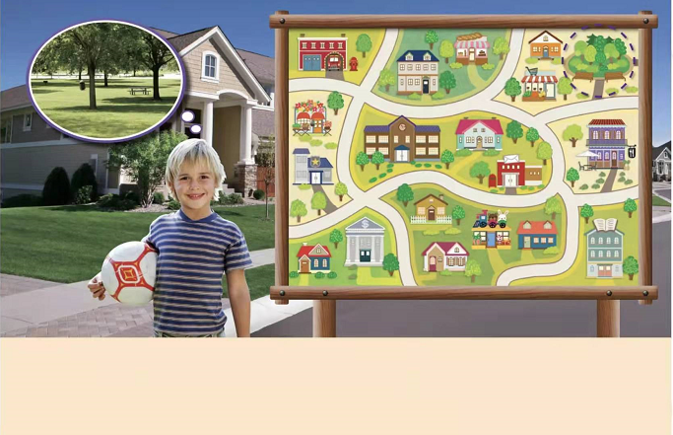

He can look at a map.
We can look at a map to find places.
Look, What a healthy and strong boy!
He wants to go to the park.
How can he find the park?

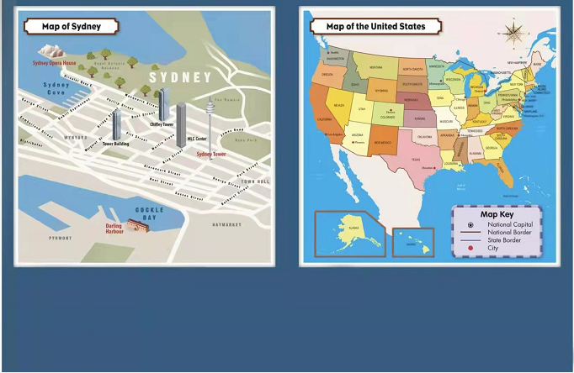
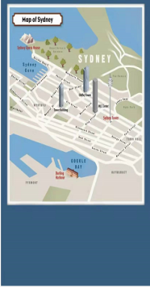

This is a map of the United States.Can you find Los Angeles on the map?
It’s in the west of the United States.

This is a map of a city. It shows streets and buildings. Can you find Sydney Tower on the map? It’s in the east of Sydney.

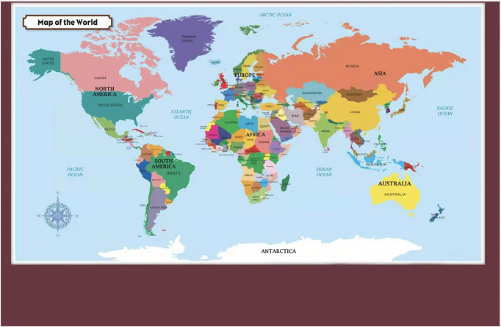

This is a map of the world. It shows countries, continents, and oceans.
Can you find the Atlantic Ocean on the map?

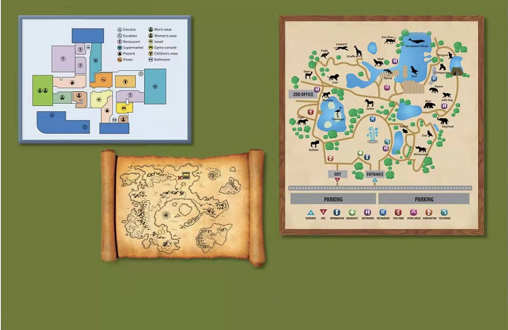

There are many other kinds of maps.
Different maps Show different places.
They can tell us to find the place Where we want to go .

What kinds of maps do you have?

