
A New School
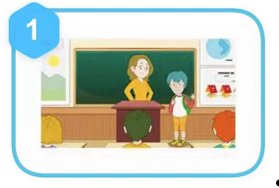
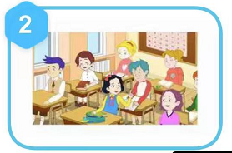

It is Monday. Dave is at a new school. It is his first day. He is worried.
Dave goes to math. He makes a friend . She is Sally. She is kind.

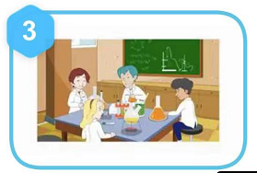
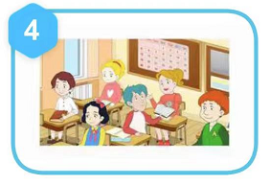

Dave goes to science. He makes a friend .He is Bruce. He is friendly.
Dave goes to English. He makes a friend. She is Daisy . She is charming.

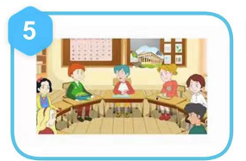
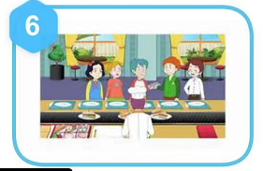

Dave goes to history. He makes a friend. He is Thomas . He is gentle.
Dave goes to cafeteria. He makes lots of friends. They help him. They are cool.

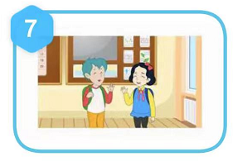

It is Monday. Dave is at a new school. It is his first day. He is relieved.

