新标准英语一年级起点五年级下册
Module3 Unit Have you got the Harry Potter DVDs? 教学设计
长海县大长山岛镇中心小学 王钟慧
- 教学目标
语言知识目标
功能：能够运用图书馆获取信息。
语法：全体学生能运用: Have you got the Harry Potter DVDs?
词汇：全体学生能理解: DVD, librarian, show, borrow。
部分学生能运用: DVD, librarian, show, borrow。
语音: 进一步强化语音语调，初步达到语调达意。
语言知识目标
听:全体学生能听懂: Have you got the Harry Potter DVDs?
说:全体学生能说: Have you got the Harry Potter DVDs?
读:全体学生能朗读课文，阅读相关短文。
写:全体学生能写出2-3个语句，介绍图书馆。
运用：全体学生能运用已学语言，介绍图书馆的资源。
学习策略：能初步借助简单的工具书学习英语。
文化意识：了解英语国家中优秀的儿童读物。
情感态度：敢于开口，表达中不怕犯错误。
任务: 选拔班级图书角管理员。
- 教学重难点
重点: 1.能听懂、会读、会认、会说、会写DVD, librarian, show, borrow。
2. 能用We have go..\We haven’t got ... 在实际情境中正确、流利交流自己有什么，没有什么。
难点: 1.英语书籍的书写格式。
2. have got疑问否定的变化。
三、学情分析
本课的核心句式有关have got的句子学生在四年级学过，基本能理解其含义，为本节课的学习奠定了一定的基础。We have got... We haven't got the ... 但由于缺乏相应的语言环境，预设学生在运用这些句式表达的时候可能会产生障碍。本班学生对英语的兴趣比较浓厚，学习分文教好，但是大部分孩子对哈里波特接触较少，对美国的国会图书馆了解的不够详细。教师要注意开阔学生的国际视野。

四、教学流程
Step 1、Warm up and lead in
a. Greeting.
b. Listen and chant.
1.Watch and think. What present is it?
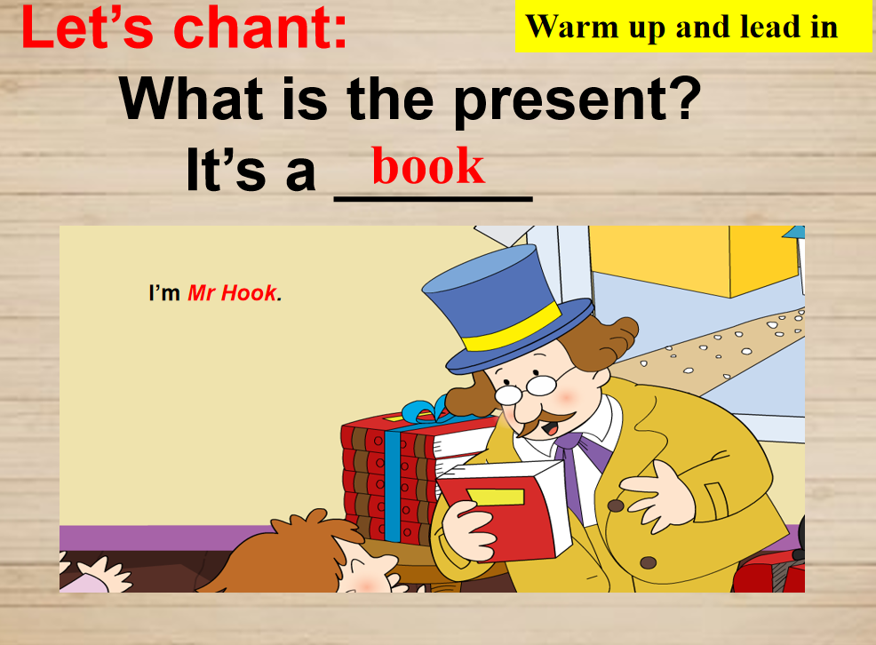
- Listen and chant.
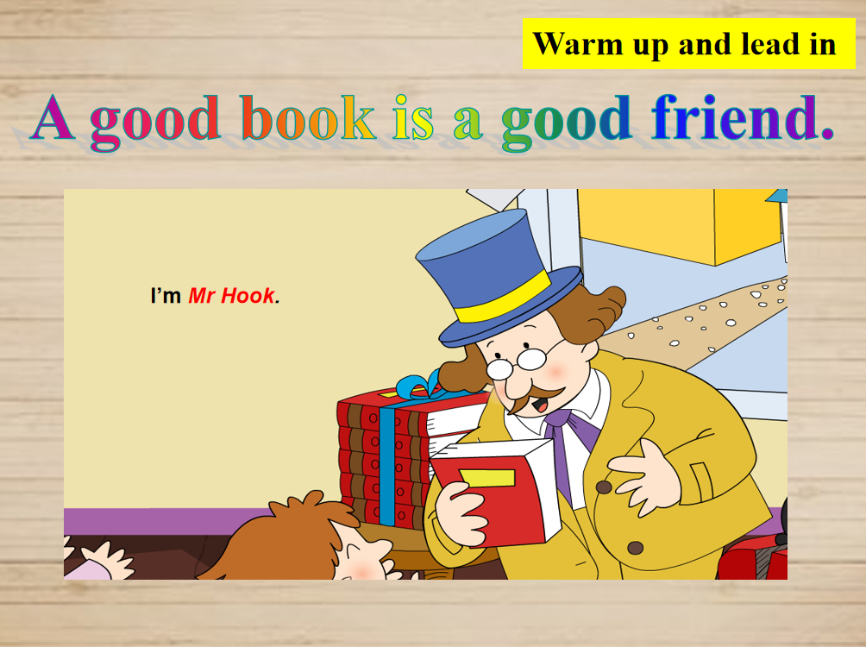
Step 2、Task Presentation
PPT展示 Today we are going to use “have/has got” to ask and describe some
Information about the library.
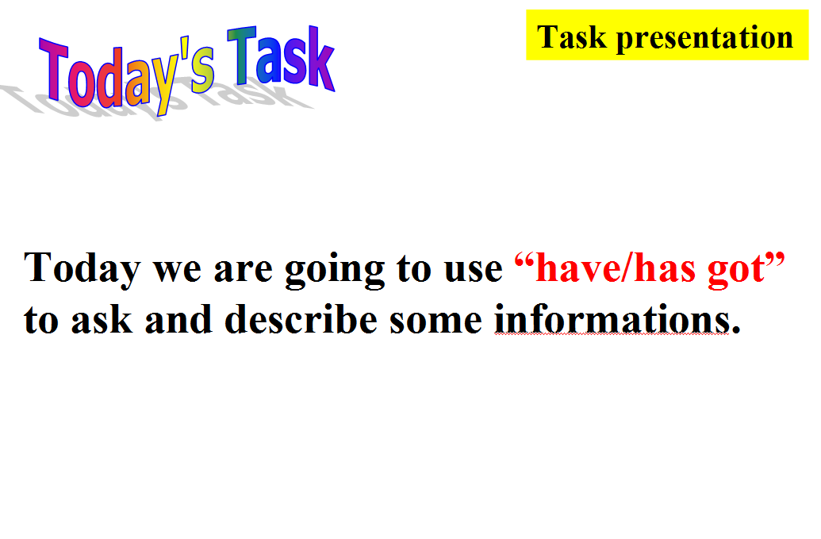

Step 3、Text Learning
- Watch and choose.
T: Lingling and Amy are at the library. What do they want to do? Let’s watch.
- What does Amy want to borrow?
- Has the library got the Harry Potter DVDs ?
(Teach the new words: borrow, DVD)
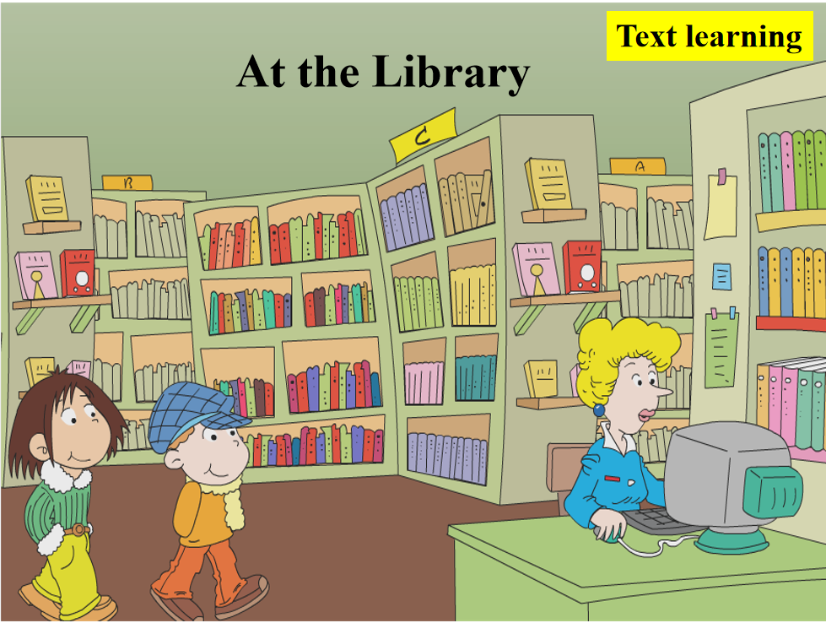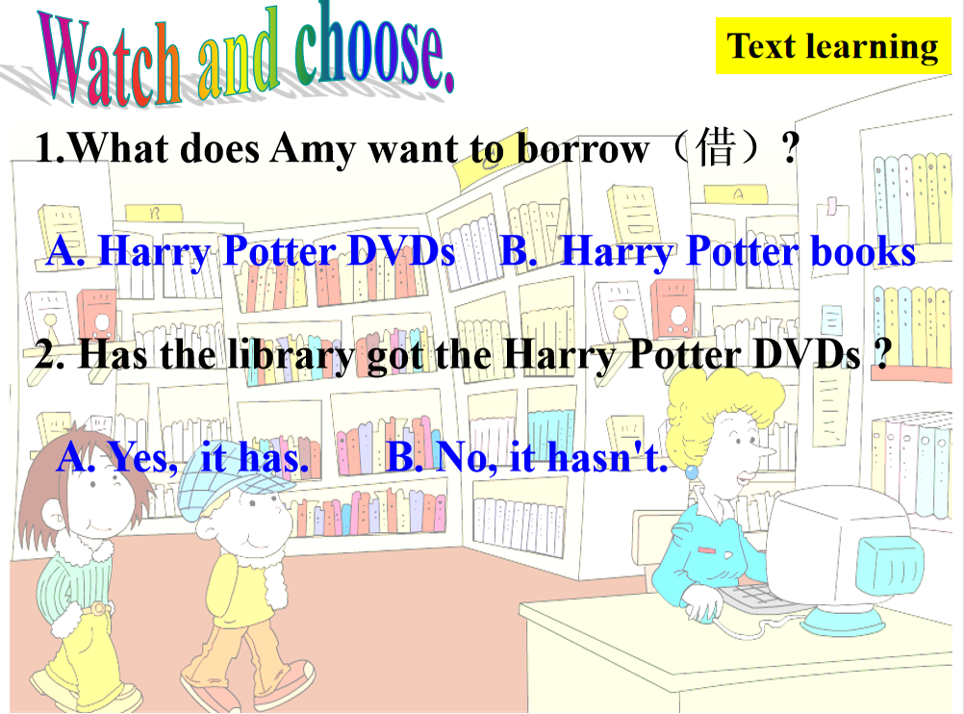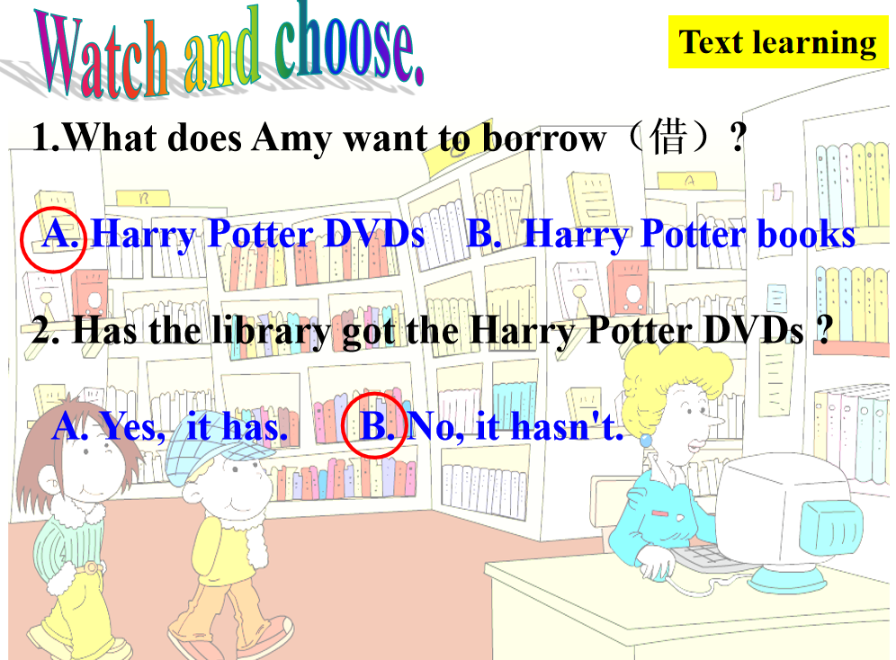
- Introduce some information about Harry Potter.
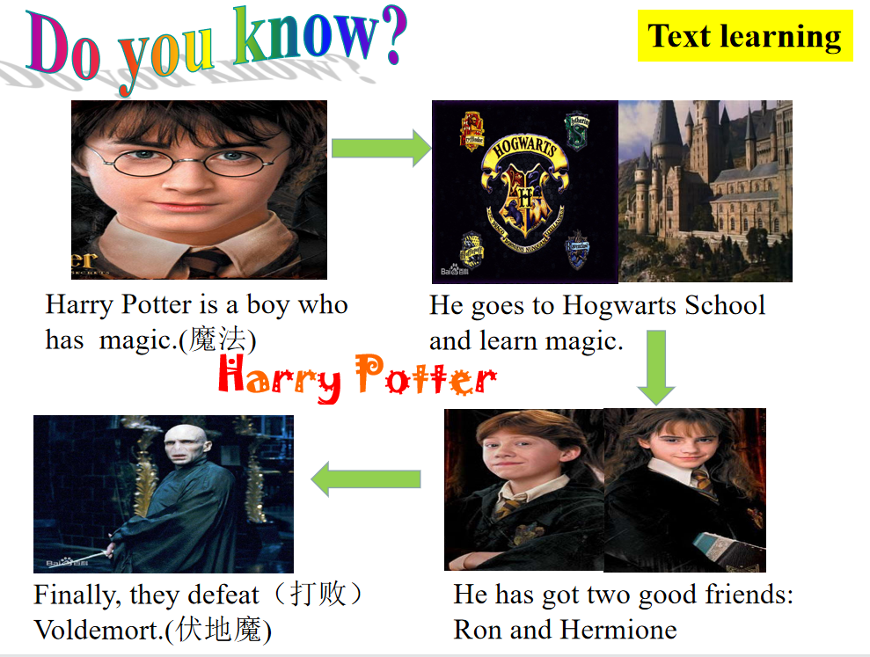
c. Listen, imitate and answer:
1. Will the librarian show the books to them?
2. Why do Amy and Lingling borrow Harry Potter books?
（Teach: show ...to）
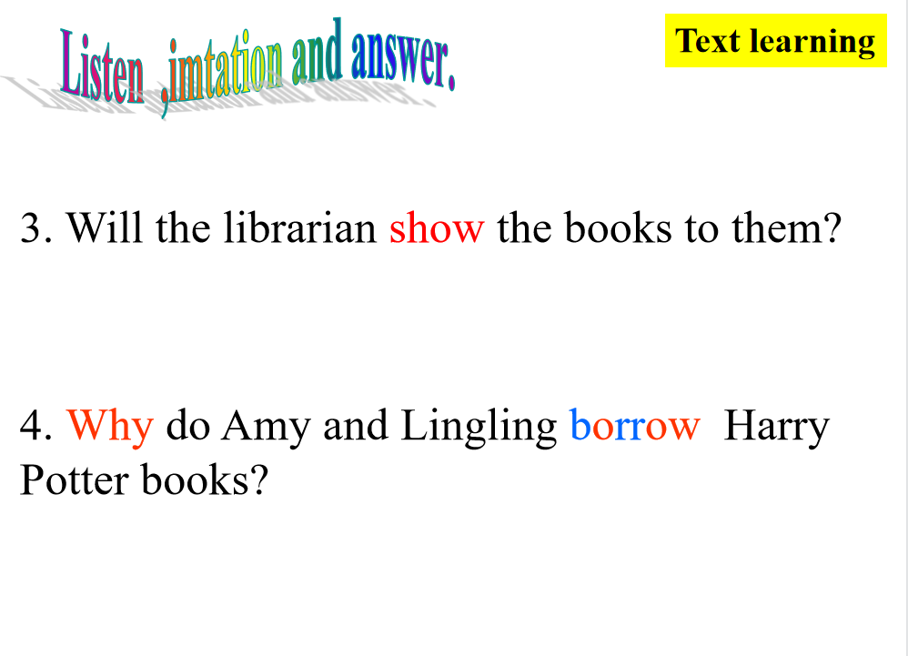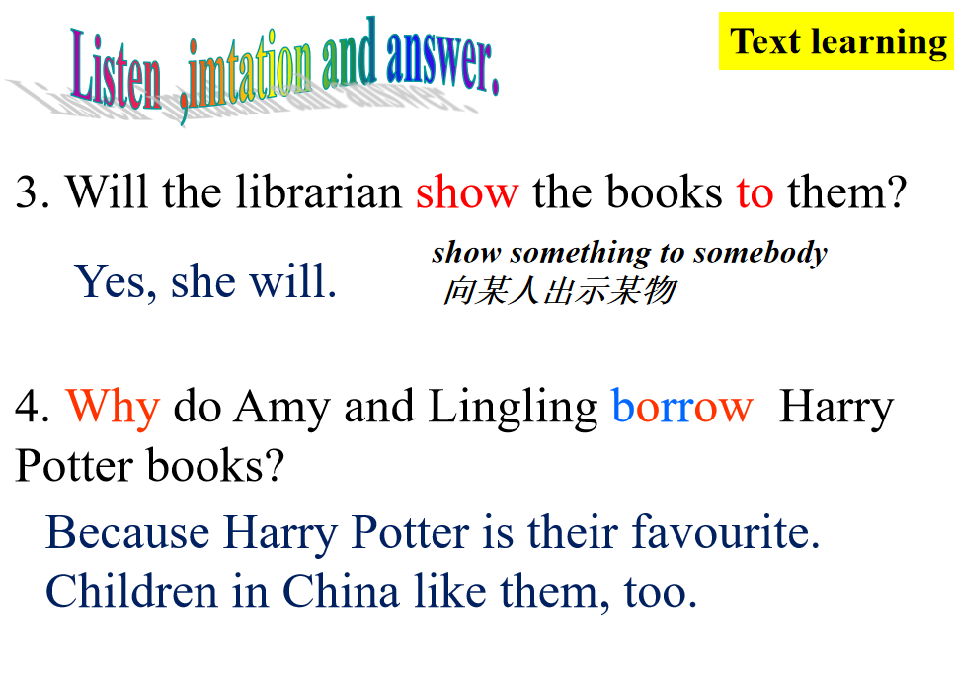
- Read and think.
How long can they have the books?
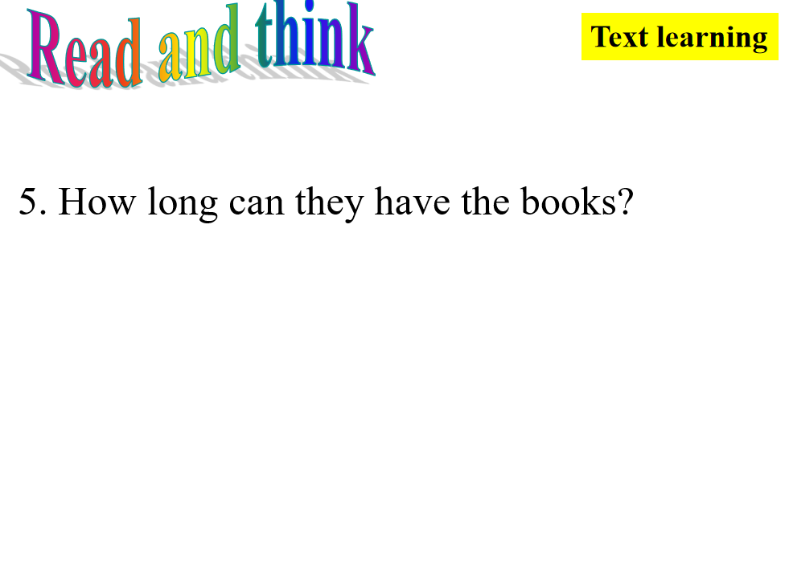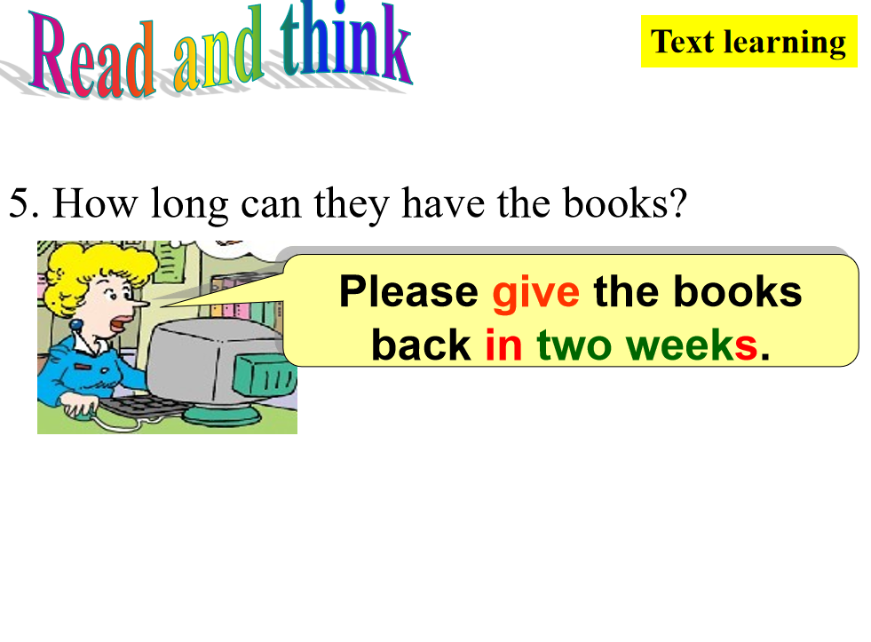
- Read and fill the blank.
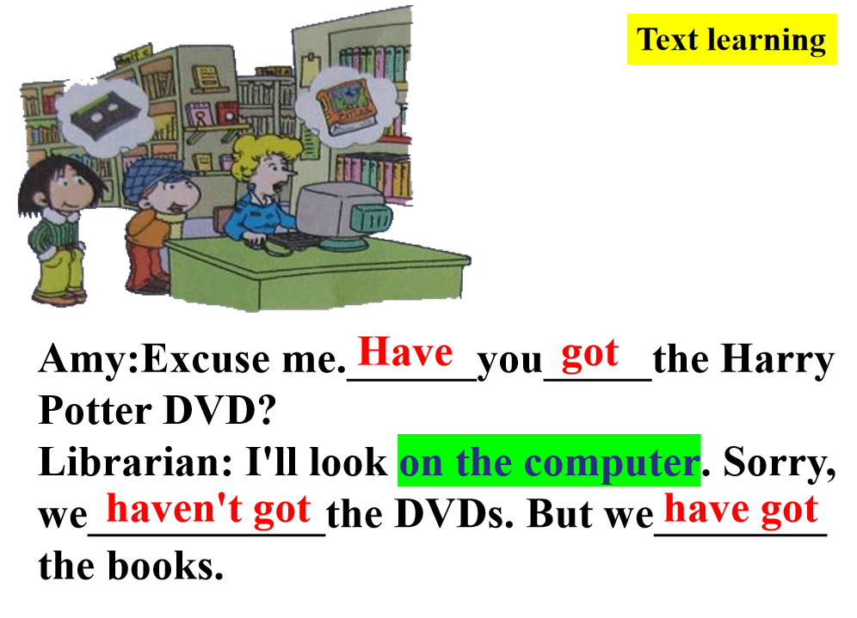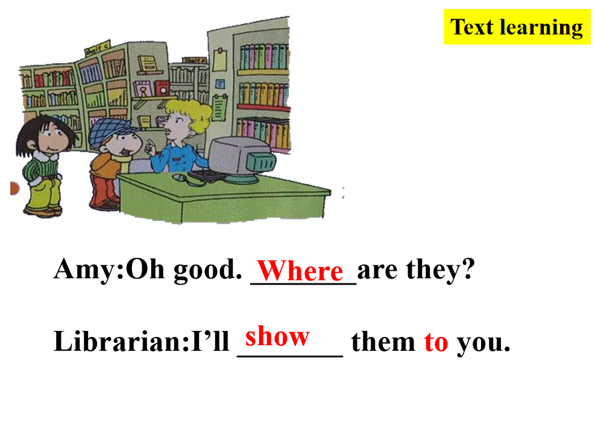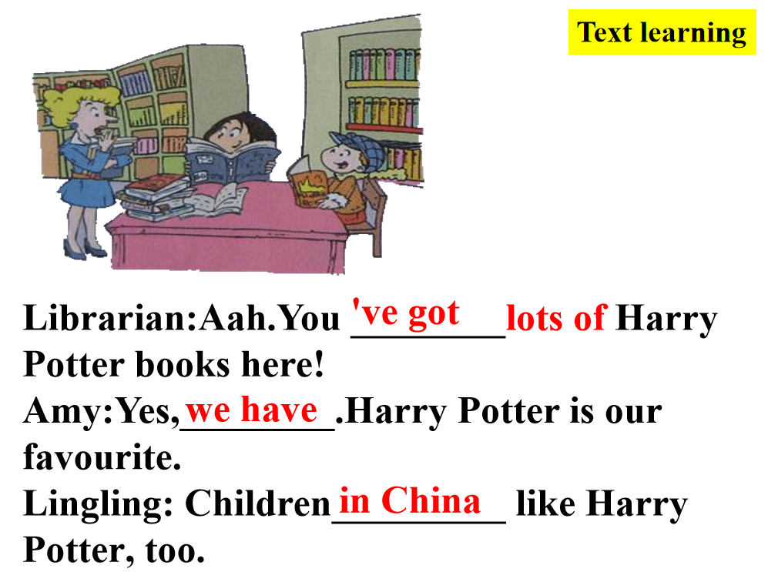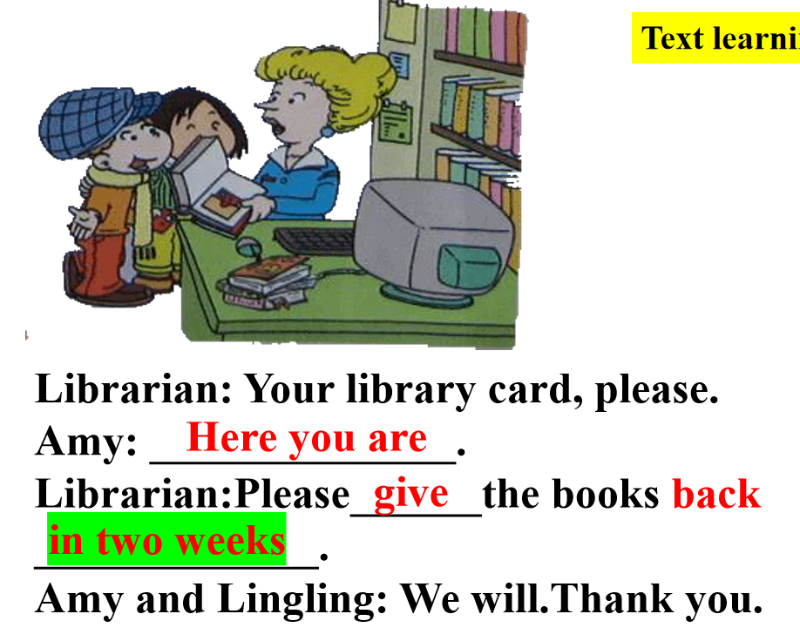

Step 4、Practice
- Play a guessing game.
Have you got.....? Yes, I have. / No, I haven't.
What books have you got? I have got.......
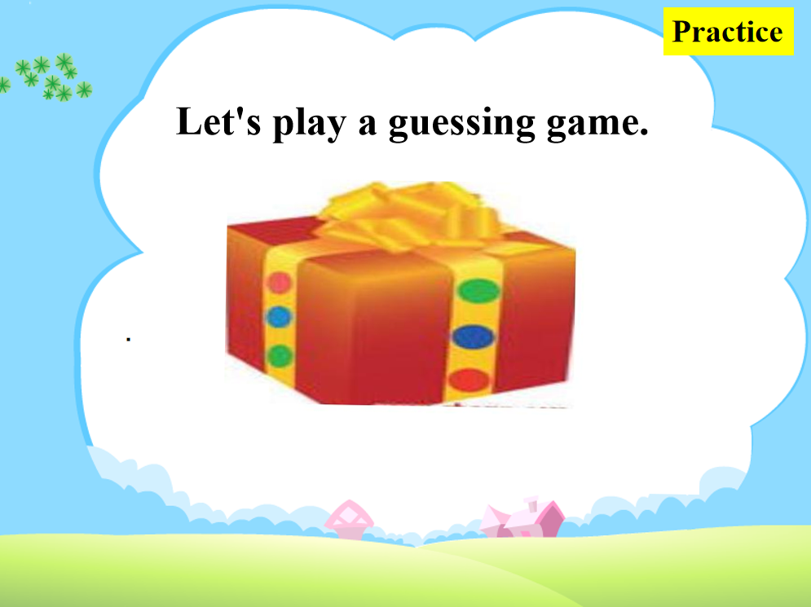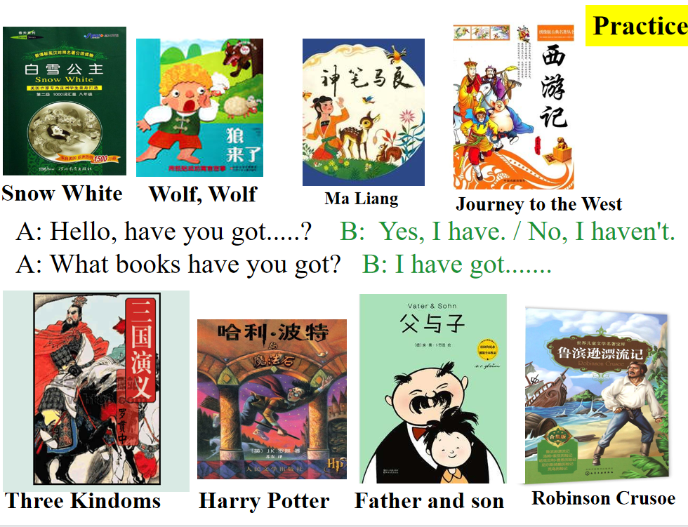
- Ask and answer with each other.
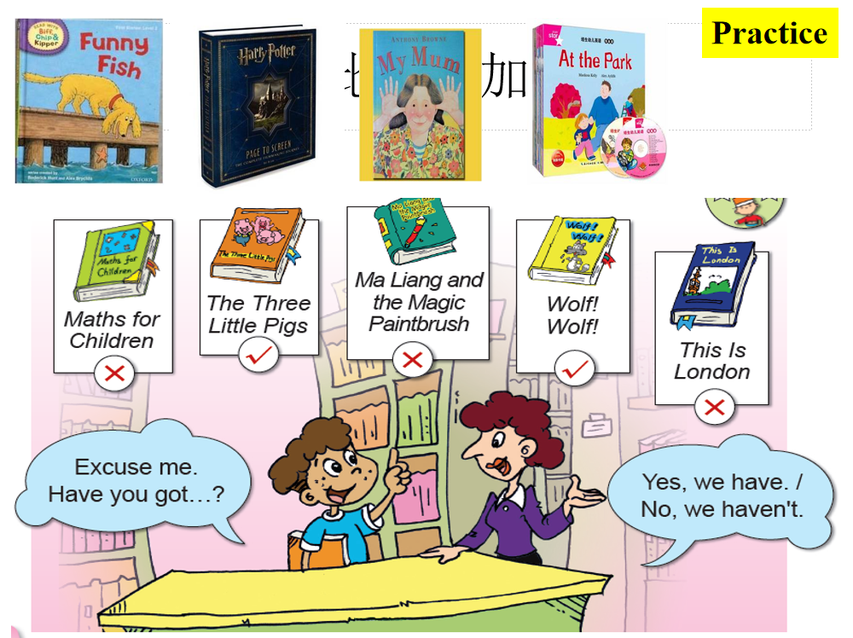

Step 5、Task completion
- Group work: Group work
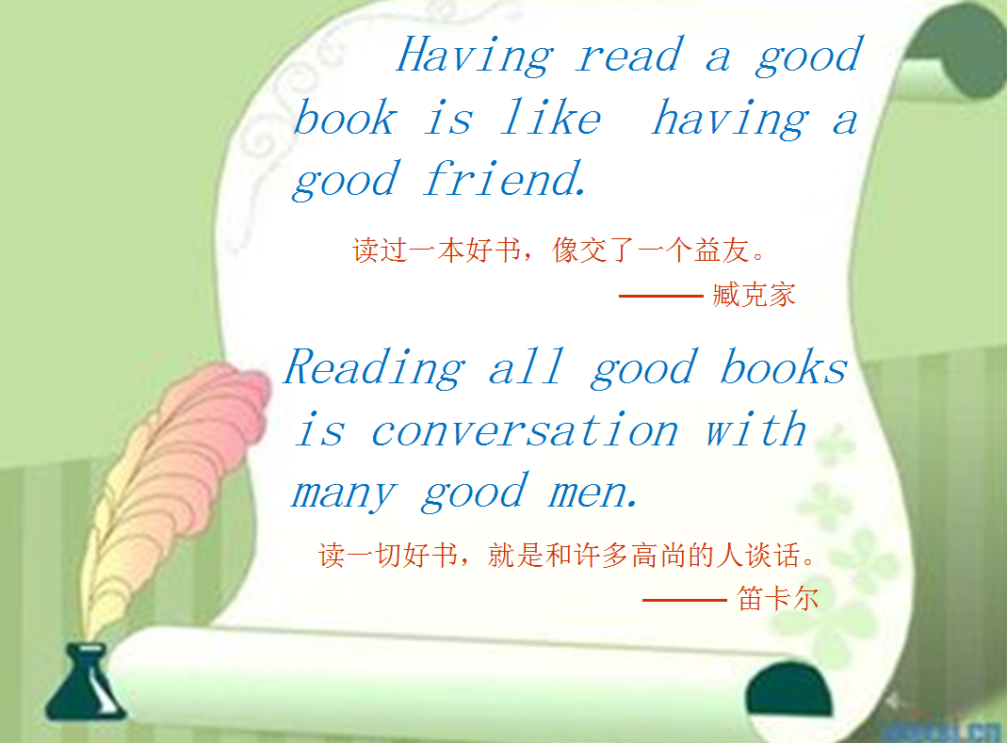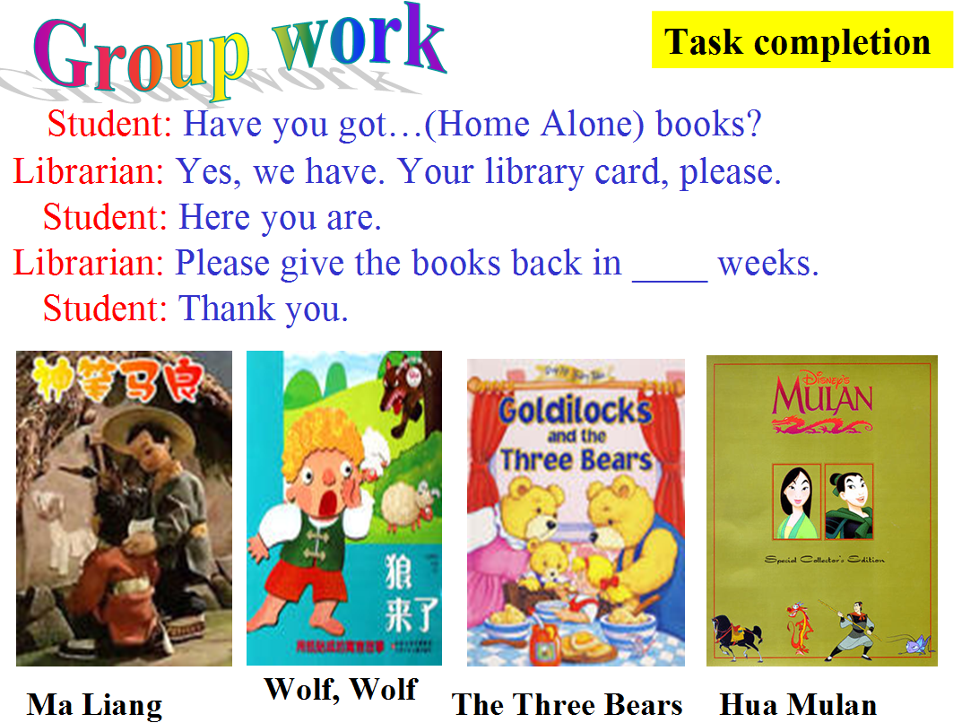

- Talk and Write: What have you got in your room?
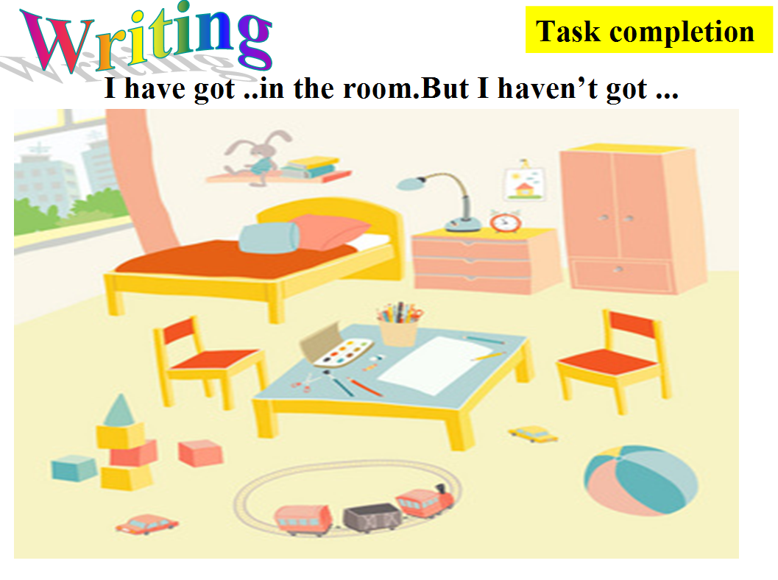

Step 6、Summary and homework
1. Sum up: What have we learnt today?
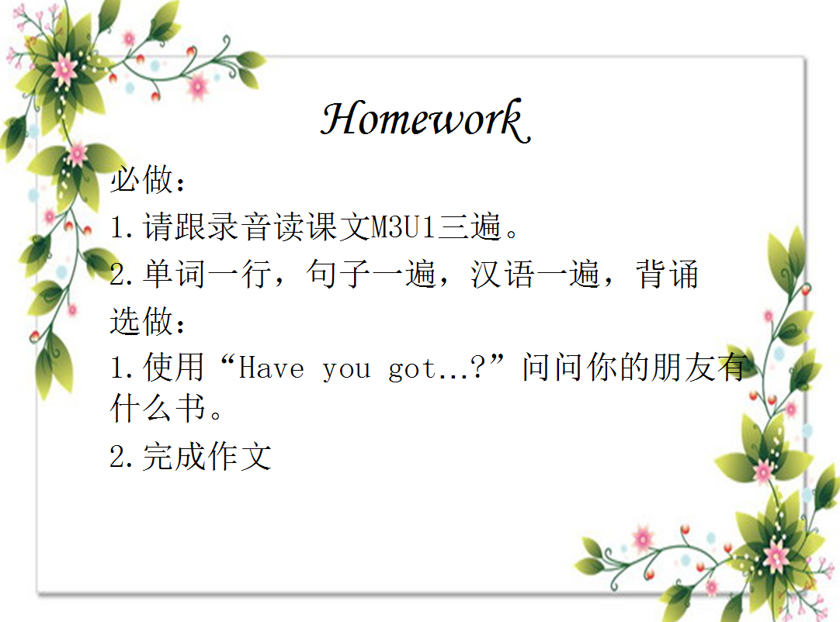2. Homework.
