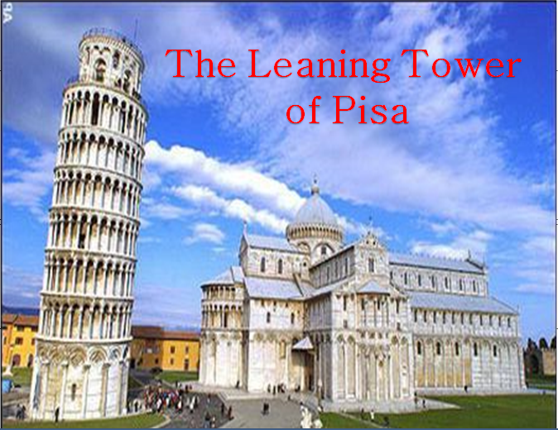
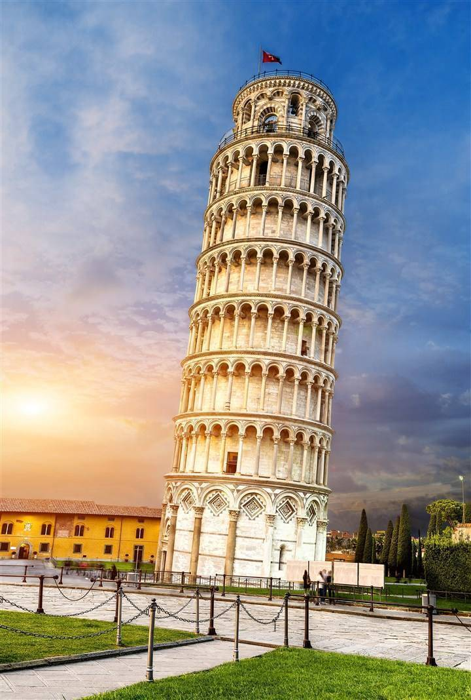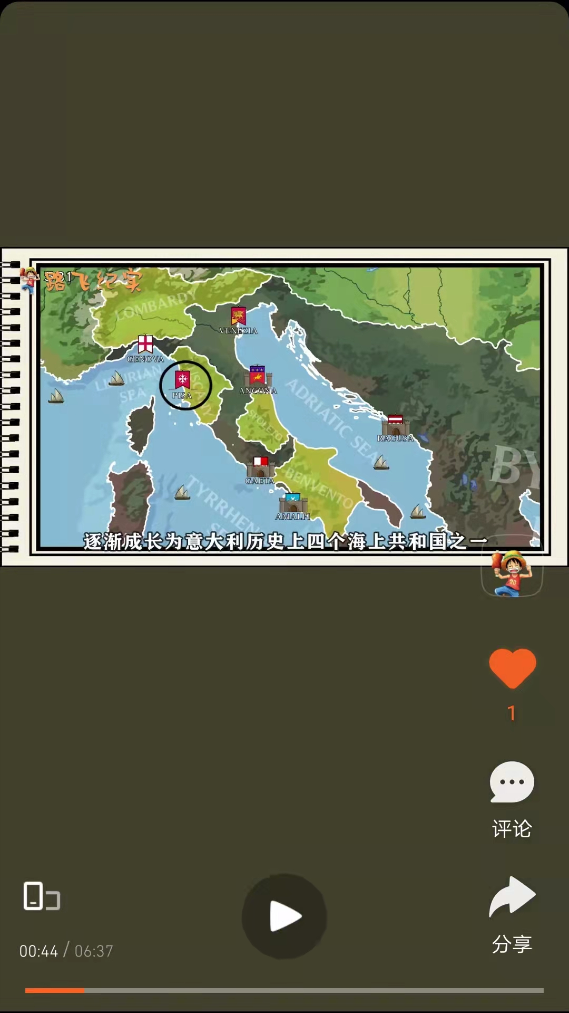
It was built in the city of Pisa, Italy in 1173.
It took nearly 200 years to complete, when the building got to the third floor, it started to lean.
The Leaning Tower of Pisa is a very famous bell tower in the world .
It’s not only beautiful, but also strange-it leans(倾斜) to one side.

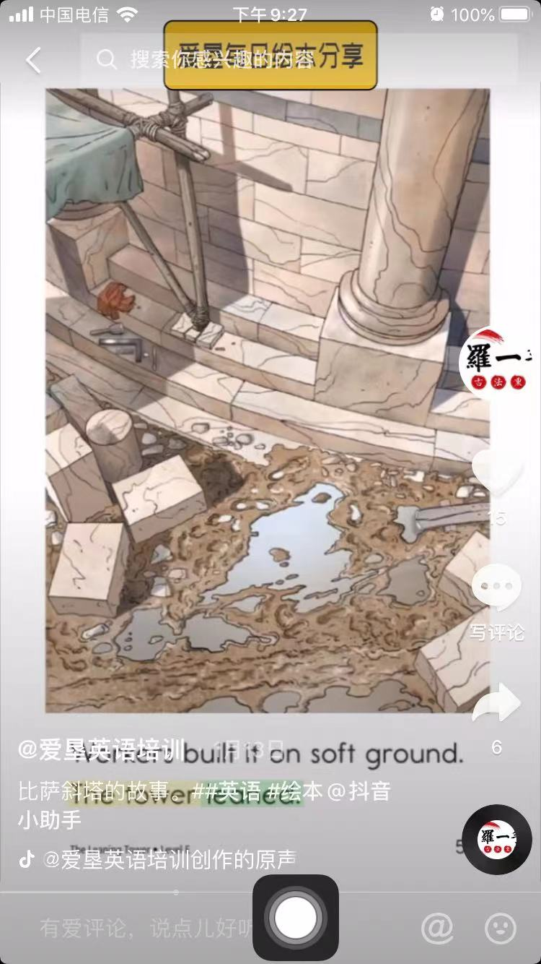
Why does the Leaning Tower of Pisa lean(倾斜)?
The builders built it on soft ground,
the tower leaned.

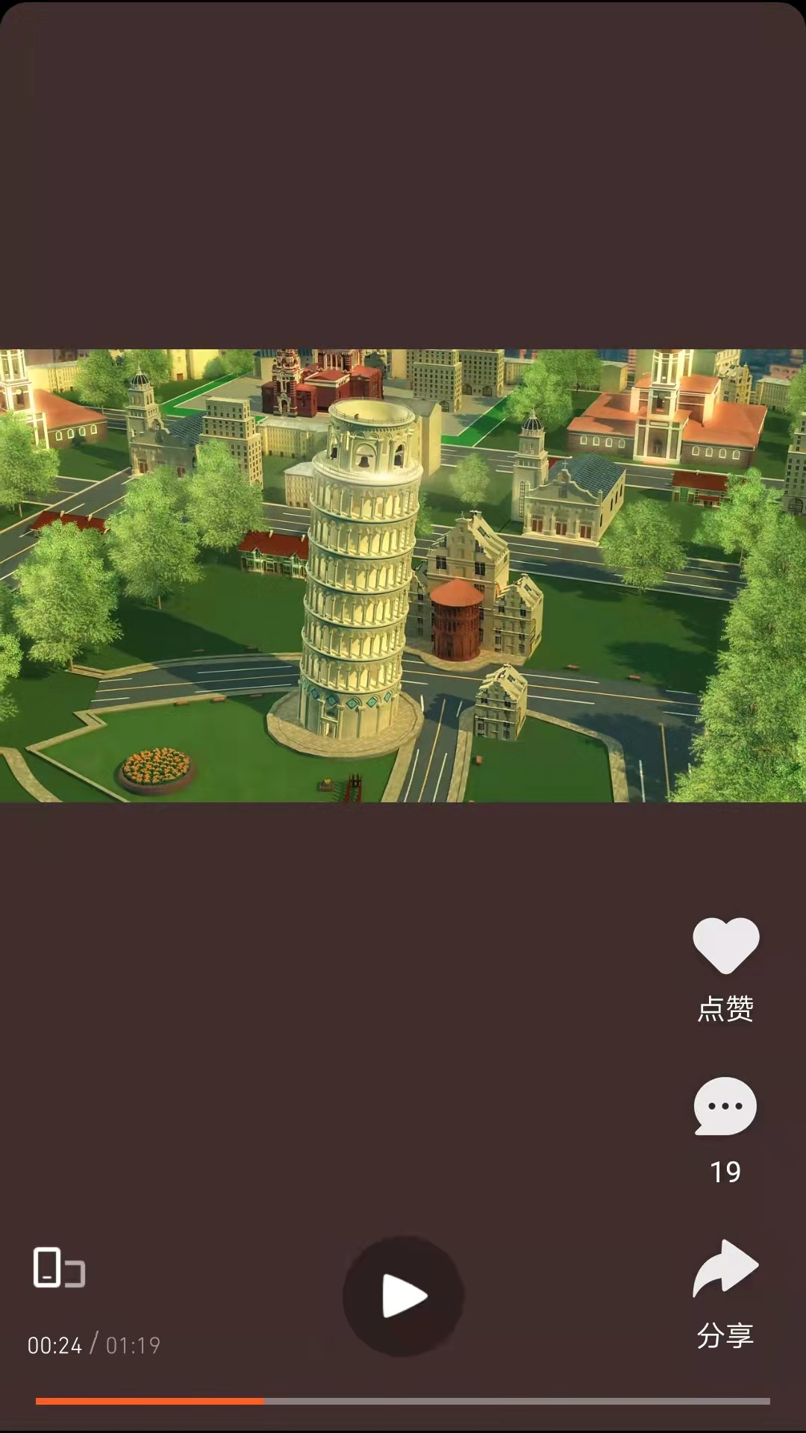
The builders built it too tall and skinny,
the tower leaned.
It got dangerous , so it was closed to the people for safety reasons in 1990.

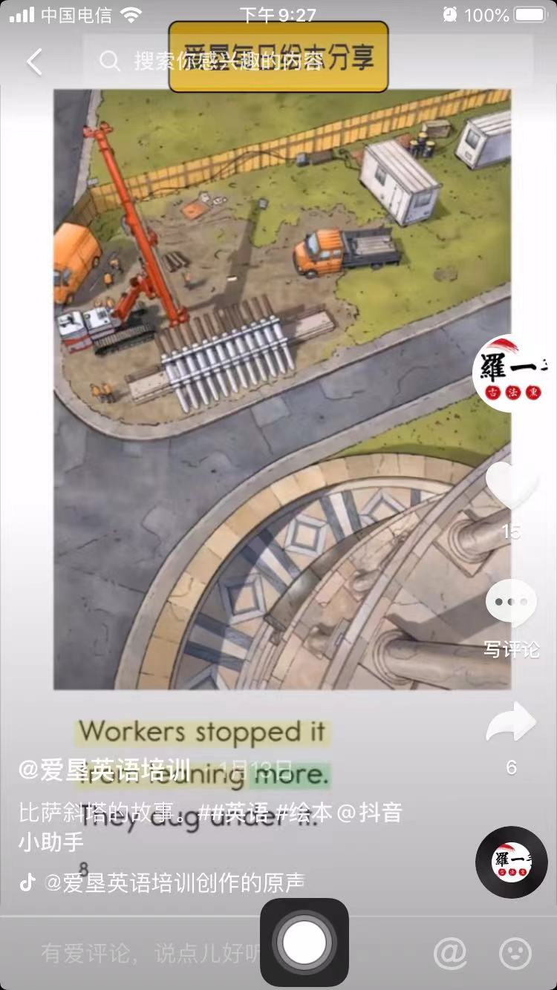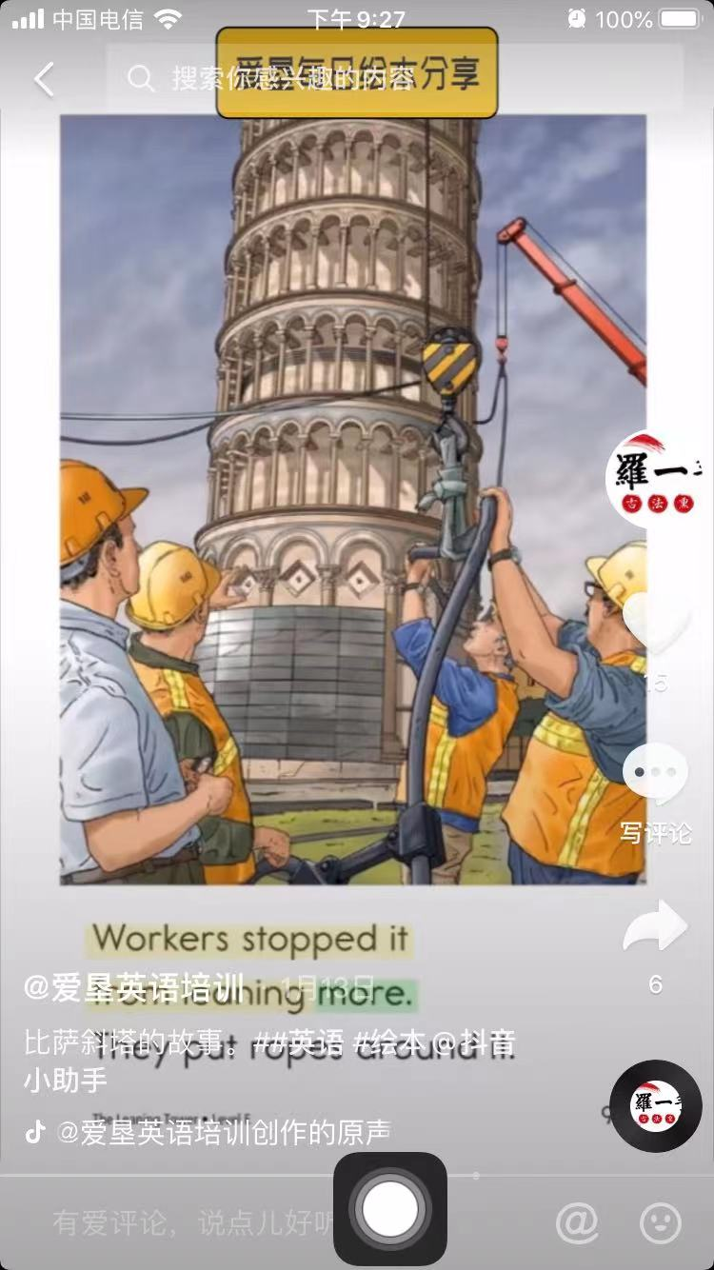
The builders wanted to stop it from leaning more, they dug under it.
They put ropes around it,
and put weights on the ropes.


The builders tried many ways to ‘rescue’(拯救) the tower. It slowed down(减缓) the leaning.
And it reopened to people in 2001.
Today, the Leaning Tower of Pisa stand at 55 or 56m tall. Hopefully it will be safe for the next 300 years.

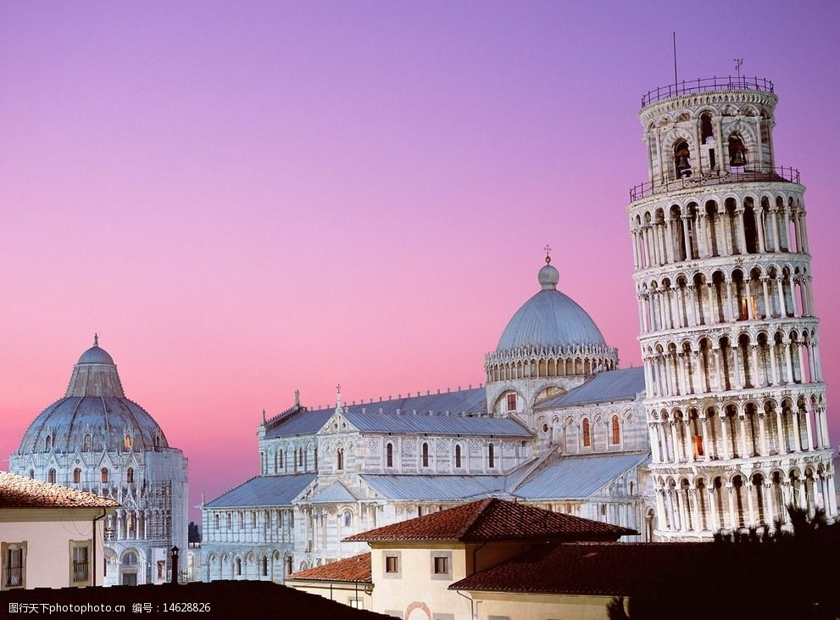
The Italian people are very proud of it,
“The Leaning Tower of Pisa will stand for ever.”they said.

