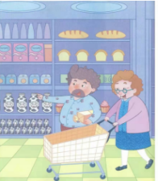
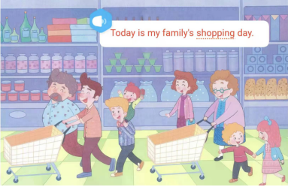
Today is my family’s shopping day.
Oh! What a big supermarket!

The supermarket is very big.
It sells many different things from China.
There are some bread and milk on the shelves.
My grandma and grandpa can buy them. They are very delicious.
They can put them in the shopping cart.

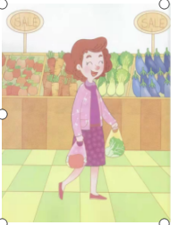
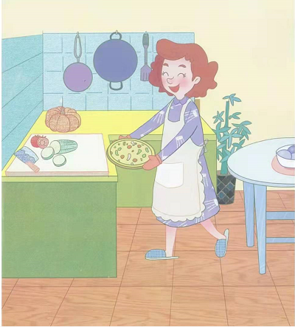
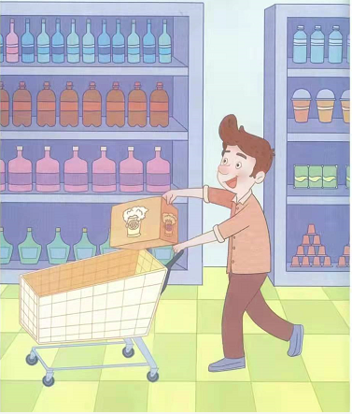
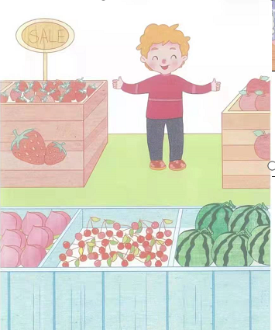
The supermarket is very big.
It sells many different things from the garden.
There are some vegetables and meat on the table.
My mother can buy them. They are very fresh.
My mother is very happy. She can put them in the plastic bag.

She make us our favourite Pizza with them for dinner. Wow! Yummy yummy.
What a great mother! We are very happy.

The supermarket is very big.
It sells many different things from China.
There are some drink on the shelves, too.
My father likes beer a lot. He can buy a dozen of beer.
But I think beer is bitter.

The supermarket is very big.
It sells many different things from the fruit farm.
There is a lot of fruit , too.
I can buy them here. I like fruit very much because they are juicy and healthy.

