小学英语一起第十一册

Review Module 6教学设计

四块石小学 张力群

小学英语一起第十一册
Review Module 6教学设计
- 教学目标：
a. 语言功能：复习拥有物和外表，以及作息时间。
b. 语言结构：一般现在时。
c. 语言知识目标：1.学生能够会听，说，读，写并会运用本模块单词及短语
2. 学生能够理解，运用本模块的目标语句
“I’ve got some Chinese chopsticks.”“I haven’t got a book about the US. ”
d. 语言技能目标：能够给笔友写信。
c. 情感态度目标：1. 提高学生学习英语的兴趣，培养学生的自信。
2. 培养学生合作学习，交流能力。
二、教学重、难点：
教学重点：巩固复习have got ,has got的用法以及作息时间的表达。
教学难点：能够介绍自己，并能给笔友写信。
三、学生分析：
在第五模块已经学习了如何给笔友写信，在此基础上，运用目标语句，以学生的生活经验为出发点，拓宽学生的思维，让学生们能够正确熟练地运用，培养学生的能力。
四、教学准备：
卡片、头饰、PPT
五、教学过程：
Step1. Revision and lead in
- Greeting:
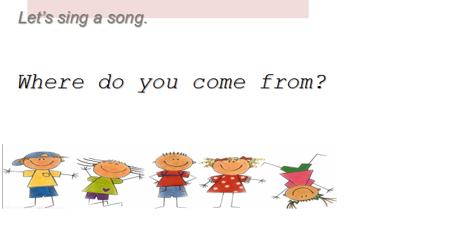
- Sing a song:
Where do you come from?
T: Where is she/ he from?

Step2. Task presentation
Task: We’re going to review Module 6 and write a letter to your friends. Today boys and girls will have a PK. Please try your best. At last, let’s see who can get more information..(说明评价机制)
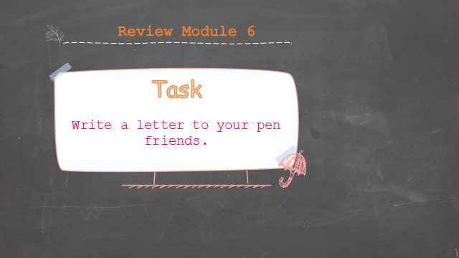

Step3. Practice
- T: Look, there is a new friend. We should say “Pleased to meet you.” What do you want to know about him?
Ss: What’s your name? How old are you? Where are you from? What can you do?
Now let’s read the letter together.（生齐读）
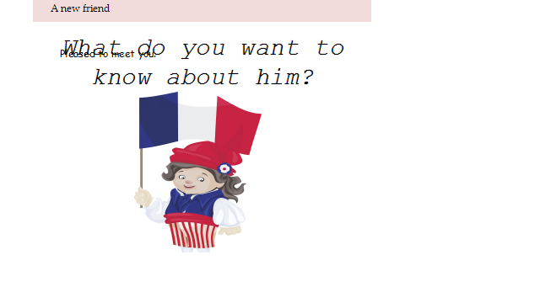
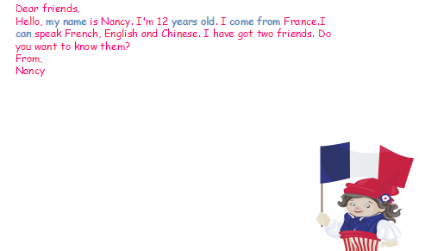

2. T: They are Lingling and Laura.They are pen friends.
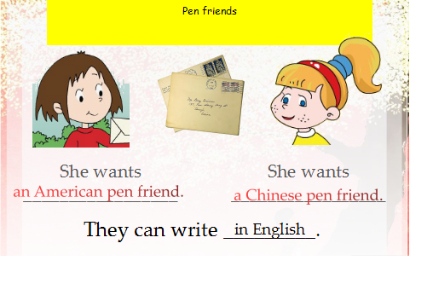

3. T: Read these two letters and fill in the table. (读信，填空)
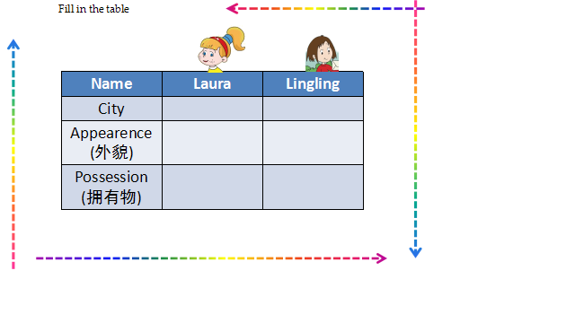

a. Answer questions and fill in the table。Summarize the use of “have / has got”(学生汇报)
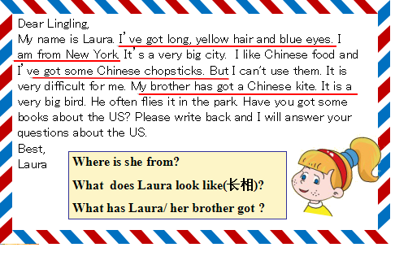

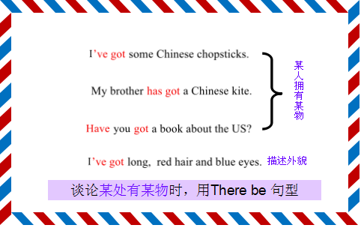

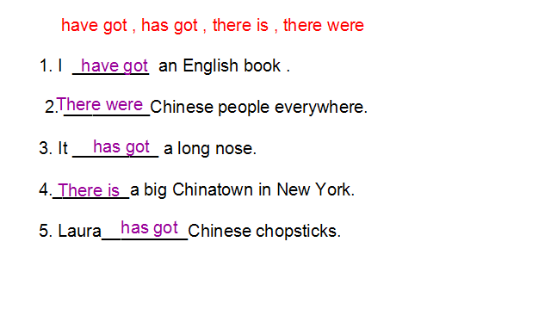

b. Fill in the table and answer questions. Then talk about new topic.(完善表格，提出新话题) “Our school starts at... It finishes at...”
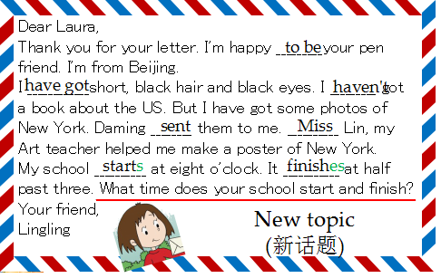

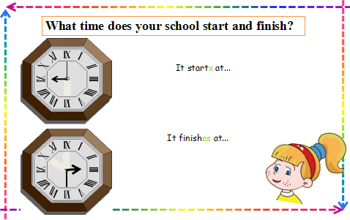
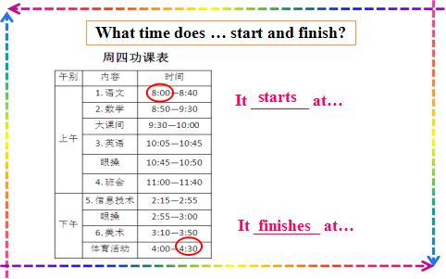

4. Retell according to the table.
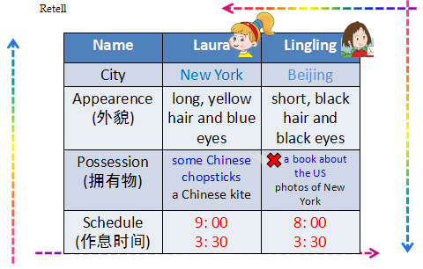

Step4. Production
1. T: New topics will keep our letters going on. There are more new topics.
T: I want to talk about hobby. My hobby is ...
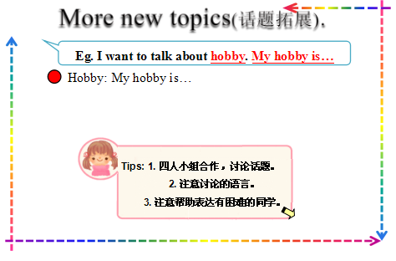
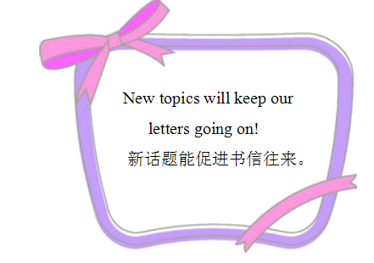

Discuss in groups. (引导学生提出更多的话题，发散学生思维)
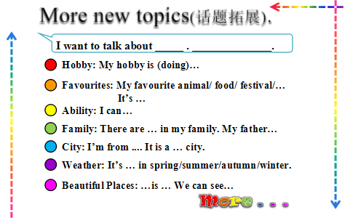

2. Introduce two new friends ---Cindy and Tom. They wrote letters to their pen friends.
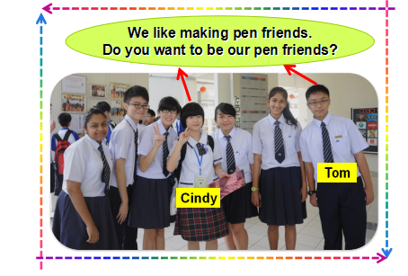
Their pen friends----Lack and Tony had replies.
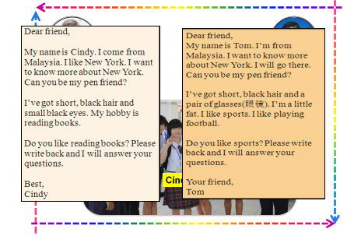
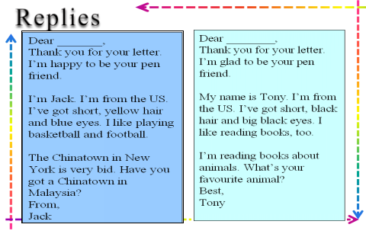

Read these letters in pairs and find whom they wrote letters to. Then fill the names.
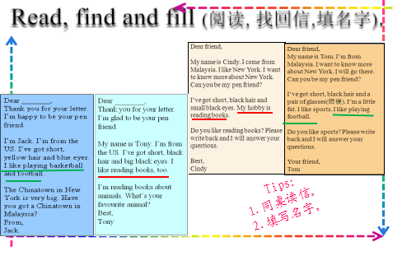

Summary how to write a letter to your pen friend. (根据评价给的信息进行总结)
Step5. Task completion
1. Discuss in pairs and talk about yourself.
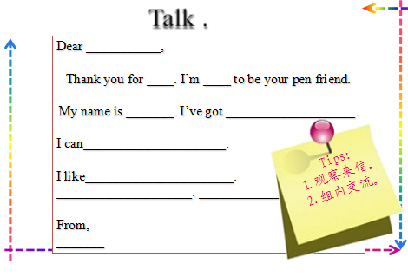

2. Writing a letter to your pen friend. (Type A/Type B)
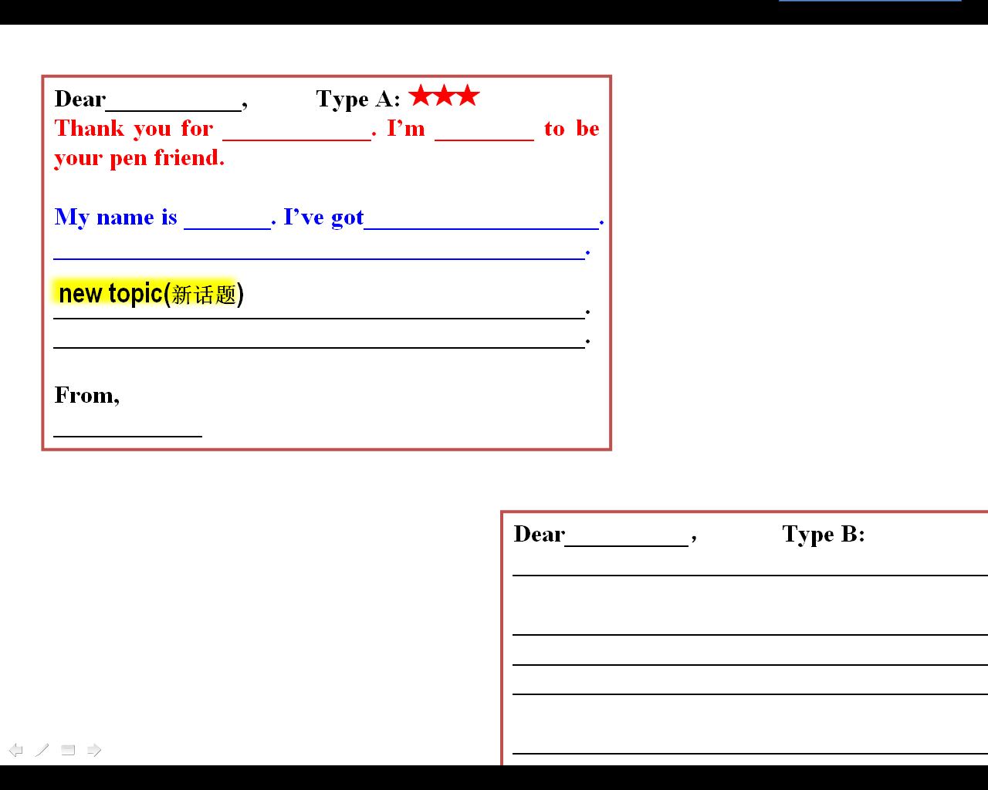
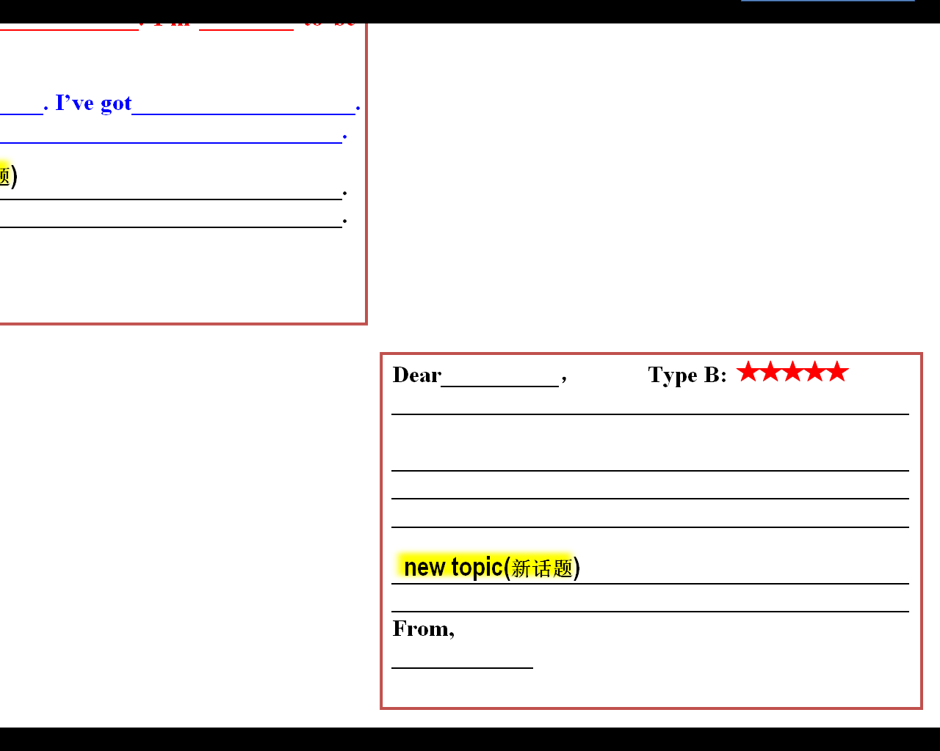

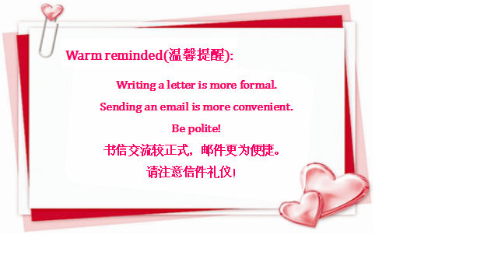
3.

Step6. Summary and homework
- Summary: What have we reviewed today?
- Homework:
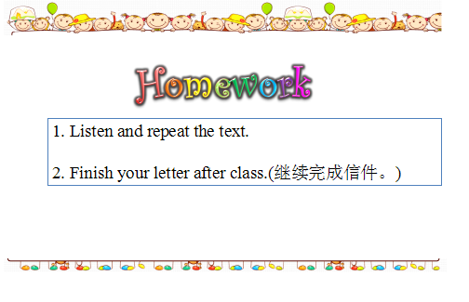

板书：
