新标准英语一年级起点六年级上册

Module 6 Unit 1
I’ve got some Chinese chopsticks.

教学设计

单位：长海县小长山岛镇中心小学
教师：马晓丽

Module 6 Unit 1 I’ve got some Chinese chopsticks. 教学设计
【教材分析】]
语言功能：说明自己拥有的物品。
语言结构：have got; has got
教学目标：
- 语言知识目标：全体学生能运用：I’ve got some Chinese chopsticks.;全体学生能理解world, difficult, answer,全体学生能运用：difficult , answer,部分学生能运用world
b.语言技能目标：能够听懂、会说并认读本模块句型，能运用所学语言谈论及询问自己及他人拥有的物品，以及简单的外貌描述。
c.情感态度目标：乐于感知并积极尝试使用英语。
教学重、难点：
重点：单词world, difficult, answer
功能句I’ve got some Chinese chopsticks.
My brother has got a Chinese kite.
Have you got a book about the US?
难点：能在实际情景中运用have got, has got句型。
【学生分析】
学生已学过have got, has got。本册教材的Module3 也对此句型进行了进
一步巩固。所以，学生比较熟悉这个语言结构。
【教学准备】
PPT课件, 点读笔，单词卡片，板书图片，评价图片，任务单等。
【教学模式】
小学“任务型活动化”六步教学模式
Step 1. Revision and lead-in
Step 2. Task presentation
Step 3. Text learning
Step 4. Practice
Step 5. Task completion
Step 6. Summary and homework

【教材】
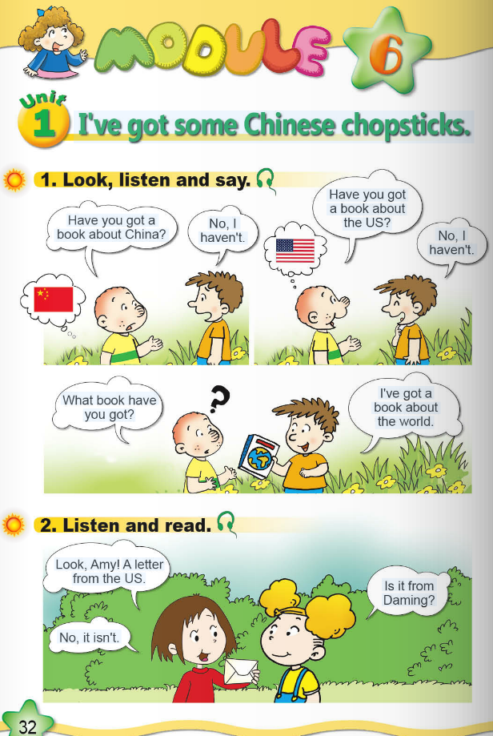

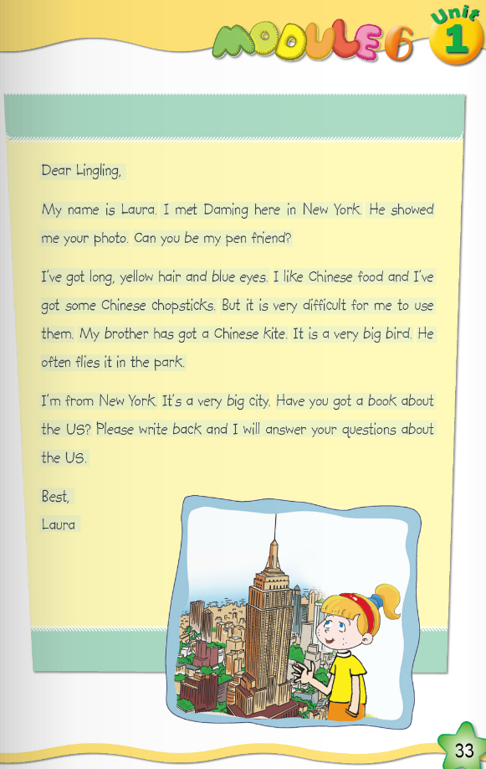

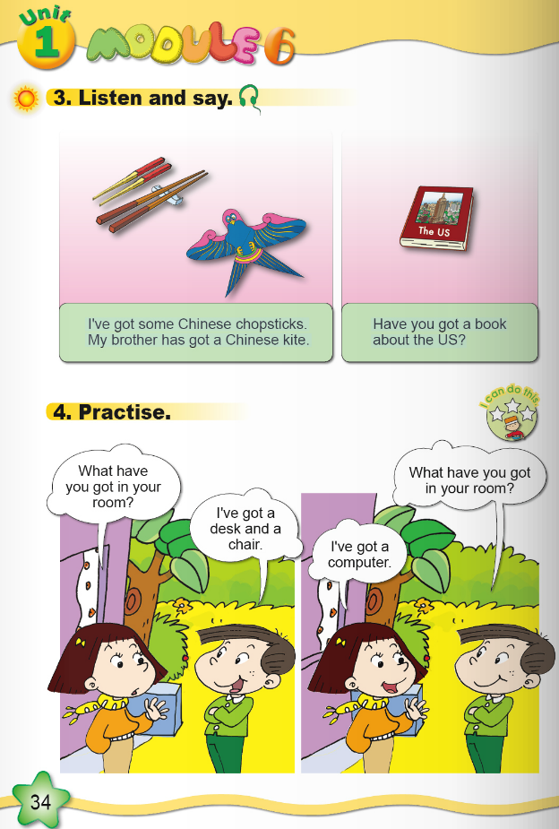

【教学过程】
Step 1. Warm-up and lead- in
- Greetings
- 介绍本节课评价机制
- Enjoy some pictures.
T: What are they doing? Do you like reading books? I like reading books. Because books can open our eyes to the world.( teach : world ; 拓字母组合语音教学or , work/worse/worst/ word)
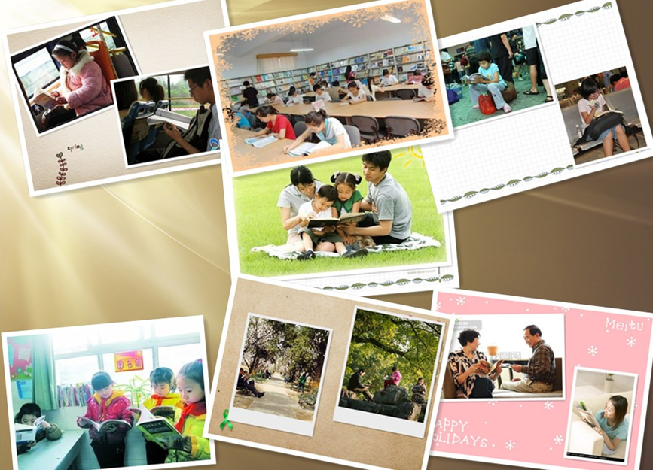
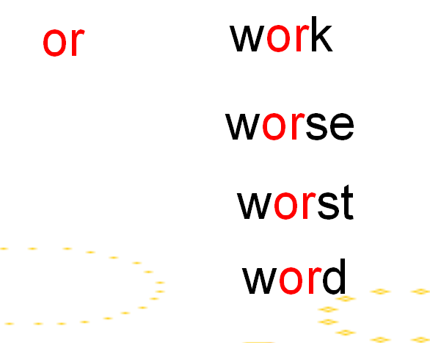
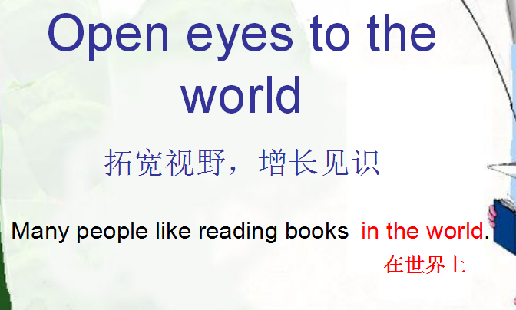

- Learn Activity 1
T: Sam’s friend has got a book. What’ s the book? Let’s watch and see.
(设计意图：通过活动一的学习，以旧带新，进一步理解新词world;通过几个练习让学生明白什么是“上位概念与下位概念”。)
- Listen and imitate.
Step 2. Task Presentation
- T: Boys and girls , today we’ll write a letter to talk about possessions and appearance with “have got”. How to talk about? Let’s learn Module6 Unit1 I’ve got some Chinese chopsticks.
(设计意图：帮助学生明确本节课的学习任务。)
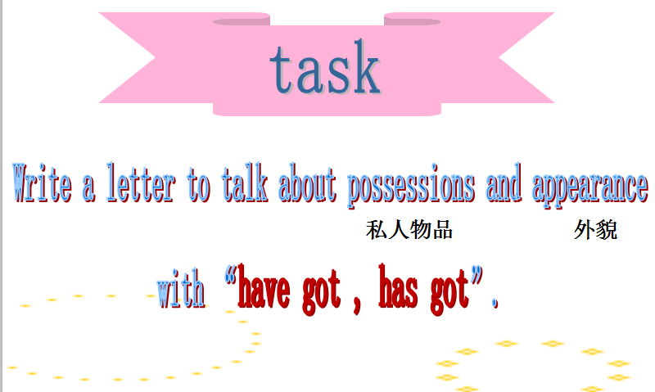

Step 3. Text learning
1. Watch the CD-ROM and answer
T: Lingling has got a letter. Who wrote the letter to Lingling? And what’s the letter about? Let’s watch the CD-ROM and see.
Ss answer and teach the new word : answer
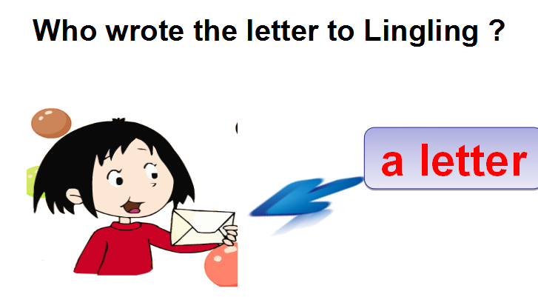
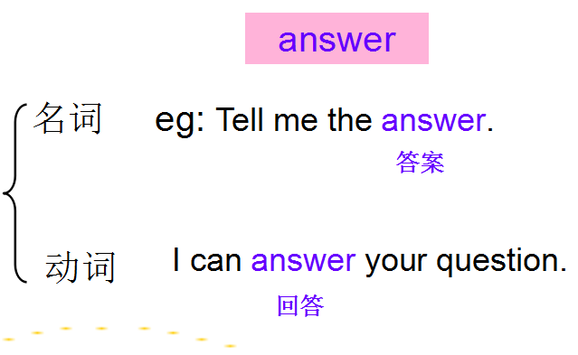

(设计意图：引导学生整体感知语篇。)
2.Watch the CD-ROM again, answer 3 questions
1）Complete the questions
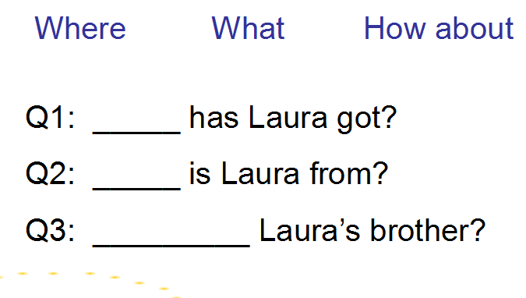

(设计意图：通过特词填空，培养学生的思维能力。)
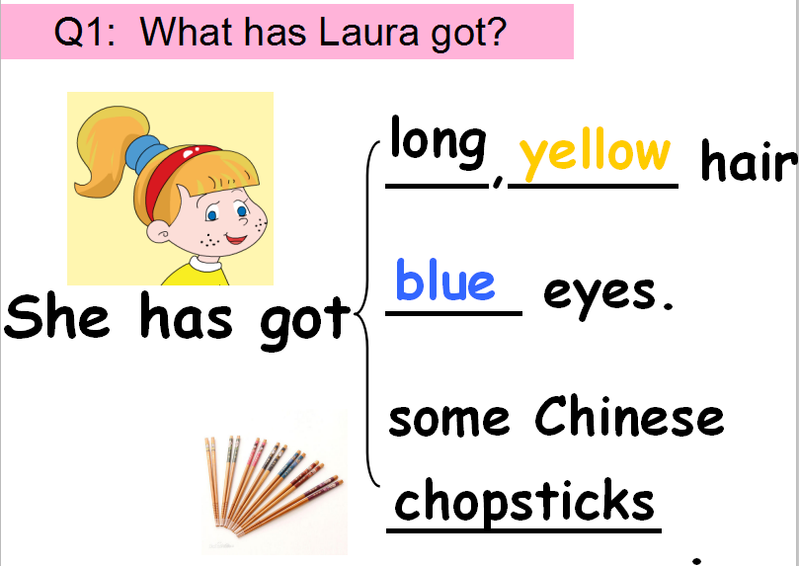
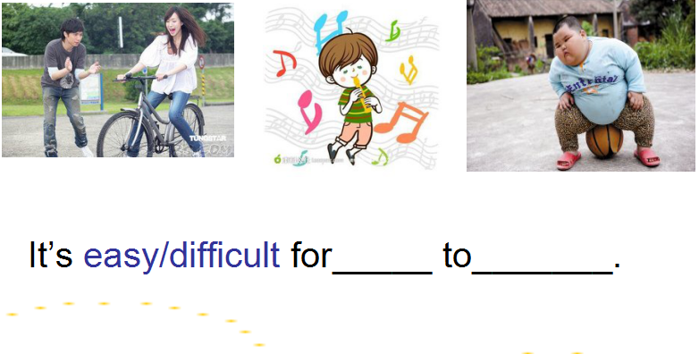
- Watch the CD-ROM and answer the first question : What has Laura got ?

(设计意图：逐步理解语篇，讲授新单词difficult。)
Watch a short video to know more about chopsticks .
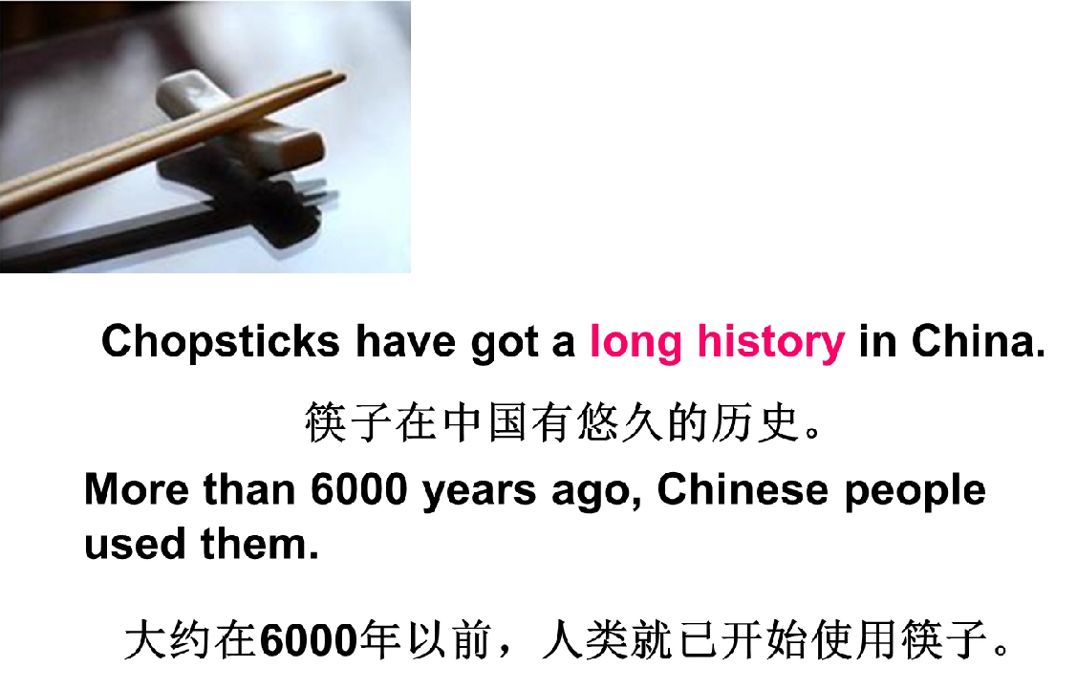

(设计意图：培养学生文化意识。)
- Read the text by themselves and answer question 2 and question 3
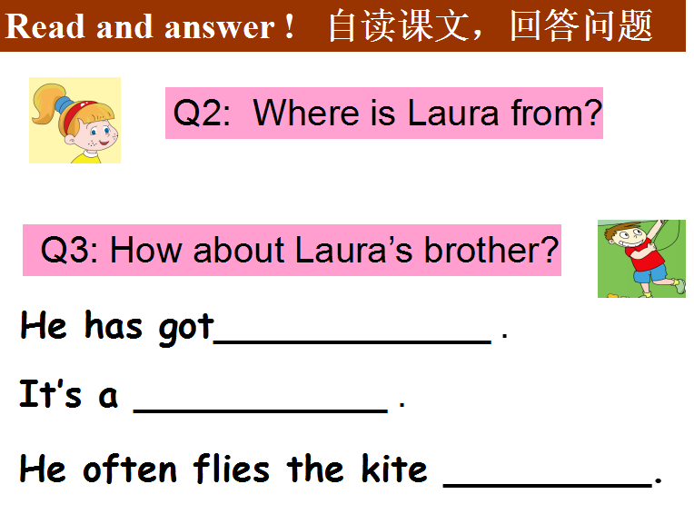

(设计意图：进一步理解语篇，并且通过引导学生自读回答问题培养学生的阅读能力。)
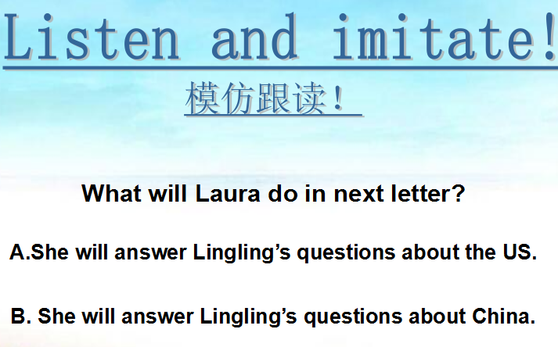
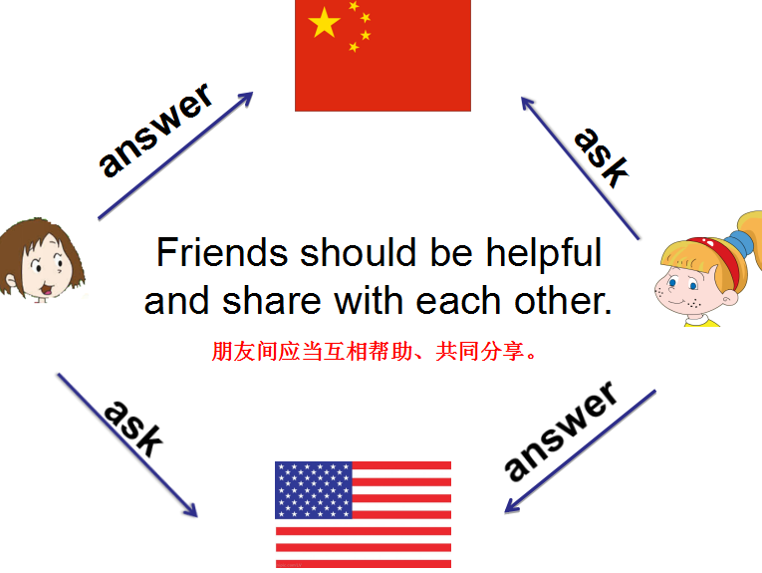
- Listen and imitate . Answer the last question：What will Laura do in next letter ?

(设计意图：引导学生带着问题跟读课文，全面理解语篇。并且对学进行适当的情感教育。)
- Retell the letter
(设计意图：培养学生的语言运用能力。)

Step 4. Practice
- Have a listening practice .
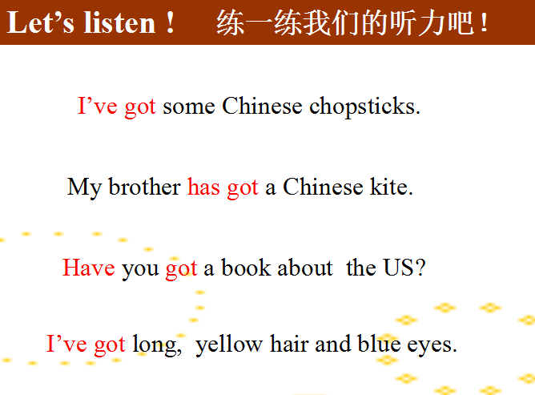

(设计意图：通过一个听力小练习将功能句提炼出来，培养学生的听力能力。再将枯燥的语法讲解以微课的形式呈现出来，提高学生的学习兴趣。)
2. Free talk
Activity 4 Read the example , then ask and answer in pairs .
Then watch some pictures of heroes---Grandpa Zhong , doctors , nurses and so on .
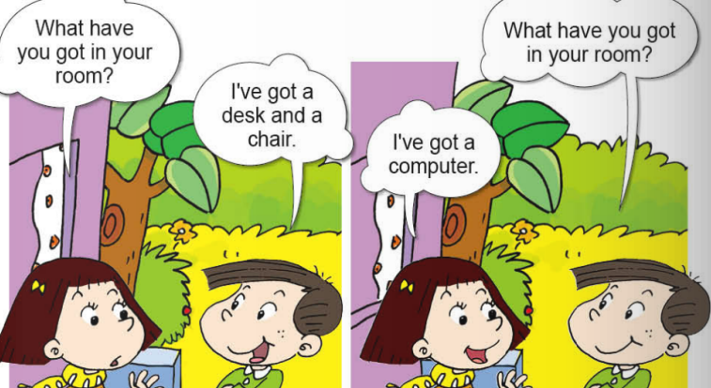
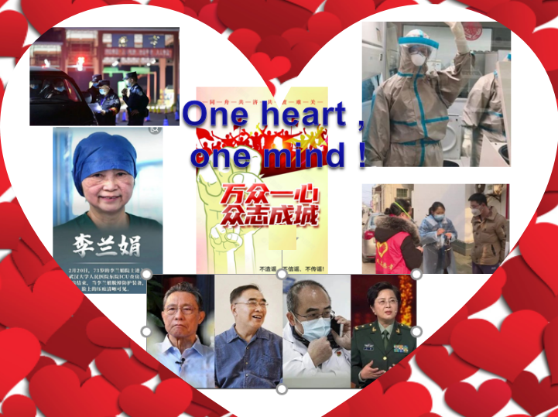
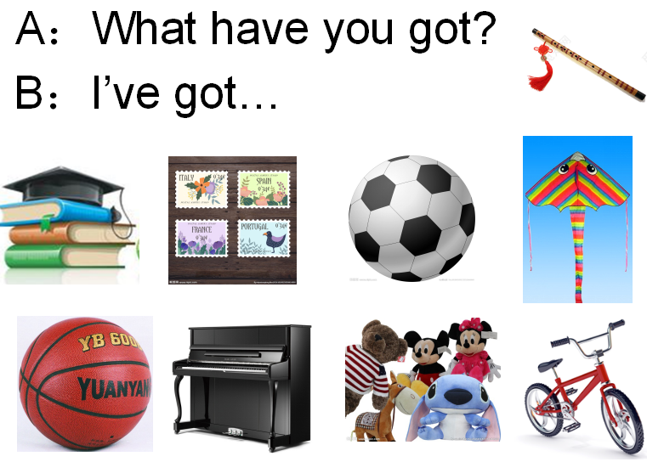

(设计意图：操练本节课主要句型；对学生进行情感教育，了解疫情发生后我们国家所做出的努力，进行爱国主义教育。)
Step 5. Task- completion
- Read and ask in pairs .
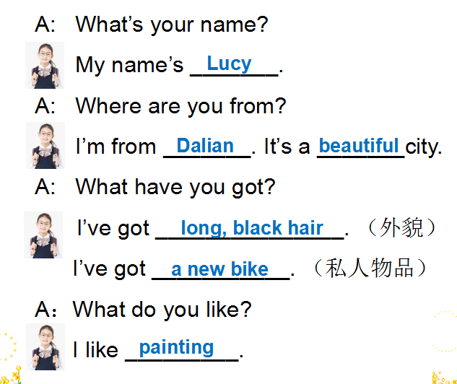

2. Listen to Lucy’s letter , then write it down .
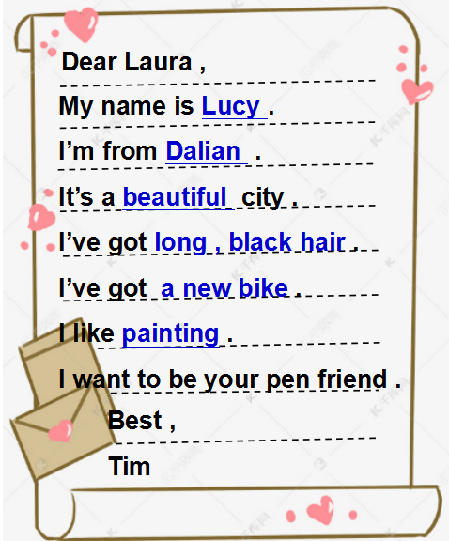
Three choices . Write according to the tips , one star ; Write by yourself , two stars ; Help Tim write to Laura ,three stars.

(设计意图：完成本课任务，与任务呈现相呼应，写作采用分层教学，给学生提供3个选择，满足不同层次学生的学习需求。)
Step 6. Summary and Homework
1.Make a summary .
2.Homework .
3.Have a test （课堂检测） .

