**新标准英语一年级起点第七册**

Revision of Module 5

**大连市长海县小长山岛镇中心小学**

**朱宏琴**

新标准英语一年级起点第十二册

Revision of Module 5

教学设计

**一、教学目标**

**语言知识目标：**

功能：使用含有不规则动词过去式的语句说明过去的活动。

语法：全体学生能运用：We went to the Great Wall. I wore warm clothes.

词汇：全体学生能理解:went,saw trip,took,fifty,minute,top,mountain,ate,candies,

plant,had,have a good time,bought,wore,go on a trip,ice,at first,fell,fall over,hurt,a lot,able,be able to,skate

全体学生能运用went, saw, took,ate,had,have a good time,bought,wore

部分学生能运用trip,took,fifty,minute,top,mountain,candies,plant, go on a trip,ice,at first,fell,fall over,hurt,a lot,able,be able to,skate,

语音：进一步巩固一般过去时陈述句的语音语调

**语言技能目标：**

全体学生能听懂、说：We went to the Great Wall. I wore warm clothes.

全体学生能认读：went, saw, took,ate,had,have a good time,bought,wore

部分学生能认读：trip,took,fifty,minute,top,mountain,candies,plant, go on a trip,ice,at first,fell,fall over,hurt,a lot,able,be able to,skate,能写出1--2个与本模块主题相关的语句。

运用：全体学生能运用“We went …”等含有不规则动词过去式的语句说明假期活动

学习策略：对所学内容能复习和归纳

文化意识：通过了解中西方学校旅行，进一步注意到中外文化异同。

情感态度：敢于尽可能多地使用英语交流，表达中不怕出错误。

**教学内容**

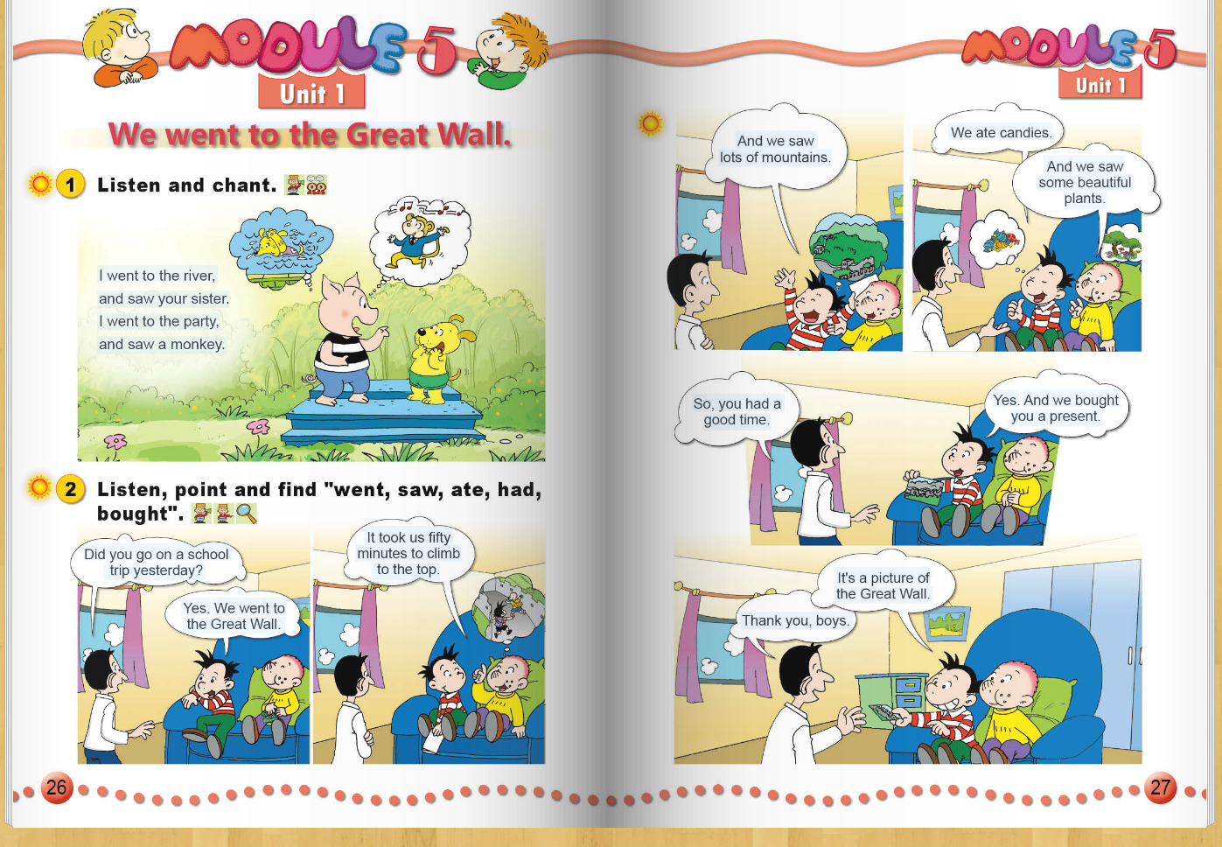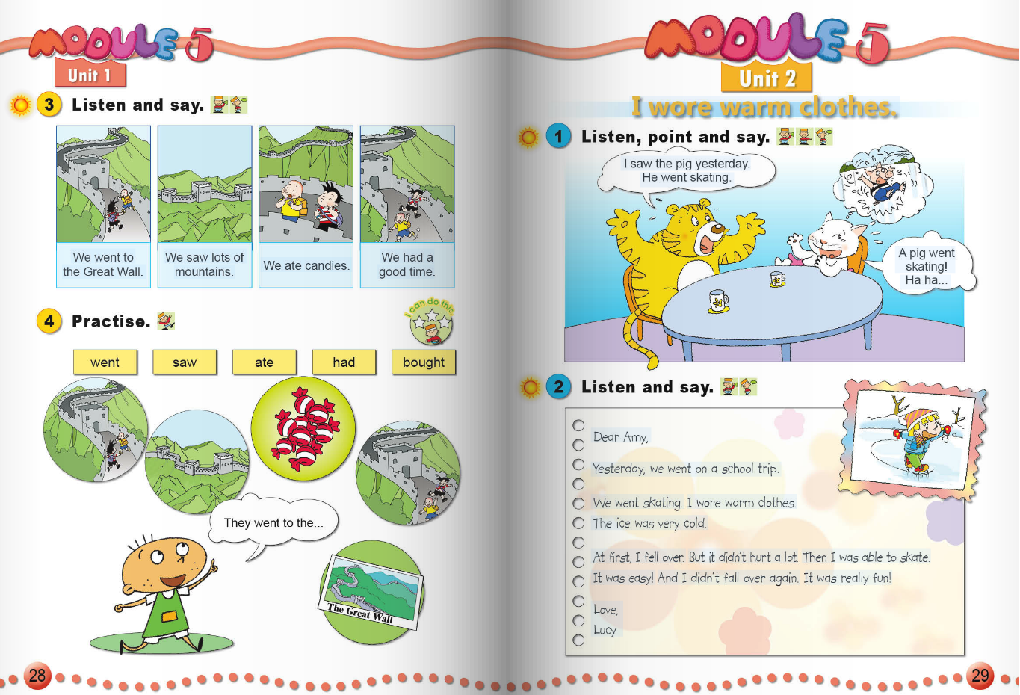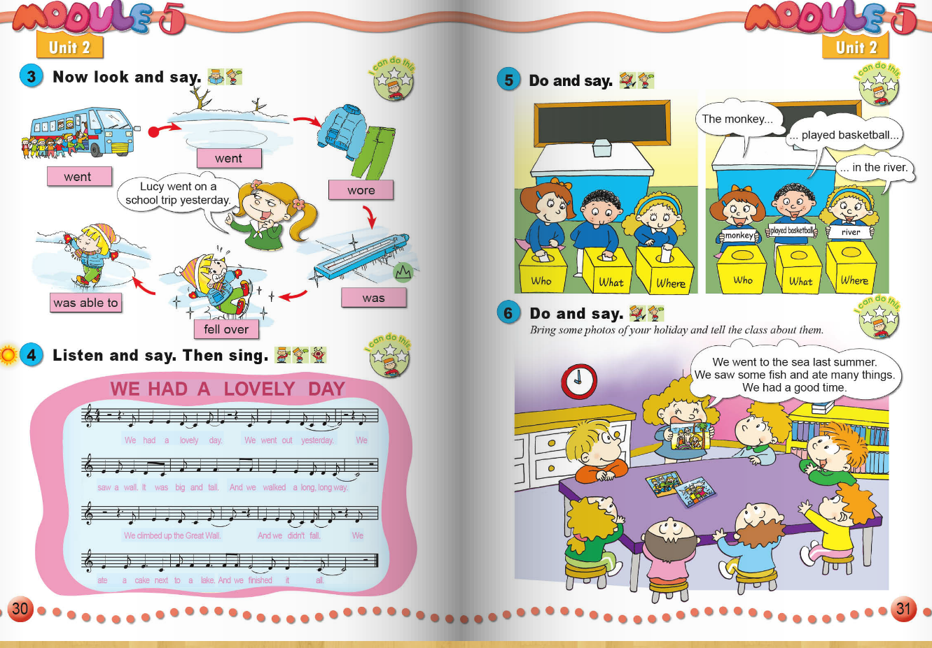

**教学准备**

卡片，CD-ROM , PPT ,task paper ...

**教学过程**

Step 1. Revision and lead-in

1.Sing together .(Module 5 Unit 2 Activity 4)

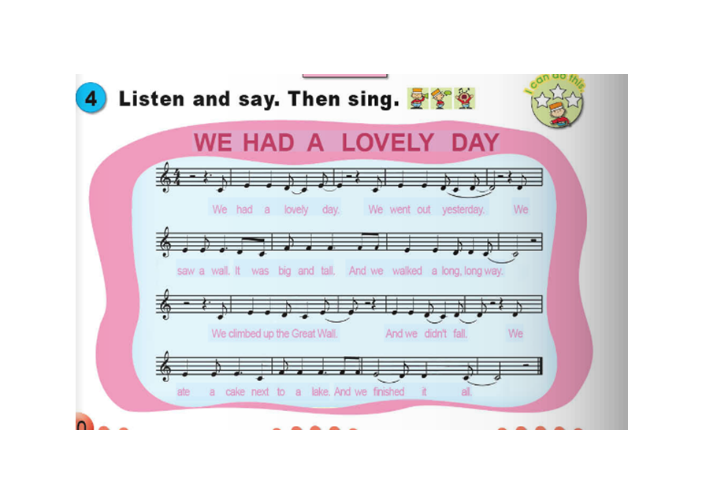

2. Free talk

T:Yesterday, I bought some apples and I ate an apple.What did you do?

S:I…

Then show them some pictures, ask them to choose one to say .

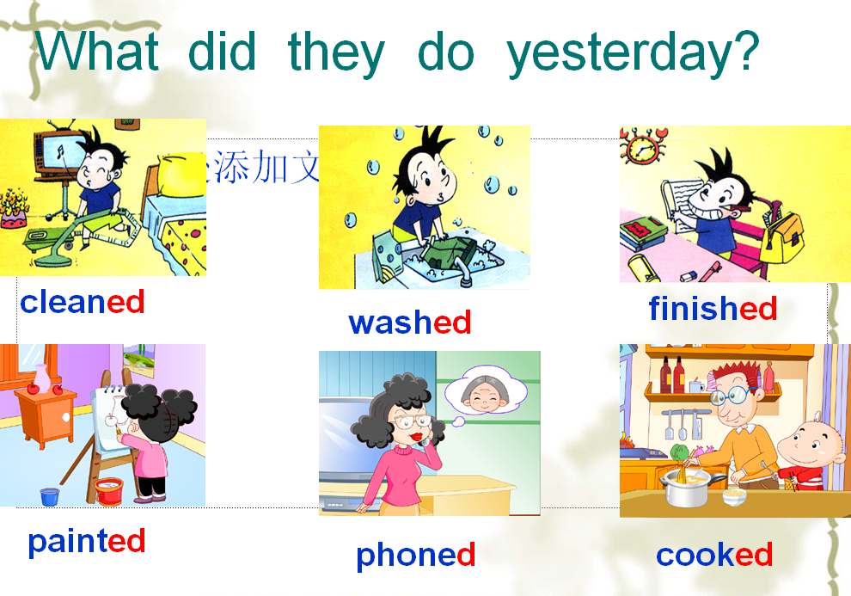

Step 2. Task Presentation

Today our task is to review Module 5 and describe a trip with the simple past tense

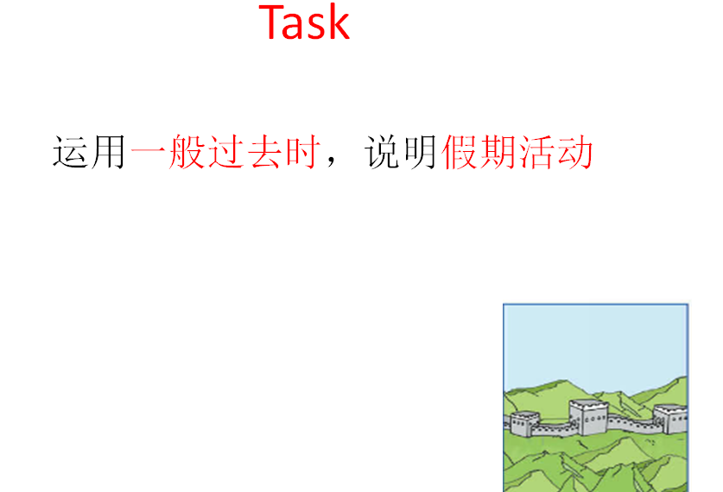

介绍评价：.Today we have two groups .Let’s see which group can climb to the top.

Step 3. Practice

1.Listen to the text and help them know the general idea .

T: Look ! Let’s listen again.and choose

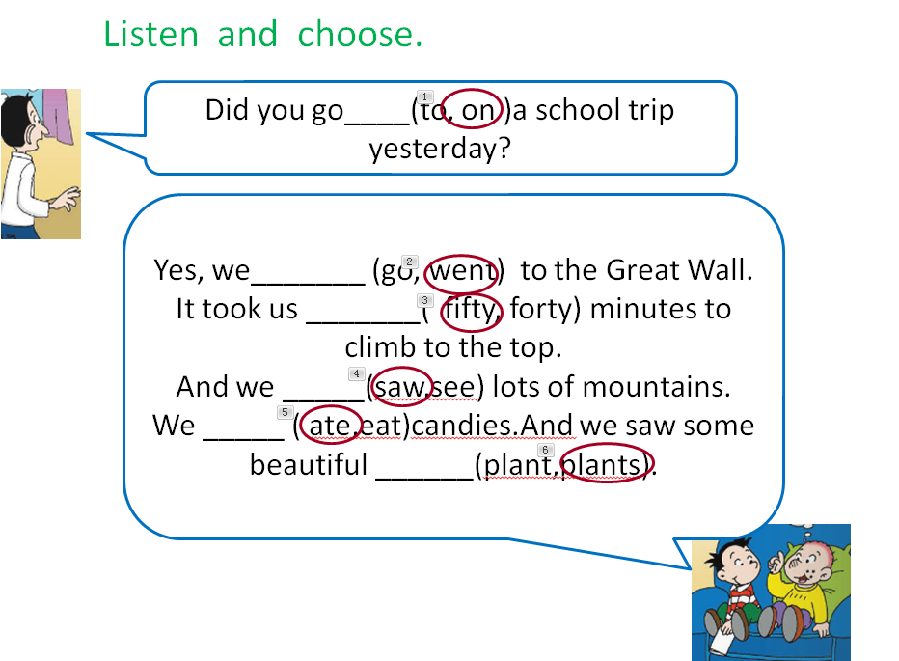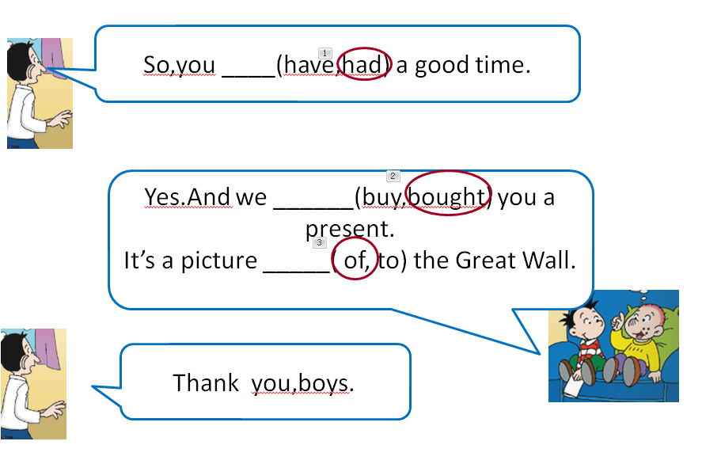

2. Read the text and judge.

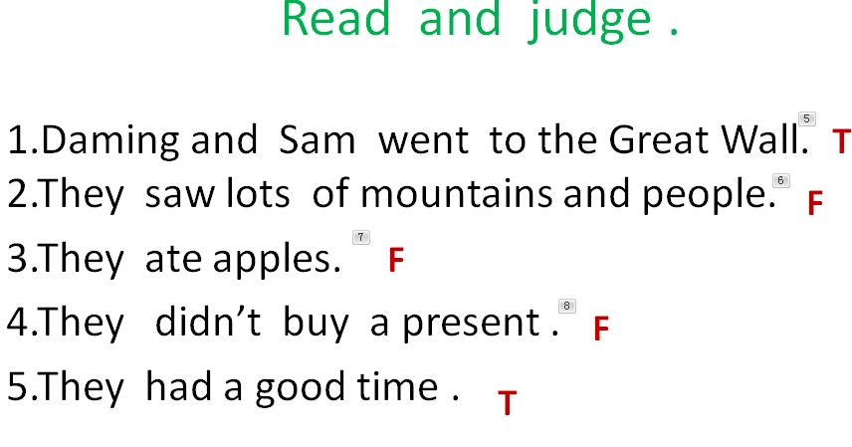

3.Retell the text in groups .

Step 4. Production

1. Have a listening exercise

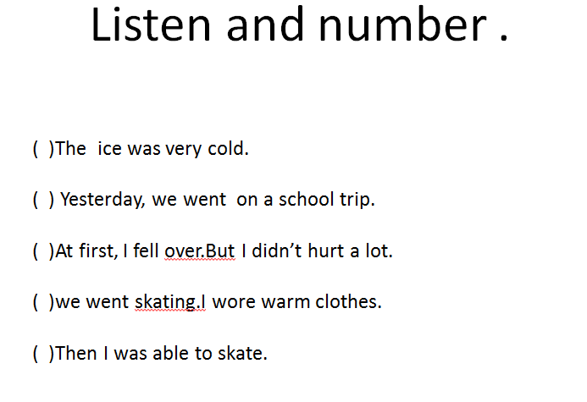

2. Show pictures to practise .Then do some exercises .

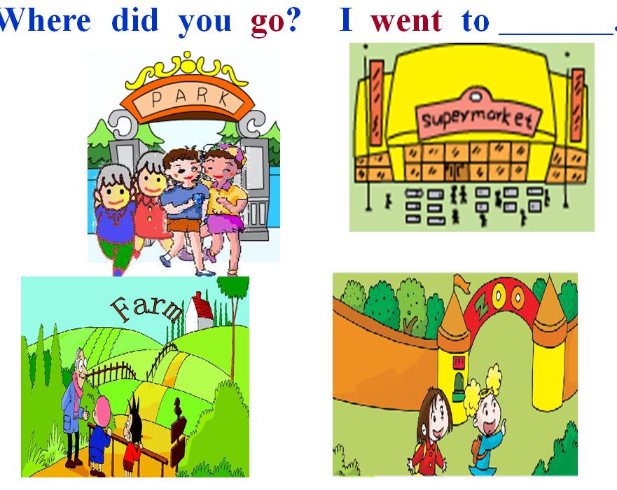

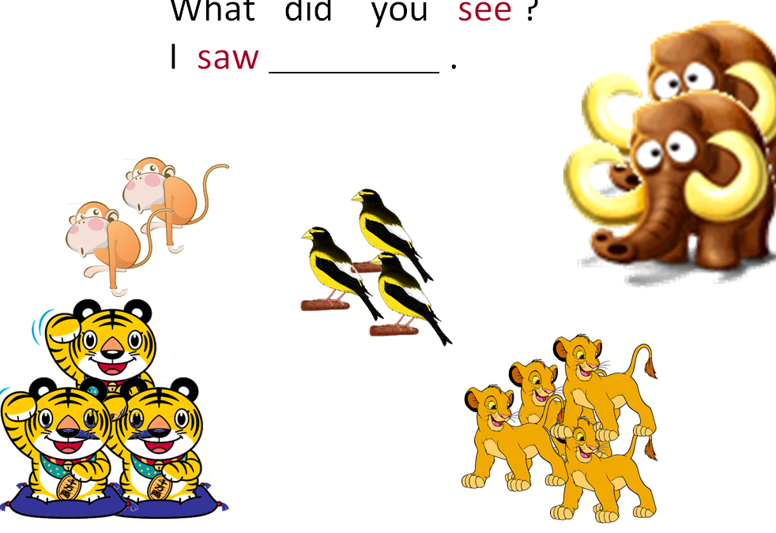

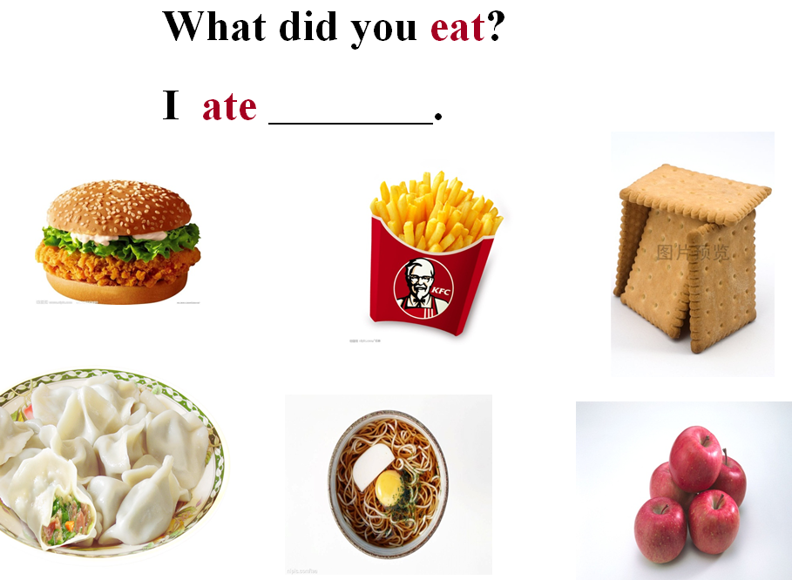

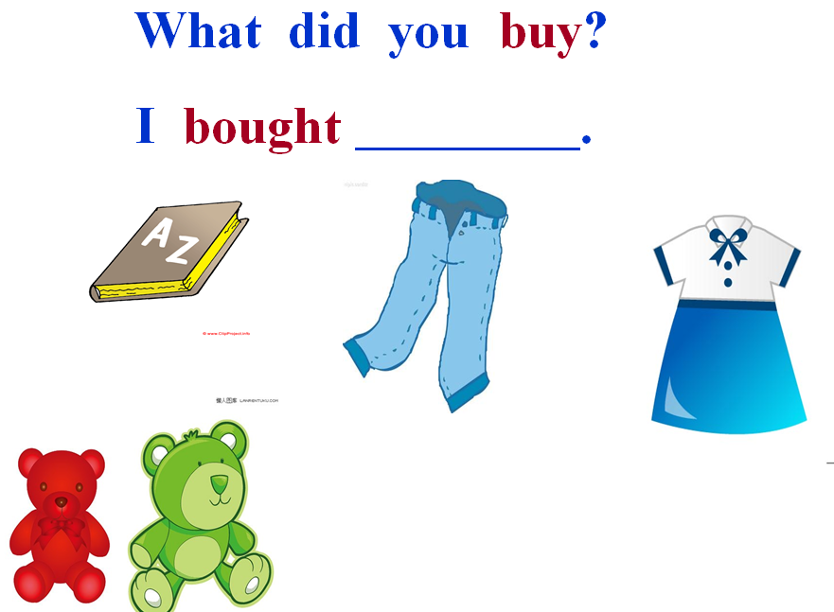

Step 5 . Task Completion

Finish our task : Describe the scenes .

Talk about your trip .

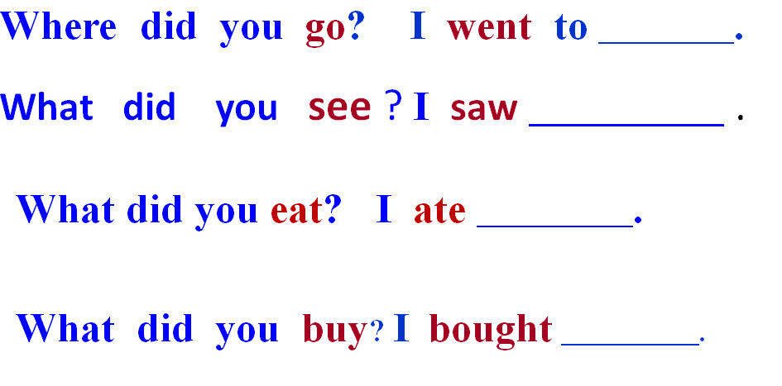

Then write it down .

Step 6 .Summary and Homework

1.Make a summary .

2. Homework

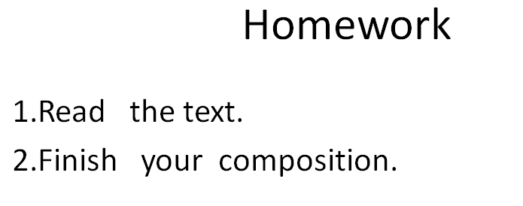

3课堂检测

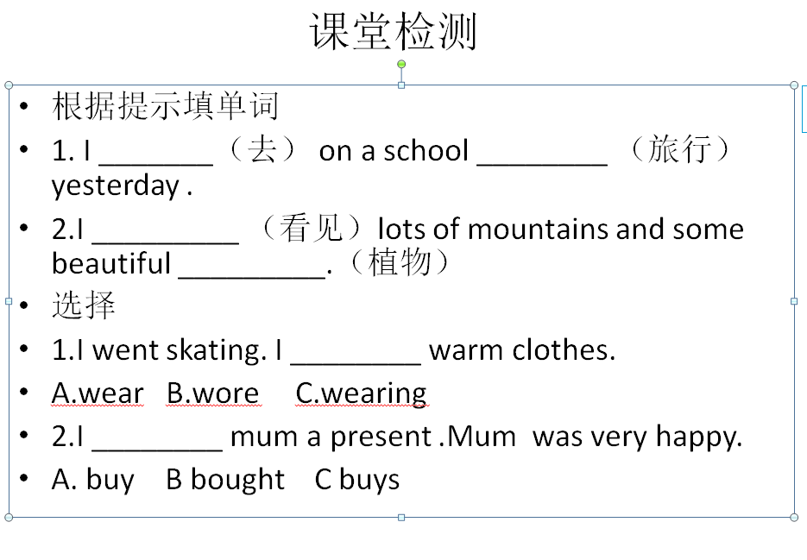

任务单

一、听一听，圈一圈

Did you go____(to, on )a school trip yesterday?

Yes, we_______ (go, went) to the Great Wall.

It took us _______( fifty, forty) minutes to climb to the top.

And we _____(saw,see) lots of mountains.

We _____ ( ate,eat)candies.And we saw some beautiful ______(plant,plants).

So,you ____(have,had) a good time.

Yes.And we ______(buy,bought) you a present.

It’s a picture _____( of, to) the Great Wall.

二、判断

1.Daming and Sam went to the Great Wall. ( )

2.They saw lots of mountains and people. ( )

3.They ate apples. ( )

4.They didn’t buy a present . ( )

5.They had a good time . ( )

三、听音,标号

( )The ice was very cold.

( ) Yesterday, we went on a school trip.

( )At first, I fell over.But I didn’t hurt a lot.

( )we went skating.I wore warm clothes.

( )Then I was able to skate.

四、小练笔

Last year(Last week,Last summer-----),

I went to ________________ .

I saw ______________________ .

I ate ______________________

I______________________ .

I ______________________

I ______________________ a good time.

课堂小检测

根据提示填单词

1. I _______（去） on a school ________ （旅行）yesterday .

2.I _________ （看见）lots of mountains and some beautiful _________.（植物）

选择

1.I went skating. I ________ warm clothes.

A.wear B.wore C.wearing

2.I ________ mum a present .Mum was very happy.

A. buy B bought C buys