新标准英语一年级起点第七册

Review Module 4

大连市长海县大长山岛镇中心小学

杨春莲

新标准英语一年级起点第七册

Review Module 4 教学设计

1. **教学目标**

**语言知识目标：**

功能：使用行为动词一般过去时讲故事。

语法：全体学生能运用：It didn’t become gold. He didn’t come back.

词汇：全体学生能理解 become, gold, ago, long ago, magic, leaves, only, angry, said等

全体学生能运用：woman ,real ,bad ,took ,angry ,said

部分学生能运用become, gold, ago, long ago, magic, leaves, away,only, painting

语音：感知用英语讲故事时的语音语调。

**语言技能目标：**

全体学生能听懂、说It didn’t become gold. He didn’t come back.

全体学生能朗读课文，阅读相关短文。并能写出1-2个与本模块主题相关的语句。

运用：全体学生能使用行为动词一般过去时讲故事。

学习策略：尝试阅读英语故事及其他英语课外读物。

文化意识：通过读民间故事进上步注意到中外文化异同。

情感态度：在小组活动中能与其它同学积极配合与合作，能体会英语学习的乐趣。

**二、教学内容**

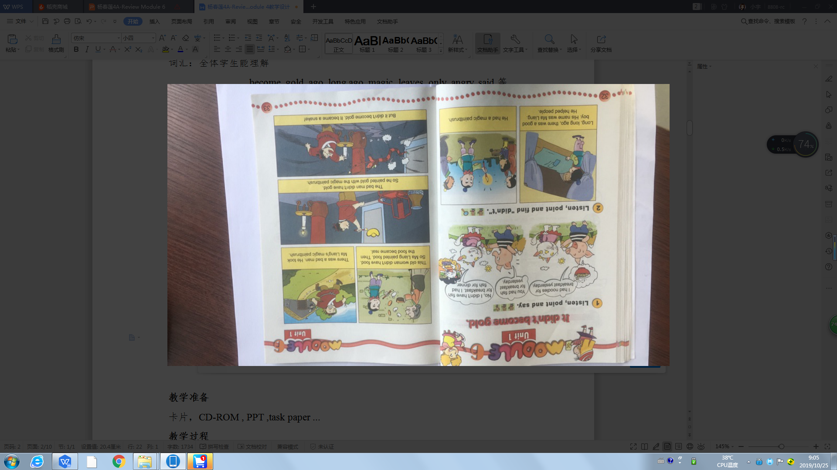

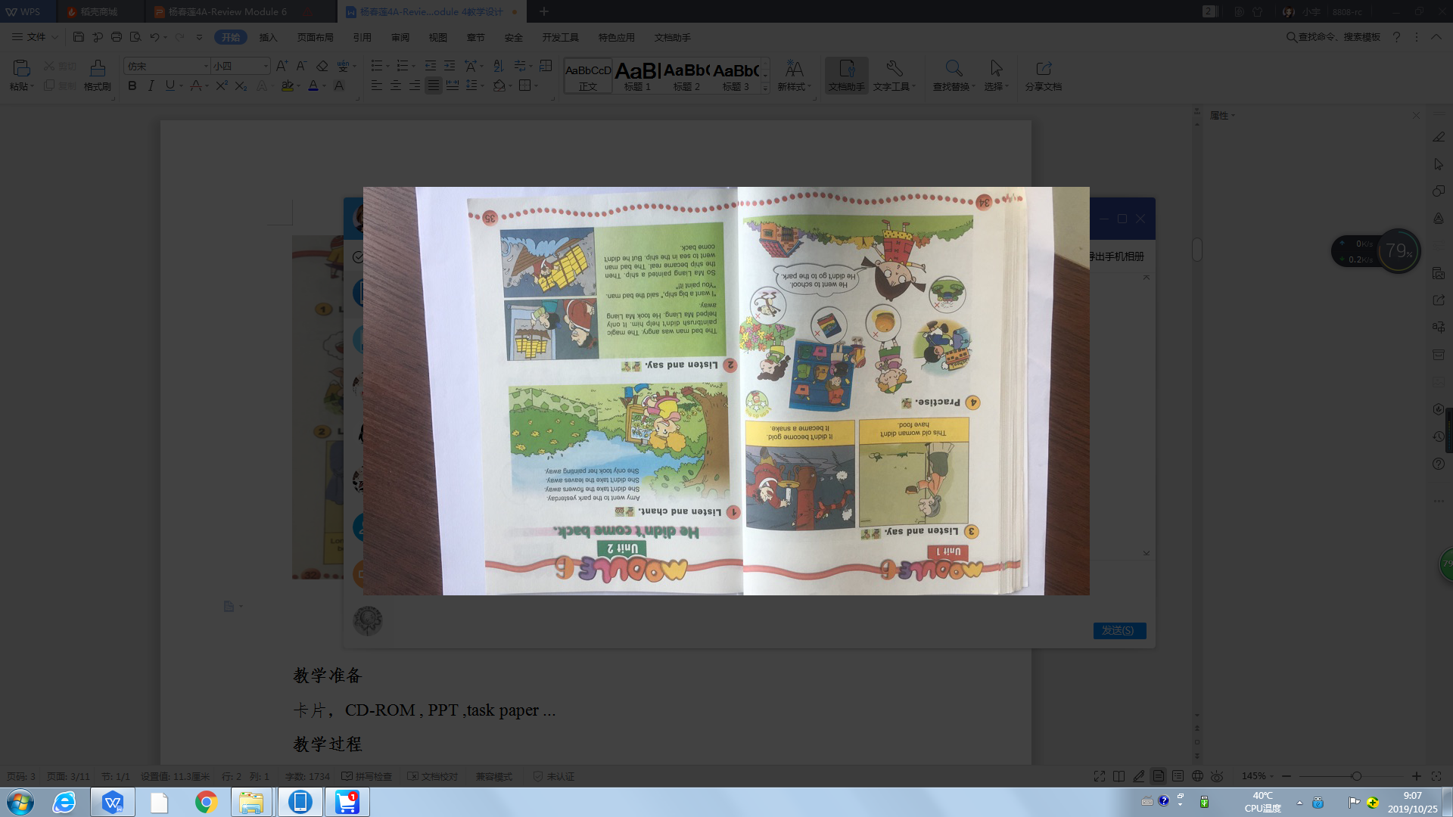

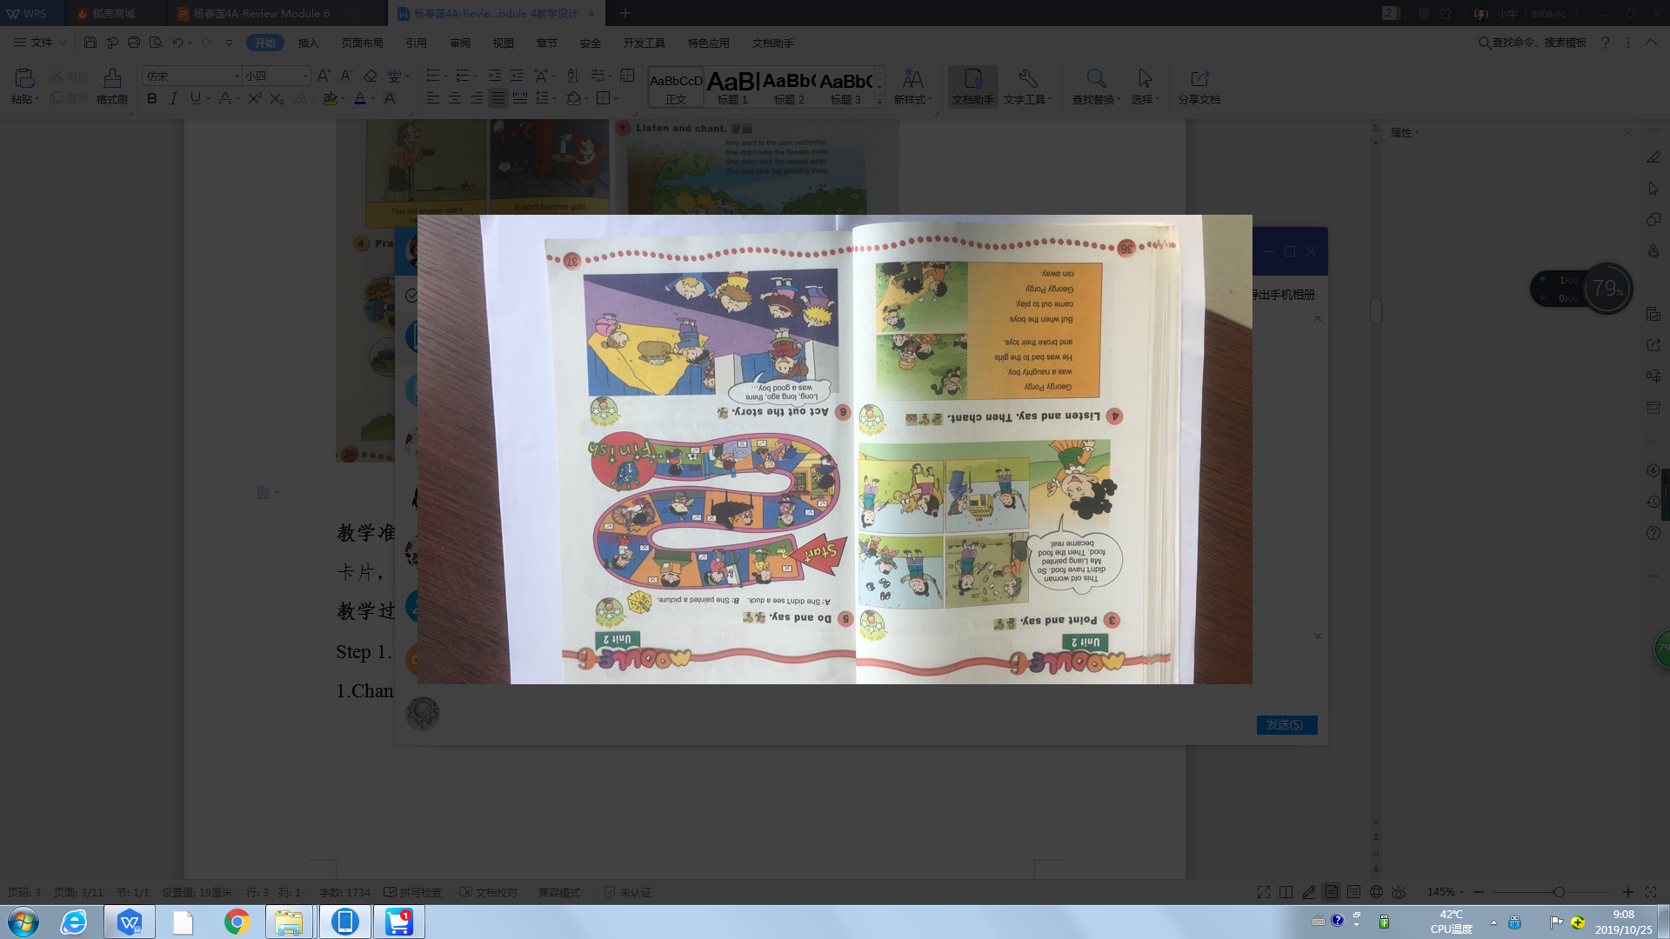

**三、教学准备**

卡片，CD-ROM , PPT ,task paper ...

**四、教学过程**

Step 1. Revision and lead-in

1.Greeting.

2.Have an answer race.

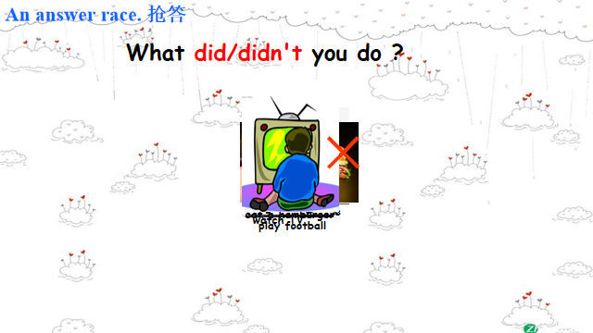

Step 2. Task Presentation

I didn’t watch TV yesterday,I read some story books. Do you like stories?Today our task is to review Module 4 and try to tell stories with the simple past tense .

(设计意图：提出本节课的学习任务，让学生明白将要做什么)

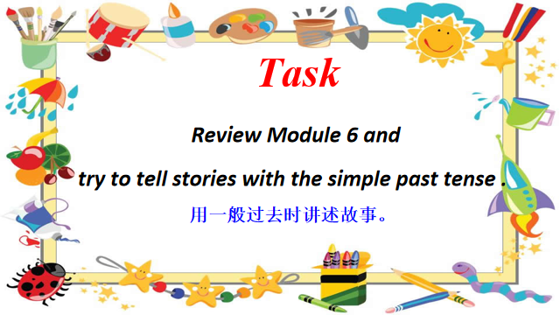

介绍评价：Here are some funny pictures of the stories for you .Today we have three groups .Let’s see which group can get more pictures .

Step 3. Practice

1.Listen to the letter and help them know the general idea .

T: Look! My student Wang Fengli wrote a letter to me on National Day. Let’s listen.

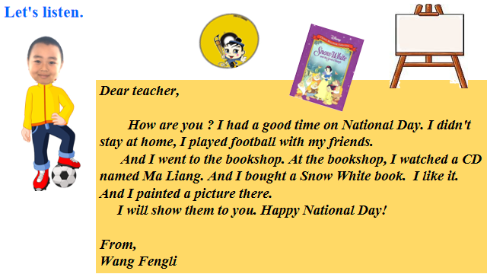

Now,read and match.

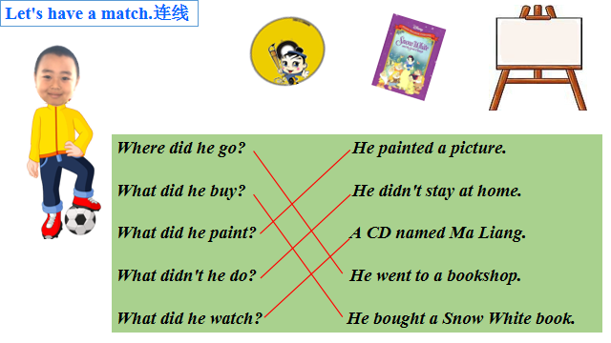

1. Watch the CD about Ma Liang.

T：Yes,, Wang Fengli watched a CD about Ma Liang,let’s watch it together.(教师同时用英语讲述故事<U1和U2课文内容的整合>)

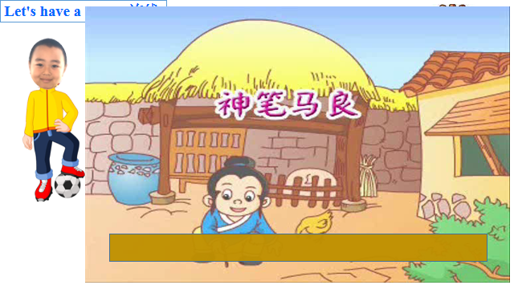

(故事配词：Long,long ago,there was a good boy,his name was Ma Liang.

He liked painting, but he didn’t have a good paintbrush.One night,an old man gave him a magic paintbrush. Ma Liang painted a cow,then,the cow became real.There was a bad man,he took Ma Liang away. He didn't have gold.

He wanted a gold mountain. Ma Liang painted it. And Ma Liang painted a ship. The bad man went to sea in a ship.Ma Liang painted the strong wind.And the bad man didn’t come back again.)

Then,fill in the blanks according to the story.

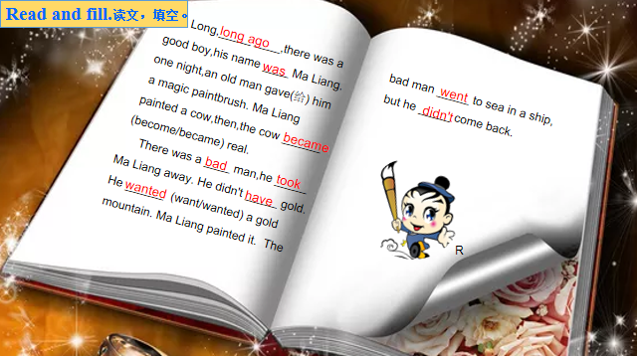

1. Read the text and try to retell the text in your groups.

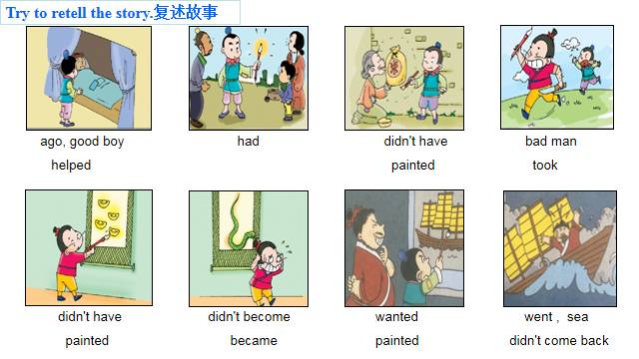

Step 4. Production

1. Read the story about Snow White.

T :Ma Liang’s story is fun. Fengli bought a nice CD. And he wants to share his Snow White book with us? Do you want to read?总结现在进行时

(设计意图：创造性的使用课外故事素材，再创情境，进行语言输出训练)

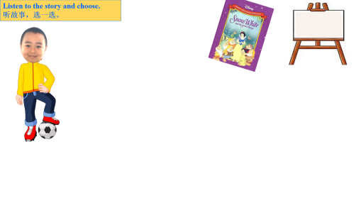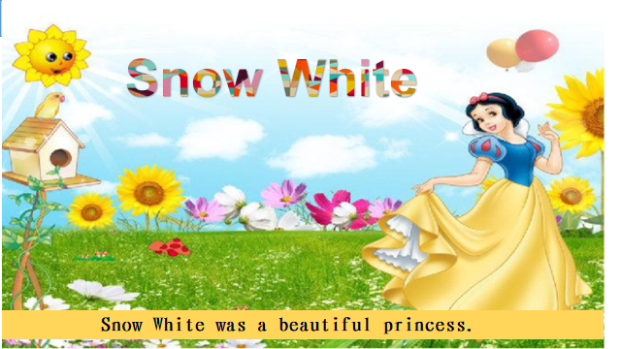

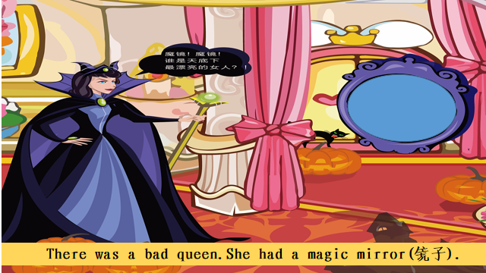 ...(略，故事图片详见PPT)

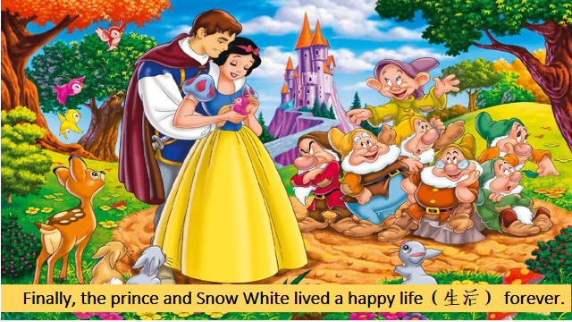

Now,read and choose.

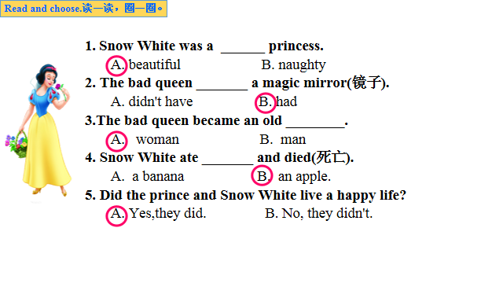

1. Enjoy Wang Fengli’s painting, and tell the story .

T:Thank you for your sharing, Fengli. You are a wonderful boy.Look, this is Fengli’s painting. It’s so beautiful, who are they？

a. What happened? I can tell you the story.(教师请一名同学一起讲述画作中的故事。One day,Xi Yangyang and his friends went to a park,he played football.Man Yangyang climbed the tree,... ,They had a very good time.)

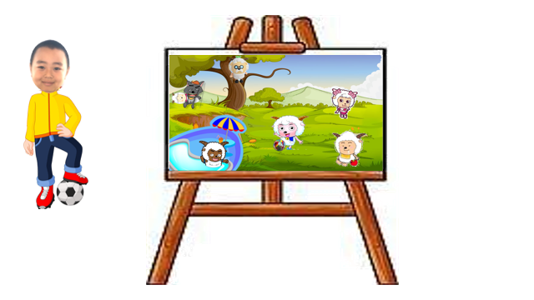

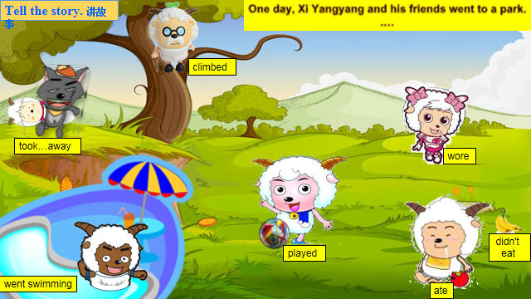

b.Now, you can make your own story in group, you can stick the characters on the picture,then tell the story in your group.（故事背景不变，人物头像是可随意粘贴的，所以图中相同的活动，每组同学设置的所从事的人物是不一样的，因而每组会有不同的故事讲述。教师为每组学生提供背景图一张，头像小卡片若干。)

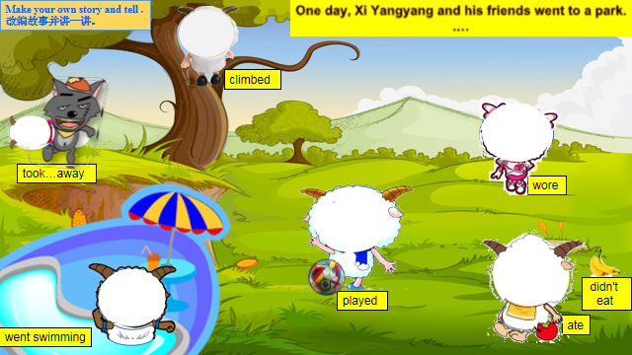

C.Tell us your story.（小组展示）

Step 5 . Task Completion

T:Wow,Wang Fengli had a very good time on National Day .Look.

1. Talk about Fengli’s happy day with partner.

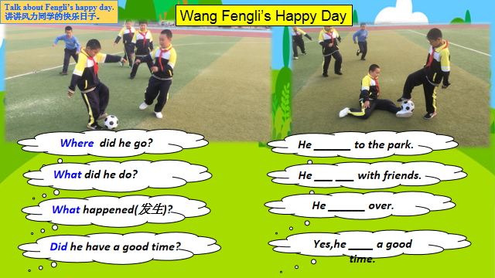

1. Then write it down . Choose one to write .

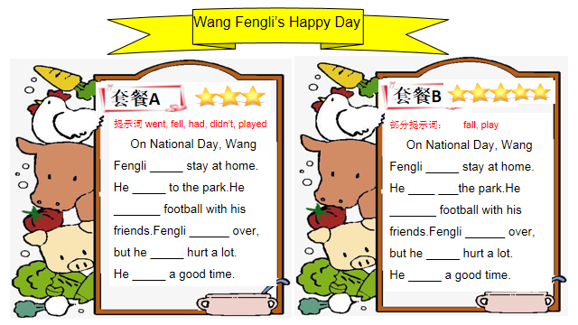

Then share .

（设计意图：写作时进行分层设计，做到上不封顶，下要保底,有效地达成教学目标。）

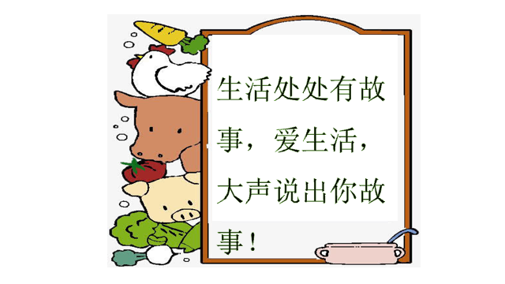

Step 6 .Summary and Homework

1.Make a summary .

2. Homework

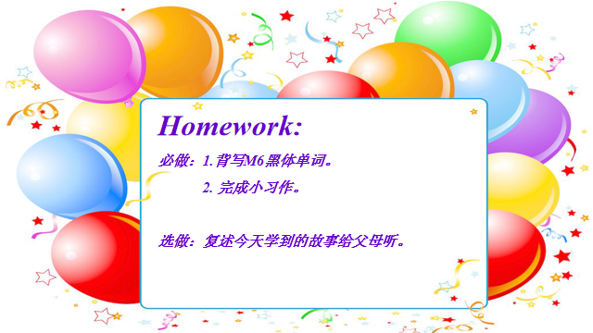

1. 课堂检测

**板书设计：**

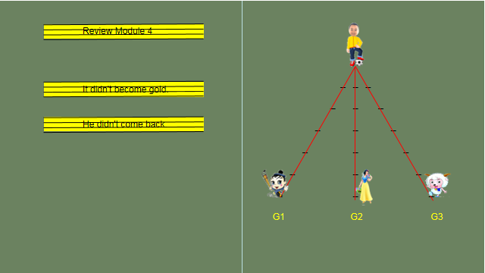

**Task Paper Name:**

一、Read and match.读一读，连一连。

***Dear teacher,***

***How are you ? I had a good time on National Day. I didn't stay at home, I played football with my friends.***

***And I went to the bookshop. At the bookshop, I watched a CD named Ma Liang. And I bought a Snow White book. I like it. And I painted a picture there.***

***I will show them to you. Happy National Day!***

***From,***

***Wang Fengli***

Where did he go? He painted a picture.

What did he buy? He didn't stay at home.

What did he paint? A CD named Ma Liang.

What didn't he do? He went to a bookshop.

What did he watch? He bought a Snow White book.

1. Read and fill in the blanks.读文，填空。

Long,_____ ____,there was a good boy,his name ____ Ma Liang. one night,an old man gave(给) him a magic paintbrush. Ma Liang painted a cow,then,the cow ______(become/became) real.

There was a ____ man,he _____ Ma Liang away. He didn't _____ gold.

He ______ (want/wanted) a gold mountain. Ma Liang painted it. The bad man _____ to sea in a ship,but he _____ come back.

1. Read and circle.读一读，圈一圈。

**1.Snow White was a ______ princess.**

A. beautiful B. naughty

**2. The bad queen _______ a magic mirror(镜子).**

A. didn't have B. had

**3.The bad queen became an old ________.**

A. woman B. man

**4. Snow White ate _______ and died(死亡).**

A. a banana B. an apple.

**5. Did the prince and Snow White live a happy life?**

A. Yes,they did. B. No, they didn't.

1. Writing.小习作(任选一个)。

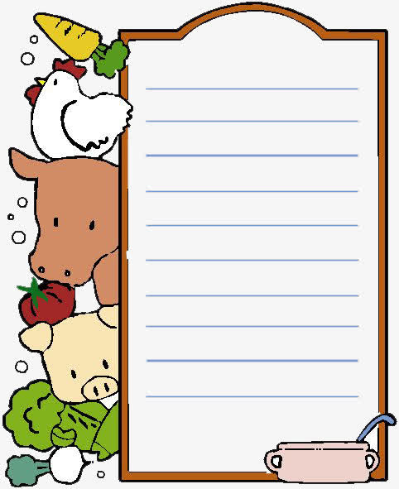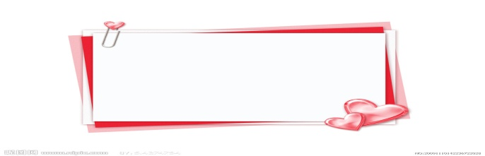

**套餐A**



提示词 went, fell, had, didn’t, played

**On National Day, Wang Fengli _______ stay at home. He _____ to the park.He ________ football with his friends.Fengli _______ over, but he ______ hurt a lot. He _____ a good time.**



**套餐A**





**套餐B**

**部分提示词： fall, play**

**On National Day, Wang Fengli ______ stay at home. He _____ ____the park.He _______ football with his friends.Fengli _______ over, but he _____ hurt a lot. He _____ a good time.**



部分提示词： fall, play

On National Day, Wang Fengli _____ stay at home. He ____ ___the park.He _______ football with his friends.Fengli ______ over, but he _____ hurt a lot.

He _____ a good time.