广鹿岛镇中心小学2018—2019学年度第二学期期中质量检测试卷
小学六年级 英语 完成时间：80分钟
题  号 | 听力部分 |  |  |  | 笔试部分 |  |  |  |  |  | 总 分
题  号 | Ⅰ | Ⅱ | Ⅲ | Ⅳ | Ⅴ | Ⅵ | Ⅶ | Ⅷ | Ⅸ | Ⅹ
得
分
听力部分（共四大题，30分）
Ⅰ.听音，找出句子中含有的单词，将序号写在前面的括号内。（每题2分，共8分）
C. cashier
C. clouds
C. angry
C. nearly

B. presenter
B. cloudy
B. hungry
B. quickly

( ) 1. A. teacher
( ) 2. A. cloud
( ) 3. A. hurry
( ) 4. A. hardly

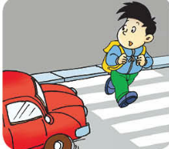
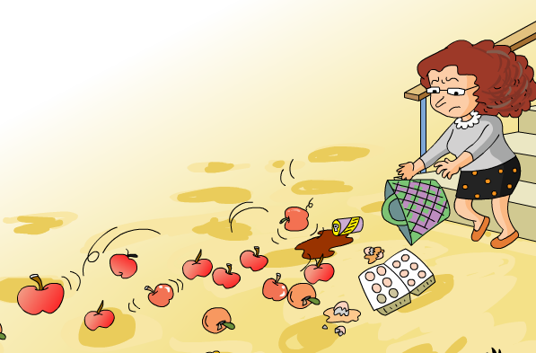
Ⅱ.听音，标号。用数字标出图片的先后顺序。（每题1分，共8分）
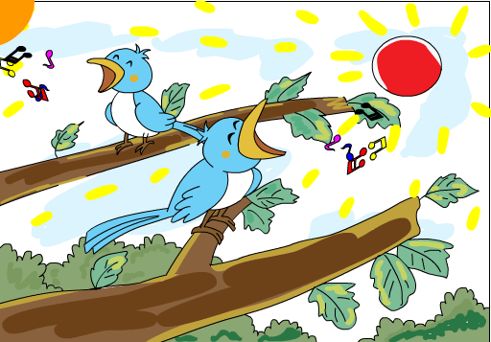
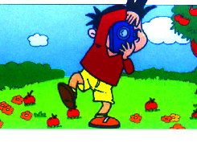
(
( ) ( ) ( ) ( )
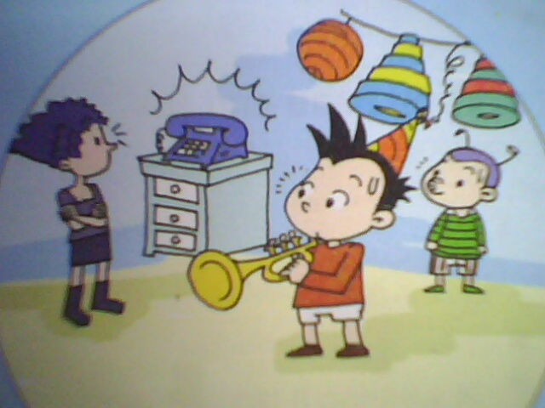

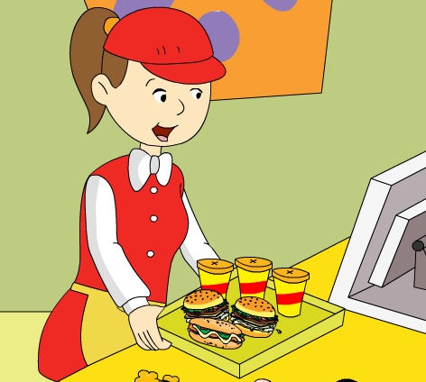

( ) ( ) ( ) ( )

Ⅲ.听问句，选答句。将正确答案序号填在括号内。 （每题2分，共8分）
A . Last weekend.
B. This weekend.
C. In the park.

A. I want orange juice.
B. I want noodles.
C. I want a cola.

( ) 1. ( ) 2.

A. It’s two dollars.
B. I like hot dogs very much.
C. Two hot dogs for me.

A. I like Beijing.
B. It’s hot.
C. It will be sunny.
( ) 3. ( ) 4.

Ⅳ.听短文，判断正误，对的写“T”，错的写“F”。（每题1分，共6分）

( ) 1. Daming is going to have a birthday party on Saturday.
( ) 2. They’re going to have lunch together.
( ) 3. They’re going to have a picnic after lunch.
( ) 4. Simon will play the suona.
( ) 5. Simon’s mum will give Daming a present.
( ) 6. Daming will get a book about America.

笔试部分（共六大题，75分）
Ⅴ.单项选择。将正确的序号填写在前面的括号里。（每题1分，共15分）
（ ）1. What do you want _______? A. drink B.to drink C. drinks
（ ）2. I am looking _______ the window. A. out of B. into C. over
（ ）3. Lingling will have American birthday this year.
A. a B. / C. an
（ ）4. I want some . A. soups B. soup C.soupes
（ ）5. Tomorrow it’s going to_______in Xi’an. A. rainy B. raining C. rain
（ ）6. It’s a _______day. Let’s go to the park! A. cold B. beautiful C. hot
（ ）7. He’s playing his favourite song and everyone is listening and ______.
A. clapped B. claping C. clapping
（ ）8. Now the dog is singing the trumpet. A.in B.with C.and
（ ）9.He is reading a book, but his friend . A.arriving B.arrives C.arrive
（ ）10. We’re going to play football_____ half past four.
A. on B. at C. in
（ ）11. Oh dear! Everything _______ falling. A. am B. is C. are
（ ）12. What _____ you do last Sunday? A. did B. do C. doing
（ ）13. Look! The kite is__________.
A.fly away B. flew away C. flying away
（ ）14. Lucy is falling. Who can help _______? A. she B. her C.hers
（ ）15. She’s talking to her friend, _______ the telephone rings.
A. and B. for C. but
Ⅵ. 根据语境提示，用词汇的适当形式补全下列句子。（每空1分，共10分）
1. The dress is sixty dollars and thirteen_________（美分）.
2. In this photo, the sun is __________（照耀）.
3. ________（享用）your _______（餐）!
4. Hurry up! The shop will________（关闭）at 7:00.
5. I can’t carry all these _________（东西）.
6. It’s very _________（黑暗的）in the _________（隧道）.
7. Her baby is __________(哭，喊). She can ________(几乎不) do anything.

Ⅶ.句子理解。（共2大题，计20分）
A.根据问句，找出相对应的答句，将序号填入题前括号内。（每题2分，共10分）
（ ）1. Here you are.
A. At half past twelve.
B. Thank you.
C. They are jumping in the water.
D. I can help you.
E. Yes, it will.

（ ）2. What are they doing?
（ ）3. When are we going to eat?
（ ）4. Will it be hot tomorrow?
（ ）5. Who can help me?

B. 根据图文提示，补全句中所缺单词。（共10分）

1. A: _______ _______ ______ _______?
B: I want a hamburger, please.

2. A: What ______ the weather ______ _______ in Harbin?
B: It will be sunny.
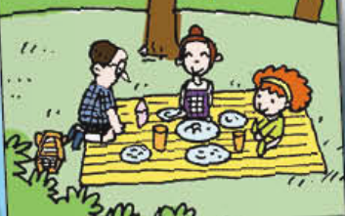
3. A: What are they doing?
B: They ______ ________ a picnic.
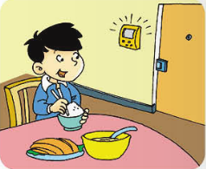
4. He _______ _______dinner, but the bell ________.

Ⅷ.情景交际。选择恰当的句子补全对话, 只填序号。（每题2分，共10分）
A. Sorry, I can’t. B. We need your help! C. I can help you!
D. I can’t carry them all. E. grab the balloons, please!

Simon’s mum：Who can help me? _________________
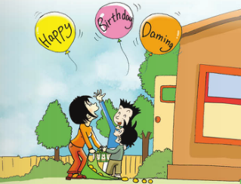
Simon：_____________I’m on the phone.
Daming:_________________ I can carry the box.
Simon’s mum: Thank you, Daming. Come on ,Simon!
__________________
Daming: Simon, ______________ They’re flying away.
Simon’s mum: Too late! But look at the balloons!
Simon: Wow! They say, “ Happy Birthday, Daming!”

Ⅸ.阅读理解。（2道大题，共15分）

A. 阅读短文，选择正确的答案。

Hi Lingling,
I had a very funny day on Saturday. I went to a park with Simon and his mum. We brought sandwiches and drinks.We wanted to have a picnic. There was a big lake in the park and there were lots of ducks. Then it started to rain. It rained and rained and rained. We ran quickly under a tree. We didn’t want to get wet. Then those naughty ducks went to our picnic and ate all the sandwiches! We were hungry and angry. But I took some photos for you. Then the rain stopped and we went home.
Love,
Daming
( ) 1. _______went to have a picnic with Simon and his mum.
A. Lingling B. Daming
( ) 2. We brought _______ .
A. hamburgers and drinks B. sandwiches and drinks
( ) 3. We saw lots of_______ in the lake. A. birds B. ducks
( ) 4. It rained and we ran quickly _______. A. under a tree B. in a house
( ) 5. We ________ the sandwiches. A. ate B. didn’t eat
B. 阅读短文，判断正误。正确的写“T”，错误的写“F”。
Normally（通常地），mother animals have the babies or eggs. But sea horses（海马）are different. The father has the babies inside him. Sea horses are fish, but their heads look like horses.Rabbits have very big ears. They can hear very, very well.They can hear dangerous animals and then run away. The big ears also stop them being hot.Birds have feathers（羽毛）to make them warm and dry. They also help birds to fly.
Turtles（海龟）can live for a very long time. Some are more than two hundred years old.
Spiders are not insects（昆虫）. Insects have got six legs and spiders have got eight.
( ) 1. All the mother animals have the babies or eggs.
( ) 2. Rabbits can hear very well.
( ) 3.Feathers can make birds warm and wet.
( ) 4. Some turtles can live for more than two hundred years.
( )5. Spiders have got eight legs.

Ⅹ.书面表达。请以＂My Plan＂为题，写一写你的六一儿童节游玩计划。（5分）
要求：条理清楚，意思连贯，语句通顺，标点正确，书写规范，40个单词左右。

The Children’s Day is coming._______________________________________________

六年级英语听力题签
注意：每道听力试题读两遍，听力时间控制在15分钟内。

Ⅰ. 听音，找出句子中含有的单词，将序号写在前面的括号内。
1、My grandma was a cashier before.
2、In Dalian, it’s going to be cloudy.
3、Don’t be angry with me!
4、It started to rain. We ran quickly to hide.

Ⅱ. 听音，标号。用数字标出图片的先后顺序。
- He’s reading, but the telephone rings.
2、What a mess! Everything is falling!
3、The birds are singing in the trees.
4、He’s crossing the road, but a car comes.
5、In Harbin, it will snow.
6、On the birthday party, Daming played the suona.
7、He took some photos in the park.
8、Here’s your food. Enjoy your meal!

Ⅲ. 听问句，选答句。将正确答案序号填在括号内。
1、When are we going to the zoo?
2、What do you want to eat?
3、What will the weather be like in Beijing?
4、How much is the hot dog?

Ⅳ. 听短文，判断正误，对的写“T”，错的写“F”。
Daming is going to have a birthday party on Sunday. His friends will come. They’re going to have lunch together. And then they’re going to sing and dance. Daming will play the suona for his friends. Simon’s mum will give Daming a present. It’s a book about space travel.

听力部分到此结束！

六年级英语参考答案

听力部分
Ⅰ. .(2×4＝8分) 1.C 2.B 3.C 4. B
Ⅱ. (1×8＝8分) 4—2—3—7 6—8—1—5
Ⅲ. (2×4＝8分) 1.B 2.B 3. C 4. A
Ⅳ. (1×6＝6分) 1. F 2. T 3. F 4.F 5. T 6. F

笔试部分
Ⅴ. (1×15＝15分) B A C B C B C.B B B B A C B C

Ⅵ. (1×10＝10分) 1.cents 2. shining 3. Enjoy , meal 4. close
5.things 6.dark, tunnel 7. crying , hardly
（请注意画线黑体部分,如果没有相应形式的变化将各扣0.5分，其他单词完全准确方可得1分。）
Ⅶ. A. (2×5＝10分) 1. B 2.C 3.A 4.E 5.D

B.（第1小题每空0.5分，第2、3、4小题每空1分）
1.What do you want 2. will , be like
3. are having 4. is eating / having , rings
（请注意画线黑体部分，如果没有相应形式的变化将各扣0.5分,其他单词完全准确方可得1分。）

Ⅷ. (2×5＝10分) D A C B E
Ⅸ. (2×5+1×5＝15分) A. 1.B 2.B 3.B 4.A 5.B
B. 1.F 2.T 3.F 4.T 5.T
Ⅹ.略。(5分)
备注：卷面满分为100分。（听力30分，笔试75分。）
优秀：90---105
良好：80---89
及格：60---79
不及格：0---59

