五年级英语阶段质量检测 2019.05
听力部分（30 分）
班级
姓名
学号

- 根据你所听到的内容，选择正确的图片。(1*6=6)
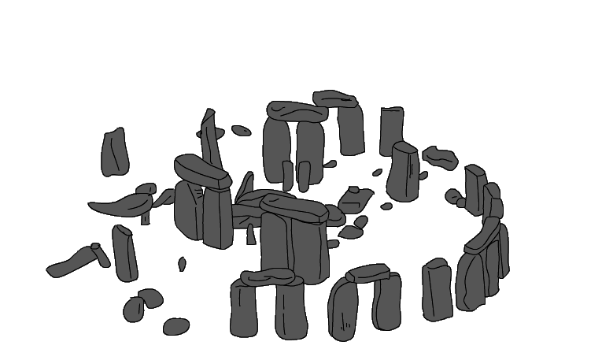
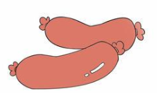

  - B. 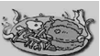 C.

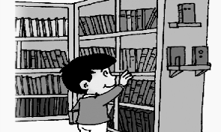

D. E. F

1.

2.

3.

4.

5.

6.

根据你所听到的问句，选择答语。(1*4=4)
A. Yes, I did. B. Delicious food.
C. Sorry, we haven’t. D. Spring.

1.

2.

3.

4.

听 5 段小对话，根据每段对话内容，选出能够回答下列问题的最佳选项。(2*5=10)
( ) 11. How long does your mother work?
A. 7 B. 8 C. 9
( ) 12. Where will you see it?
A. In the library. B. On the computer. C. On the books. ( ) 13. Where are they talking?
A. At the shop B. At home. C. At school. ( ) 14. Where is Grandma?
A. In the US. B. In the UK. C. In China. ( ) 15. What will we have?
A. Eggs and sausages. B. Dumplings. C. Mooncakes.

.听短文，判断对错。符合的用“T”表示，不符合的用“F”表示(2*5=10)
（ ）1. Lingling wants to buy a hat for her grandma.
（ ）2. The brown hat is big.
（ ）3. Lingling’s grandma likes big hats.
（ ）4. There are some flowers on the red hat.
（ ）5. Lingling will take the red hat.

笔试部分（70 分）

单项选择（本题共 10小题，每小题 1 分，满分 10分）
( ) 1. She _______in a factory 10 years ago. A. worked B. work C. works
( ) 2. What did you ______ for lunch? A. have B. had C. has
( )3. I love summer, because I can go _______. A. swim B. swimming C. swiming
( ) 4.The book is very good, ____it is too difficult for so little a girl. A. so B. and C. but
( )5. Mum, I ____ like this dress. I want to buy it. A. really B. usually C. quickly
( )6. Jim’s schoolbag is heavy. He carries it ____his hand. A. on B. over C. with
( )7. ---Whose book is it? -----Oh, it’s ________. A. me B. my C. mine
（ ）8. I sent you some English books. Did you read_______？ A.it B. them C. they
( )9. My school bag is pink. I carry it _____ my shoulder. A.with B.over C. to
( )10. We’ll ____ the animals in the zoo this weekend. A. see B. saw C. looking
II.读一读，根据提示写单词（本题共10小题，每题1分，共10分）
1. I like eating . (鸡肉)
2. Sam had a this morning. （三明治）
3. I can play with the in winter. （雪）
4. He carries his bag on his .（背部）
5.I’ve got an book. （有趣的）
6. I will go to Stonehenge. It will t________ three h___________.
7.Winter is my favourite s___________.
8.Fish and chips is a t__________ English d________.

III.读一读，选择正确短语的适当形式填空（本题共五小题，每题2分，共10分）
in two weeks, play with, in the river, fall from, Chinese music

1. Look! The leaves are the trees now.
2. You should give the DVDs back .
3.My mother likes ， she can play the erhu well.
4. There are some ducks .
5. Tom likes his toy car.
IV.选择相应的答句，并将答句的序号填入题前括号中（本题共五小题,每题1分，共5分）
( ) 1. What music did he play? A. Did you read them?
( ) 2. I sent you some books. B. It’s easy for you to carry.
( ) 3. This bag has got wheels. C. He played Chinese music.
( ) 4. What did he do? D. He was a doctor.
( ) 5. Where did he work? E. In a hospital.
V. 根据对话内容选择适当的句子完成对话（本题共五小题,每题2分，共10分）
A: What a big supermarket!
B: Yes. Could I buy a new football?
A:Sure.
We’ll take them home.
We’re going to buy some vegetables.
But we’re going to buy some food first.
They look nice.
Let’s go and find a cool football.
B: OK. Let’s go. What are we going to buy?
A: Let’s see the shopping list.
B: How about these vegetables?
A: Mm, they are fresh（新鲜）.
B: Do we need any meat?
A: Yes. There’s meat over there.
Let’s go and buy some.
B: Could we go and have a look at footballs?.
A: Of course.
B: Great! Let’s go!
VI.按要求完成下列句子（本题共五小题，每题2分，共10分）
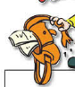
- Your _______ is ________. You can’t carry it.
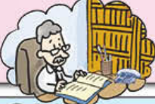

2. He _______ in an __________.
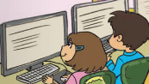
3. You can ________ the ____________.

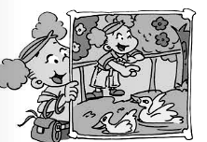
4. My favourite __________ is ____________. It’s warm.

5. What did you have for breakfast this morning? (按实际情况回答)
_________________________________
VII.阅读理解 （本题二小题，第一题五小题，每题1分：第二题五小题，每题1分，共10分）
(一) 阅读短文，判断下面句子。一致的用“T”表示，不一致的用“F”表示
There aren’t many rules at my home. In my room, for example, I can do what I want. My favourite pop group is F4, so I put a lot of posters( 海报)of them on the wall. I can play their music as loudly as I like, but sometimes Mum comes and shuts the door. I have a TV in my room, too. Before I watch TV in the evening, I do my homework. “ Work comes first,” Mum always says so. I clean my room once a week. It takes me half an hour. I usually wash my clothes, of course I use the washing machine. I like to watch football games. But I can’t watch them from Monday to Friday.
（ ）1.There aren’t many rules at his home.
（ ）2.F4 is his mother’s favourite pop group.
（ ）3.He doesn’t do his homework before watching TV in the evening .
（ ）4.I usually wash my clothes .
（ ）5.I can watch football games from Saturday to Sunday.
（二）根据短文内容，回答下列问题
There was a basketball match on the playground last Sunday. There were two teams, the red team and the blue team. Li Ming was a player of the red team. He played well.
All the members of the two teams wanted to win the match. Li Ming hurt his leg in the second half. But his teammates tried their best to compete. At the end of the match, the blue team got 90 points. The red team got 98 points. Li Ming got 24 points. The red team won the match.
1. Was there a basketball match last Sunday? _____________________
2. How many teams were there? _________________________________
3. What’s the matter with Li Ming? _________________________________
4. How many points did the red team get? ____________________________
5. Which team won the match? ______________________________________

VIII.书面表达（本题共5分）
请以My Favourite Season为题目，写一篇短文，描述你喜欢的季节及喜欢的原因。要求：语言
通顺，用词准确，表达自然，不少于40个词

_______________

__________________________________
__________________________________
__________________________________
___________________________________
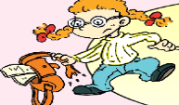

五年级英语阶段质量检测2019.05
听力部分
- 根据你所听到的内容，选择正确的图片。(1*6=6)
- She had eggs and sausages.
- Have you got any DVDs here?
- We can see lots of very big stones.
- My grandpa was a flute player.
- You can borrow books in the library.
- We had fish and chips for dinner.

根据你所听到的问句，选择答语。(1*4=4)
- What did she have for dinner?
- What’s your favourite season?
- Did you read the newspaper?
- Have you got the DVDs about the animals?
III.听 5段小对话，根据每段对话内容，选出能够回答下列问题的最佳选项。(2*5=10)
- ---What does your mother do?
---She is a nurse. And she is very busy everyday. She works form 9 to 4.
Question: How long does your mother work?
2.----What’s this ?
-------It’s a DVD. We’ll see a movie named Harry Potter.
Question: Where will you see it?
3.--- This red dress is very beautiful.
----- I don’t like it.
----- What about the pink one?
----- It’s so beautiful. I’ll take it.
Question: Where are they talking?
4.---Hello, boy. I sent you some English books. Did you read them?
----- Yes, grandma. They’re interesting.
----- Great! Will you come to visit me this summer? I’ll take you to the Buckingham Palace.
Question: Where is Grandma?
5.---Wake up, wake up!
----- Oh, We are late.
----- Don’t worry, we’ll have English breakfast.
Question: What will we have?

IV.听短文，判断对错。符合的用“T”表示，不符合的用“F”表示

A: Sam , I want to buy a present for my grandma. Her birthday is coming.

B: What do you want to buy, Lingling?

A: I’d like a hat.

B: Look at this brown one. Isn’t it beautiful?

A: Oh, yes. But it’s a little small. My grandma likes big hats.

B: This red one is big. And it’s got flowers on it.

A: But she doesn’t like red. Oh, look! There is a blue hat with flower.

B:It’s really nice.

A: OK, I’ll take it.

