**新标准英语一起十二册**

**Module4 Unit1 I can’t carry all these things.教学设计**

大长山中心小学 傅海华

**〔语言功能〕**说明原因，请求帮助

**〔语言结构〕**一般现在时

**〔教学目标〕**

1. 语言知识目标：a. 复习词汇：how long, near, along, more than, kilometre, metre, office building

复习目标语句：How long is the Great Wall? It’s more than forty thousand li long. How old is it? It’s more than two thousand years old. It’s more than four hundred metres high!

b. 复习并阅读运用一般现在时描述的与地方相关的语篇。

2. 语言技能目标: a. 能听懂对地方特征进行的简单的英语描述；

b. 能在读懂短文的基础上，运用一般现在时描述地方特征；

c. 掌握并运用目标语句和词汇书写简单的关于地方特征的小练笔。

3. 情感态度目标：乐于接触异国文化，增强祖国意识。

**〔教学重、难点〕**

重点: 能掌握can的用法，运用一般现在时态寻求帮助。

难点：能正确运用一般现在时说明原因，寻求帮助。

**〔学生分析〕**

学生在三年级开始学习“can”相关功能句的使用，并且对 “can”有表示能力以及意愿的表达有了一定的知识储备。本课是引导学生进一步理解“can”的表示意愿的用法，进而说明原因，寻求帮助。

**〔教学准备〕**

PPT课件， task paper

**〔教学过程〕**

**Step 1、Warm up and lead-in**

1. Greetings.

2. Warmer: Play a guessing game.

T: What’s he/she doing? S: He’s/ She’s …

T: What are they doing? S: They’re talking/ making a call.

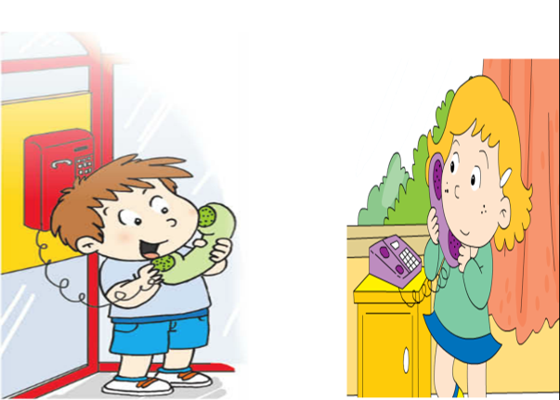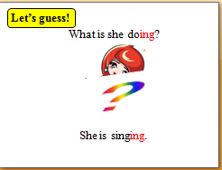

3. Listen and chant.

(1) Listen and answer.

T: What’s the girl doing? Can you tell me? Ss: She’s studying music hard.

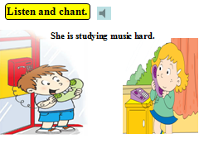

T: Thank you for your help.

(2) Listen and chant.

**Step2、Task presentation**

T: Today let’s learn M4U1, our task is to tell the reason and ask for help.

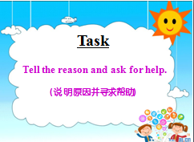

**Step3、Text learning**

1. Watch and choose.

T: Daming is going to have a birthday party. Let’s look “What Simon’s Mum buy for Daming’s birthday party?”.

S: She’s buying balloons, a cake and oranges.

(Check the answer and teach “balloon, things”)

T: Look, what are they? Ss: They’re balloons.

T: In this class, we’ll have two groups. And I’ll give the winner a sentence.

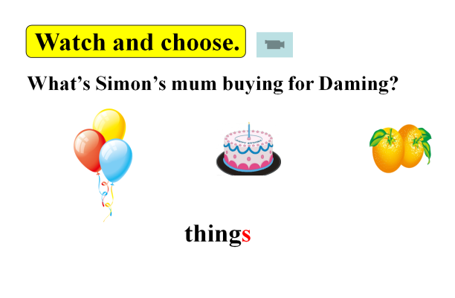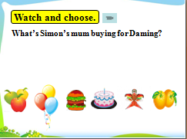

1. Listen and answer.

T: Simon’s mum can’t carry all these things. How does she ask for help?

S: Who can help me?

T: How does Simon answer?

S: Sorry, I can’t.

T: How does Daming answer?

S: I can help you.

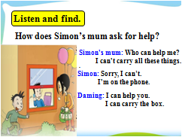

1. Read part 3 and answer:

Q1: What’s happening?

Q2: How does Simon’s mum ask for help?

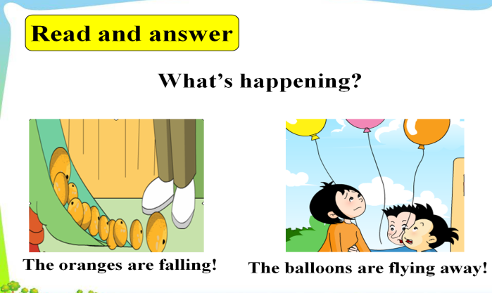

1. Sum up: How to ask for help and answer.

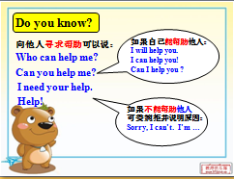

1. Listen and imitate.
2. Act out the dialogue.

**Step4、Practice**

1. Listen and say. Then sum up.

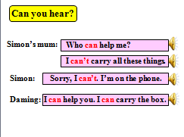 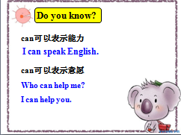

1. Make a dialogue. Then write it down.

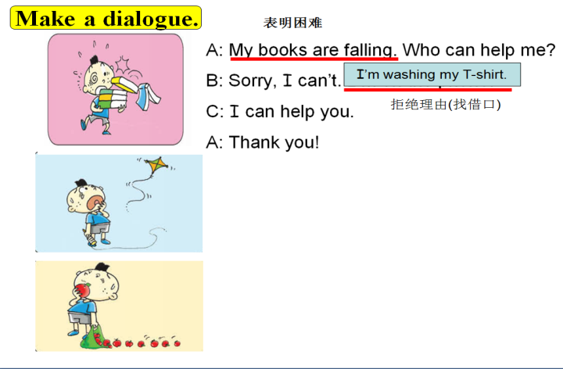

**Step5、Task completion**

1. Read and answer the Qs. (Task paper)
2. Let’s dub. Then write. (Task paper)

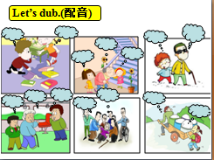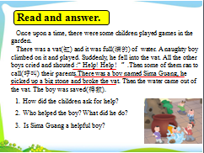

T: You are helpful children. And there are lots of love moments in our life. Let’s see.

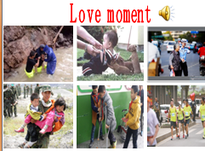

**Step6、Summary and homework**

1. Sum up.

T: What have we learnt today? S: Tell the reason and ask for help.

T: I’ll give a sentence for you.

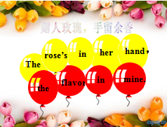

1. Homework

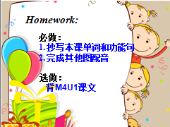

**〔板书设计〕**

