**Review Module 3教学设计**

1. 教学目标：

a. 语言功能：描述节日。

b. 语言结构：一般现在时。

c. 语言知识目标：

1.学生能够会听，说，读，写并会运用本模块单词及短语Halloween,trick or

treat,give,festival,scary,mask,neighbor,night,Easter,chick,chocolate.

2. 学生能够理解，运用本模块的目标语句Halloween is an autumn festival in the UK.It’s really fun.Children go to their neighbours’ houses and ask,”Trick or treat?”Easter is in spring in the UK.

d. 语言技能目标：

了解万圣节和复活节这两种节日，并能用简单的句子描述节日。

c. 情感态度目标：乐于接触外国文化，体会中外文化的异同。

二、教学重、难点：

教学重点：了解并介绍西方的节日，学习与节日相关的词汇以及介绍节日的结构。

教学难点：运用一般现在时介绍自己最喜欢的节日，并能在真实的语境中运用。

1. 教学内容：

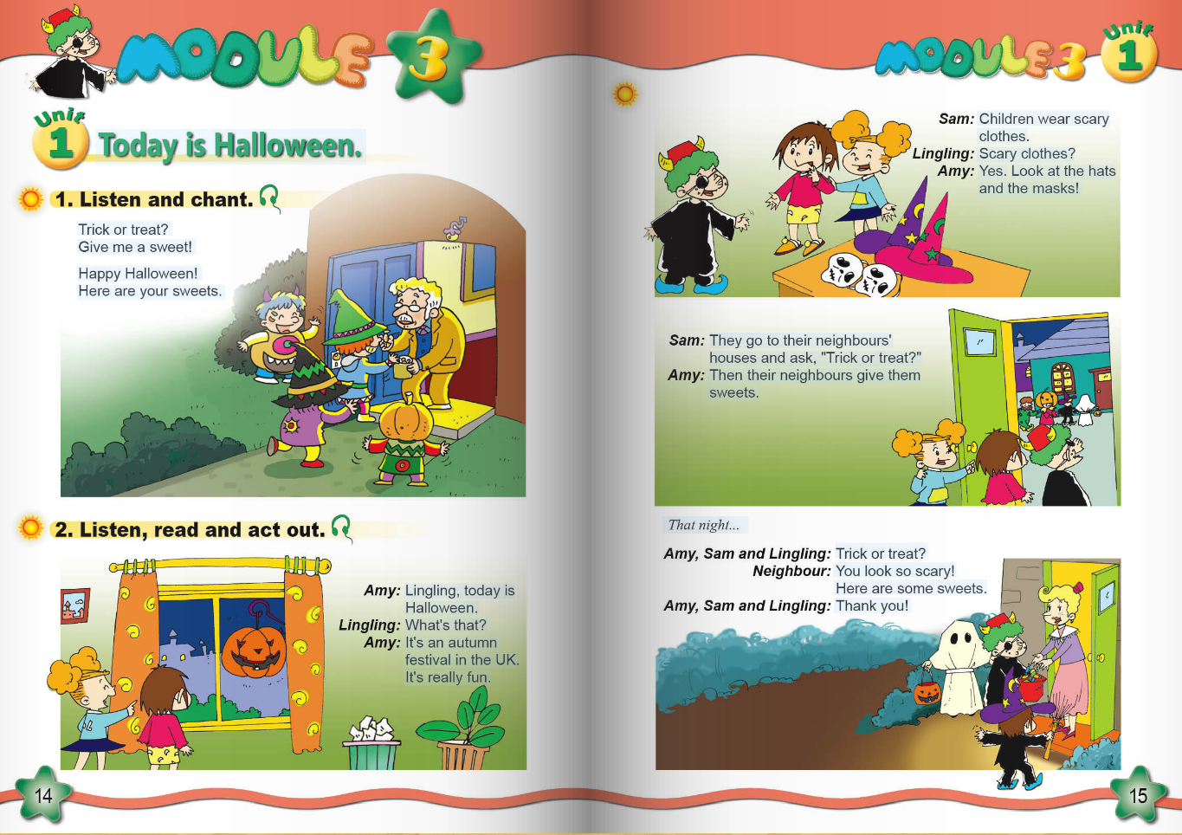

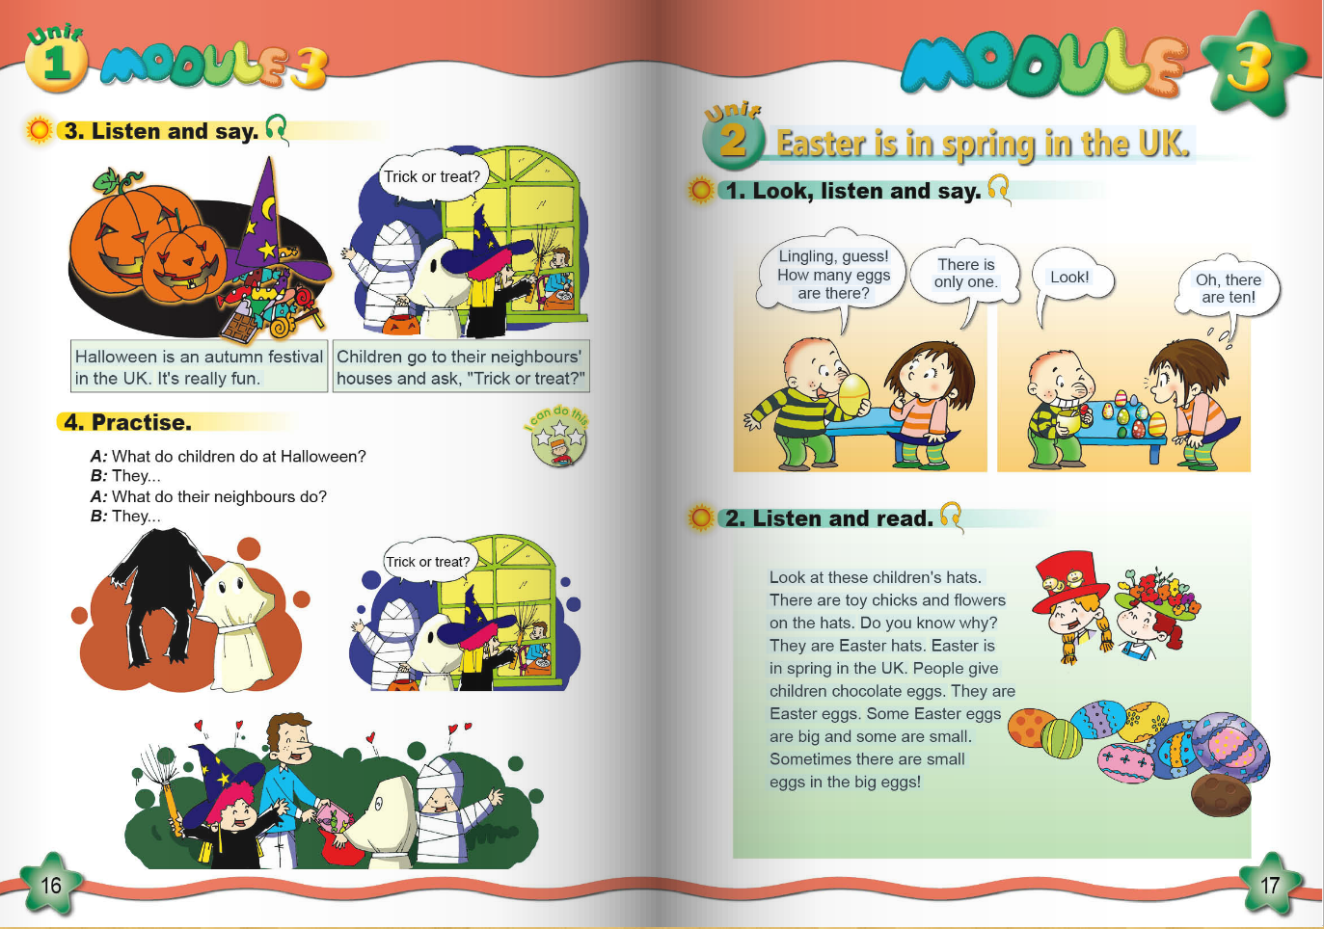

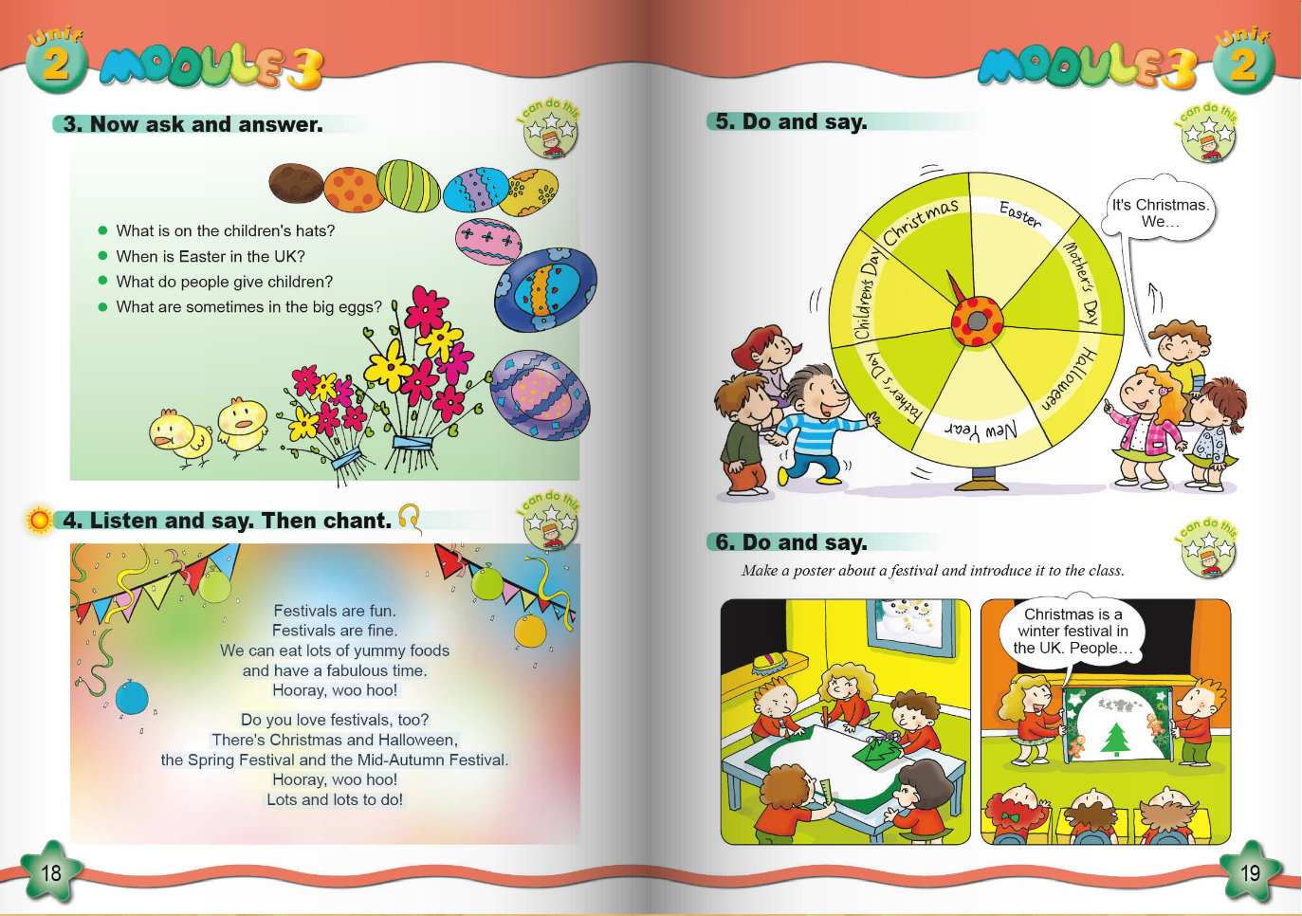

1. 教学过程：

**Step1. Revision and lead in**

1. Greeting: ---Hello! children!
2. Sing a song: 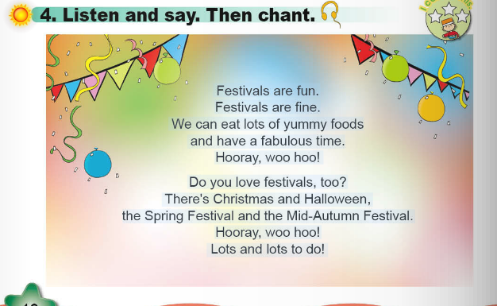
3. Free talk:

T: There are many festivals. What’s your favourite festival?

My favourite festival is _____.

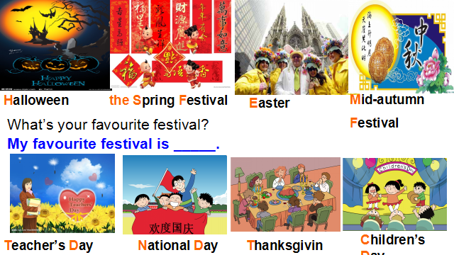

**Step2. Task presentation**

Task: We’re going to review Module 4 and talk about your favourite festival. Now we’ll have two groups--Goup1 and Group2. Please try your best. At last, let’s see what you can find.(说明评价机制)



**Step3. Practice**

1. T:Read the text by yourself and complete the blanks.

2. T: There are two festivals. What are they?----They’re Halloween and Easter.

T: Can you tell me about Halloween and Easter?

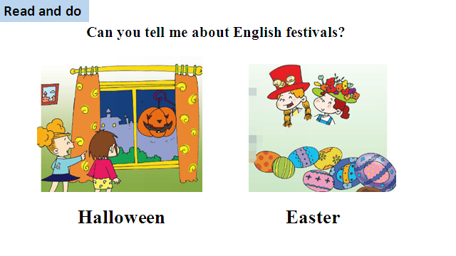

3. T: There are four questions, let’s read together. (出示问题，齐读并板书，粘贴关键词)

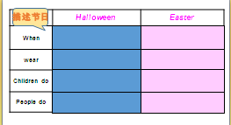

4. Try to fill in the tables.(出示题单，进行选择填空，然后小组讨论并汇报)

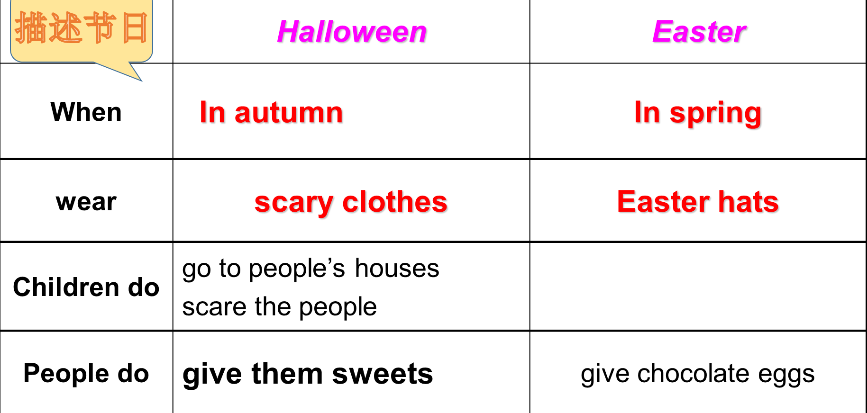

5. T: When you talk about your favourite festival, you can describe it according to these five questions.

T: Choose one festival and try to describe it according to the table.(根据表格，描述节日)

**Step4. Production**

1. Let’s fill in the blanks.

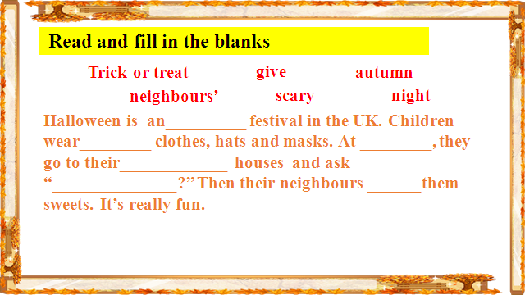

2.Read and tick T or F

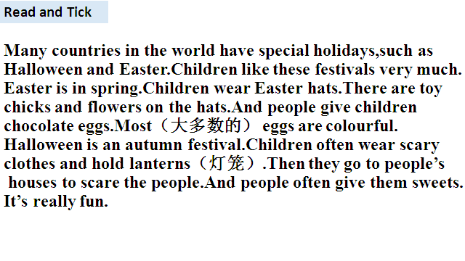 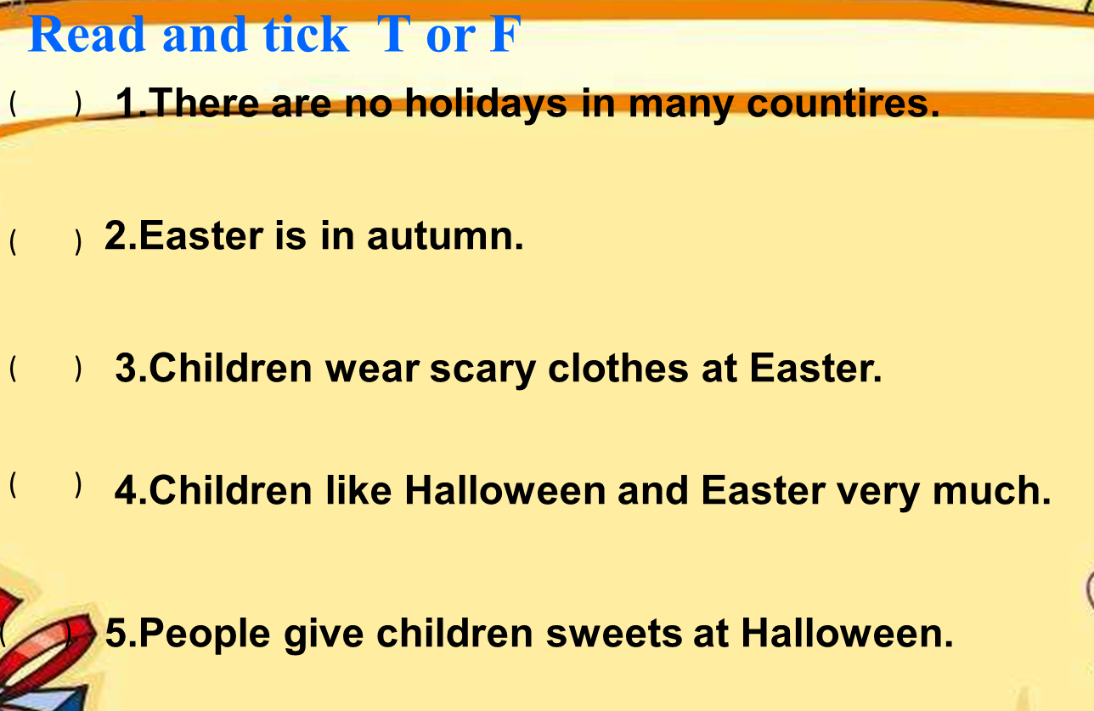

3.Enjoy the articles.

1. 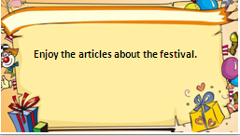 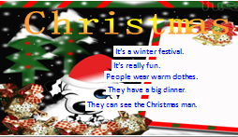 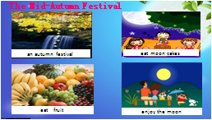 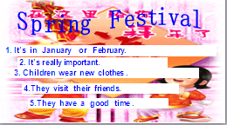

T: Can you tell me more about the Spring Festival?(引导学生介绍更多关于春节的信息，对于说对的学生给予奖励)

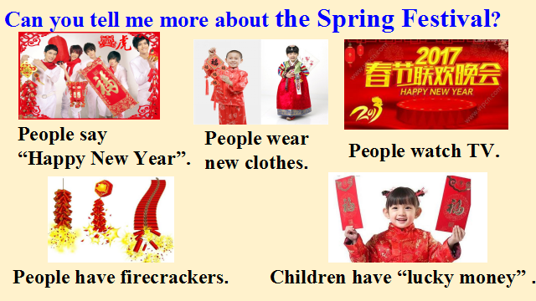

**Step5. Task completion**

**1. Introduce your favourite festival in groups.**

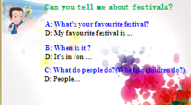

**2. Writing. My Favourite Festival（奖励作文优秀学生）**

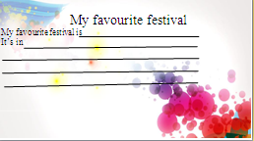

**Step6. Summary and homework**

1. Summary: What have we reviewed today?

T: We reviewed two western festivals. And we can describe our favourite Chinese festival.

1. Homework: 