小学英语四年级（下）期末测试卷（一起）[2017.07]
班 级
姓 名
同学们，一个学期的学习快要结束了，你想了解自己的学习情况吗？那就在这里测试一下吧！只要你像平时那样开动脑筋、认真思考，就一定能取得好成绩。相信自己，开始答题吧！
听力部分（40分）
Ⅰ.听音，选出你所听到的单词，将其序号填入括号内。（每题2分，共10分）
( ) 1. A. south B. grass C. leaves
( ) 2. A. machines B. report C. glasses
( ) 3. A. powerful B. difficult C. beautiful
( ) 4. A. met B. laughed C. looked
( ) 5. A. because B. message C. cheap
Ⅱ.听音，用数字（1、2、3、4、5）给下列图片重新排序。（每题2分，共10分）
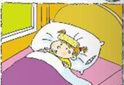
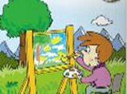
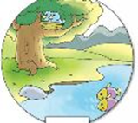
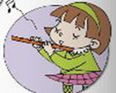
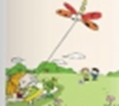

( ) | ( ) | ( ) | ( ) | ( )
Ⅲ. 听音，选出你所听到的句子，并将其序号填入括号内。（每题2分，共10分）
( ) 1. A. Don’t walk on the grass! | B. Don’t write on the book!
( ) 2. A. Let’s play the piano! | B. Let’s paint a picture!
( ) 3. A. It’s 11:30 am. It’s lunch time. | B. It’s 6:30 pm. It’s dinner time.
( ) 4. A. The wolf ran down the hill. | B. The wolf ran up the hill.
( ) 5. A. The girl is very nervous. | B. The girl is very scared.
Ⅳ.听短文，根据短文内容，判断正（T）误（F）。（每题2分，共10分）
( )1. This passage is about kangaroos.
( )2.Kangaroos can jump on their front legs.
( )3.All kangaroos have a special bag.
( )4.Kangaroos eat grass and leaves.
( )5.We can only see kangaroos in China.

笔试部分（60分）
Ⅴ.单项选择 请根据语境选择最佳选项并将序号填入括号（每题1分，共10分）
( ) 1. Be quite, please. Grandpa___________.
A. sleeps B. is sleeping C. slept
( ) 2. The boy looked after sheep every day. He _______.
A. is bored B. was bored C. was scared
( ) 3.Yesterday, Ben was ill. He didn’t________.
A. go to school B. went to school C. go school
( ) 4. I bought a schoolbag. It’s not beautiful, _______ it’s helpful.
A. because B. and C. but
( ) 5. Mum is playing the pipa, and it ________a guitar.
A. looks like B. look like C. looks after
( ) 6. Amy is good _______English, and she’ll write the report.
A. at B. to C. for
( ) 7. Let’s _______ English newspaper!
A. making an B. make a C. make an
( ) 8. Guangzhou is a big city. It’s in the_______ of China.
A. east B. south C. west
( ) 9. This summer, I_________ Xi’an with my family.
A. visit B. visited C. am going to visit
( ) 10. There ____ no wolf, so the people________ very angry.
A. were...was B. was...were C. were...were
VI.填空，将句子补全。（前五题每题1分，后五题每题2分，共15分）
1. Once upon a time, a little boy _______ ___ (照顾) sheep in the field.
2. It’s a __________（意想不到的） party for his mother.
3. The boy broke the door and (逃走) yesterday.
4. This book is one yuan.It’s (便宜的).
5. He is writing a （便条，信，口信）for his teacher.
6. This machine cuts p_______, and that machine makes crisps.
7. Grandma, I bought a computer. I can send e_______ to you.
8. I played in a concert and I was very p_______.
9. I like Chinese cartoon very m________.
10. This is a m______ of the US. People of this country s______ English.
VII.情景反应。（每题2分，共10分）
I II
( ) 1.Where do you live? A.Yes, please.
( ) 2.Why do fish live in the water? B. Because cats can’t live in the water.
( ) 3. What’s happening now? C. I live in Dalian.
( ) 4. Will you fly your kites tomorrow? D. Lucy is cooking .
( ) 5. Do you want to listen to the Chinese music?. E.No. But I’ll play football.
Ⅷ.情景交际（每题2分，共10分）
Ms Smart: What will you do?
Amy:________________. It will be about our school.
A. What about you?
B. I’ll write the reports.
C. I’ll cut the paper.
D. We’ll make a Chinese newspaper.
E. I’m good at Art.
F. Yes, I will.

Daming: I’ll draw the pictures.______________
Amy:__________________ I’m good at Chinese.
What will you do, Sam?
Sam:___________________
Ms Smart: Lingling, ________________?
Lingling: I’ll stick the pictures on the newspaper.
Ms Smart: Wow! Your Chinese newspaper is great!

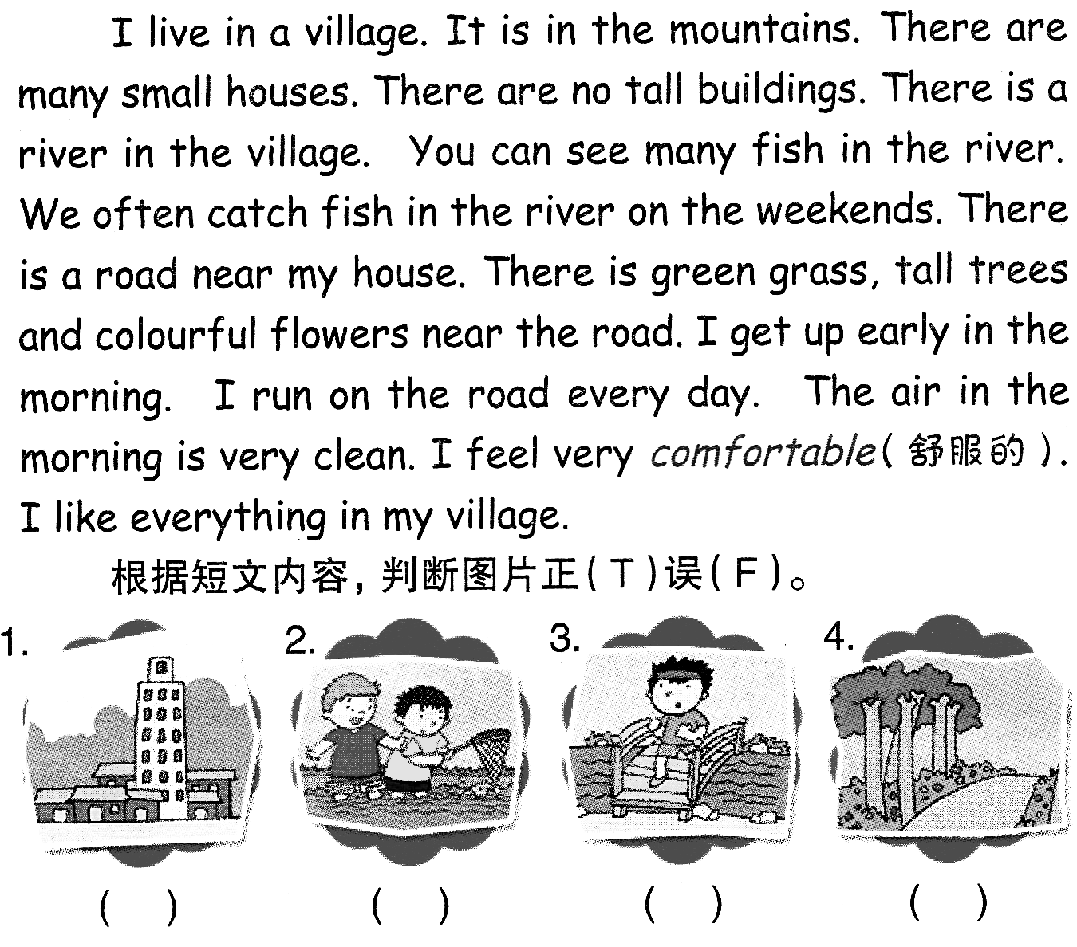
Ⅸ.阅读理解（每题2分，共10分）
Uncle Sam has a boat. He is going to take the children out on his boat this weekend.
Uncle Sam: My boat can hold (容纳) ten people. You can invite (邀请) some of your friends on the trip.
Mary: Can I bring Cindy with me, Uncle Sam?
Uncle Sam: All right. What about you, Peter?
Peter: I’ll invite Tom and John.
Uncle Sam: Sure.
Mary: Will grandpa and grandma come, too?
Uncle Sam: No, they don’t like sailing (航行) on a boat.
Peter: Where are we going?
Uncle Sam: We’ll go to the sea near our town. There are many beautiful beaches. You can fish or swim there.
Mary: Can we row a boat?
Uncle Sam: Yes, there are small boats for rowing.
Mary: When will we come back?
Uncle Sam: About seven in the evening. Your mother will make dinner for us.
Peter: That’s great!
( ) 1. Uncle Sam and the children are talking about_____.
A. Uncle Sam’s boat B. A trip on a boat C.A picnic.
( ) 2. _________ people will go on Uncle Sam’s boat.
A. Six B. Ten C.Eight
( ) 3. The children can swim and fish ________.
A. in the sea B. on a beach C.in the town
( ) 4. Grandpa and grandma won’t go with them because
A. They don't have friends to invite.
B. They don't like the boat trip.
C. They don’t like children.
( ) 5. Mother will ________ .
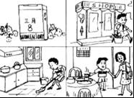
A. be at home B. row a boat C.go fishing
Ⅹ.写作园地。（5分）
看图，请用简短的话语描述Tom在上次Women’s Day(妇女节)所做的事情。
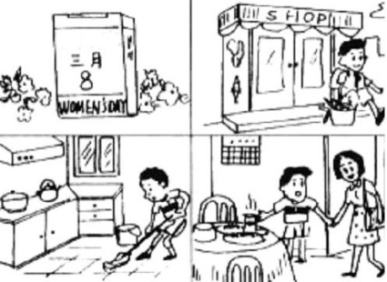
要求：1.以Women’s Day 为题。 2.不少于30个单词。
3.语句连贯、通顺。
Women’s Day
____________________________________ __________ _____

________________________________________________________ _________ _________ __

四年级听力原文：
Ⅰ.听音，选出你所听到的单词，将其序号填入括号内。（每题2分，共10分）
1. He lives in the south of China.
2. Wear these special glasses, please.
3. These computers are beautiful.
4. Everyone laughed at the boy.
5. I love kangaroos because they are very cute.
Ⅱ.听音，用数字（1、2、3、4、5）给下列图片重新排序。（每题2分，共10分）
1. Fish live in the river and birds live in the tree.
2. Sam is drawing a picture in the park.
3. Amy had got ill. She couldn’t go to school.
4. We’ll fly kites in the park this Sunday.
5. Lingling is playing the flute.
Ⅲ. 听音，选出你所听到的句子，并将其序号填入括号内（每题2分，共10分）
1. Don’t write on the book!
2. Let’s play the piano!
3. It’s 6:30 pm. It’s dinner time.
4. The wolf ran up the hill.
5. The girl is very nervous.
Ⅳ.听短文，根据短文内容，判断图片正（T）误（F）。（每题2分，共10分）
Kangaroos live in Australia. They jump on their back legs. The mother kangaroo has a special bag for her baby. Kangaroos eat grass and leaves. They drink water. You can also see kangaroos in zoos in China.

四年级英语评分标准
Ⅰ.听音，选出你所听到的单词，将其序号填入括号内。（每题2分，共10分）
ACCBA
Ⅱ.听音，用数字（1、2、3、4、5）给下列图片重新排序。（每题2分，共10分）
32154
Ⅲ. 听音，选出你所听到的句子，并将其序号填入括号内（每题2分，共10分）
BABBA
Ⅳ.听短文，根据短文内容，判断图片正（T）误（F）。（每题2分，共10分）
TFFTF
Ⅴ.单项选择 请根据语境选择最佳选项并将序号填入括号（每题1分，共10分）
BBACAACBCB
VI.填空，将句子补全。（前五题每题1分，后五题每题2分，共15分）
1. looked after 2.surprise 3.ran away 4.cheap 5.message
6. otatoes 7.mails 8.roud 9.uch 10.ap peak
（如果没有相应形式的变化将各扣0.5分，其他单词完全准确方可得满分。）
VII.情景反应。（每题2分，共10分）
CBDEA
Ⅷ.情景交际（每题2分，共10分）
DEBCA
Ⅸ.阅读理解（每题2分，共10分）
BAABA
Ⅹ.写作园地。（5分）

