学 校
班 级
姓 名
题号 | Ⅰ | Ⅱ | Ⅲ | Ⅳ | Ⅴ | Ⅵ | Ⅶ | Ⅷ | Ⅸ | Ⅹ | Ⅺ | Ⅻ | 总分
得分
小学英语四年级（下）期末测试卷（一起）
听力部分（50分）
Ⅰ.听音，选出你所听到的单词，将其序号填入括号内。（每题1分，共10分）
( ) 1. A. best | B. bored | ( ) 2. A.cheese | B. country
( ) 3. A. happen | B. happy | ( ) 4. A. skate | B. shout
( ) 5. A. machine | B. message | ( ) 6. A. water | B. west
( ) 7. A. instrument | B. interesting | ( ) 8. A. last | B. laugh
( ) 9. A. piano | B. proud | ( ) 10.A.special | B. scared
Ⅱ.听音，用数字（1、2、3、4、5）给下列图片重新排序。（每题2分，共10分）
 |  |  | 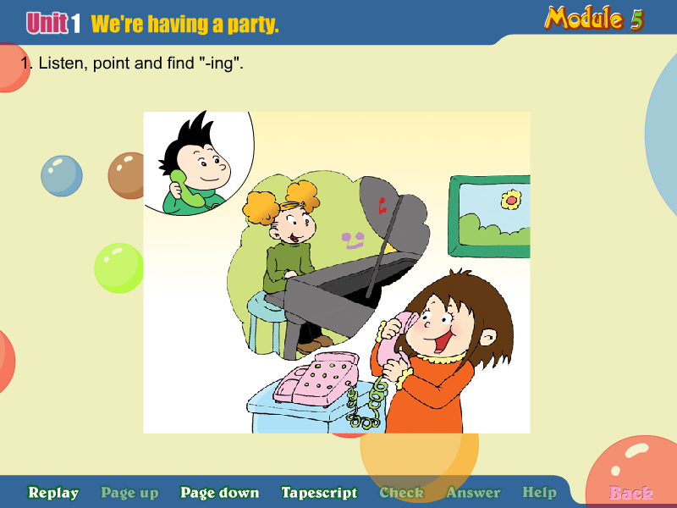 | 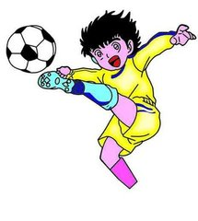
（ ） （ ） （ ） （ ） （ ）
Ⅲ.听音判断正确（T）或错误（F）（10分）
( )1. I can send e-mails to you.
( )2. This pen costs 19 yuan.
( )3. She didn’t tidy her room yesterday.
( )4. The animals had a concert last weekend.
( )5. He is drawing books and birds.
Ⅳ. 听音，选出你所听到的句子，并将其序号填入括号内（每题2分，共10分）
( )1. A. It washes the potatoes. B. It cuts the potatoes.
( )2. A. Dad bought a computer for me yesterday.
B. Dad bought a pink computer for my sister yesterday.
( )3. A. It costs one hundred and eight yuan.
B. It costs one hundred and eighteen yuan.
( )4. A. The wolf ran down the hill. B. The sheep ran down the hill.
( )5. A. My mother played the piano. B. My friend played the flute.

Ⅴ. 听音，按所听顺序用数字（1、2、3、4、5）给句子重新排序。（每题2分共10分）
（ ） | Her name is Wang Hong. She is a student,too.
（ ） | She is nine years old. She lives in China.
（ ） | She has black eyes. She has black hair, too.
（ ） | I am Xiao Fang.I am a girl. I am a student. I have a good friend.
（ ） | I like my friend.

笔试部分（50分）
Ⅵ. 请按顺序默写出26个字母的大、小写，书写要规范（共13分）

Ⅶ.请根据所给语境，写出单词的正确形式（每空1分，共7分）
1.The computer c______only 200yuan. It’s c__________.
2. The boy saw a wolf and he r_______to the village.
3. Tom is singing! Can you h______?
4. It’s dinner t_______. Let’s have a dinner.
5. My cousin lives in the e______of America, and he can s_______English.

Ⅷ.单项选择 请根据语境选择最佳选项并将序号填入括号（每题1分，共10分）
( ) 1. Don’t sing here. The baby___________.
A. sleeps B. is sleeping C. slept
( ) 2. The camera is not beautiful,_____ it is good.
A. but B.and C. so
( ) 3.Once upon a time, a boy______ some sheep.
A. looks after B. looked like C. looked after
( ) 4. I like playing _______football,but my brother likes playing___erhu.
A . the... the B. 不填...the C . the...不填
( ) 5. There ___a small lake in the park. We often play near it.
A. was B. is C .are
( ) 6. You are good _____Art, and you’ll draw the picture.
A. at B. to C. for
( ) 7. Let’s _________this Saturday.
A. have funny B. having fun C. have fun
( ) 8. After a long walk, I am _________.
A. tired B. happy C. bored
( ) 9. This weekend, I___________ the zoo.
A. am visiting B. visited C. am going to visit
( ) 10. Don’t ______ the box. It’s dangerous.
A. touch B. touches C. touching

Ⅸ.请为所给问句选择正确的答语，将序号填入括号内（每题1分，共5分）
( ) 1.What’s the time? | A. It’s pink.
( ) 2.When did you get up last Sunday? | B. He’ll go to Shanghai.
( ) 3.What color is it? | C. At 6 o’clock.
( ) 4. Which city is in the west? | D. Xi’an.
( ) 5.Where will he go this summer? | E. It’s 2 o’clock

Ⅹ. 根据语境选择恰当词语把句意补充完整，并将序号填入横线上（每题1分，共5分）
A. surprise B. surprised C. having D. special E. presents

It’s Mother’s Day today. It’s a_______day for us. We’re ________a party for mum. It’s a_______for mum. We give some________ to mum. Mum is_______ but very happy.

Ⅺ. 连词成句（每题1分，共5分）
1. I / send/ will/ you / postcard / a
_________________________________________________.
2. went / she/ a / into/ shop
___________________________________________________.
3. the / time / what / is
___________________________________________________?
4. lives / he / in /north/ the /America / of
___________________________________________________.
5. do / like /why / you/ Australia
___________________________________________________?

Ⅺ 阅读短文，判断正误，正确的打“T”，错误的画“F”（每题1分，共5分）
Mr black and Mrs Black live at 15 King Road. They have two children.One is seven and the other is nine. In the morning Mr. Black goes to work by car and the children go to school. Their father takes them to school every day. Mrs. Black stays at home. She does a lot of housework in the morning. And in the afternoon, sometimes she goes to see her friends, sometimes she goes shopping. They have dinner at 6:15. After that they play games, or go for a walk, or watch TV.
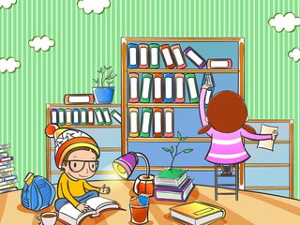
( ) 1. There are four people in the Black family.
( ) 2. Mr black and Mrs Black have a son and a daughter.
( ) 3.The children go to school every day by bus.
( ) 4. Mrs. Black does a lot of housework in the afternoon.
( ) 5.The children don’t do homework after dinner.

小学英语四年级(下)期末测试卷答案及评分标准
听力部分（50分）
Ⅰ.听音，选出你所听到的单词，将其序号填入括号内。（每题1分，共10分）
1.B 2.A 3. A 4.B 5.B 6.A 7.A 8.B 9.B 10.A
Ⅱ.听音，用数字（1、2、3、4、5）给下列图片重新排序。（每题2分，共10分） 3 4 1 5 2
Ⅲ.听音判断正确（T）或错误（F）（10分）
1.F 2.T 3.T 4.F 5.F
Ⅳ. 听音，选出你所听到的句子，并将其序号填入括号内（每题2分，共10分）
1.A 2.A 3.B 4.B 5.A
Ⅴ. 听音，按所听顺序用数字（1、2、3、4、5）给句子重新排序。
2 3 4 1 5

笔试部分(50分）
Ⅵ.按顺序默写出26个字母的大、小写，书写要规范（共13分）
Ⅶ.请根据所给语境，写出单词的正确形式（每空1分，共7分）
1.costs/cost cheap 2. ran 3.hear 4. time 5. east speak
Ⅷ.单项选择 请根据语境选择最佳选项并将序号填入括号（每题1分，共10分）
1.B 2. A 3. C 4. B 5. B 6. A 7.C 8. A 9.C 10. A
Ⅸ.请为所给问句选择正确的答语，将序号填入括号内（每题1分，共5分）
E C A D B
Ⅹ. 根据语境选择恰当词语把句意补充完整，并将序号填入横线上（每题1分，共5分）
D C A E B
Ⅺ. 连词成句（每题1分，共5分）
- I will send you a postcard.
- She went into a shop.
- What is the time ?
- He lives in the north of America
- Why do you like Australia?
- Ⅺ 阅读短文，判断正误，正确的打“T”，错误的画“F”（每题1分，共5分）
- T 2.F 3.F 4. F 5.T

小学英语四年级（下）听力原文（一起）
听力部分（50分）
Ⅰ.听音，选出你所听到的单词，将其序号填入括号内。（每题1分，共10分）
- bored 2.cheese 3.happen 4.shout 5.message 6.water7. instrument 8.laugh9.proud 10.special
Ⅱ.听音，用数字（1、2、3、4、5）给下列图片重新排序。（每题2分，共10分）
1.Let’s go to school.
2.Sam is playing football.
3.Daming is reading an interesting book..
4.Tom is flying a kite.
5.Amy is playing the piano.
Ⅲ.听音判断正确（T）或错误（F）（10分）
1. I can send letters to you.
2. This pen costs 19 yuan.
3. She didn’t tidy her room yesterday.
4. The animals had a party last weekend.
5. He is drawing books and dogs.
Ⅳ. 听音，选出你所听到的句子，并将其序号填入括号内（每题2分，共10分）
1. It washes the potatoes.
2. Dad bought a computer for me yesterday.
3. It costs one hundred and eighteen yuan.
4. The sheep ran down the hill.
5. My mother played the piano.
Ⅴ. 听音，按所听顺序用数字（1、2、3、4、5）给句子重新排序。（每题2分共10分）
I am Xiao Fang.I am a girl. I am a student. I have a good friend.Her name is Wang Hong. She is a student,too.She is nine years old. She lives in China.She has black eyes. She has black hair, too.I like my friend.



