长海县2015~2016学年度第一学期期末质量检测试卷
小学六年级 英语 完成时间：80分钟
题  号 | 听力部分 |  |  |  | 笔试部分 |  |  |  |  |  | 总 分
题  号 | Ⅰ | Ⅱ | Ⅲ | Ⅳ | Ⅴ | Ⅵ | Ⅶ | Ⅷ | Ⅸ | Ⅹ
得
分
听力部分（共四大题，30分）
Ⅰ.听音，找出句子中含有的单词，将序号写在前面的括号内。（每题1分，共8分）
( ) 1. A. thousand
( ) 2. A. stop
( ) 3. A. ever
( ) 4. A. word
( ) 5. A. ours
( ) 6. A. America
( ) 7. A. sing
( ) 8. A. street
B. thirty
B. sleep
B. never
B. world
B. hours
B. American
B. thing
B. start
C. thirsty
C. stamp
C. every
C. work
C. course
C. Australia
C. think
C. straight

Ⅱ.听音标号。用数字标出图片的先后顺序。（每题1分，共8分）
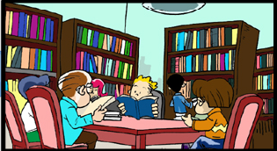
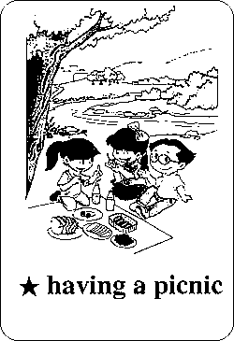



（ ）
（ ）
（ ）
（ ）




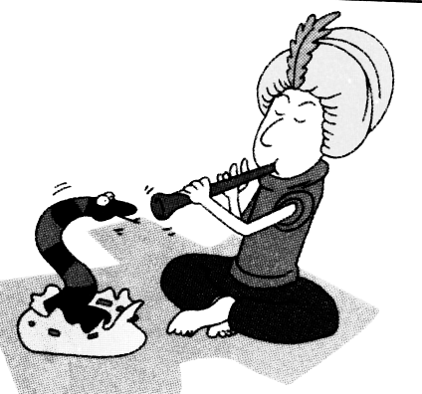

（ ）
（ ）
（ ）
（ ）
（ ）

Ⅲ.听问句，选答句。将正确答案序号填在括号内。（每题1分，共8分）
( ) 1. A .Yes, I can. ( ) 2. A. Tomorrow.
B. Sorry, you can’t. B. Last Sunday.
C. No, I haven’t. C. Next week.
( ) 3. A. Thanksgiving. ( ) 4. A. Yes, I am.
B. Christmas. B. No, I’m not.
C. The Spring Festival. C. I’m Chinese.
( ) 5. A. In the park. ( )6. A. Yes, I do.
B. Every day. B. Yes, of course.
C. Go swimming. C. I love Chinese food.
( ) 7. A. Collecting stamps. ( )8. A. In China.
B. I’m reading a book. . B. Twelve hours.
C. I’m going to play football. C. They love bamboo.
Ⅳ.听短文，判断正误，对的写“T”，错的写“F”。（每题1分，共6分）
( )1. Laura is Lingling’s pen friend.
( )2. Laura has got short, black hair.
( )3. Lingling can speak Chinese and English well.
( )4. Daming sent some photos of New York to Lingling.
( )5. Mr Lin helped Lingling make a poster of New York.
( )6. Lingling’s school finishes at five o’clock.
笔试部分（共六大题，70分）
Ⅴ.单项填空。将正确的序号填写在前面的括号里。（每题1分，共15分）
( )1.A: How is the tree? B: It’s 6 metres. A. long B. tall C. old
( )2. Last summer I went to Hainan. I ______go to Beijing this summer.
A. going to B. go to C. am going to
( )3. Simon really __________ visit the Great Wall.
A. to want B. wants C. wants to
( )4. These stamps are _______ China and they ________ from 1988.
A. on, are B. in, are C. from, are
( )5. A: What _______ she__________? B: She’s reading.
A. does, doing B. is, doing C. does, do
( )6. Thank you for ___________ me. A. help B. to help C. helping
( )7. Maths is difficult ________ me. Can you help me? A. for B. to C. from
( )8. Tom can’t speak Chinese, ________ he loves China.
A. and B. but C. or
( )9. I always go to school _________ bike. A. ride B. on C. by
( )10. Sh! The baby ___________ . Be quiet! A. sleeps B. sleeping C. is sleeping
( )11. Daming _________ his room and found a new cup. A. tidy B. tidies C. tidied
( )12. Sam and I often ___________ to this playground.
A. come B. comes C. coming
( )13. One of my ________ is new. A. a pen B. pen C. pens
( )14. It’s fun __________ football. A. play B. to play C. playing
( )15. Gerry _________ English. He often reads English books.
A. don’t like B. likes C. doesn’t like
Ⅵ.根据提示，完成下列句子。（每空1分，共10分）
1. I often clean the _____________ (黑板) for my teachers.
2. Look! Lingling is ________ ________ (写给) her mum.
3. —This is my friend, Laura. — __________(高兴的) to meet you, Laura.
4. I __________ (几乎，差不多) read seven books this year.
5. I like collecting __________ (硬币). It’s interesting.
6. There are 193 ___________ _________ (成员国) in the UN.
7. My mum didn’t bring any drinks. She __________ (忘记).
8. You can answer the questions with different ___________ (方法).
Ⅶ.句子理解。（共2大题，计15分）
A.根据问句，找出相对应的答句，将序号填入题前括号内。（每题1分，共5分）
( ) 1. How tall is this boy? A. No, they don’t.
( ) 2. Has she got a book about the US? B. An office building.
( ) 3. What did you see? C. Sure.
( ) 4. Do snakes love music? D. He’s 1.67 metres tall.
( ) 5. Can you tell me about Thanksgiving? E. Yes, she has.
B.根据图文提示，补全句中所缺单词。（每空1分，共10分）

1. A: What are you doing?
B: I’m ________ my new stamps _______ my stamp book.

2. A: What did you see?
B: I _______ a ________ ________ in the street.

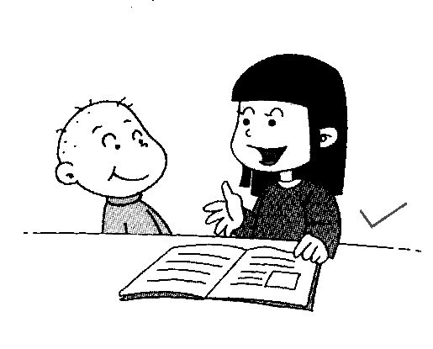
3. A: ______ you often _________ __________?
B: Yes, every day.

4. The light is red. _________ __________.
Ⅷ.情景交际。从所给的选项中选择恰当的句子补全对话, 将答案序号写在横线上。（每空2分，共10分）
A. They speak Chinese and English.
B. Is there a Chinatown near here?
C. So interesting.
D. Is the food different from Chinese food?
E. What is the Chinatown like?
E. Do you live here now?

A: ____________________________
B: Yes. This Chinatown is very big.
A: ____________________________
B: There are lots of Chinese shops and
restaurants there.
A: Do the people speak Chinese in Chinatown?
B: Not just Chinese. ________________________
A: _____________________________
B: Yes, it is.
A: _____________________________

Ⅸ.阅读理解。（共2大题，计15分）

A. 阅读短文，选择正确的答案。（每题2分，共10分）

Do you know Beijing? It’s the capital of China. Beijing is a very big and very beautiful city. It’s got a very long history. There are lots of famous places of interest in Beijing. They are the Great Wall, the Summer Palace(颐和园), the Ming Tombs, the Forbidden City(故宫) and other places.

Thousands of people from different countries come to visit Beijing every year. The best season to visit Beijing is autumn. On National Day, the Tian’anmen Square is like a sea of flowers. All the people in Beijing are trying to make the city more beautiful.

( )1. ________ is the capital of China.

A. Shanghai B. Beijing C. Dalian

( )2. Beijing is ____________ city in China.

A. a small and beautiful B. a big and young C. an old and beautiful

( )3. -How many famous places are there in the text(课文)? -There are _______.

A. Four B. Five C. Six

( )4. When you visit Beijing, __________ is the best time.

A. every year B. the autumn C. National Day

( )5. The people in Beijing _______ the city very much.

A. don’t like B. miss C. love

B. 阅读短文，回答问题。 （每题1分，共5分）
Today is Sunday. It’s fine. There is a sports meeting(运动会) in our school. On the playground, there are many students and players. Some football players are playing football over there, and many students are watching. Near the building, the boys are jumping.
There is a big tree near the playground. Under the tree, some girls are playing table tennis. Liu Mei, Wei Hua and many other girls are playing basketball beside the tree. Look! There are some boys under the tree, they are watching their classmates(同学) playing basketball.
1. Is there a sports meeting in our school today?
______________________________________________________________
2. What are the boys doing near the building?
______________________________________________________________
3. Where are the girls playing table tennis?
______________________________________________________________
4. What are the boys doing under the tree?
______________________________________________________________
5. Can you see Wei Hua? What is she doing?
______________________________________________________________

Ⅹ.书面表达。以“My Favourite Festival”为题，介绍你最喜欢的节日。（共5分）
提示：When is it? What do you eat? What do you do?
要求：条理清楚，意思连贯，语句通顺，书写规范，40个单词左右。
_________________________________________________________________________________________________________________________________________________________________________________________________________________________________________________________________________________________________________________________________________________________________________________________________________________________________________________________________________________________________________________
六年级英语听力题签
注意：每道听力试题读二遍，听力时间控制在20分钟以内。
Ⅰ. 听音，找出句子中含有的单词，将序号写在前面的括号内。
1. I’m thirsty. I want to drink some water.
2. This is my favourite Chinese stamp.
3. Does he ever tidy his bed?
4. I’ve got a book about the world.
5. The bear sleeps for ten hours a day.
6. I’m Carol. I come from America.
7. I think we should visit beautiful places in China.
8. Go straight on. The school is on your left.
Ⅱ. 听音标号。用数字标出图片的先后顺序。
1. The bridge is about fifty meters long.
2. I went to a library yesterday.
3. We give presents to our friends on Christmas.
4. I’ve got some Chinese chopsticks. My brother has got a Chinese kite.
5. The snake can use its body to dance.
6. A child sleeps for ten hours a night.
7. I often tidy my bed in the morning.
8. Let’s have our picnic under the tree.
Ⅲ. 听问句，选答句。将正确答案序号填在括号内。
1. Can we drink some water?
2. When did you go to the Great Wall?
3. Which festival in China is your favourite?
4. Are you Chinese or English?
5. What do you often do at the weekend?
6. Have you got any food?
7. What do you like doing?
8. Where do pandas live?
Ⅳ.听短文，判断正误，对的写“T”，错的写“F”。
Dear Laura,
Thank you for your letter. I’m happy to be your pen friend. I’ve got short, black hair. I can speak Chinese well. And I can speak some English.
I haven’t got a book about the US. But I have got some photos of New York. Daming sent them to me. Miss Lin, my Art teacher, helped me make a poster of New York with those photos.
My school starts at eight o’clock. It finishes at four o’clock. How about your school?
Best, Lingling
听力部分到此结束！
六年级英语参考答案及评分标准
听力部分
Ⅰ.(1×8＝8分) 1.C 2.C 3.A 4. B 5. B 6.A 7.C 8.C
Ⅱ. (1×8＝8分) 2—8—1—3 6—4—7—5
Ⅲ. (1×8＝8分) 1.B 2.B 3. C 4. C 5.C 6.B 7.A 8.A
Ⅳ. (1×6＝6分) 1. T 2.F 3. F 4.T 5. F 6. F
笔试部分
Ⅴ. (1×15＝15分) BCCCB CABCC CACBB
Ⅵ. (1×10＝10分) 1.blackboard 2. writing to 3. Pleased 4. almost
5.coins 6.member states 7.forgot 8. ways
（请注意画线黑体部分，如果没有相应形式变化将各扣0.5分，其他单词完全准确方可得1分。）
Ⅶ. A. (1×5＝5分) 1. D 2. E 3. B 4. A 5. C
B. (1×10＝10分) 1.putting into 2. saw lion dance
3. Do read stories 4. Don’t cross
（请注意画线黑体部分，如果没有相应形式变化将扣0.5分。其他单词完全准确方可得1分。）
Ⅷ. (2×5＝10分) B E A D C
Ⅸ. (2×5＝10分) A. 1.B 2.C 3.B 4.B 5.C
(1×5＝5分) B. 1. Yes, (0.5分) there is. (0.5分)
2. Near the building, the boys are jumping.(1分)
3. Under the tree（1分）, some girls are playing table tennis.
4. They are watching their classmates playing basketball. (1分)
5. Yes, I can. (0.5分) She is playing basketball beside the tree. (0.5分)
(阅读回答问题，请批卷教师根据情况，把握评分标准)
Ⅹ.略。(5分)
备注：卷面满分为100分。（听力30分，笔试70分。）
优秀：90---100
良好：80---89
及格：60---79
不及格：0---59

2016年 1 月 8日

