长海县2015—2016学年度第一学期期末质量检测试卷
小学五年级 英 语 完成时间：80分钟
题  号 | 听力部分 |  |  |  | 笔试部分 |  |  |  |  |  | 总分
题  号 | Ⅰ | Ⅱ | Ⅲ | Ⅳ | Ⅴ | Ⅵ | Ⅶ | Ⅷ | Ⅸ | Ⅹ
得
分

听力部分（共四大题，35分）
Ⅰ.听音，根据所听句子找出相应的单词，将序号写在括号内。（每题2分，共10分）
( ) 1. A. true
( ) 2. A. small
( ) 3. A. fine
( ) 4. A. forty
( ) 5. A. presenter
B. shoe
B. show
B. fire
B. sixty
B. firefighter

C. June
C. special
C. five
C. eighty
C. worker


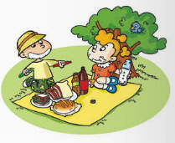
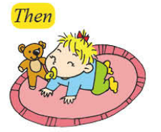
Ⅱ.听音，标号。用数字标出图片的先后顺序。（每题2分，共10分）
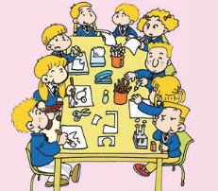
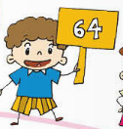

（ ） （ ） （ ） （ ） （ ）
Ⅲ. 听对话，选择最佳答句。将正确答案的序号填在括号内。（每题1分，共5分）
( )1. Was there a clock in the park before?
A. Yes, there was. B. No, there wasn’t. C. Yes, there is.
( )2. How old is Amy now?
A. Ten years old. B. Eleven years old. C. Twelve years old.
( )3. What colour is Lingling’s dress?
A. White. B. Blue. C. Red.
( )4. What festival are they talking about?
A.Easter. B. Christmas. C. Halloween.
( )5. Does Tom like stories?
A. He’s happy. B. Yes, he does. C. No, he doesn’t.

Ⅳ.听短文，判断正(T)误(F)。（每题2分，共10分）
( )1.It was raining yesterday.
( )2. Zara made a cake with her mum.
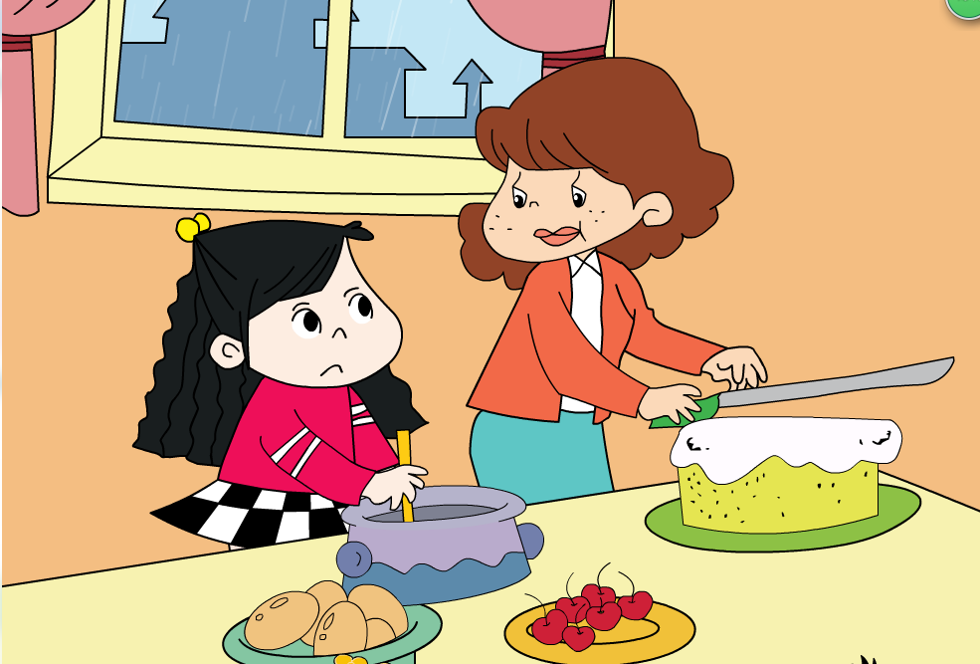
( )3. Zara ate the cake with her grandma.
( )4. Zara was thirsty, but she didn’t drink any water.
( )5. After the rain, Zara went out to play.

笔试部分（共六大题，65分）
Ⅴ.单项选择。（每题1分，共10分）
( )1. There ______a bench here before, but there is one now.
A. wasn’t B. weren’t C. didn’t
( )2. Mark can jump very _______. He can play basketball well.
A. fast B. high C. well
( )3. The boy _____ the books ______, he wanted to find The Three Little Pigs.
A. take ... down B. takes ... down C. took ...down
( )4. I’m going to ________ a film with my family at the weekend.
A. see B.saw C. looking at
( )5. She _______speak English then. But now she _______speak.
A. couldn’t, can B. could, can C. can’t, could
( )6. This English supermarket sells many different things_______ China.
A. at B. to C. from
( )7. This big coat is ________. That’s yours.
A. my B. mine C. yours
( )8. I ate some bread and ________ some water this morning.
A. made B.bought C. drank
( )9. In China, we usually finish school _______ 4 o’clock.
A. in B. on C. at
( )10. ---It’s time to have lunch. You should __________. ---OK.
A. tidy the room B. wash your hands C. jump on the bed
Ⅵ.根据语境提示，用词汇的适当形式完成下列句子。（每空1分，共10分）
1. My _________(邻居) is a kind grandma.
2. Halloween and Easter are English __________(节日).
3. Linda has got some pictures of the Great __________(长城).
4.We can _________ _________(玩得开心) at _____ __(课间休息) time.
5. She __________(喝)some milk every morning.
6. These __________(有用的) dogs can help the __________(失明的) people.
7. I _________(经常) help mum with some housework.
Ⅶ.句子理解。（共15分）
A. 选词填空，将单词的适当形式填入横线上。

toy sometimes restaurant sell country

Many English supermarkets are big. They_______ different things. They sell food from lots of __________.They also sell clothes, _________and CDs. __________ there are __________ at the supermarkets. Many families go to the supermarkets together.


B.根据图文提示，补全下列句子。
1 . ---________ _________ run fast?
--- Yes, he can.


2. ---What are we going to do tomorrow?

---We’re ________ ________ ________ _________.
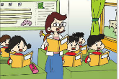
3. A:In the UK, children often sit around tables.
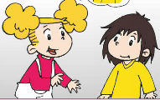
B: In China, _______ _______ _______ ________.

4. ---Are you sad?

---No, ________ __________.
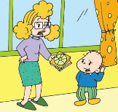

5. You should _______ _______ with the CDS.

Ⅷ.情景交际。根据对话内容，从方框中选择正确选项，将其序号写在横线上。
（每题2分，共10分）
A: _______________ I can’t find it.
A. No, it isn’t mine.
B. Where is my skirt?
C. Thanks.
D. It’s blue.
E. There is a blue skirt on the bed.
. H .And then her friends are going tio go home. e will be home at seven o’clock. E. Is he very busy?
B: Is your skirt red?
A: No, it isn’t. ________________
B: ________________ Is that your skirt?
A: ________________ It’s Amy’s.
B: Don’t worry. Let’s look for it together.
A: __________
B: You’re welcome.

Ⅸ.阅读理解。（共15分）
- 阅读短文，判断正误。正确的写“T”，错误的写“F”。
Yesterday, I went to the park and played basketball with some friends. Amy, Lingling and I were in a team. I could run fast, Amy and Lingling could catch the ball well. Our team won at last. We got thirty-six points, they got twenty points. We were happy. But then we felt hungry, I bought some bread, we ate it together. Then we were thirsty and drank some water. After I went home, I was tired. Amy went to bed late. She was bored and wanted me to play with her, but I didn’t. I went to bed early.
( )1. I went to school and played basketball yesterday.
( )2. I could catch the ball well, Amy and Lingling could run fast.
( )3. Our team won and we were very happy.
( )4. We were hungry and thirsty.
( )5. Amy and I went to bed together.

B.阅读短文，选择最佳答案。
In September, every school in the UK has a harvest festival(收获节).Children take food to school for a special lesson(一堂课). In the lesson, they learn about food and where it comes from.
Sara and Mark are English. They learnt about milk and rice last lesson. Their teacher told them that milk comes from cows. They also knew that rice grows(生长)on the ground in China, India(印度) and Thailand(泰国) and so on, not in the UK. After the lesson, the children went to the school hall(礼堂).They sang songs about farms, and read poems about animals. The headmaster(校长) told them how hard farmers work to give everyone food. After school, they took the food to old people.
( )1. Every school in the UK has a harvest festival in __________.
A. October B. September C. November
( )2. ---Why do children take food to school at harvest festival?
--- Because they ________.
A. have a special lesson B. have a picnic C. are hungry
( )3. The farmers grow rice in___________.
A. the UK and China B. India and Thailand C. Thailand and the UK
( )4. Children sang songs and read poems _________.
A. in the library B. in the park C. in the school hall
( )5. What’s the title(题目)of the text?
A. Harvest Festival B . Milk and Rice

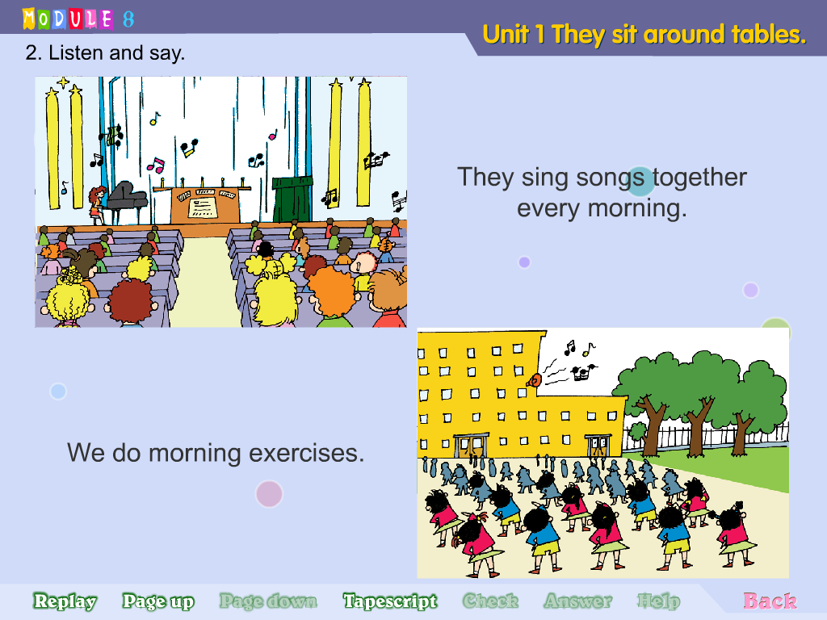
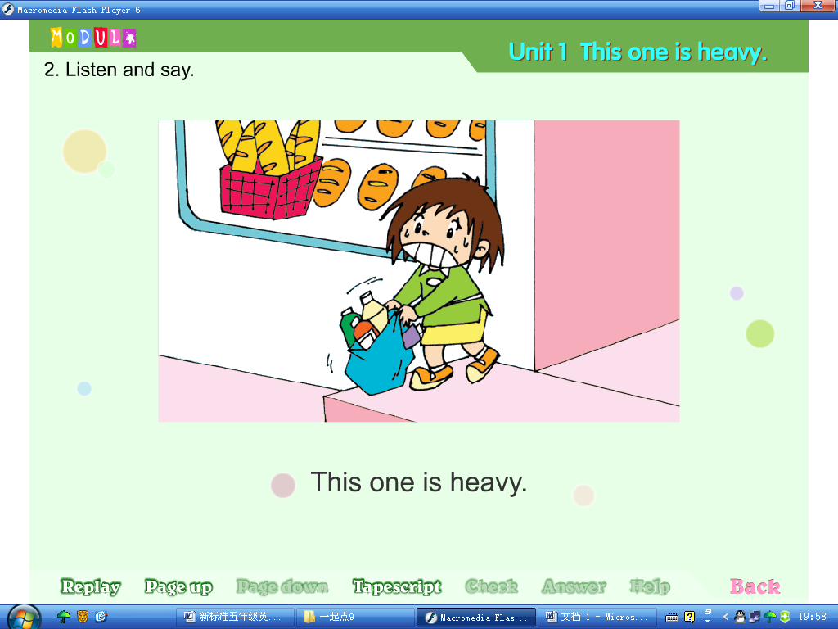
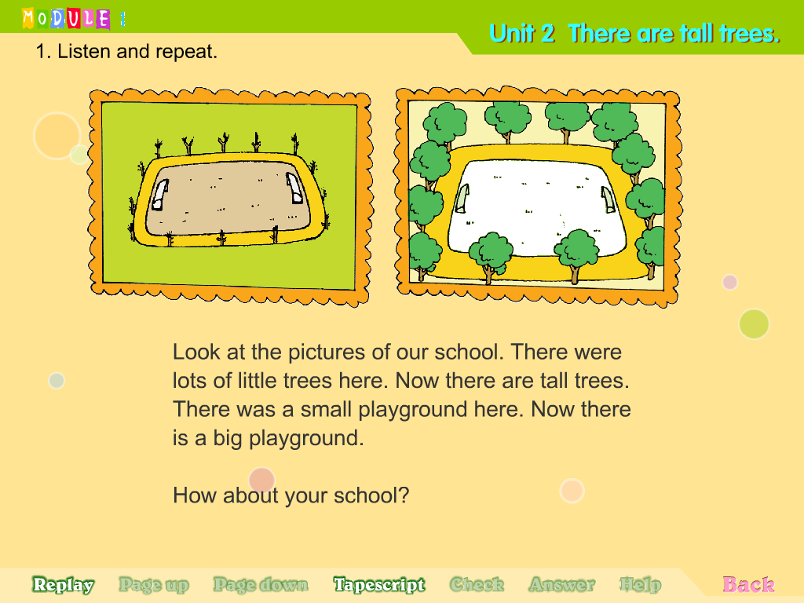
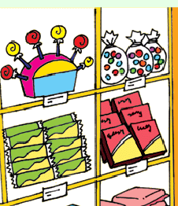
Ⅹ.书面表达。请结合提示，使用“should”“shouldn’t”制定五条班规。（5分）
要求：条理清楚，语句通顺，标点正确，书写规范，不少于5句话。
Class Rules

You should
温馨小贴士

be helpful
be late
listen in class
talk in class
play in class
work hard
be kind
…
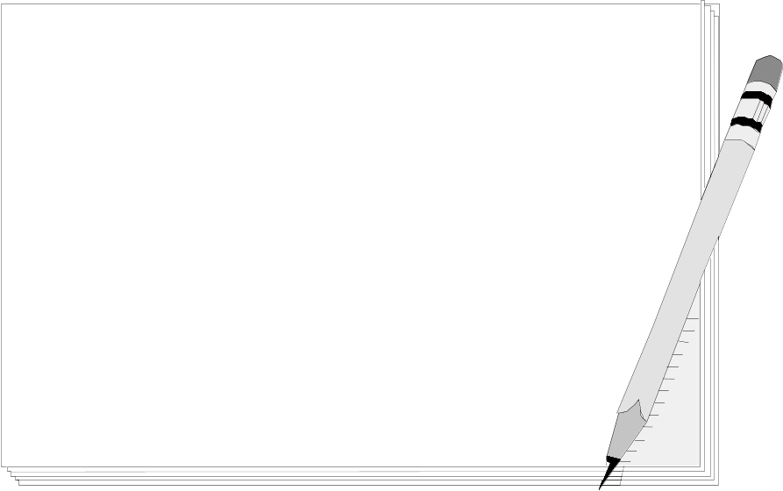

五年级英语听力题签
※注意：每道听力试题读二遍。时间控制在15分钟以内。

Ⅰ.听音，找出句子中含有的单词，将序号写在前面的括号内。
1. ---Where’s my shoe?
---Oh, it’s there.
2. This bird can speak. It’s special.
3. Don’t play with fire.
4. What’s twenty plus twenty?
5. My grandpa was a presenter before.

Ⅱ.听音，标号。用数字标出图片的先后顺序。
1. In the UK, children often sit around tables in class.
2. When I was one year old, I couldn’t walk.
3. This naughty boy is angry.
4. They’re going to have a picnic at the weekend.
5. He got sixty-four points.

Ⅲ. 听对话，选择最佳答句。将正确答案的序号填在括号内。
1. A: Look! The park is different now. There’s a big clock.
B. Yes, there weren’t any clocks here before.
Question: Was there a clock in the park before?

2. A: What’s this?
B. It’s an invitation to Amy’s birthday. She’s going to be eleven.
Question: How old is Amy now?

3. A: Look at the blue dress. Is it yours,Lingling?
B: Yes, it’s mine.
Question: What colour is Lingling’s dress?

4. A: What’s your favourite festival?
B: My favourite festival is Easter. On the day, people give children chocolate eggs.
Question: What festival are they talking about?

5. A: You look so happy Tom. What’s the matter?
B: My sister is going to tell me stories.
Question: Does Tom like stories?

Ⅳ.听短文，判断正(T)误(F)。
Yesterday, it was raining. Zara couldn’t go out. She was sad. She helped her mum make a cake. After that, she was hungry. She ate the cake with her mum. She was very thirsty. So she drank some water. Then the rain stopped. Zara went out to play. Zara was very happy.

听力部分到此结束！

五年级英语参考答案及评分标准
听力部分(35)
I. (2×5=10 分) BCBAA
II. (2×5=10 分) 2---3---1---4---5
III. (1×5＝5分) BABAB
IV. (2×5=10 分) TTFFT

笔试部分(65分)
V、(1×10＝10分) ABCAA CBCCB
VI、(1×10＝10分) neighbour, festivals, Wall, have fun, break,
drinks, useful, blind, often
（备注：其中3个单词如果没有相应形式的变化要扣减0.5分， 其它单词必须拼写完全准确方可得1分）
VII、A.（1×5=5分）
sell, countries, toys, Sometimes, restaurants
(单词没有变化，扣0.5分)
B. (共10分，第1、4、5小题每空1分，第2、3小题每空0.5分)
1. Can he 2. going to tell stories 3. we/ children sit in lines
4. I’m not 5. not play
（备注：其中Can如果没有首字母大写要扣减0.5分， 其它单词必须完全准确方可得分）
VIII、(2×5＝10分) BDEAC
IX、(2×5 + 1×5＝15分)
A. F F T T F
B. B A B C A
X、（5分）略
请任教五年级的英语老师批阅作文，并自行把握评分标准,做到心中有数。

备注：卷面满分为100分。（听力35分，笔试65分。）
优秀：90---100
良好：80---89
及格：60---79
不及格：0---59 2016年 1月8 日

