长海县2015—2016学年度第一学期期末质量检测试卷
小学四年级 英语 完成时间：60分钟
题  号 | 听力部分 |  |  |  | 笔试部分 |  |  |  |  |  | 总分
题  号 | Ⅰ | Ⅱ | Ⅲ | Ⅳ | Ⅴ | Ⅵ | Ⅶ | Ⅷ | Ⅸ | Ⅹ
得
分
听力部分（共四大题，40分）
Ⅰ. 听音选词。请选出你所听到的单词。（每题2分，共10分）
( )1、A. tell B. well C. fell
( )2、A. beside B. between C. before
( )3、A. gold B. key C. skirt
( )4、A. won B.became C. carried
( )5、A. stay B. real C. trip
Ⅱ. 听音标号。用数字标出图片的先后顺序。（每题2分，共10分）
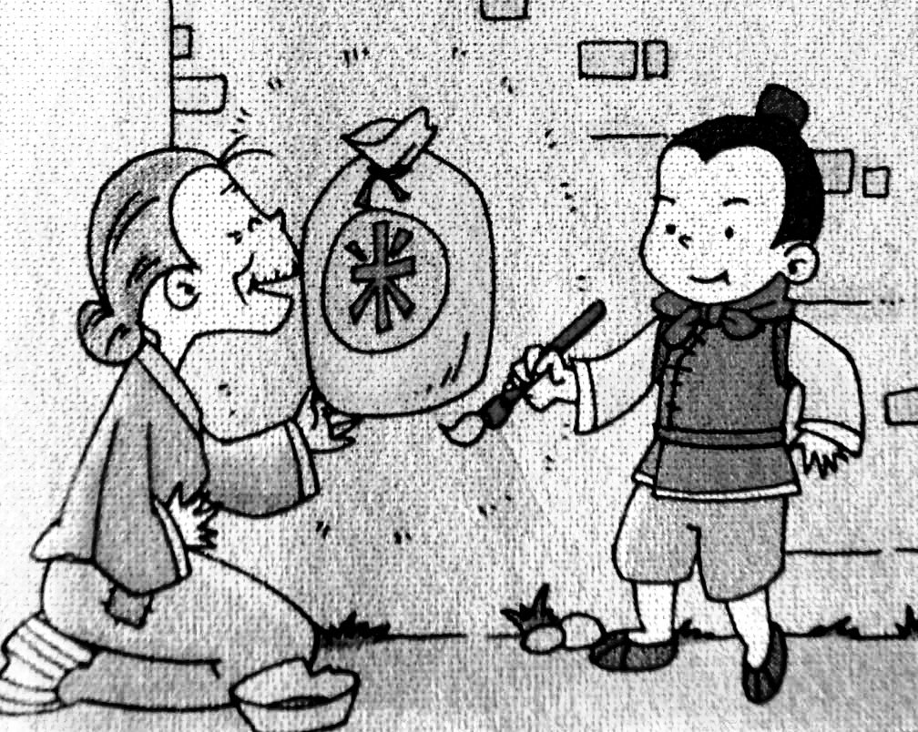
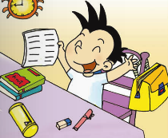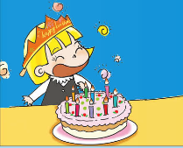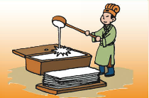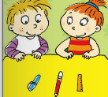
（ ） （ ） （ ） （ ） （ ）
Ⅲ. 听音选句。把正确的选项填在前面的括号内。（每题2分，共10分）
（ ）1、A. I love my family. B. My parents love me.
（ ）2、A. Turn left! B. That’s right!
（ ）3、A. The ice was very cold. B. We saw some beautiful plants.
（ ）4、A. Tom ate chocolates in class. The teacher was very angry.
B. Tom was very hungry. He ate chocolates in class.
（ ）5、A. Please say “Hello!” to your teachers.
B. “I want a big ship.” said the bad man.

Ⅳ. 听短文，判断正(T)误(F)。（每题2分，共10分）
( ) 1. Ms Smart cooked noodles on Sunday.
( ) 2. Sam watched TV.
( ) 3. Amy painted a picture.
( ) 4. Mr Smart phoned Grandpa.
( ) 5. They were very happy.
笔试部分（共六大题，60分）
Ⅴ.单项填空。（每题1分，共10分）
( )1. I _______ got a new friend. Her name is Lucy.
A. had B. have C. has
( )2. My trousers were very dirty. I __________ them.
A. played B. finished C.washed
( )3. Lingling didn’t ________to school yesterday.
A. walk B. walked C. walks
( )4. Chinese people invented _____________.
A. phone B. printing C. bicycle
( )5. We ___________candies at the party yesterday.
A. ate B. eat C. tea
( )6. Long, long ago, there _______ a good boy. His name was Ma Liang.
A. is B. were C. was
( )7. A: ________ you take Amy’s doll? B: No, I didn’t.
A. Are B. Did C. Have
( )8.________ did she do last Sunday? She went to the zoo.
A. When B. What C. Where
( )9. Sam ________his bike and bumped his head.
A. fell over B. looked for C. fell off
( )10. Lucy went skating yesterday. She _________warm clothes.
A. wear B. wears C. wore
Ⅵ. 根据所给语境，补全句子。（共15分）
A. 根据汉语提示，结合语境，填入所缺单词。（每题1分，共5分）
1. The bad man __________（带走）Ma Liang’s magic paintbrush.
2. （服用）this medicine. Drink a lot of water.
3. It ________（花费）me fifty minutes to finish this work every day.
4. We ______ ____________ (拍摄)some pictures in the park now.
B. 选择恰当的单词填空。（每题2分，共10分）
ate , were , went , juice , saw
Yesterday, Sam and I _______ to the Great Wall. We ________lots of
Mountains. We _______hungry and thirsty. I _______an apple. Sam drank lots of__________. We had a good time.
Ⅶ. 情景反应。（每题2分，共10分）
( )1. Did you see my black bike? A. No, I can’t.
( )2. When did they come? B. Yes, I do.
( )3. What happened to you? C.They came last Wednesday.
( )4. Do you eat fruit every day? D. Yes, I did.
( )5. Can you play the flute? E. I cut my finger.
Ⅷ. 情景交际。选择正确答案的序号填写在空格处。(每题2分，共10分)
Daming: What’s the matter, Amy ?
Amy: I can’t find it. Did you see it?
Daming: _________________
A. No, I didn’t.
B. Thank you!
C. I lost my favourite doll.
D. Yes, I did .
E. I found it under the bed.

Daming: Lingling, did you see Amy’s doll ?
Lingling: ________________
Daming: Where did you find?
Lingling: __________________
Amy: _______________

Ⅸ.短文阅读,判断正(T)误(F)。（每题2分，共10分）
Last weekend , I went to a book shop with Wang Hua. I bought five books about English. And then we went for a bike ride in the park. I cleaned my room. Mum helped me wash my shirt. We had a happy day!
( )1. Last weekend we went to a shoe shop.
( )2. Wang Hua bought five English books.
( )3. Wang Hua and I rode a bike in the park.
( )4. I didn’t wash my shirt.
( )5. What a boring day !
Ⅹ.想一想，写一写。(共5分）
Dear children, do you want to be healthy? Health is wealth(财富). Please eat___________ every day. Drink lots of __________. Go to bed_________ and do some exercise. You can___________. Always wash your hands before you eat and ___________ you go to the toilet.
四年级英语听力题签
注意：每道听力试题读二遍，听力时间控制在15分钟内。
Ⅰ. 听音选词。请选出你所听到的单词。（每题2分，共10分）
1、I’m very well now.
2、Look at the man beside the car. He’s my father.
3、 Mum bought me a skirt.
4、The boy won a gold cup.
5、It was raining. I stayed at home.

Ⅱ. 听音标号。用数字标出图片的先后顺序。（每题2分，共10分）
1、The pencil was between the ruler and the pen.
2、It was my birthday on Saturday.
3、I finished my homework.
4、This old woman didn’t have food.
5、Chinese people invented paper.

Ⅲ. 听音选句。把正确的选项填在前面的括号内。（每题2分，共10分）
1. I love my family.
2. That’s right!
3. We saw some beautiful plants.
4. Tom ate chocolates in class. The teacher was very angry.
5. “I want a big ship.” said the bad man.

Ⅳ. 听短文，判断正(T)误(F)。（每题2分，共10分）
Yesterday was Sunday. Mr Smart cooked noodles. Sam helped him. Ms Smart phoned Grandma. Tom watched TV. Amy painted a picture. What a happy day!

听力部分到此结束！

四年级英语参考答案及评分标准

听力部分40分
Ⅰ. (2×5＝10分) BACAA
Ⅱ. (2×5＝10分) 3—-2—-5---1---4
Ⅲ. (2×5＝10分) ABBAB
Ⅳ. (2×5＝10分) F F T F T

笔试部分60分
Ⅴ. (1×10＝10分) BCABA CBBCC
Ⅵ. (1×5 + 2×5＝15分)
A组：1.took 2.Take 3.takes 4. are taking
(请注意画线黑体部分，如果T没有大写将扣0.5分，其他单词完全准确方可得1分。）
B组：1.went 2. saw 3.were 4. ate 5. juice
(每个单词选填完全准确方可得2分。）
Ⅶ. (2×5＝10分) DCEBA
Ⅷ. (2×5＝10分) CADEB
Ⅸ. (2×5＝10分) F F T T F
Ⅹ. (5分) (每空1分, 其中有2个词空固定答案已给出，其它3个由学生自主发挥英语思维。）
_____ ，_____，early, _____ , after

备注：卷面满分为100分。（听力40分，笔试60分。）
优秀：90---100
良好：80---89
及格：60---79
不及格：0---59
2016年 1月 8 日

