新标准英语一起十一册
Module4 Unit1 Thanksgiving is very important in the US.教学设计
大长山中心小学 傅海华
〔语言功能〕介绍节日
〔语言结构〕一般现在时
〔教学目标〕
1. 语言知识目标：全体学生能运用“Thanksgiving is very important in the US.”，全体学生能理解“Thanksgiving, nearly”，全体学生能运用“nearly”， 部分学生能运用“Thanksgiving”。
2. 语言技能目标：能够听懂、会说并认读本单元句型，能运用所学语言介绍中外节日。
3. 情感态度目标：乐于了解外国节日，接触外国文化，拓宽国际视野。
〔教学重、难点〕
重点: 单词nearly；
功能句 What do you do on Thanksgiving?
We always have a big, special dinner.
We say thank you for our food, family and friends.
难点：能运用一般现在时描述中西方节日的主要特征。
〔学生分析〕
本课以节日为话题，贴近学生实际生活，激发了学习兴趣。学生学习过儿童节，万圣节，复活节等节日，并掌握一般现在时的语言结构，这样能够使学生积极参与活动，从而能介绍自己喜欢的节日。
〔教学准备〕
单词卡片，PPT课件， task paper，点读笔，食物图片
〔教学过程〕
Step 1、Warm-up and lead-in
1. Greetings.
2. Warmer: Free talk
T：Today I take some pictures of festivals. Let’s look what are they? (Show pictures about the Spring Festival and the Lantern Festival)
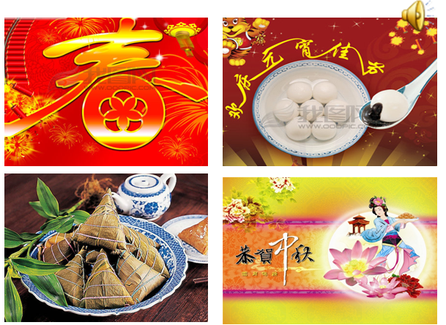
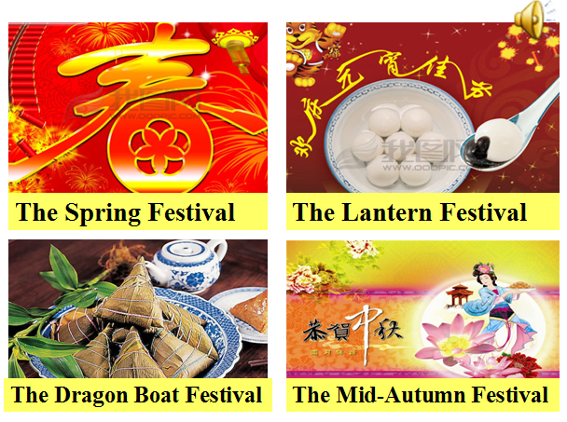
T: What do you eat at these festivals? What do you do?
T: My favourite festival is the Spring Festival. What’s your favourite festival?
S: My favourite festival is ……
3. Look, listen and say.
(1) Listen and answer: What’s their favourite festival?
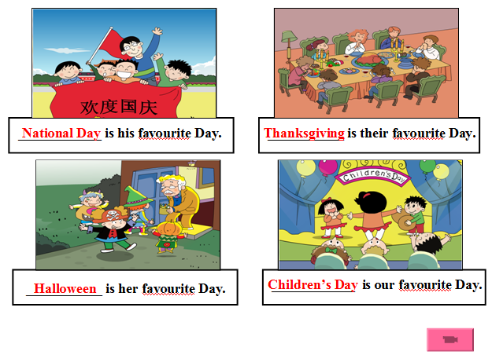
Ss: National Day, Halloween, Children’s Day, Thanksgiving.（教授单词Thanks+giving= Thanksgiving）

T: Today we’ll have two groups. One is Thanks group, the other is Giving group.（说明评价机制，奖励感恩节食物，并计分）
(2) Listen and imitate.
Step 2、Task presentation
T: Today our task is learning an important festival in the US and describing the other festivals we like in China or in the western country. Now let’s learn Module4 Unit1.
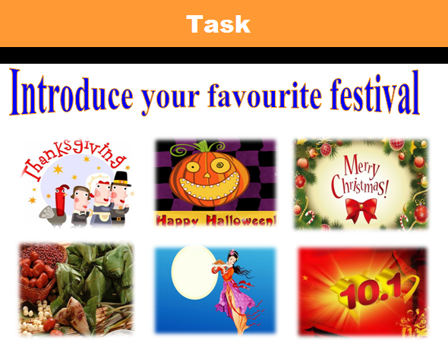

Step 3、Text learning
1. Watch the CD-ROM and choose: What is Simon’s favourite festival?
A. New Year B. Christmas C. Thanksgiving
(1) The Ss watch and choose the answer.（板贴情境图）
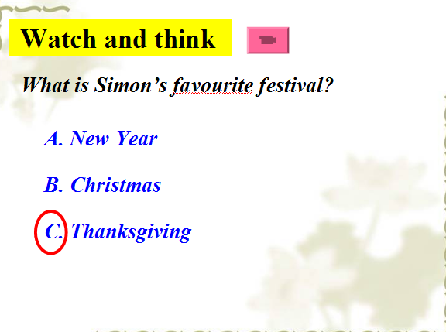

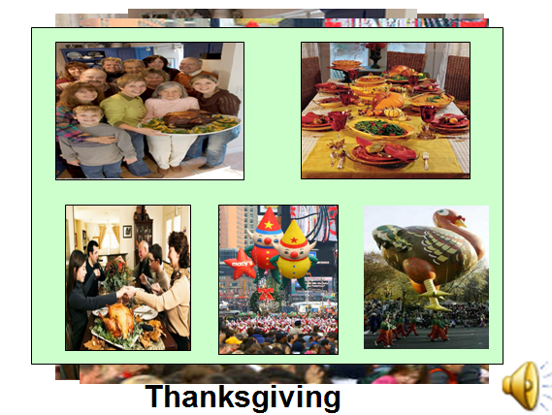
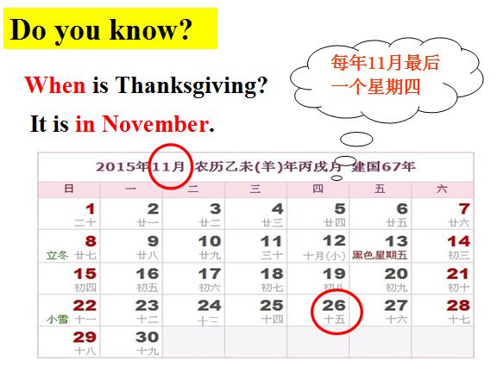
(2) Show the pictures about “ Thanksgiving” （了解感恩节，文化渗透，特词提问）

T: When is it? Ss: It’s in November.
2. Listen and answer: What do you do on Thanksgiving, Simon? （板书功能句）
(1) Listen and discuss in groups. Then report.
Ss: We always have a big, special dinner.
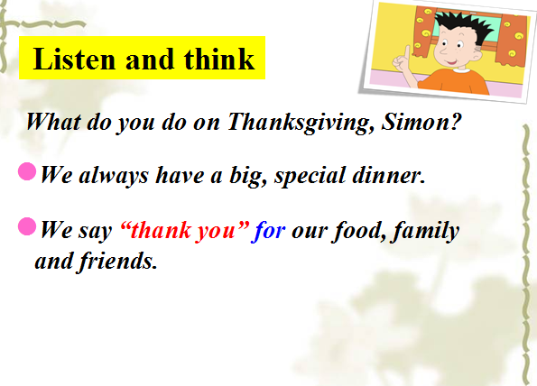
We say thank you for our food, family and friends.
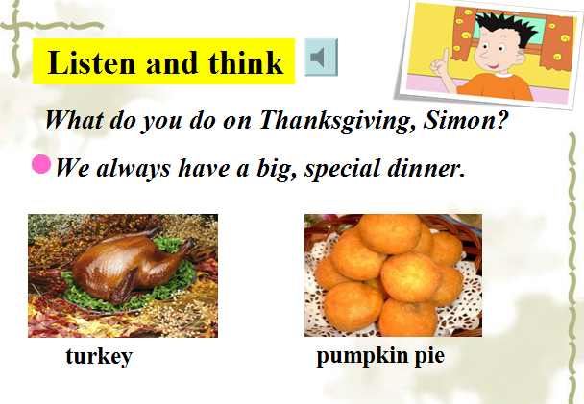
(2) T: How is your feeling, Simon? S: I have a lot of fun.
(3) Ask and answer in pairs.
(4)T: We can do lots of things on Thanksgiving. Is Thanksgiving very important in the US?
S: Yes. Thanksgiving is very important in the US.
T: What about these festivals in China?
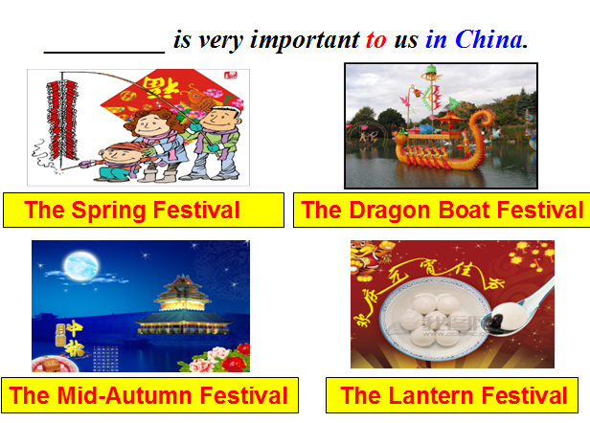

3. Read and answer.
T: Thanksgiving is very important in the US. So Simon wrote a poem about Thanksgiving. Do you want to hear it?
Ss: Yes, please.
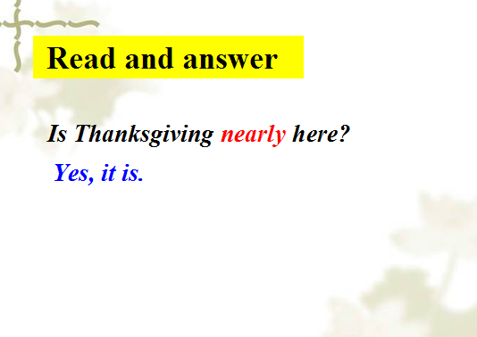
T: Read part3 and think “Is Thanksgiving nearly here?”

(1) Answer and teach the new word “nearly”, ear[ɪə], hear, year, dear
(2) Think and say. ________ is nearly here. （引导学生运用nearly）
T: The National Day is nearly here. Can you write a poem about it?
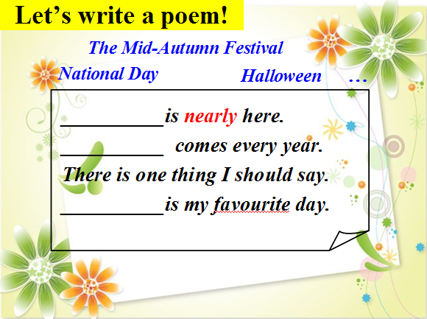

4. Listen and repeat. Then act it out.
5. Read and finish the dialogue.（课文整合）
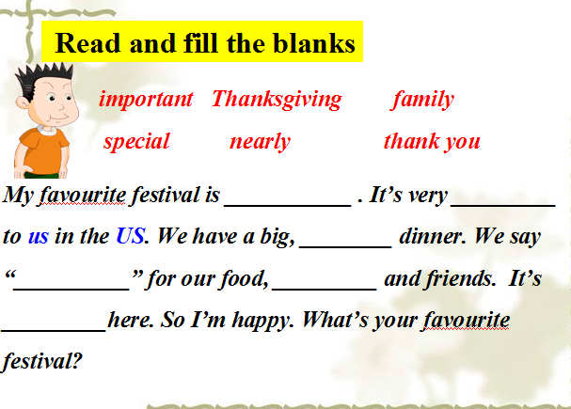

Step 4、Practice
- Listen and guess: The luck lable.
T: I’ve got some colorful paper about Thanksgiving. You can choose one then listen and repeat or guess the information.
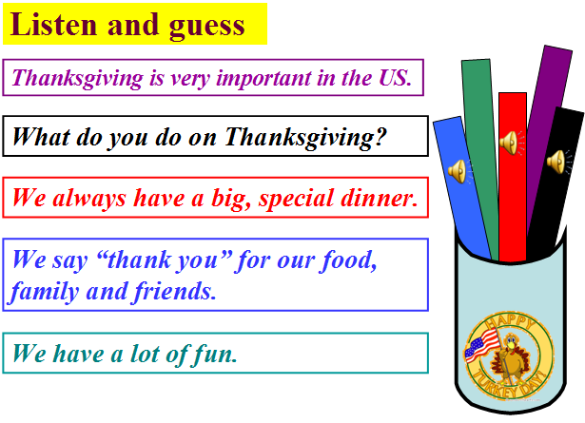

2. Retell or introduce Thanksgiving.
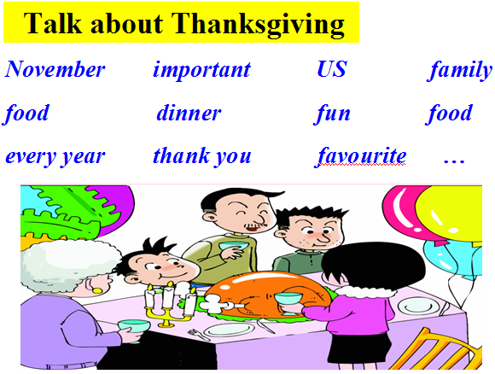
T: Who can say more about Thanksgiving. You can say according to the blackboard or these words.

Step 5、Task completion
1. Talk show: talk about festivals you like.
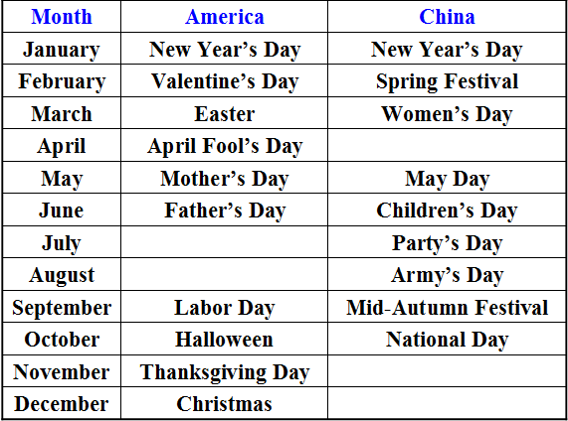
T: Children, do you remember today’s task? Let’s talk about your favourite festival
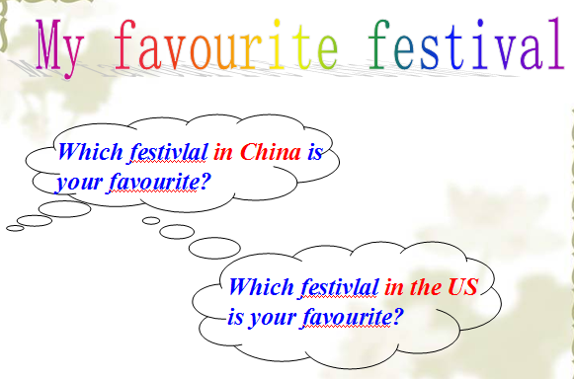
- Writing: My favourite festival.
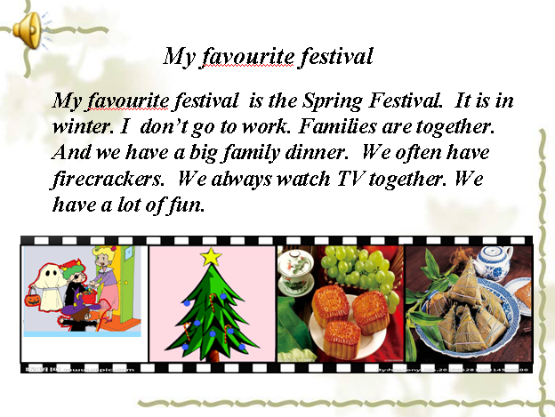

Step 6、Summary and homework
1. Sum up: What have we learnt today?
T: We know an important festival in the US——Thanksgiving and we can describe our favourite festival. (引导生复述功能句)
T: So Thanksgiving is very important in the US.（板题）
T: We can have Thanksgiving in China. We can say thank you for parents, teachers and classmates. We can say thank you for all good things.
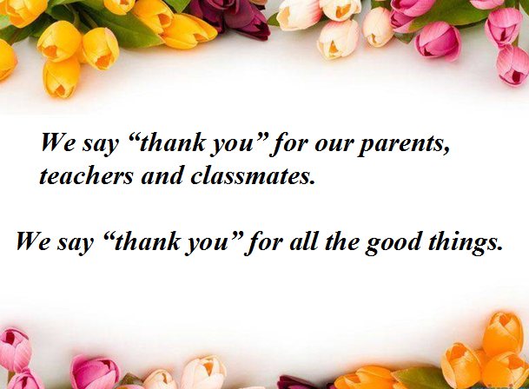

T: Look, which group is the winner? （看小组得分）Today’s winner can have a big, special dinner.
2. Homework:
A: Listen and read the text; Write the words and sentences.
B: Talk about your favourite festival with your friends.
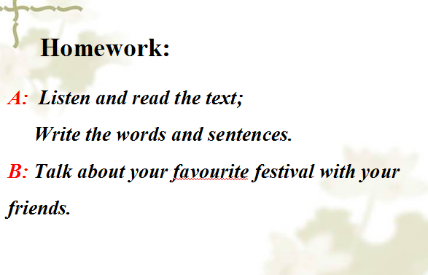

〔板书设计〕
