海洋岛学校小学二年级英语期末质量检测（2015.6）

答题时间：50分钟
学校
班级
姓名
听力部分 (70分)
- 听音，选出你所听到的单词，把序号写在括号里。（20分）
（ ）1. A. photo B. picture ( ) 2. A. game B. ground
( ) 3. A. camera B. cinema ( ) 4. A. radio B. right
( ) 5. A. secret B. street ( ) 6. A. sad B. say
( ) 7. A. take B. talk ( )8. A. write B. wrong
( ) 9. A. family B. flower ( ) 10. A. late B. little



二、听音，给下面的图片标号。（10分）

（ ） （ ） （ ） （ ） ( )

三、判断所听内容与图片是否一致，一致的在括号里画“√”，不一致的画“X”。 （10分）
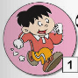
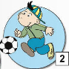
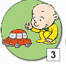


5

（ ） （ ） （ ） （ ） （ ）

四、听录音，在正确的图片下打“√”。（10分）


1、



2、

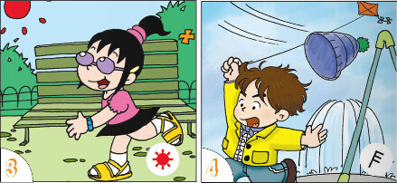
3、

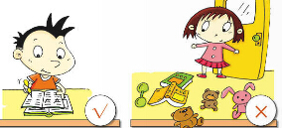
4、


5、

五、听音，选出你所听到的句子。 （10分）
（ ）1. A. The train is going up a hill.
B. The train is going down a hill.
( ) 2. A. He is playing with his train.
B. He is playing with his car.
（ ）3. A. Sam is tidying his room.
B. Sam isn’t tidying his room.
( ) 4. A. I usually play football on Sundays.
B. He usually plays football on Sundays.
( )5. A. He is singing a song.
B. He is saying a poem.

六、听短文，给下列图片用数字1.2.3.4.5重新排序。（10分）
It’s Children’s Day today.




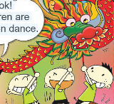
（ ） （ ） （ ） （ ） （ ）
笔试部分 (30分)
七、看图选词填空，完成句子。（10分）
room picture raining hot hospital

1. He is drawing a .

2.
It is now.

It’s very .
3.



4. The train is going past a .

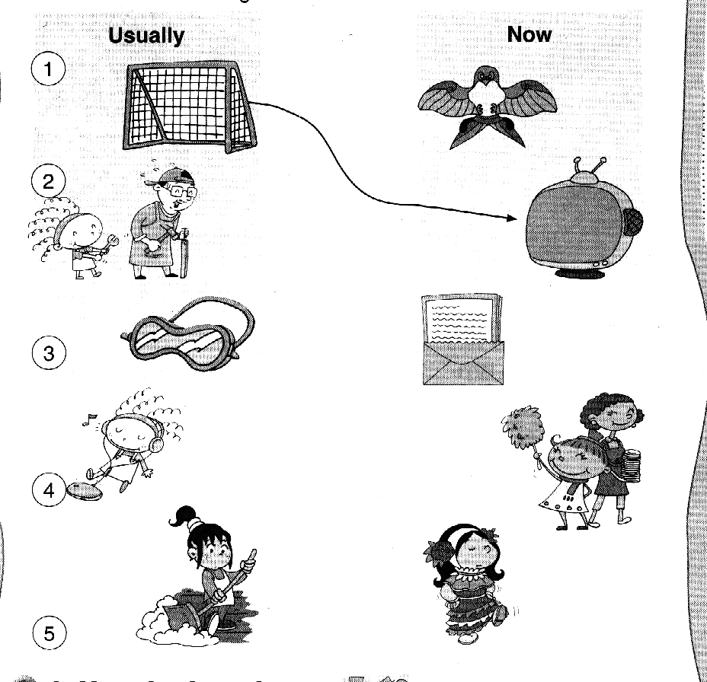
5.
She is tidying the

- 选择，将正确答案的序号填入括号内。（5分）
（ ）1. She is listening ______ the radio.
A. in B. to
( ) 2. My grandma usually ________.
A. cook B. cooks
( )3. Tom is playing ______ his train.
A. with B. and
( )4. It’s in front ______ the school.
A. of B. to
( )5. Lingling _______ skipping.
A. are B. is
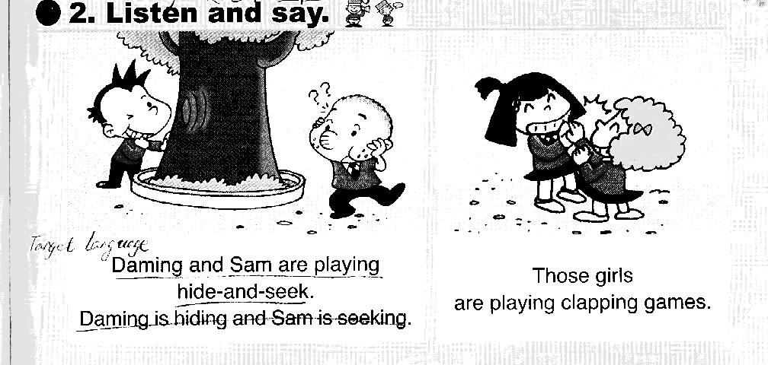
九、读句子，与对应的图片连线。 （10分）
1. He is doing a play.

2. They are playing clapping games.

3. She is watching TV.

4. He is eating.

5. She is listening to the radio.

十、情景反应。把问句与答句连线。（5分）
- Excuse me.Where is the zoo? A. It’s sunny.

- What’s the weather like? B. It’s in front of the school.

- What are you doing? C. They’re playing clapping games.

- What are they doing? D. I am flying a kite.

- Is he doing his homework? E. Yes, he is.

二年级英语听力题签 2015.6
一、听音，选出你所听到的单词，把序号写在括号里。（20分）
1. photo 2. game 3. cinema 4. right
5. street 6. say
7. take 8. write 9. flower 10. little

二、听音，给下面的图片标号。（10分）
1. Turn left.
2. We are turning around.
3. Go staight on.
4. The train is going up a hill.
5. Turn right.

三、判断所听内容与图片是否一致，一致的在括号里画“√”，不一致的画“X”。 （10分）
1、He is running.
2、He is playing basketball.
3、He is playing with his train.
4、She is walking.
5、They are playing football.

四、听录音，在正确的图片下打“√”。（10分）
1、I usually ride my bike.
2、She’s playing the piano.
3、It’s windy.
4、She isn’t tidying her room.
5、He is writing a letter.

五、听音，选出你所听到的句子。 （10分）
1.The train is going up a hill.
2.He is playing with his car.
3.. Sam isn’t tidying his room.
4. I usually play football on Sundays.
5. He is saying a poem.

六、听短文，给下列图片用数字1.2.3.4.5重新排序。（10分）
此题注意慢读、停顿
It’s Children’s Day today. Daming is doing a play. Lingling is singing a song. Sam is saying a poem.
Amy is dancing. Some children are doing a dragon dance.

二年级英语参考答案及评分标准
听力部分
一．（2×10=20分）BABBBBAABB
二、（2×5=10分）53241
三、（2×5=10分）√××√×
四、略
五、（2×5=10分）ABBAB
六、（2×5=10分）13542
七、（2×5=10分） picture raining hot hospital room
八、（1×5=5分） BBAAB
九、略
十、（1×5=5分） 1、B 2、A 3、D 4、C 5、E

