獐子小学二年级英语期末质量检测（2015.6）

答题时间：40分钟
学校
班级
姓名
听力部分 (70分)
- 听音，选出你所听到的单词，把序号写在括号里。（20分）
（ ）1. A. photo B. picture ( ) 2. A. game B. ground
( ) 3. A. camera B. cinema ( ) 4. A. radio B. right
( ) 5. A. secret B. street ( ) 6. A. sad B. say
( ) 7. A. take B. talk ( )8. A. write B. wrong
( ) 9. A. family B. flower ( ) 10. A. late B. little


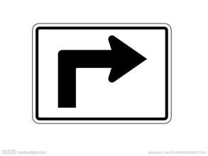
二、听音，给下面的图片标号。（10分）

（ ） （ ） （ ） （ ） ( )

三、判断所听内容与图片是否一致，一致的在括号里画“√”，不一致的画“X”。 （10分）
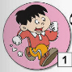
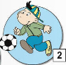
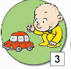


5
（ ） （ ） （ ） （ ） （ ）

四、听录音，在正确的图片下打“√”。（10分）
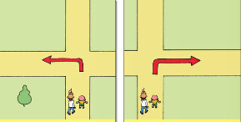

1、
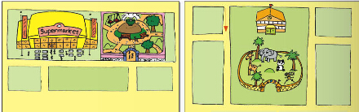
2、

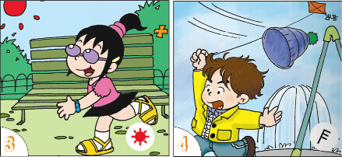
3、

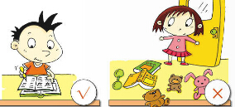
4、


5、

五、听音，选出你所听到的句子。 （10分）
（ ）1. A. The train is going up a hill.
B. The train is going down a hill.
( ) 2. A. He is playing with his train.
B. He is playing with his car.
（ ）3. A. Sam is tidying his room.
B. Sam isn’t tidying his room.
( ) 4. A. I usually play football on Sundays.
B. He usually plays football on Sundays.
( )5. A. He is singing a song.
B. He is saying a poem.

六、听短文，给下列图片用数字1.2.3.4.5重新排序。（10分）
It’s Children’s Day today.




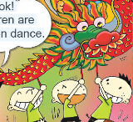
（ ） （ ） （ ） （ ） （ ）
笔试部分 (30分)
七、看图选词填空，完成句子。（10分）
room picture raining hot hospital

1. He is drawing a .

2.
It is now.

It’s very .
3.



4. The train is going past a .

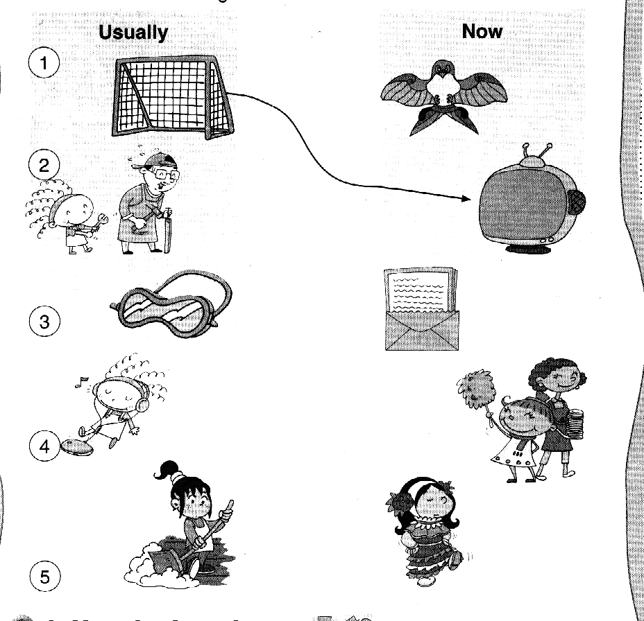
5.
She is tidying the

- 选择，将正确答案的序号填入括号内。（5分）
（ ）1. She is listening ______ the radio.
A. in B. to
( ) 2. My grandma usually ________.
A. cook B. cooks
( )3. Tom is playing ______ his train.
A. with B. and
( )4. It’s in front ______ the school.
A. of B. to
( )5. Lingling _______ skipping.
A. are C. is
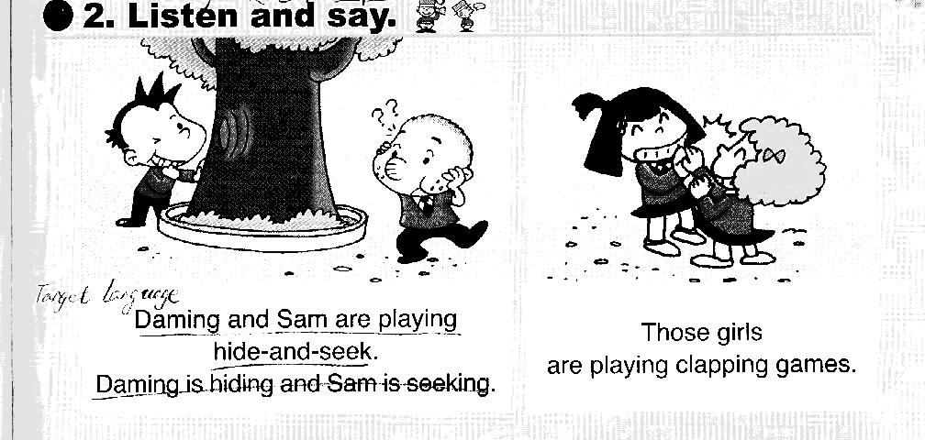
九、读句子，与对应的图片连线。 （10分）
1. He is doing a play.

2. They are playing clapping games.

3. She is watching TV.

4. He is eating.

5. She is listening to the radio.

十、情景反应。把问句与答句连线。（5分）
- Excuse me.Where is the zoo? A. It’s sunny.

- What’s the weather like? B. It’s in front of the school.

- What are you doing? C. They’re playing clapping games.

- What are they doing? D. I am flying a kite.

- Is he doing his homework? E. Yes, he is.

二年级英语听力题签 2015.6
听音，选出你所听到的单词，把序号写在括号里。（20分）
（ ）1. A. photo B. picture ( ) 2. A. game B. ground
( ) 3. A. camera B. cinema ( ) 4. A. radio B. right
( ) 5. A. secret B. street ( ) 6. A. sad B. say
( ) 7. A. take B. talk ( )8. A. write B. wrong
( ) 9. A. family B. flower ( ) 10. A. late B. little

二、听音，给下面的图片标号。（10分）
1. Turn left.
2. We are turning around.
3. Go staight on.
4. The train is going up a hill.
5. Turn right.

三、判断所听内容与图片是否一致，一致的在括号里画“√”，不一致的画“X”。 （10分）
1、He is running.
2、He is playing basketball.
3、He is playing with his train.
4、She is walking.
5、They are playing football.

四、听录音，在正确的图片下打“√”。（10分）
1、Turn left.
2、Where’s the supermarket? It’s next to the park.
3、It’s windy.
4、She isn’t tidying her room.
5、He is writing a letter.

五、听音，选出你所听到的句子。 （10分）
（ ）1. A. The train is going up a hill.
B. The train is going down a hill.
( ) 2. A. He is playing with his train.
B. He is playing with his car.
（ ）3. A. Sam is tidying his room.
B. Sam isn’t tidying his room.
( ) 4. A. I usually play football on Sundays.
B. He usually plays football on Sundays.
( )5. A. He is singing a song.
B. He is saying a poem.

六、听短文，给下列图片用数字1.2.3.4.5重新排序。（10分）
此题注意慢读、停顿
It’s Children’s Day today. Daming is doing a play. Lingling is singing a song. Sam is saying a poem.
Amy is dancing. Some children are doing a dragon dance.

