长海县2014~2015学年度第二学期期末质量检测
小学六年级 英语 完成时间：80分钟
题  号 | 听力部分 |  |  |  | 笔试部分 |  |  |  |  |  | 总 分
题  号 | Ⅰ | Ⅱ | Ⅲ | Ⅳ | Ⅴ | Ⅵ | Ⅶ | Ⅷ | Ⅸ | Ⅹ
得
分
听力部分（共四大题，30分）
Ⅰ.听音，找出句子中含有的单词，将序号写在前面的括号内。（每题1分，共6分）
C. took
C. son
C. away
C.crying
C.same
C.scared

B. books
B. sunny
B. arrive
B. trying
B. dream
B. special

( ) 1. A. looks
( ) 2. A. sun
( ) 3. A. around
( ) 4. A. flying
( ) 5. A. team
( ) 6. A. speak

Ⅱ.听音，标号。用数字标出图片的先后顺序。（每题1分，共8分）


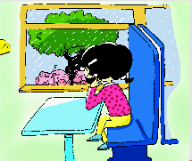
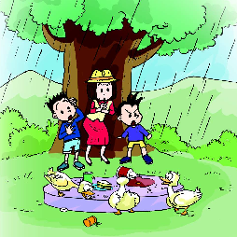
( ) ( ) ( ) ( )

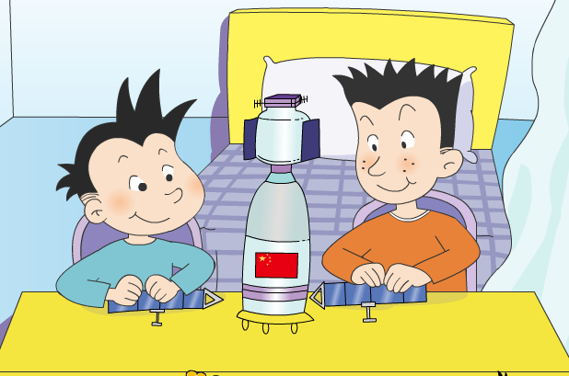
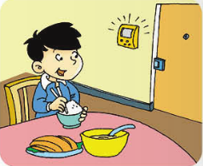


( ) ( ) ( ) ( )

Ⅲ.听对话，选答语。将正确答案序号填在括号内。 （每题2分，共10分）

（ ）1. When are they going to eat?
A. At twelve o’clock. B. At half past eleven. C. At half past twelve.

（ ）2. Can Simon help his mum?

A. Yes, he can. B. No, he can’t. C. We don’t know.

（ ）3. What’s the book about?
A. Spaceships. B. Shenzhou V. C. Space.
（ ）4. Where is Lingling going?
A. To the library. B. To the museum. C. To the supermarket.
（ ）5. What’s Tom’s favourite sport?
A. Football. B. Baseball. C. Basketball.

Ⅳ.听短文，判断正误，对的写“T”，错的写“F”。（每题1分，共6分）
( ) 1. Helen Keller was born in 1890 in America.
( ) 2. Helen Keller couldn’t see or hear.
( ) 3. It’s easy for Helen Keller to learn.
( ) 4. “Happy” was Helen’s first word.
( ) 5. Helen Keller couldn’t write books.
( ) 6. Helen Keller is a model for blind people.

笔试部分（共六大题，70分）
Ⅴ.单项选择。将正确的序号填写在前面的括号里。（每题1分，共15分）
( )1. The hot dog ________good. I want to eat a hot dog.
A. looks B.look C. looking
( )2. Look at the ducks. _____are eating our sandwiches. A.We B.You C.They
( )3. I took some _____. They are very beautiful. A. photos B. photo C. photoes
( )4. The oranges are falling ______ the stairs. A. on B. down C. over
( )5. ---_____are we going to swim? --- At two o’clock.
A. Where B.Who C.When
( )6. He is playing the erhu, ______ the bell rings. A. and B. but C. so
( )7. Everyone ________the dog is very clever. A. say B. says C. said
( )8. My brother is interested __________ collecting stamps.
A. at B. in C. on
( )9. How did Helen Keller learn______and write? A. read B. to read C. reading
( )10. I ______ two hours in the library yesterday. A.spend B.spends C.spent
( )11.---Why are you________? ---It’s very funny.
A. laugh B. laughing C. laughs
( )12. Yesterday I ______my flute to school, but today I didn’t______ it.
A. bring, brought B. brought , bring C. brought , brought
( )13. Good luck_______ the future! A. for B. on C. of
( )14. We’re going to middle school in _______September. A. a B. the C. /
( )15. We’ll always ______ friends. A. be B. is C. are
Ⅵ. 根据语境提示，用词汇的适当形式补全下列句子。（每空1分，共10分）
1. There are some _________ _________(乌云) in the sky.
2. Mum bought a new _________(杯子) for me yesterday.
3. I like __________(旅行), and I’m going to __________(旅行) this summer holiday.
4. My father will ________(飞) to Shanghai tomorrow.
5. I’ll ________(保留) it forever.
6. That’s a ___________(极好的) idea.
7. Best ________(祝愿) to you!
8. Six years ago, we spoke only very _________(极少量的) English.

Ⅶ.句子理解。（共2大题，计20分）
A.根据问句，找出相对应的答句，将序号填入题前括号内。（每题2分，共10分）
（ ）1. How much is it?
A. I’m going to Dalian.
B. By bus.
C. I want a cola.
D. It’s thirteen dollars.
E. I had a picnic with my family.

（ ）2. What did you do last Sunday?
（ ）3. How will you go to your new school?
（ ）4. Can I help you?
（ ）5. Where are you going this summer?

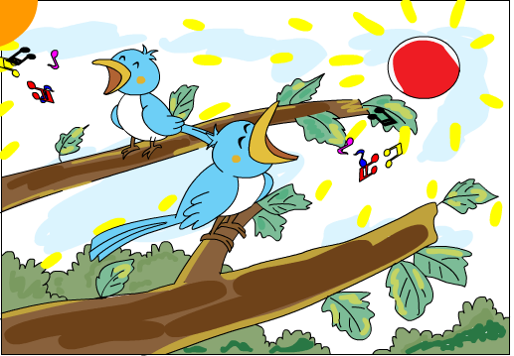
B.根据图文提示，补全句中所缺单词。（共10分）
1. In this photo, the sun is __________.
The birds ______________ in the trees.
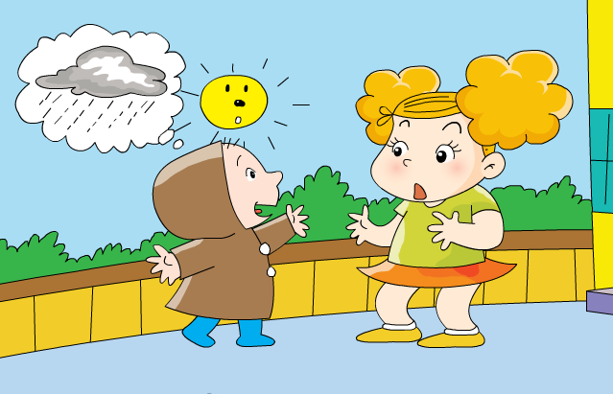
2. A: ________ are you wearing a raincoat?
B: Because it’s __________ rain.
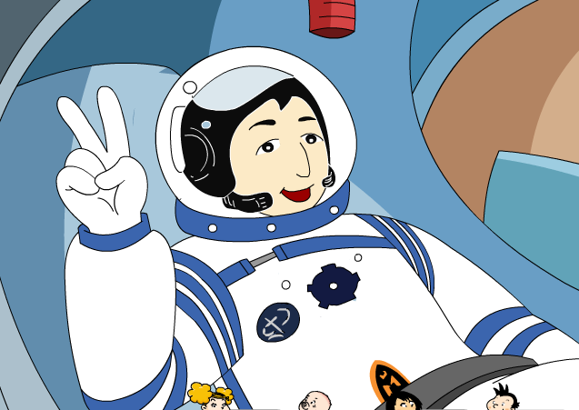
3. A: How many hours did Yang Liwei spend in space?
B: ________ _______ about ___________ hours in space.
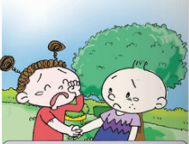
4. I’m very sad _______ _______ goodbye to you.

Ⅷ.情景交际。选择恰当的句子补全对话, 只填序号。（每题2分，共10分）
A. It’s about space travel. B. Who gave it to you? C. It’s a birthday present.
D.Then we can make a paper Chinese spaceship. E.China sent people into space, too.

Simon: What a great book! _________________
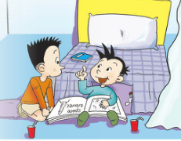
Daming：Your mum gave it to me._________________
Simon: What’s it about?
Daming: _______________ There are many pictures of
spaceships from China, Russia and the US.
Simon: China?
Daming: Yes!____________________
Simon: Really? I want to read about that.
Daming: Let’s read it together! ___________________

Ⅸ.阅读理解。（2道大题，共10分）

A. 阅读短文，判断正误。正确的写“T”，错误的写“F”。
Hi, my name is Lilin . I’m Chinese, but I live in England. I speak English very well, but sometimes I make mistakes. Last Sunday we went to visit a farm. I was very excited. I told my friends I wanted to see a ship. Everyone looked surprised and laughed a lot. My teacher said, “There are no ships on the farm.” Oh ! I made a mistake. I wanted to say “sheep”, not “ship”. I was so shy. It was very funny. We all laughed.
1. ( ) Lilin lives in China.
2. ( ) Sometimes Lilin makes mistakes with English words.
3. ( ) Lilin went to the sea.
4. ( ) There were ships on the farm.
5. ( ) Lilin wanted to say ”sheep”.
B. 阅读短文，选择正确的答案。
Once upon a time, there was a boy called Lu Ban. Lu Ban wanted to be a carpenter（木匠）. So he said goodbye to his parents and left home to find a teacher. He walked and walked. He was very tired, but he didn’t stop. He saw a very high mountain. He climbed and climbed. It was very dangerous, but he didn’t stop. Finally, he found a good teacher. The teacher told him to clean his tools（工具）for seven days and make one thousand holes in some wood. Lu Ban did everything the teacher said. The teacher was very satisfied（满意的）and taught him how to be a good carpenter. Lu Ban stayed for three years with his teacher. Then he became a great carpenter. He is famous all over China till today.
1. Lu Ban was a ________. A. teacher B. driver C. carpenter
2. It was ________ for Lu Ban to find a good teacher. A. easy B. hard C. funny
3. Lu Ban cleaned the tools for _______.
A. seven days B. two weeks C. five hours
4. Lu Ban stayed for _______ with his teacher.
A. one year B. two years C. three years
5. Did the teacher like Lu Ban?
A. Yes, he did. B. No, he didn’t. C. We don’t know.
Ⅹ.书面表达。（5分）
同学们，小学生活即将结束，九月份，你们就要升入中学了。给你的好朋友写
一封信，谈一谈你的感受及打算吧！40个单词左右。

Dear______________,
__________________________________________________________________
__________________________________________________________________
__________________________________________________________________
From,
_____________
六年级英语听力题签
注意：每道听力试题读两遍，听力时间控制在15分钟内。

Ⅰ. 听音，找出句子中含有的单词，将序号写在前面的括号内。
1、It looks like you’re going to stay hungry, Simon.
2、In Dalian, it will be sunny.
3、The train will arrive at the station at 10 o’clock.
4、Grab the balloons! They’re flying away.
5、We’re going to have a baseball team.
6、I’m scared because there is a snake.

Ⅱ. 听音，标号。用数字标出图片的先后顺序。
1、There is a cup on the cap.
2、They made a model of a Chinese spaceship.
3、He is eating dinner, but the bell rings.
4、Helen Keller was born in the US.
5、Naughty ducks! They’re eating our sandwiches.
6、I want some meat.
7、Tomorrow, it will be windy in Beijing.
8、I’m on a train and I’m looking out of the window.

Ⅲ. 听对话，选答语。将正确答案序号填在括号内。
1、Boy: I’m hungry. When are we going to eat, mum?
Mum: At half past twelve.
Question: When are they going to eat?
2、Mum: Simon, can you help me? I can’t carry all these things.
Simon: Sorry mum, I’m on the phone.
Question: Can Simon help his mum?
3、Daming: Look, I’ve got a new book.
Lingling: Wow, it’s about spaceships. I’m interested in it.
Question: What’s the book about?
4. Amy: What are you going to do this Sunday，Lingling?
Lingling: I am going to go to the supermarket.
Question: Where is Lingling going?

5. David: Tom, let’s play basketball this afternoon!
Tom: Great! Basketball is my favourite. I can play it very well.
Question: What’s Tom’s favourite sport?

Ⅳ. 听短文，判断正误，对的写“T”，错的写“F”。
Helen Keller was born in 1880 in America. She had an illness at nineteen months old. After that she couldn’t see or hear. But she learned to read and write. It’s very difficult for her to learn. But she was a very clever girl and she tried hard. “Water” was Helen’s first word. She wrote books about her life. She was famous. She helped blind people everywhere.

听力部分到此结束！

六年级英语参考答案

听力部分
Ⅰ. (1×6＝6分) 1.A 2.B 3.B 4. A 5. A 6. C
Ⅱ. (1×8＝8分) 5—8—6—1 7—2—3—4
Ⅲ. (2×5＝10分) 1.C 2. B 3. A 4. C 5.C
Ⅳ. (1×6＝6分) 1. F 2. T 3. F 4.F 5. F 6. T

笔试部分
Ⅴ. (1×15＝15分) A C A B C B B B B C B B A C A

Ⅵ. (1×10＝10分) 1.dark clouds 2. cup 3.travelling travel 4. fly
5. keep 6. wonderful 7. wishes 8. little
（请注意画线黑体部分,如果没有相应形式的变化将各扣0.5分，其他单词完全准确方可得1分。）
Ⅶ. A. (2×5＝10分) 1. D 2.E 3.B 4.C 5.A
B. 1. shining , are singing （3分） 2. Why, going to （2分）
3. He, spent, twenty-one （3分） 4. to , say （2分）
（请注意画线黑体部分，如果没有相应形式的变化将各扣0.5分,其他单词完全准确方可得1分。）

Ⅷ. (2×5＝10分) B C A E D
Ⅸ. (1×10＝10分) A. 1. F 2. T 3. F 4. F 5.T
B. 1.C 2.B 3. A 4. C 5. A
Ⅹ.略。(5分)
备注：卷面满分为100分。（听力30分，笔试70分。）
优秀：90---100
良好：80---89
及格：60---79
不及格：0---59

2015年 7 月 8 日

