长海县2014—2015学年度第二学期期末质量检测
小学五年级 英 语 完成时间：80分钟
题  号 | 听力部分 |  |  |  | 笔试部分 |  |  |  |  |  | 总分
题  号 | Ⅰ | Ⅱ | Ⅲ | Ⅳ | Ⅴ | Ⅵ | Ⅶ | Ⅷ | Ⅸ | Ⅹ
得
分

听力部分（共四大题，35分）
Ⅰ.听音，找出句子中含有的单词，将序号写在前面的括号内。（每题1分，共5分）
( ) 1. A. red B. read C. ride
( ) 2. A. actress B. player C. actor
( ) 3. A. history B. factory C. subject
( ) 4. A. ours B. flowers C. hours
( ) 5. A. go shopping B. go skiing C. go skating


Ⅱ.听音，标号。用数字标出图片的先后顺序。（每题2分，共10分）
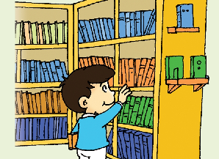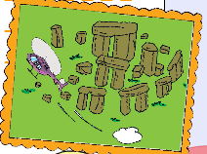
( ) ( ) ( ) ( ) ( )

Ⅲ. 听问句，选答句。将正确答案序号填在括号内。（每题2分，共10分）
( ) 1. A . Hong Kong. B. Fish and chips. C. Winter.
( ) 2. A. I’m happy. B. By plane. C. It’s ￡30.
( ) 3. A. Miss Yu. B. In the theatre. C. In July.
( ) 4. A. Stick. B. Some eggs. C. A ticket.
( ) 5. A. Yesterday. B. 4 pm. C. At six o’clock.

Ⅳ.听短文，判断正(T)误(F)。（每题2分，共10分）
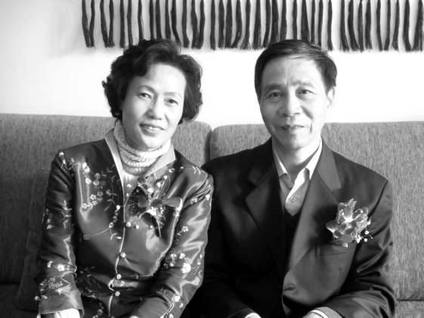
( )1. My father is a policeman now.
( )2. He goes to work at 7:30 every morning.
( )3. My mother is a Chinese teacher in a high school.
( )4. She goes to work at eight o’clock every morning.
( )5. It’s a photo of my parents.

笔试部分（共六大题，65分）
Ⅴ.单项选择。（每题1分，共10分）
( ) 1. My grandparents ________teachers before .
A. were B. are C. was
( ) 2. Yesterday she ______ an English breakfast.
A. have B. had C. has
( ) 3. You _______ talk to your friends in the library ．
A．can B．are C．can’t
( ) 4. In______ , I can play with the snow.
A. winter B. autumn C. summer
( ) 5. ---Is this your dress , Amy? ---No, _______is pink.
A. my B. mine C. me
( ) 6.--- ________is the Great Wall ? ---In Beijing .
A. How old B. How long C. Where
( ) 7. She ________TV on Sundays.
A. watched B. is watching C. watches
( ) 8. -----Will you help me? -----_____________ !
A. Of course B. Thank you C. Good idea
( ) 9. _________Day is on the eighth of March.
A．Women’s B．woman C．men
( ) 10. Mum bought new chopsticks ________ you.
A．with B．for C．to
Ⅵ.根据语境提示，用词汇的适当形式完成下列句子。（每题2分，共10分）
1. Daming ___________( 画) a f lower on a piece of paper, and then he painted it.
2. I like reading the books , they are very ______________（有趣的）.
3. The schoolbag is ______________(轻的). I can carry it on my back.
4. Beijing is a very important __________(地方 ) in China.
5. I ___________（遇见）my classmates at the gate yesterday.
Ⅶ.句子理解。（共15分）
A. 根据问句找出相对应的答句，将序号填入题前括号内。
( )1. What did she do ? A. I’m going to clean my car.
( )2. What are you doing? B. Some animals .
( )3. What music does he play ? C. We’re taking some photos.
( )4. What will we see in the zoo ? D. She played on the beach.
( )5. What are you going to do ? E. He plays Chinese music .

B.根据语境提示，选词并用其恰当的形式补全下列短文。
present visit send make give
I’m going to _______my cousin in America. What _______ can I take? Last year, I _______ him a book. This year, I want to _________him a different gift. Maybe you can help me to _______ a kite.
Ⅷ.情景交际。根据对话内容，从方框中选择正确选项，将其序号写在横线上。（每题2分，共10分）
Amy: Excuse me.
Librarian: I’ll look on the computer. Sorry, we haven’t got the DVDs.
Amy: Oh good. Where are they?
Librarian: __________________
Amy: Harry Potter is my favourite.
Librarian: Your library card, please.
Amy: ___________________
Librarian: Please give the books back in two weeks.
Amy: __________________
A. But we have got the books.
B. Here you are.
C. I’ll show them to you.
D. I will. Thank you.
E. Have you got the Harry Potter DVDs?
. H .And then her friends are going tio go home. e will be home at seven o’clock. E. Is he very busy?

Ⅸ.阅读理解。（共15分）
- 阅读短文，判断正误。正确的写“T”，错误的写“F”。
There are four seasons in a year. My favourite season is spring. It’s warm. There are flowers on the trees. I can see ducks in the river. I can go to the park and fly my kite. Amy loves summer. It’s hot. She can go swimming with her mother. She can wear skirts.

( )1. I love summer.
( )2. Amy’s favourite season is spring.
( )3. It’s hot in summer.
( )4. Amy can go swimming in winter.
( )5. I can fly my kite in the park in spring.

- 阅读短文，选择最佳答案。
Ben is in Grade Three. He has a lot of hobbies. He likes playing basketball best. But he dislikes doing homework after school. And his teacher always finds a lot of mistakes in his homework.
Last Tuesday his math teacher Miss Black looked at Ben’s homework and saw that he got all his answers right. She was very surprised. The next morning before math class, Miss Black asked Tom to her office and said to him, “You got all your homework right this time. Who helped you? Did your parents help you?”
Ben’s parents often help him with his homework, but this time they didn’t help Ben because they weren’t at home. Ben answered, “ No, Miss Black. My mum and dad were very busy last night, so I did my homework by myself. ”

（ ）1. What is Ben’s favourite sport?
A. Basketball. B. Football. C. Baseball.
（ ）2. Does Ben usually do his homework by himself ?
A. Yes, he does. B. No, he doesn’t. C. I don’t know.
（ ）3. Why did Miss Black ask Ben to come to her office?
A. Because Ben got all his homework right.
B. Because Ben was naughty.
C. Because Ben got all his homework wrong.
（ ）4. Who often helps Ben with his homework?
A. Ben’s classmates. B. Ben’s friends. C. Ben’s mother and father.
（ ）5. What’s the meaning of the word “ dislike”?
A. 喜爱 B.不喜欢 C. 渴望
Ⅹ.书面表达。（5分）
亲爱的同学们，请给你的好朋友写一封信，同他（她）一起分享你的一次快乐之旅吧！
内容提示：1. Where did you go?
2. When did you go there?
3. How did you go there?
4. What did you do (eat/drink/ see /visit…)?
5. How did you feel?
要求：1、要点齐全，表达准确，语句通顺，书写规范，可适当发挥；
2、词数40词左右。
Dear ______________，____________________________________________________________________
____________________________________________________________________
____________________________________________________________________
Love，
_______________

五年级英语听力题签
※注意：每道听力试题读二遍。时间控制在15分钟以内。

Ⅰ.听音，找出句子中含有的单词，将序号写在前面的括号内。
- Grandma sent me English books. I read them.
2. The actors told lots of jokes. They were very funny.
3. Susan likes Chinese history.
4. It will take us three hours to get there .
5. I like skiing in winter . I love skiing with my father.

Ⅱ.听音，标号。用数字标出图片的先后顺序。
1. The black bag is big and nice but it’s very heavy.
2. My father worked in a hospital before.
3. We took a helicopter ride over Stonehenge.
4. Families usually have lunch together on Sundays.
5. If you like reading.You can borrow books in the library.

Ⅲ. 听问句，选答句。将正确答案序号填在括号内。
1. Where did you go last year?
2. How much is it?
3. Who is your English teacher?
4. What did you have for breakfast ?
5. What time will you get up in the morning?

Ⅳ.听短文，判断正(T)误(F)。
Look at the picture. My father is an erhu player. He’s very busy. He goes to work at 6:30 every morning. He was a policeman before. My mother is a teacher now. She teaches Chinese well. She works hard. She goes to work at 7 o’clock every morning. She works in a high school. I love my parents.

听力部分到此结束！

五年级英语参考答案及评分标准
听力部分(35分)
I. (1×5=5 分) BCACB
II. (2×5=10 分) 5---4---1---3---2
III. (2×5＝10分) ACABC
IV. (2×5=10 分) F F T F T

笔试部分(65分)
V、(1×10＝10分) ABCAB CCAAB
VI、(2×5＝10分) drew , interesting , light , place , met
（备注：其中2个单词如果没有过去式相应形式的变化要扣减1分， 其它3个必须拼写完全准确方可得2分）
VII、（1×5 + 2×5词=15分）
- DCEBA
B. visit , present , sent(gave) , give (send) , make
（备注：其中1个单词如果没有过去式形式变化要扣减1分， 其它4个必须完全准确方可得2分）
VIII、(2×5＝10分) EACBD
IX、 (2×5 + 1×5＝15分)
A. F F T F T
B. A B A C B
X、（5分）略
请任教五年级的英语老师批阅作文，并自行把握评分标准,做到心中有数。

备注：卷面满分为100分。（听力35分，笔试65分。）
优秀：90---100
良好：80---89
及格：60---79
不及格：0---59

2015年 7月 8 日

