长海县2014—2015学年度第二学期期末质量检测
小学四年级 英语 完成时间：60分钟
题  号 | 听力部分 |  |  |  | 笔试部分 |  |  |  |  |  | 总分
题  号 | Ⅰ | Ⅱ | Ⅲ | Ⅳ | Ⅴ | Ⅵ | Ⅶ | Ⅷ | Ⅸ | Ⅹ
得
分
听力部分（共四大题，40分）
Ⅰ. 听音选词。请选出你所听到的单词。（每题2分，共10分）
( ) 1. A. send B. sheep C. stick
( ) 2. A. country B. cost C. concert
( ) 3. A. rest B. best C. restaurant
( ) 4. A. north B. month C. south
( ) 5. A. plan B. postcard C. please
Ⅱ. 听音标号。用数字标出图片的先后顺序。（每题2分，共10分）
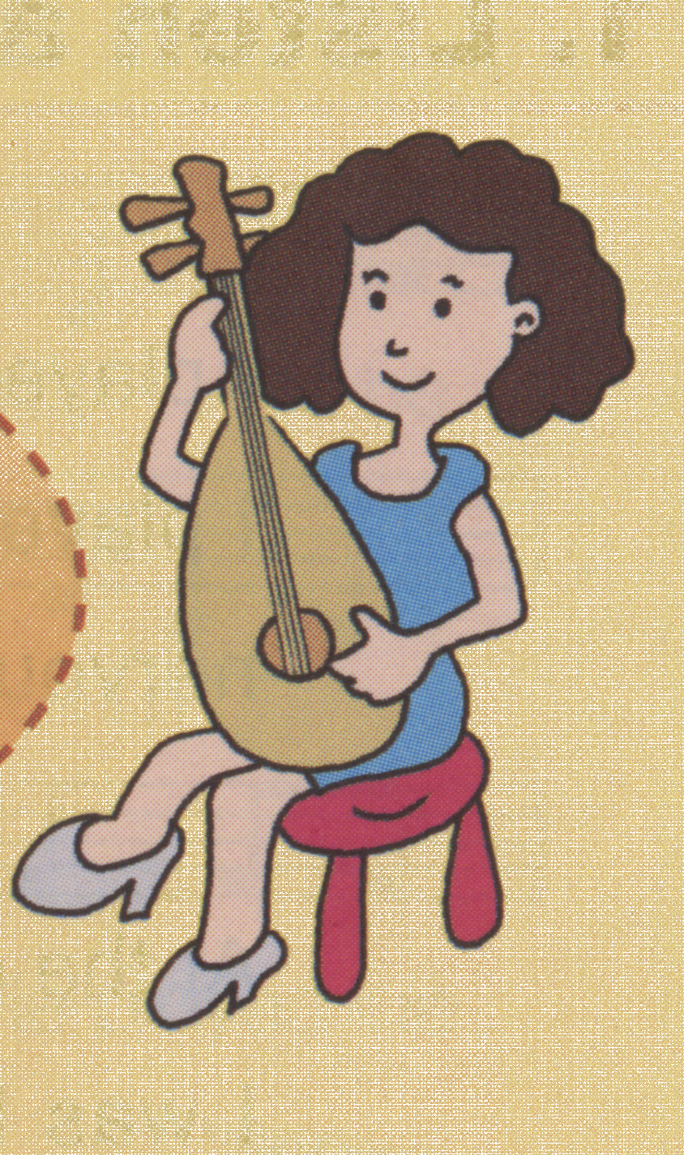

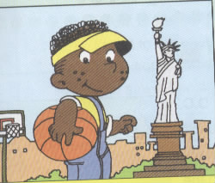
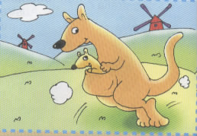
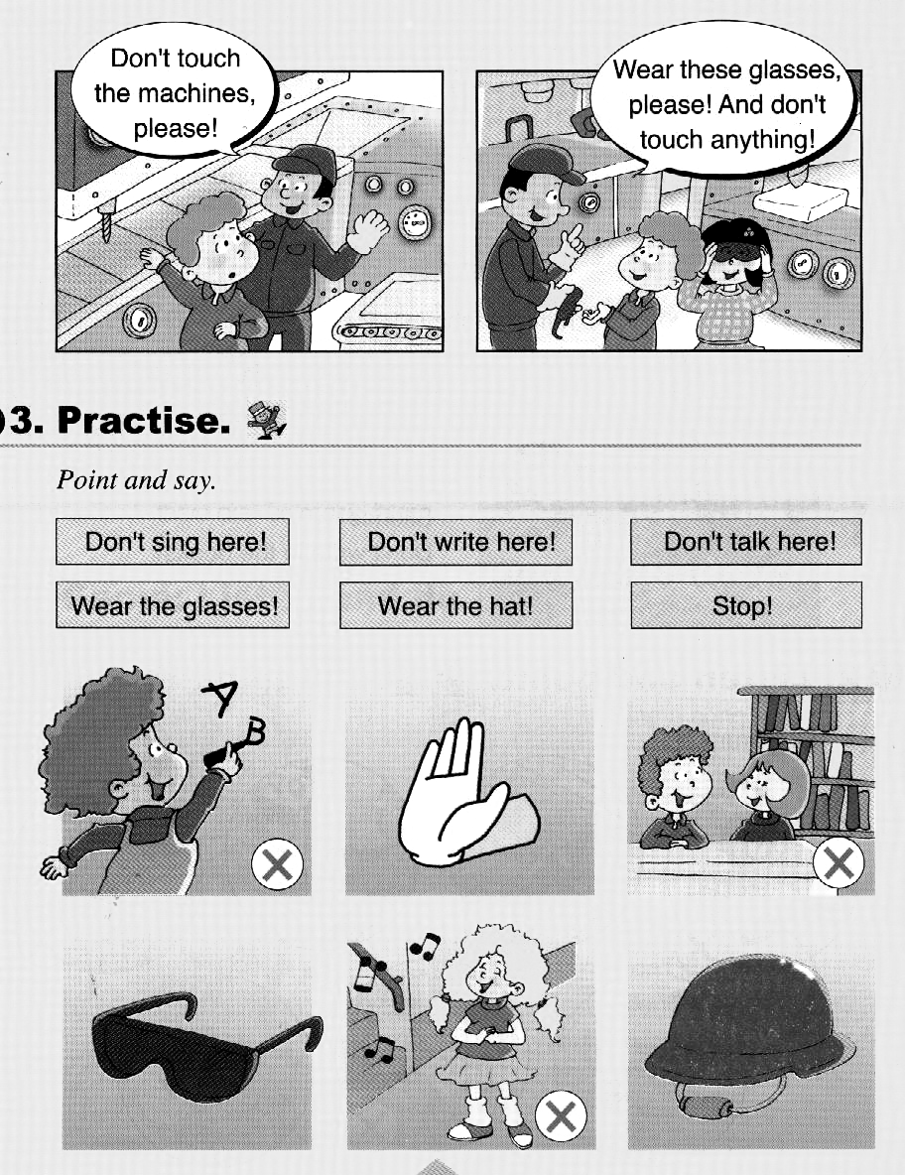

( ) ( ) ( ) ( ) ( )
Ⅲ. 听音选句。把正确的选项填在前面的括号内。（每题2分，共10分）
( )1. A. Don’t walk on the grass! B. Don’t write on the books!
( )2. A. He’s drawing books and birds. B. He’s making a card for his father.
( )3. A. Let’s make an English newspaper! B. Let’s have fun this Saturday!
( )4. A. It’s in the south of China. B. It’s in the north of China.
( )5. A. I’m going to go back to the UK. B. I’m going to go back to the US.
Ⅳ. 听短文判断正误。正确的写T, 错误的写F。（每题2分，共10分）
( )1. The postcard is from Daming.
( )2. Kangaroos are Lingling’s favourite animals.
( )3. Kangaroos jump on their right legs.
( )4. Lingling is going to eat in an American restaurant.
( )5. We can see kangaroos in zoos in China.
笔试部分（共六大题，60分）
Ⅴ.单项填空。（每题1分，共10分）
( )1. A: Where did you go yesterday? B: I ______ to a shop.
A. go B. went C. goes
( )2. This pen _______ one hundred and eighteen yuan.
A. cost B. costs C. costing
( )3. ______ the end, everyone clapped. I _______happy.
A. In , am B. on ,were C. In , was
( )4. A: What’s __________now? B: Tom is singing.
A. happen B. happened C. happening
( )5. Pipa looks______ a guitar.
A. after B. at C. like
( )6. I’m good at English. I’ll _________ the reports.
A. writing B. write C. writes
( )7. It’s 6:30 ______ now. It’s breakfast time.
A. ap B. am C. pm
( )8. He lives ________ the east of the US.
A. in B. to C. into
( )9. A: Why do you love koalas? B: ________ they are very cute.
A. Because B. So C. And
( )10. A: Let’s make an English newspaper!
B: _________.
A. Thank you. B. That’s a great idea! C. Yes, please.
Ⅵ. 根据所给语境，补全句子。（共15分）
A. 根据汉语提示，结合语境，填入所缺单词。（每题2分，共10分）
1. Look! This machine cuts the ___________（土豆）.
2. Then the boy jumped in the river and_________(喊) , “ Help , help! ”
3. I’m a good boy. My parents are very ____________(自豪的) of me.
4. Let’s _________（与……见面）at 10 o’clock in the park.
5. I like _____________（澳大利亚的）food and animals.
B. 根据语境，选择恰当的单词, 将其序号填写在横线上。（每题1分，共5分）
A. playing B. surprise C. singing D. clapping E. having

It’s Mother’s Day today. We’re _______ a party now. Tom is _______ a song. Amy is _________ the violin. It’s a _________ party for our mothers. They are very happy. Now they are __________.
Ⅶ. 情景反应。（每题2分，共10分）
( )1. Who played in the concert? A. Yes, it was.
( )2. Was it Chinese music? B. I’ll go to Beijing.
( )3. Does he live in New York? C. I’m listening to music.
( )4. Where will you go this summer? D. My mother.
( )5. What are you doing? E. Yes, he does.
Ⅷ. 情景交际。选择答案的序号填写在空格处。(每题2分，共10分)
A: Look. This country is the US. He lives in the east of the US.
B:
A: No, he doesn’t. Los Angeles is in the west of the US.
B: Does he live in New York?
A. I want to go to the US one day.
B. My cousin Simon lives there.
C. Does he live in Los Angeles?
D. Yes, maybe.
E. New York is in the east of the US.

A: Yes, he does.
B: Maybe you can visit your cousin.
A:
Ⅸ. 短文阅读,判断正(T)误(F)。（每题2分，共10分）
Once upon a time, there was a little Chinese boy. His name was Kong Rong. There were many people in his family. One day, his father came home. He had a big bag. There were lots of pears in the bag. Everyone wanted（想要） to eat the pears. His father said, " Kong Rong, give(给) a pear to each person(每个人)." Kong Rong gave the very big pears to his grandpa and grandma. Then he gave the big pears to his father and mother. Kong Rong gave other pears to his brothers. They ate the pears. Then he saw one very small pear. "This pear is for me. I will eat it."he said. All his family were very happy with Kong Rong. His father said,” You are a very good boy.”

( )1. Kong Rong was a Chinese boy.
( )2. There were lots of apples in the bag.
( )3. Everyone liked the pears.
( )4. Kong Rong gave big pears to his parents.
( )5. Kong Rong ate the very big pear.
Ⅹ.想一想，写一写。(共5分）
暑假将至，假如你是Sam，请给你的朋友Lucy写一个明信片，介绍你的暑假计划。
提示词：the US / the UK / Shanghai/ Dalian / Beijing…
send you a postcard / go swimming / read books/ listen to music /see kangaroos/ fly a kite…

Dear Lucy,
This summer, I will go to______________. I’ll ___________________. ______________________________.
I’ll be happy.
Love,
Sam
四年级英语听力题签
注意：每道听力试题读两遍，听力时间控制在15分钟内。
Ⅰ. 听音选词。请选出你所听到的单词。
1. There was a boy. He looked after sheep.
2. Look. This country is the US.
3. East and west, home is the best.
4. Last month, she went into a shop.
5. I haven’t got any plan now.
Ⅱ. 听音标号。用数字标出图片的先后顺序。
1. This camera is expensive.
2. Don’t write here!
3. The mother kangaroo has a special bag for her baby.
4. Mum played the pipa in the concert.
5. He lives in the east of the US.
Ⅲ. 听音选句。把正确的选项填在前面的括号内。
1. Don’t walk on the grass.
2. He’s drawing books and birds.
3. Let’s have fun this Saturday!
4. It’s in the north of China.
5. I’m going to go back to the UK.
Ⅳ. 听短文，判断正误。正确的写T, 错误的写F。
Dear Daming,
Tomorrow I ’m going to go to Australia. I will see kangaroos there. Kangaroos are my favourite animals. They are cute. They jump on their back legs .The mother kangaroo has a special bag for her baby. Kangaroos drink water and eat leaves. You can also see kangaroos in zoos in China. I’m going to eat in an Australian restaurant. I’ll be happy.
Have a good time.
From,
Lingling

听力部分到此结束！

四年级英语参考答案及评分标准

听力部分
Ⅰ. (2×5＝10分) BABBA
Ⅱ. (2×5＝10分) 4—-2—-1---5---3
Ⅲ. (2×5＝10分) AABBA
Ⅳ. (2×5＝10分) F T F F T

笔试部分
Ⅴ. (1×10＝10分) BBCCC BBAAB
Ⅵ. A组(2×5＝10分)：1.potatoes 2. shouted 3.proud 4.meet 5. Australian
(请注意画线黑体部分，如果没有形式的变化将扣1分，其他单词完全准确方可得2分。）
B组(1×5＝5分)：1. E 2. C 3. A 4. B 5. D
Ⅶ. (2×5＝10分) D A E B C
Ⅷ. (2×5＝10分) B C E A D
Ⅸ. (2×5＝10分) T F T T F
Ⅹ. (5分) 作文内容请评卷教师自行把握
（请注意第一个空1分，第二个空2分，第三个空2分）

备注：卷面满分为100分。（听力40分，笔试60分。）
优秀：90---100
良好：80---89
及格：60---79
不及格：0---59

2015年 7月 8 日

