长海县2014—2015学年度第二学期期中质量检测试卷
小学四年级 英语 完成时间：60分钟
题  号 | 听力部分 |  |  |  | 笔试部分 |  |  |  |  |  | 总分
题  号 | Ⅰ | Ⅱ | Ⅲ | Ⅳ | Ⅴ | Ⅵ | Ⅶ | Ⅷ | Ⅸ | Ⅹ
得
分

听力部分（共四大题，40分）
Ⅰ. 听音选词。请选出你所听到的单词。（每题2分，共10分）
( )1. A. glass B. grass C. game
( )2. A. proud B. please C. present
( )3. A. cheese B. cost C. cheap
( )4. A. special B. sheep C. surprise
( )5. A. before B. bored C. bought
Ⅱ. 听音标号。用数字标出图片的先后顺序。（每题2分，共10分）
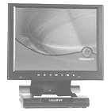
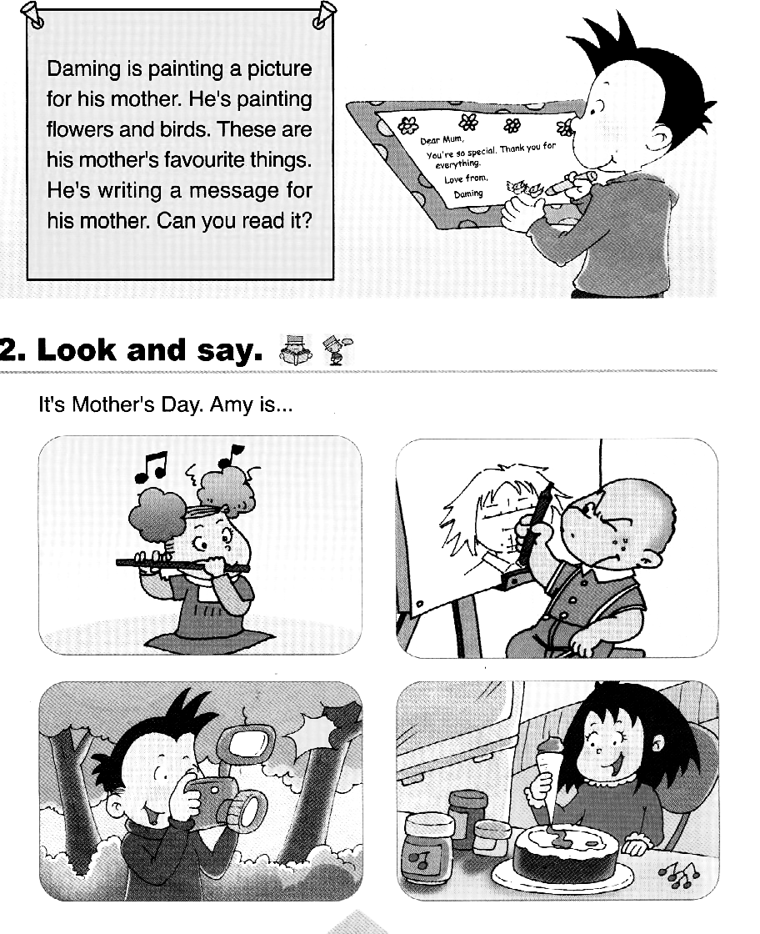
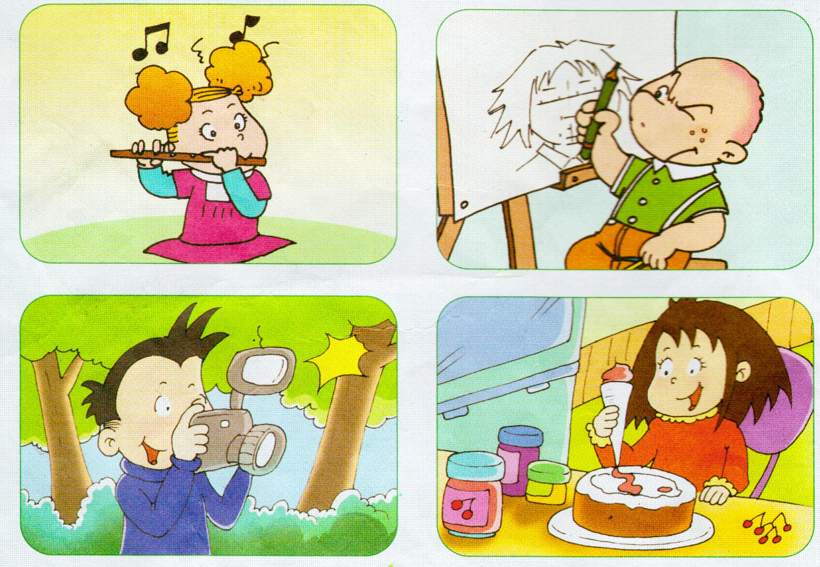
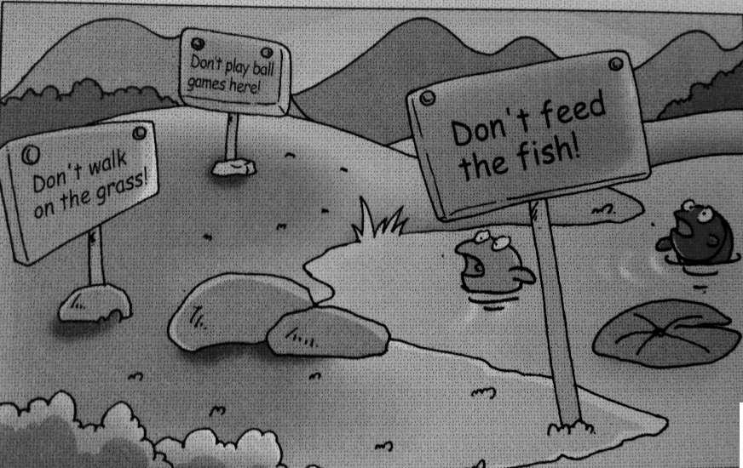
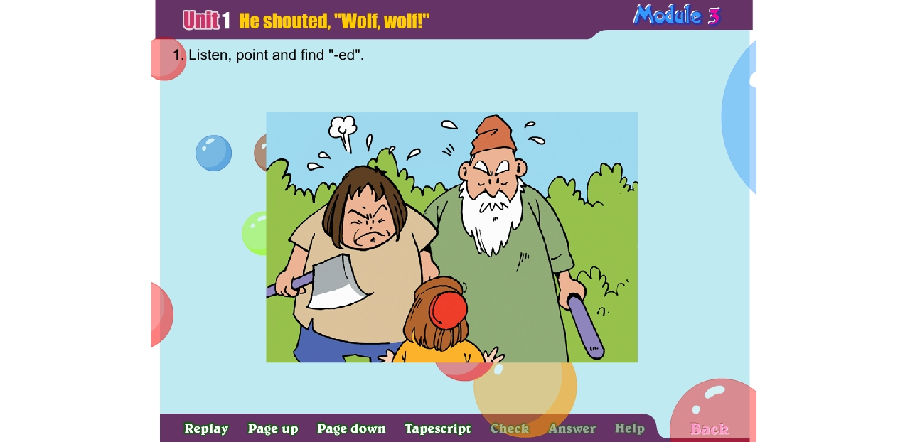

( ) ( ) ( ) ( ) ( )
Ⅲ. 听音选句。把正确的选项填在前面的括号内。（每题2分，共10分）
( )1. A. The pen costs 118 yuan. B. The pen costs 18 yuan.
( )2. A. The boy ran to the village. B. The people ran up the hill.
( )3. A. Lily saw a snake. She was scared. B. Lily saw a cat. She was scared.
( )4. A. What’s happening now? B. What are you doing now?
( )5. A. He’s making a card. B. He’s writing a message.
Ⅳ. 听对话，判断正误。正确的写T, 错误的写F。（每题2分，共10分）
( ) 1. They are having a picnic.
( ) 2. Tom is playing the piano.
( ) 3. Sam is playing the violin now.
( ) 4. Today is Lingling’s mother’s birthday.
( ) 5. It’s a surprise party for Lingling’s mother and Ms Smart.
笔试部分（共六大题，60分）
Ⅴ.单项填空。（每题1分，共10分）
( )1. Sam and Amy __________ listening to music in the room.
A. is B. are C. can
( )2. Don’t __________ball games here ! It’s dangerous.
A. plays B. playing C. play
( )3. Look! The boys are laughing and _______________.
A. claping B. clap C. clapping
( )4. A: _______ did you go yesterday? B: I went to a shop.
A. When B. Where C. What
( )5. Mr Li is playing _______ guitar.
A. a B. / C. the
( )6. My mother ______ a present for me last Sunday.
A. buy B. bought C. give
( )7. A: What does this machine do? B: It ________ the potatoes.
A. wash B. washes C. washing
( )8. The wolf didn’t _____ up the hill.
A. come B. went C. came
( )9. I _______ got a new computer. It’s helpful.
A. have B. has C. had
( )10. A: It’s Father’s Day today. Happy Father’s Day!
B: ________.
A. That’s great B. Thank you C. OK
Ⅵ. 根据所给语境，补全句子。（共15分）
A. 根据汉语提示，结合语境，填入所缺单词。（每题2分，共10分）
1. ___________ (欢迎) to Changhai. It’s very beautiful.
2. This machine __________ (放置) the crisps in the bags.
3. I will send an ________ （电子邮件）to you.
4. There are twelve _________ (月份) in a year.
5. A: Can you ______(听见) the music? B: Aah! It’s great.
B. 根据语境，选择恰当的单词, 将其序号填写在横线上。（每题1分，共5分）
A. end B. before C. concert D. proud E. clapped

I played in a __________ last year. I played the piano. I was very
nervous _________ the concert. In the _______, everyone ________.
I was happy. And I was very __________.
Ⅶ. 情景反应。（每题2分，共10分）
( )1. Is it expensive? A. Yes, please.
( )2. Where did you go yesterday? B. She’s dancing.
( )3. What’s happening now? C. Last year.
( )4. Do you want to listen to Chinese music? D. No, it’s cheap.
( )5. When did you go there? E. I went to the park.
Ⅷ. 情景交际。选择答案的序号填写在空格处。(每题2分，共10分)
Lingling: I went to a concert yesterday.
A. Dad played the erhu.
B. Was it Chinese music?
C. It looks like a violin.
D. My mum and dad played
in the concert.
E. It looks like a guitar.
Amy: ______________________
Linging: Yes, it was. ____________
Amy: What did they play?
Lingling: _____________________
Amy: What’s an erhu?
Linging: _____________________
And Mum played the pipa.
Amy: ____________________
Ⅸ. 短文阅读,判断正(T)误(F)。（每题2分，共10分）
It’s seven o’clock. The Whites are at home. Mr White is sitting on a sofa. He is reading a newspaper. Mrs White is sitting at the desk. She is writing a letter. Tom is ten. He is in the garden(花园). He’s playing with his cat. Its name is Mimi. It’s a lovely cat. Kitty is four. She is playing with her toys on the floor.
( )1. The Whites are at home at eleven o’clock.
( )2. Mr White is reading a book.
( )3. Tom is playing with his cat in the garden..
( )4. Tom’s mother is writing a letter.
( )5. Tom’s sister is ten years old.
Ⅹ.想一想，写一写。(共5分）
There was a boy. He _______ ________sheep. One day, he ran to the village and _______ “Wolf, wolf!” But there was no wolf. The wolf came and ate all the sheep at last. The boy learnt a ________and wouldn’t tell _______again.

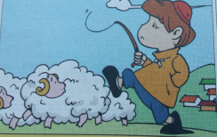


四年级英语听力题签
注意：每道听力试题读二遍，听力时间控制在15分钟内。
Ⅰ. 听音选词。请选出你所听到的单词。
1. Don’t walk on the grass!
2. Happy Mother’s Day! A present for you.
3. This pen is one yuan. It’s cheap.
4. You’re so special. Thank you for everything.
5. The boy looked after sheep. He was bored.
Ⅱ. 听音标号。用数字标出图片的先后顺序。
1. My father bought me a computer. It’s beautiful.
2. Don’t feed the fish!
3. The people ran up the hill. There was no wolf.
4. She played the flute yesterday.
5. He is drawing a picture.
Ⅲ. 听音选句。把正确的选项填在前面的括号内。
1. The pen costs 118 yuan.
2. The boy ran to the village.
3. Lily saw a cat. She was scared.
4. What’s happening now?
5. He’s writing a message.
Ⅳ. 听对话，判断正误。正确的写T, 错误的写F。
Daming: Hi, Lingling! What are you doing?
Lingling: Hi, Daming. We’re having a party now. Amy is playing the piano.
Daming: What’s happening now?
Lingling: Oh, Tom is singing. Can you hear?
Daming: Yes.
Lingling: And now Sam is playing the violin.
Daming: I can hear the violin. Is it your mum’s birthday?
Lingling: No, it’s Mother’s Day today. It’s a surprise party for Ms Smart and my mother.
Daming: You are great!

听力部分到此结束！

四年级英语参考答案及评分标准
听力部分
Ⅰ. (2×5＝10分) BCCAB
Ⅱ. (2×5＝10分) 2—-5—-3---1---4
Ⅲ. (2×5＝10分) AABAB
Ⅳ. (2×5＝10分) F F T F T
笔试部分
Ⅴ. (1×10＝10分) BCCBC BBAAB
Ⅵ. A组(2×5＝10分)：1.Welcome 2. puts 3.email 4.months 5. hear
(请注意画线黑体部分，如果没有形式的变化将扣1分，其他单词完全准确方可得2分。）
B组(1×5＝5分)：1. C 2. B 3. A 4. E 5. D
Ⅶ. (2×5＝10分) DEBAC
Ⅷ. (2×5＝10分) BDACE
Ⅸ. (2×5＝10分) F F T T F
Ⅹ. (5分) looked after(2分), shouted (1分), lesson(1分), lies(1分)

备注：卷面满分为100分。（听力40分，笔试60分。）
优秀：90---100
良好：80---89
及格：60---79
不及格：0---59

2015年 5月 4 日

