新标准英语一起十一册
Module4 Unit1 Thanksgiving is very important in the US.
大长山中心小学 傅海华
〔语言功能〕介绍节日
〔语言结构〕一般现在时
〔教学目标〕
1. 语言知识目标：全体学生能运用“Thanksgiving is very important in the US.”，全体学生能理解“Thanksgiving, nearly”，全体学生能运用“nearly”， 部分学生能运用“Thanksgiving”。
2. 语言技能目标：能够听懂、会说并认读本单元句型，能运用所学语言介绍中外节日。
3. 情感态度目标：乐于了解外国节日，接触外国文化，拓宽国际视野。
〔教学重、难点〕
重点: 单词nearly；
功能句 What do you do on Thanksgiving?
We always have a big, special dinner.
We say thank you for our food, family and friends.
难点：能运用一般现在时描述中西方节日的主要特征。
〔学生分析〕
本课以节日为话题，贴近学生实际生活，激发了学习兴趣。学生学习过儿童节，万圣节，复活节等节日，并掌握一般现在时的语言结构，这样能够使学生积极参与活动，从而能介绍自己喜欢的节日。
〔教学准备〕
单词卡片，PPT课件， task paper，点读笔
〔教学过程〕
Step 1、Warm up and lead in
1. Greetings.
2. Warmer: Free talk
T：Today I take some pictures of festivals. Let’s look what are they? (Show pictures about the Spring Festival , the Lantern Festival, the Dragon Boat Festival, the Mid-Autumn Festival )
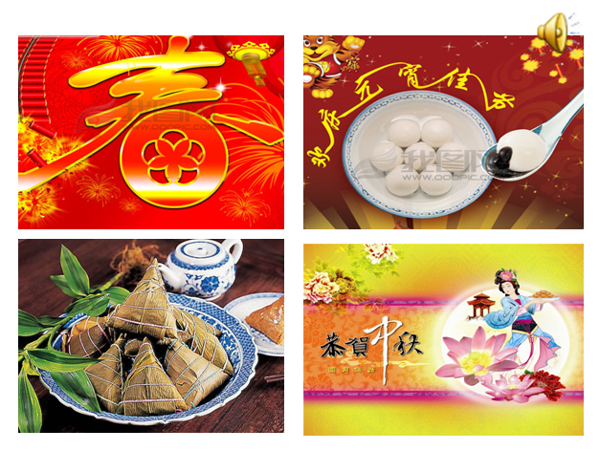
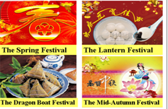
T: What do you eat at these festivals? What do you do?

Step 2、Task presentation
1. Free talk
T: My favourite festival is the Spring Festival. What’s your favourite festival?
S: My favourite festival is ……
2. Lead in （课文活动1）
T: Our friends are talking about the festivals, too.
(1) Listen and answer: What’s their favourite festival?
Ss: National Day, Thanksgiving, Halloween, Children’s Day.（教授单词Thanks+giving= Thanksgiving）
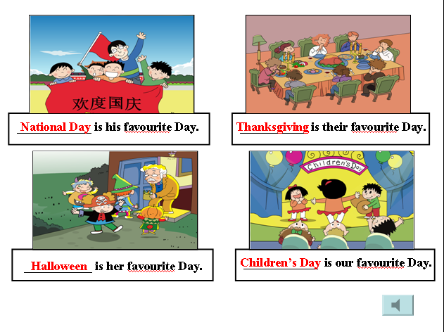

(2) Listen and repeat.
(3) Today let’s learn an important festival in the US and try to describe the other festivals we like.
Step 3、Text learning
1. Watch the CD-ROM and choose: What is Simon’s favourite festival?
A. New Year B. Christmas C. Thanksgiving
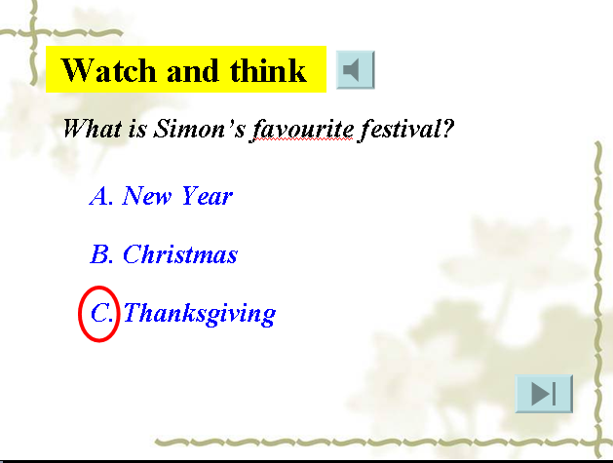

(1) The Ss watch and choose the answer.
(2) Show the video about “ Thanksgiving”
T: Do you know Thanksgiving? Let’s watch a video and learn more.（了解感恩节，文化渗透）
T: When is it? Ss: It’s in November.
2. Listen part2 and answer: What do you do on Thanksgiving, Simon?
Ss: We always have a big, special dinner.
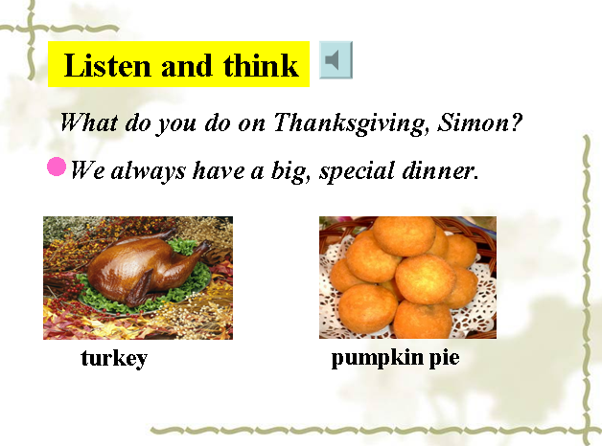
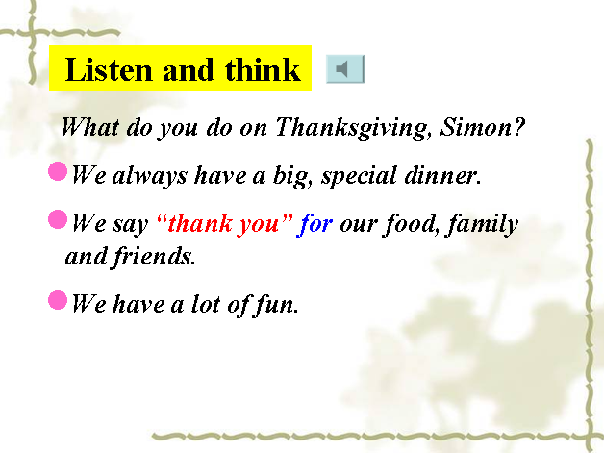
We say thank you for our food, family and friends.
T: Is Thanksgiving very important in the US?
S: Yes. Thanksgiving is very important in the US. （板题）
3. Teach the new word “nearly” (Lead in the poem)
T: Simon wrote a poem about Thanksgiving. Do you want to hear it?
Ss: Yes, please.
(1) Listen part3 and teach nearly (ear, hear, dear, clear).
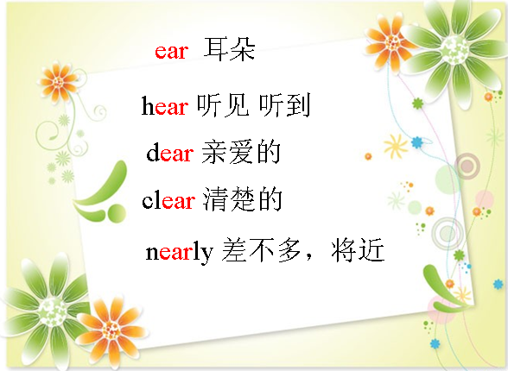

(2) Let’s write a poem: ________ is nearly here.
T: Can you make a poem, too?（引导学生运用nearly说更多的节日，如Easter, Mother’s Day, National Day, my birthday.）
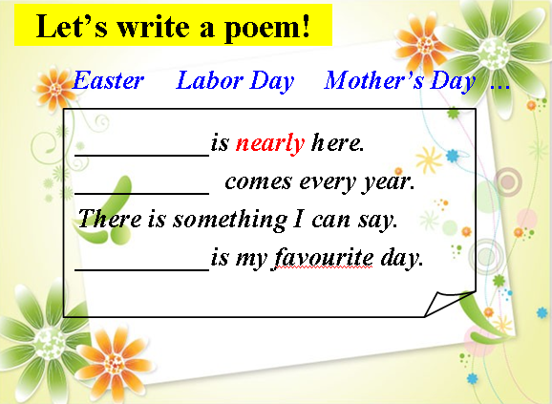

4. Listen and repeat. Then act out.
5. Read and finish the dialogue.
Step 4、Practice
- Play a guessing game: The luck lable.
T: I’ve got some colorful paper about Thanksgiving. You can choose one and guess the information.

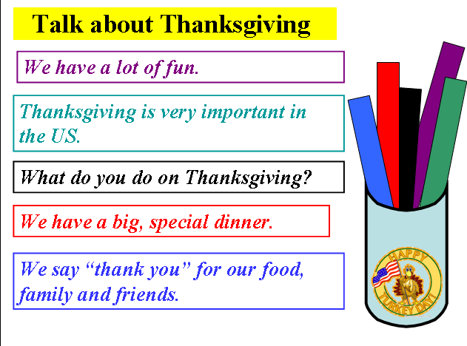

2. Retell or introduce Thanksgiving.
T: Who can say more about Thanksgiving. Maybe you can use these words.
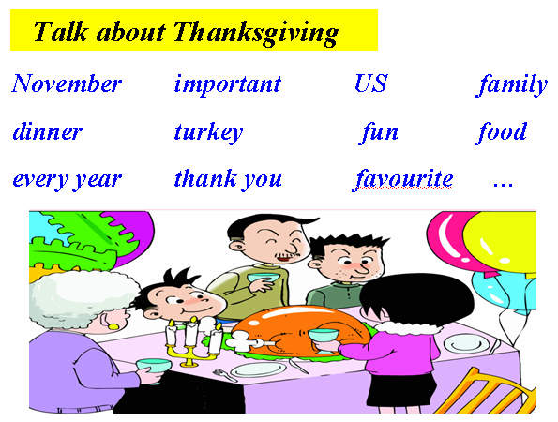

T: We can have Thanksgiving in China. We can say thank you for parents, teachers and classmates. We can say thank you for all good things.
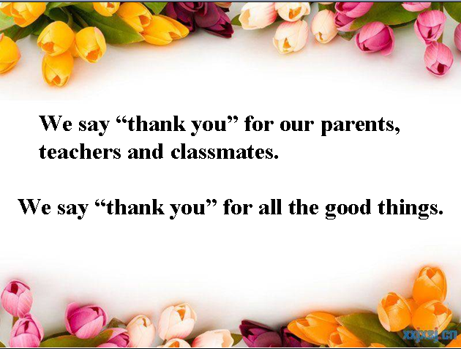

Step 5、Task completion
1. Talk show: talk about festivals you like. （学会介绍节日的方法）
Tips: What is it? When is it?
What do you do? What do you eat?
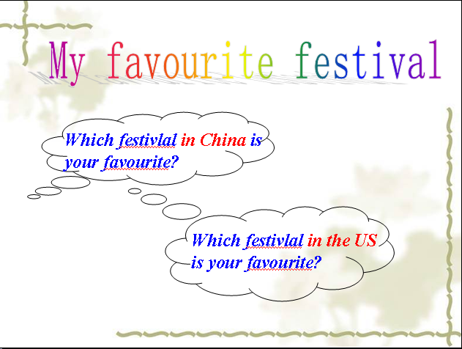

- Writing: My favourite festival. (Then choose the students to read. Then talk about in groups.)
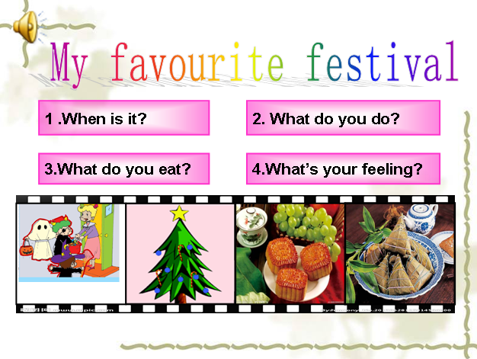

Step 6、Summary and homework
1. Sum up: What have we learnt today?
T: We know an important festival in the US——Thanksgiving and we can describe our favourite festival.
2. Homework:
A: Listen and read the text; Write the words and sentences.
B: Talk about your favourite festival with your friends.
〔板书设计〕 Module4 Unit1
Thanksgiving is very important in the US.
When in November
What have a big, special dinner
say thank you for
How have a lot of fun

