Book7 Module9 Unit1 What happened to your head?教学设计
海洋岛学校 刘建丽
一、教材分析
本课为新标准英语（一年级起始用）第七册第九模块第一单元，本单元教学主题为What happened to you? 本节课学生将学习用“What happened to you?”来提问来询问别人发生了什么事情，并能根据一定的场景来回答，摔倒，受伤，摔下来等并学习短语a bike ride, 和thirsty, watermelon, carried这几个单词。
二、学生分析
学生通过前几模块的学习，已经初步掌握了过去时态的用法，并了解了动词过去时的规则变化，能进行一般的问答。本模块是对过去时态的巩固延伸，接触动词过去式的不规则变化，并学会用其描述过去发生的事故。
三、教学目标
（一）语言知识目标：在口语操练中复习和巩固已学的词汇和句型；掌握新单词thirsty，carried，watermelon以及短语a bike ride.同时要求掌握句型What happened to …?以及了解fall off, fall over的区别。
(二 ) 语言技能目标：向他人说明描述过去发生的意外事故，培养学生的发散思维能力、分析、迁移等综合运用英语的能力。
（三）情感态度目标：激发学生学习语言的兴趣，培养合作意识与创新精神。教育学生能够正确对待和处理日常生活中发生的事故,对学生进行安全教育，培养学生的安全意识
四、教学重点、难点
（1）能听懂会说 what happened to you?听懂会说happen,carried, ride, thirsty, watermelon,对句型What happened to you?的掌握以及在生活场景中的运用。
（2）教学难点是区分单词：fall over和fall off.
五、教具准备
单词卡片、水果图片、教学课件
六、教学过程
Ⅰ、Warm up.
1. Greetings.
2. Do a chant《Five little monkeys》
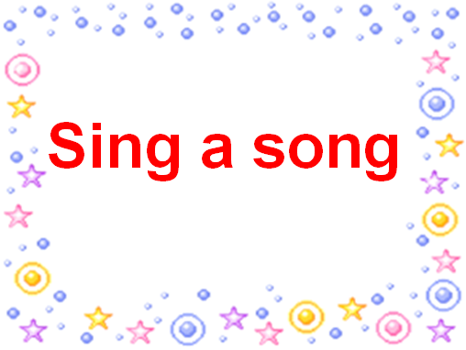
1) T: You did a good job. Today we are going to have five groups. I will give a nice name.(依次出示 apple, orange ,kiwi, banana, watermelon的图片， 同时教授新单词watermelon)
2）T: Look ,there is a bear, what happened to the bear? Let’s listen and find the answer. (教授fall off 、fall over 以及过去式)
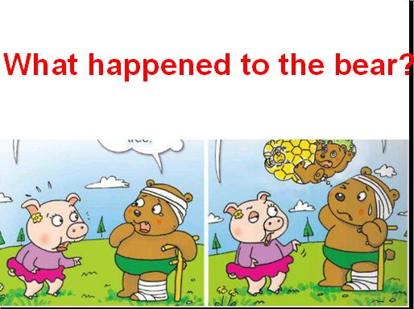
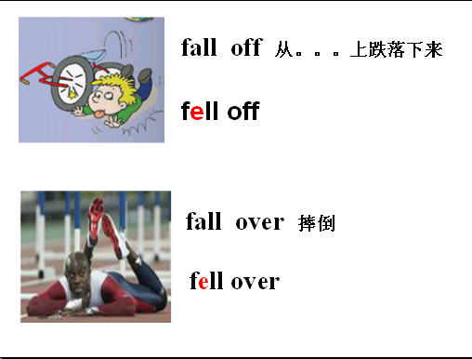
Ⅱ、Presentation.
每个人都曾经受过伤，那我们今天就来看看受伤时用英语怎么说吧。
Ⅲ、 Text
1、T: What happened to Daming? Do you know? Let’s answer the question What did Sam and Daming do yesterday? First,listen.
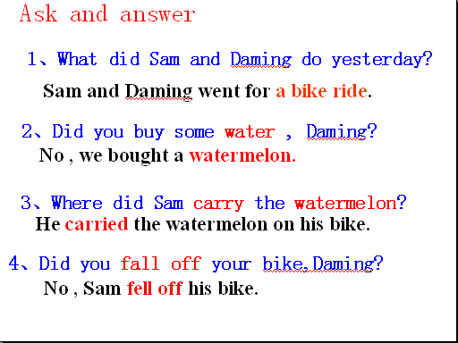
2、Daming and Sam went for a bike ride. (教授bike ride). They were hungry and thirsty？ Did you buy some water ，Daming? Open your books and answer the questions,underline the question.

3、Daming and Sam bought a watermelon. Where did Sam carry the watermelon? Did you fall off your bike, Daming? Let’s find the answer.
4、Daming and Sam went for a bike ride yesterday,they were hungry and thirsty. They bought a watermelon, Sam carried the watermelon on his bike. But he fell off the bike. Ok ,this time listen again and act out the passage.
Ⅳ.Practise
- T: Now boys and girls, close your books. And try to complete the story.
一、选择正确的图片。
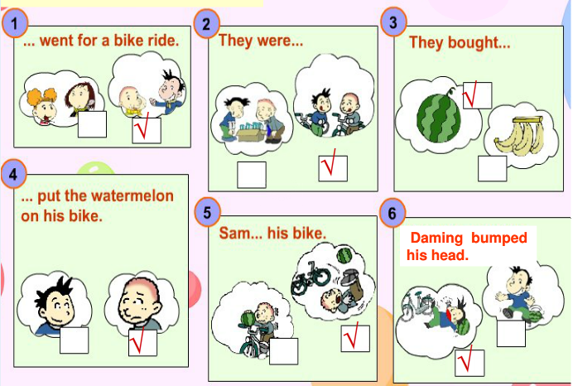

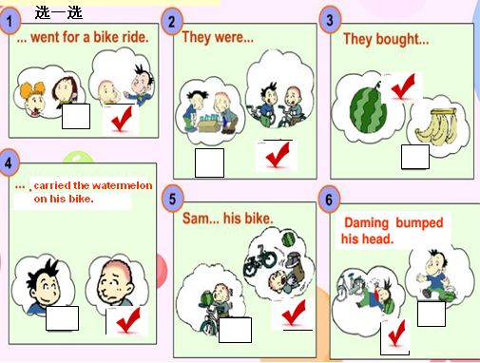
二、填上适当的单词。
a bike ride on thirsty hungry carried watermelon
Daming and Sam went for_________
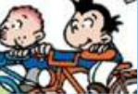
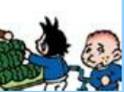

They were ________ and _______.
So they bought a _________.
Sam _________the watermelon __________ his bike.
(学生独立完成后，集体订正答案，用齐读的方式复述故事以巩固文本内容。)

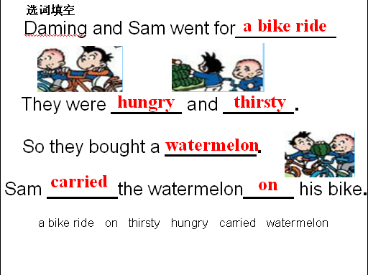
Ⅴ、Completion
T: Look, there are some pictures here .What happened to her/him?
图片：She fell over.
分小组练习说图片。(图片的数量可以根据教学实情况进行调整，尽可能多展示几幅让学生有选择的余地，也给学生多一些练习的机会。)
T: 同学们，在我们的日常生活中，经常会遇到一些小意外。请回忆一下你的经历中都发生了哪些小意外,小组内进行交流。
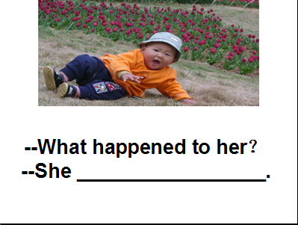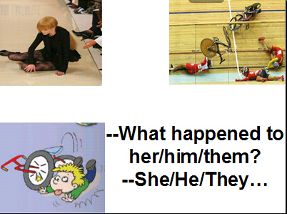
Ⅵ、Summary and homework:
1. Listen and retell the story.
2. Try to tell an accident about yourself for your classmates.
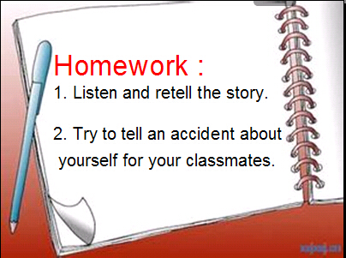
Ⅶ、板书设计
Module9 Unit 1 What happened to your head?
1、--Did you buy some water?
--No, we bought a watermelon.
2、--Did you fall off your bike?
-- No, Sam fell off his bike.

