小学四年级 英语 检测时间：60分钟
题  号 | 听力部分 |  |  |  |  | 笔试部分 |  |  |  |  |  | 总分
题  号 | Ⅰ | Ⅱ | Ⅲ | Ⅳ | Ⅴ |  | Ⅵ | Ⅶ | Ⅷ | Ⅸ | Ⅹ | 总分
得
分
听力部分
Ⅰ.听音选词。选出你所听到的单词（每题1分，共5分）
（ ）1. A. key B. knee C.fell
（ ）2. A. watch B. wash C. what
（ ）3. A. before B. beside C.beween
（ ）4. A. matter B. mountain C. medicine
（ ）5. A.paint B. pringting C. practise
Ⅱ.听音标号。用数字在括号内标出图片的先后顺序。（每题2分，共10分）
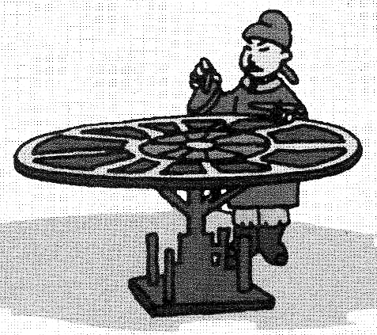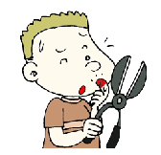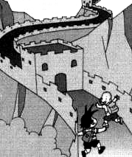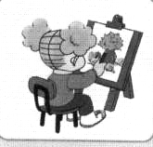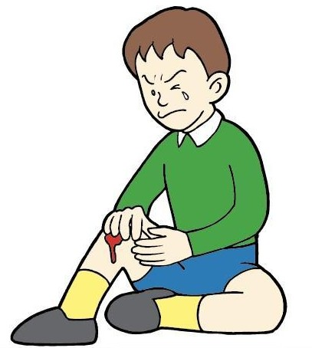
( ) ( ) ( ) ( ) ( )
Ⅲ.听音，选出你所听到的句子。（每题2分，10分）
（ ）1、 A. I cleaned my room. B. I finished my homework.
（ ）2、 A. She usually walks to school. B. She didn’t walk to school.
（ ）3、 A. Where did you go? B. When did you do?
（ ）4、 A. Did you go to the Great Wall? B. Did you see my black bike?
（ ）5、 A. I bumped my head. B.I cut my finger.
Ⅳ.听一听，判断对错（T or F）。大明昨天都做了什么.（每题2分，共10分）
- （ ）Yesterday was Sunday.
- （ ）Daming didn’t go to school.
- （ ）He finished his homework.
- （ ）He cheaned his room.
- （ ）Daming was a good boy.
笔试部分
Ⅴ.单项填空。将正确答案的序号填写在前面的括号里。（每题1分，共10分）
（ ）1. _________ today? – I’m very well.
A.What’s this? B.Where do you live? C.How are you?
（ ）2.Chinese people invented _________.
A.print B.printing C.printed
（ ）3.Did you ______ the Great Wall?
A.see B.sees C.saw.
（ ）4. I usually ____ some cakes,but I ____ some fruit yesterday.
A.eat,eat B.eat,ate C.ate,eat
（ ）5. 4.She didn’t _____ at 6 yesterday?
A.get up B.gets up C.getting up
（ ）6. Maliang ____ a paintbrush.It was magic.
A.have B.has C.had
（ ）7. Come _____ , please！
A. in B. of C.at
（ ）8. Yesterday I _______ Grandma.
A. phone B. phoned C.phones
（ ）9.Drink ________ water or juice
A. a lot B. lots of C.a lots of
（ ）10. We were ______. So we bought a watermelon.
A. thirsty B. dirty C.angry
Ⅵ.词语运用。根据提示，用词汇的适当形式完成下列句子。（每题1分，共10分）
1. ___________（什么时候）did they come? – They came last week
2. We ________（穿）warm clothes yesterday.
3. I was ________ (在……之间) the two girls .
What happened to you?
I fell over/cut my finger.
4. The bad man was_________(生气的). He__________(带走)Ma Liang away.
5. My room were ________ （脏的）yesterday. I ________(打扫，清理) it.
6. He ______ ______ his bike and hurt his knee yesyerday.
7. Wash your hands __________ （在……之前）you eat.
Ⅶ.根据语境，选择恰当的单词填空。（共2大题，计10分）
invented healthy happened played hungry
1. We were and thirsty.
2. She the flute yesterday.
3. Chinese people paper.
4.What________to you?
5. Do you want to be _________?
Ⅷ 看问句，找出相对应的答句，将序号填入题前括号内。（每题2分，共10分）
( )1. Where does she live? A. I finished my homework.
( )2. What did you do yesterday? B. Yes, I did.
( )3. Where did you go? C. I hurt my knee.
( )4. Did you see my black bike? D. She lives in Dalian.
( )5.What happened to you? E. I went to London.
Ⅸ.情景交际。选择恰当答案的序号填写在横线上。(每题2分，共10分)
Amy:What did you do yeayerday, Daming?
A.What did you do there?
B.I felt(感觉) a litter tired.
C.Did you go with your parents?
D.It took us fifty minutes
E.I went on a trip to the Great Wall.
Daming:①_____________________
Amy:②._________________.
Daming:No,I didn’t.I went with my friend.
Amy: ③_________________.
Daming:We climbed to the top of the wall and saw a lot of mountains.
Amy:Did you go by bus?
Daming:Yes,we did.④._____________
Amy:Did you have a good time?
Daming:Yes,we did.⑤.___________.But I was very happy.
Ⅹ.阅读短文。将正确答案的序号填在括号内（每题2分，共10分）
Hello,I’m Lanlan.I went to the zoo with my parents last Sunday.There were lots of people in the zoo.I saw many animals there.They are pandas,lions,tigers,monkeys, and snakes…And I took many photos.
My parents bought me a hot dog for lunch.And I bought a toy panda for my friend,too.
( ) 1. Lanlan went to the zoo with her____. A. mother. B. father C.father and mother
( ) 2.There were lots of people _____. A. in the zoo. B. in the park. C.at school
( ) 3.They saw many _____. A. fruit B. food C.animal
( ) 4.____ bought a hot dog for Lanlan? A. parents B. mother. C. Lanlan.
( ) 5. Did the have a good time?
A. No,they didn’t. B. Yes,they did. C.Yes,they are.
Ⅺ.对于怎样保持身体健康，你有怎样的建议？让我们一起来写一写！（5分）
Do you want to be healthy?
- Eat some fruit and vegetables __________ day.
- Do some ____________.
- Drink lots of __________ or _________.
- 关于健康，你还有什么好的建议？
____________________________________
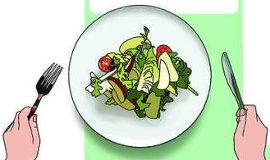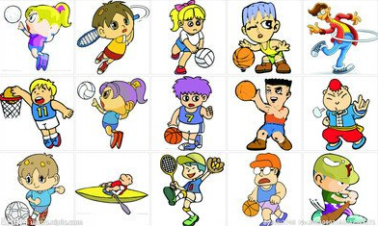
每一天
四年级英语听力题签
注意：每道听力试题读二遍，听力时间控制在20分钟内。
I、听音选词。选出你所听到的单词。
No.1 knee No. 2 wash No.3 beween No.4 matter No.5 practise
II、听音标号。用数字在括号内标出图片的先后顺序。。
1. I fell off my bike.I hurt my knee.
2. We went to the Great Wall.
3. Chinese people invented printing.
4. I cut my finger.
5. Amy painted a picture.
III、听音，选出你所听到的句子。
1. I finished my homework.
2. She usually walks to school.
3. Where did you go?
4. Did you see my black bike?
5. I bumped my head.
IV、Ⅳ.听一听，判断对错（T or F）。大明昨天都做了什么，，
Yesterday was Saturday.Daming didn’t go to school.He stayed at home.In the moring ,he He finished his homework.Then he washed his shoes.In the afternoon,he helped his mum and cooked noodles.His mum was very happy.”You are a good boy Daming!”.Daming was happy, too.

听力部分到此结束！

四年级英语参考答案及评分标准
Ⅰ. 听音选词。选出你所听到的单词。
1. B 2. B 3. C 4. A 5.C
Ⅱ. 听音标号。用数字在括号内标出图片的先后顺序。
3 4 2 5 1
Ⅲ. 听音，选出你所听到的句子。
1. B 2. A 3. A 4. B 5. A
Ⅳ. 听一听，判断对错（T or F）。大明昨天都做了什么
1. F 2. T 3.T 4. F 5.T
笔试部分
Ⅴ. 单项填空。将正确答案的序号填写在前面的括号里。
1. C 2. B 3.A 4. B 5. A 6. C 7. A 8.B 9. B 10. A
Ⅵ. 词语运用。根据提示，用词汇的适当形式完成下列句子。
- When 2. wore 3.between 4. angry , took 5.dirty,cleaned 6. fell off 7. before
(共10个词，画线黑体应注意：首字母大写“W” 是0.5分； 动词过去式如果没有变化，仍是动词原形，只能得0.5分)
Ⅶ. 根据语境，选择恰当的单词填空。
1. hungry 2. played 3. invented 4. happened 5. healthy
Ⅷ. A.看问句，找出相对应的答句，将序号填入题前括号内。
1. D 2. A 3.E 4.B 5.C
Ⅸ. 情景交际。选择恰当答案的序号填写在横线上。
E C A D B
Ⅹ. 阅读短文。将正确答案的序号填在括号内
1. C 2. A 3. C 4. A 5. B
Ⅺ.对于怎样保持身体健康，你有怎样的建议？让我们一起来写一写！（第4题2分）
1.every 2.exercise 3.water and juice 4.教师根据学生答案自行判断

