五年级英语测试卷

听力部分

听音，选出所听单词
1.A bench B both C benches
2.A.could B clean C.chocolate
3.Aheavy B. high C.Helloween
4.A.nothing B November C night
5.A sixty B seventy C start

二、听音，标号。
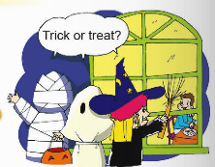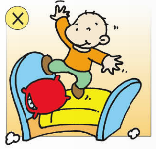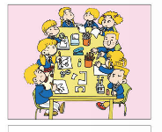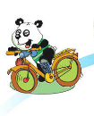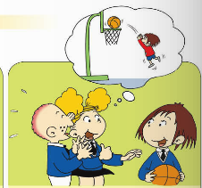
（ ） （ ） （ ） （ ） ( )

- 听音，根据问句选择正确的答句。
( ) 1、A、It’s in spring. B、It’s in autumn.
( ) 2、A、They wear scary clothes. B、They wear toys and flowers on the hats.
( ) 3、A、We are going to play with toys. B、They are going to play basketball.
( ) 4、A、It’s mine. B、It’s me.
( ) 5、A Yes, I do. B、Yes, I can.

- 听短文，选择
1. When is Amy going to have a party?
A. On Saturday B. On Sunday C. On Monday
2. What are they going to do together?
A. have lunch B. play football C. read books
3. What are they going to do after lunch?
A. sing and dance B. make a cake C. play with a toy
4. Who are going to make a cake for Amy?
A. Her father B. Her mother C. Her brother
5.What is Jack going to give Amy?
A. A cake B.A toy C.A gift

笔试部分
选择
1.There ______tall trees .
A. is B. are C. was
2. She was thirsty . She _____some water .
A. drink B. drank C. drinking
3. You ______listen in class .
A. should B. shouldn’t C. couldn’t
4. . Look . Tom is ______a mess .
A. make B. making C. makeing
5. We are going to _______.
A. having lunch B. took photos C. dance
6. There were _____apples on the tree .
A. some B. any C. an
7. I _____play football at all .
A. can B. can’t C. did
8. .Many ______go to the supermarket .
A. family B. families C. familys
9.He _____ to eat my apple .
A. is want B. want C. wants
10.She wants _____ my dress.
A. to wear B. wearing C. wear

二、根据语境提示，补全句子。
1.You can jump really _________.（高高地）So you can play basketball ___________.（好）
2.It’s raining . But the ______________（工人）are _______（还）working .
3.Today is ___________（万圣节）It’s in _______________ （十一月）.
4. Look！The girls are __________ (学习)English .I often ________（学习） English at ________.（晚上）
5. You were in China ________ （达）two years .

三、句子理解
(一)补全句子

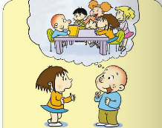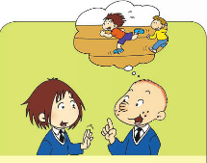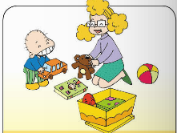
1.In the UK,they ______ _______ tables.
2.What are we going to do ?
We are going to ________ ________ .
3.Can you _______ _______ ?
No,I can’t .
4.He ______ forty _______ .
5.You should _______ your __________.

（二）情景反应
( ) 1.You shouldn’t play with the CDs!
( )2. What’s the matter?
( ) 3. Are you going to sing a song?
( ) 4. Whose bag is it?
( ) 5. Can you run fast ?
A、Yes, I am.
B、It’s mine.
C、Yes, I can.
D、Nothing.
E、I’m sorry.

四、根据情景，补全对话。
A. But it isn’t hers! B. It isn’t yours
C. . What’s the matter?
D. It isn’t his. E. They are wet.
Sam: It’s mine!
Amy: 1)__________,Sam. It’s mine!
Ms Smart: 2)___________
Amy: Sam wants to wear my T-shirt.
Sam: 3)________ It’s mine.
Amy: 4)_________ It’s mine!
Ms Smart: But both your red T-shirts are there.5) _______ Look!
Sam: Then Whose T-shirt is it?
Lingling: It’s mine . Look!
Sam and Amy: I’m sorry.
Lingling: That’s OK .

- 阅读
  - 阅读理解，判断正（T）误（F）。
Mrs White is from America. She works in a Chinese school. She has a lot of things(事情) to do next week. On Monday she is going to visit a school. On Tuesday afternoon she is going to the library. On Wednesday, after work she is going to see a film with her son, Tom. She is going to swim on Thursday. On Friday she is going to clean her house. Saturday is her birthday. She is going to have a birthday party with her family. On Sunday morning, she is going to the supermarket. She is going to buy lots of things(东西) for the family. What a busy( 繁忙的 ) woman !

( ) 1、Mrs White is a Chinese teacher.
( ) 2、She is going to swim on Friday.
( ) 3、She is going to have a birthday party On Saturday.
( ) 4、Tom is going to see a film on Wednesday.
( ) 5、She will be bored next week.
  - 选择
Pandas live in the mountains of Sichuan, Shanxi and Gansu in China. They’re fat. They are black and white. They are very cute. They’ve got two big eyes and a short tail. Pandas can climb and swim.They love bamboo. They start eating bamboo when(当…时候) they are about 6 months old. They eat for 12 hours a day. Now ,there are only about 1600 pandas in the wild(野外). Some of them are in danger(危险) of dying out(死亡). People are trying to save(挽救) them and protect(保护) them. We should plant many trees. Don’t cut trees. We should make friends with pandas. Don’t kill them. We should make the air clean. Don’t play with fire in the forest. Because we live in the same world with them. We’re family.

( ) 1、What can we do to help the pandas in danger?
A、kill the pandas B、plant many trees
C、make friends with them D、 B and C
( ) 2、Their favourite food is ______________.
A、rice B、bamboo C、chocolate D、coconut
( ) 3、How many pandas are there in the wild now ?
A、about 12 B、about 6 C、about 1600
( ) 4、Pandas are from _____________.
A、China B、America C、 Canada
( ) 5、What are pandas like ? Which one isn’t true?
A、black and white B、thin C、cute D、two big eyes and a short tail

- 写作园地
以“My Favourite Festival ”为题目写一篇作文。要求语句通顺，书写工整规范，不少于5句话。
My Favourite Festival
My favourite fesyival is

