长海县2014—2015学年度第一学期期末质量检测试卷
小学五年级 英 语 完成时间：80分钟
题  号 | 听力部分 |  |  |  | 笔试部分 |  |  |  |  |  | 总分
题  号 | Ⅰ | Ⅱ | Ⅲ | Ⅳ | Ⅴ | Ⅵ | Ⅶ | Ⅷ | Ⅸ | Ⅹ
得
分

听力部分（共四大题，35分）
Ⅰ.听音，找出句子中含有的单词，将序号写在前面的括号内。（每题2分，共10分）
( ) 1. A. sometime
( ) 2. A. night
( ) 3. A. blind
( ) 4. A. could
( ) 5. A. take down
B. sometimes
B. light
B. find
B. should
B. take away

C. somewhere
C. right
C. kind
C. would
C. tidy up


Ⅱ.听音，标号。用数字标出图片的先后顺序。（每题2分，共10分）
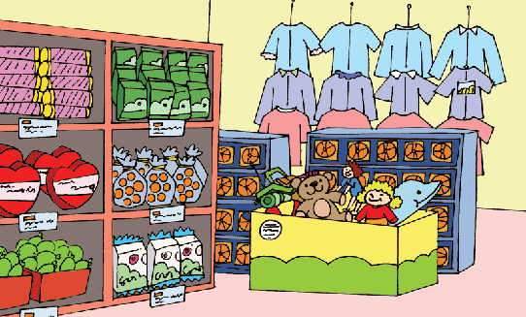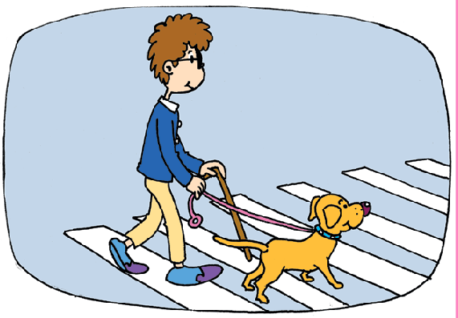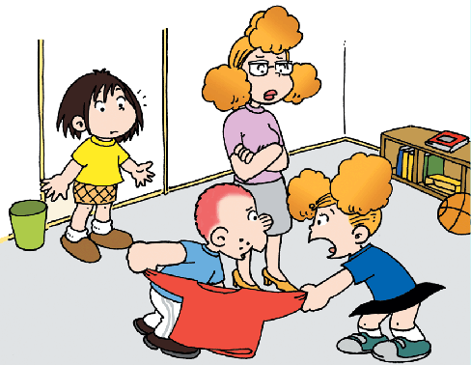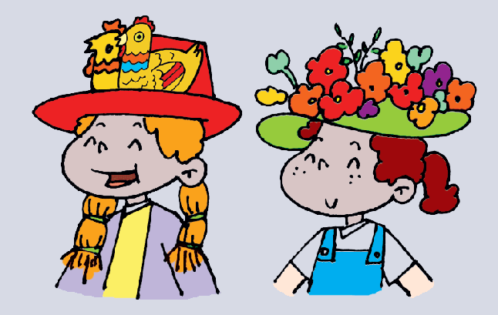
( ) ( ) ( ) ( ) ( )
Ⅲ.听音补全句子，在横线上填入所缺单词。（每题1分，共5分）
1. You shouldn’t be late. You should __________ hard.
2. I _________ I can do it well by myself.
3. _________ your books and listen to me carefully!
4. There are lots of games. The students can __________ at break time.
5. My grandparents have lived here ________sixty years.
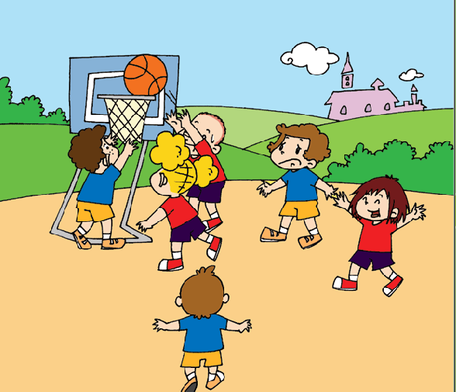
Ⅳ.听短文，判断正(T)误(F)。（每题2分，共10分）
( )1.Sam’s team played football in the park yesterday.
( )2. They got fifty points and the other team got thirty-six points.
( )3. Lingling got twelve points and Amy got seventeen points.
( )4.Their team won the match(比赛).
( )5. They were very sad.

笔试部分（共六大题，65分）
Ⅴ.单项选择。（每题1分，共10分）
( )1. There ______any benches here before, but there was a house then.
A. wasn’t B. weren’t C. didn’t
( )2. Many families _______ to the supermarkets together.
A. go B. going C. goes
( )3. ---Trick or treat? ---__________________ Here are your sweets.
A. Happy birthday! B. Happy Children’s Day! C. Happy Halloween!
（ ）4. ---What are you going to do tomorrow? --I’m going to _____.I want a new pen.
A. go swimming B. go shopping C. tell stories
( )5. ---Hi, Sam ! This bag is mine and ______is over there. ---Thank you, Tom!
A. your B. yours C. you
（ ）6. --- Can you play basketball? ---Yes, I can . But I can’t play _____.
A. fast B. high C. well
（ ）7. Because there was a fire .The firefighters ________ see the people.
A. couldn’t B. shouldn’t C. can’t
( )8. I get up ______ half past six in the morning.
A. in B. on C. at
( )9. I’m ________, I want to walk in the park.
A. bored B. hungry C. tired
( )10. ---Tom, you shouldn’t play _____the CDs. ---I’m sorry, Mum.
A. for B. with C. in

Ⅵ.根据语境提示，用词汇的适当形式完成下列句子。（每题2分，共10分）
1.She was very thirsty. So she ____________(喝) some water.
2. When I was a child, I couldn’t ___________(说) English then.
3. Yao Ming is a super basketball player, and he has got many ______________(迷，粉丝).
4. These ___________(工人) are working hard in the rain.
5.We cleaned the room. The room is __________(干净的) now.
Ⅶ.句子理解。（共15分）
A. 根据问句找出相对应的答句，将序号填入题前括号内。
A. That’s OK.
B. No, I’m not.
C. Yes, I do.
D. Nothing.
E. Yes, I can.
( )1. Can you run fast ?
( )2. What’s the matter ?
( )3. I’m sorry.
( )4. Are you sad ?
( )5. Do you like the park now ?

B.根据图文提示，补全下列句子。
1. 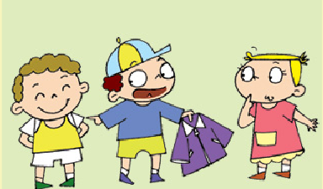 2. 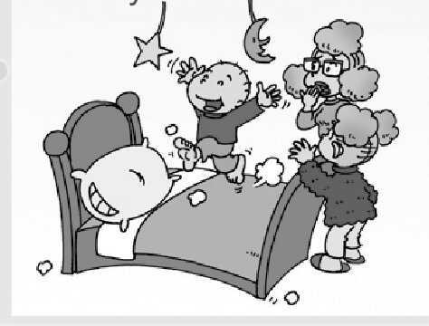3. 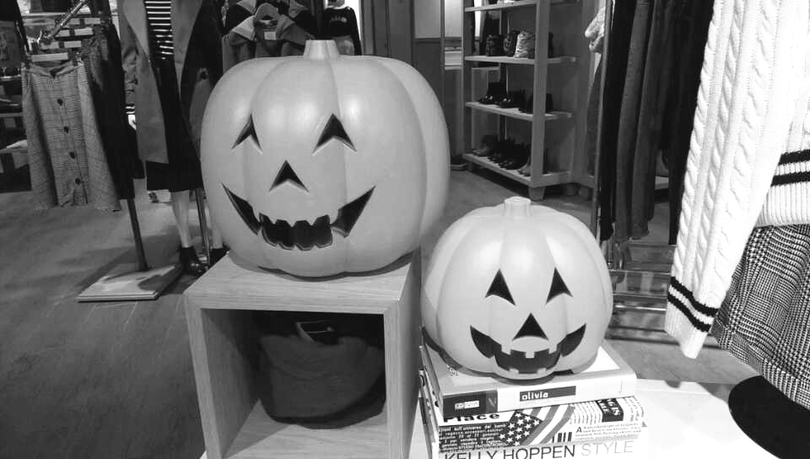 4. 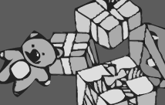

1 . ----Whose coat is it?

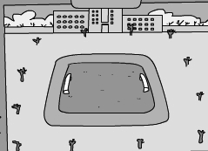
----- ________ _________.

2. You ____________ _________ on the bed.

3. Halloween is _____ autumn _____________.

4. We ______ going to _______(给)you some surprise presents.

5. _________ _________ lots of little trees before. 5.
Ⅷ.情景交际。根据对话内容，从方框中选择正确选项，将其序号写在横线上。（每题2分，共10分）
Amy: Come on , Lingling. Let’s go to the supermarket.
Lingling: Great!
A. You are helpful children.
B. This one is heavy.
C. what a big supermarket!
D. And there is a lot of fruit
E. Let’s go !
. H .And then her friends are going tio go home. e will be home at seven o’clock. E. Is he very busy?
Lingling: Oh,
Amy: Yes, it is. There are many sweets over there.
Sam: , too.
Ms Smart: Please help me put the bags in the car.
Lingling: ______________________ I can’t carry it.
Sam: Let me help you.
Ms Smart: __________________________ Have an ice cream.
Lingling, Amy and Sam: Thank you !

Ⅸ.阅读理解。（共15分）
- 阅读短文，判断正误。正确的写“T”，错误的写“F”。
Dear Daming ,
Yesterday, I went to Sam and Amy’s school. I took some photos there.
In the UK, children often sit around tables in class. We sit in lines in China.
They sing songs together every morning. We do morning exercises.
In the UK, school often starts at 9 o’clock and finishes at half past three.
In China, we usually start school at 8 o’clock and finish at 4 o’clock.
School is fun here. But I miss my friends back in China.
Love,
Lingling

( )1.It’s a letter from Daming to Lingling.
( )2.Lingling was in the US. She visited a school yesterday.
( )3. In the UK, children often sit around tables in class.
( )4. We sing songs together every morning in China.
( )5. In the UK, school often finishes at three o’clock.

B.阅读故事，选择最佳答案。
There was a shoe shop. The shoemaker(鞋匠) made the shoes. He was very poor(贫
穷). He didn’t have much money(金钱). He had only one piece of leather(皮革) for one pair of shoes.
That night, the shoemaker put the leather on the table. Then he went to bed. The next day, He saw a new pair of shoes on the table. He was very excited and very happy. Soon a man came into the shop. He bought the shoes. Now the shoemaker had some money. The shoemaker bought some more leather. He put it on the table. Then he went to bed. The next day, there were two new pairs of shoes on the table. That night , the shoemaker hid behind the door. He saw two little elves(小精灵) make the shoes. The shoemaker wanted to say “Thank you”. He made some little clothes for them. He also cooked them a big dinner. At night, the elves came to the shop again. This time, there wasn’t any leather. But they were very happy to find the new clothes and food.

( )1、There was a shoemaker. He was very________. He had only one piece of leather for one pair of shoes.
A. fat B . poor C. tall
( )2、The elves made ___________ pairs of shoes for the shoemaker.
A. one B . two C. three
( )3、The shoemaker thanked the elves very much, and he cooked_______ for them.
A. food B . clothes C. toys
( )4、The shoemaker and the elves were all __________at last.
A. hungry B . angry C. happy
( )5、What’s the title(题目) of the story?
A. Make the shoes B . The Elves and the Shoemaker
Ⅹ.书面表达。（5分）
同学们，你们班的外籍小朋友Amy下一个星期天就要过生日了。她要举行一个生日派对,并盛情邀请你们参加。在她的生日派对上你们都打算做些什么呢？请提前帮她策划一下吧!
Amy’s birthday party’s plan

Amy is going to have a birthday party next Sunday. All of us want to make her happy. What are we going to do ?
First ,________________________________________________________________
Next ,________________________________________________________________
Then ,________________________________________________________________
Finally(最后)___________________________________________________________

We hope everyone will have a good time.

五年级英语听力题签
※注意：每道听力试题读二遍。时间控制在15分钟以内。

Ⅰ.听音，找出句子中含有的单词，将序号写在前面的括号内。
1. Sometimes there are restaurants at the supermarkets.
2. At night, children wear scary clothes.
3. You are so kind. We all love you .
4. We should listen in class.
5. ---Tom! Let me help you tidy up! ---Thank you , Amy!

Ⅱ.听音，标号。用数字标出图片的先后顺序。
1. This man is blind. His dog can help him.
2. There are toy chicks and flowers on the hats.
3. This supermarket is very big. It sells many different things.
4. Look! There’s a clock. But there wasn’t a clock here before.
5. This T-shirt isn’t yours. It’s mine!

Ⅲ.听音补全句子，在横线上填入所缺单词。
1. You shouldn’t be late. You should ____study______ hard.
2. I _____think____ I can do it well by myself.
3. _____Open____ your books and listen to me carefully!
4.There are lots of games. The students can ____have fun______ at break time.
5. My grandparents have lived here ____for___ _sixty years.

Ⅳ.听短文，判断正(T)误(F)。
Yesterday, Sam’s team played basketball in the park. They got fifty points. The other team got thirty-six points. Sam got seventeen points. Amy got thirteen points. And Lingling got twenty points. Their team won! They were very happy.

听力部分到此结束！

五年级英语参考答案及评分标准
听力部分(35)
I. (2×5=10 分) BACBC
II. (2×5=10 分) 3---1---5---2---4
III. (1×5＝5分) study , think , Open , have fun , for
（备注：其中1个单词如果没有首字母大写要扣减0.5分，其它4个必须拼写完全准确方可得1分）
IV. (2×5=10 分) F T F T F

笔试部分(65分)
V、(1×10＝10分) BACBB CACAB
VI、(2×5＝10分) drank , speak , fans , workers , clean
（备注：其中3个单词如果没有相应形式的变化要扣减1分， 其它2个必须拼写完全准确方可得2分）
VII、（1×5 + 1×10词=15分）
- EDABC
- 1. It’s , his 2.shouldn’t , jump 3. an , festival 4.are , give 5.There were
（备注：其中2个单词如果没有首字母大写要扣减0.5分， 其它8个必须完全准确方可得1分）
VIII、(2×5＝10分) ECDBA
IX、(2×5 + 1×5＝15分)
A. F F T F F
B. B C A C B
X、（5分）略
请任教五年级的英语老师批阅作文，并自行把握评分标准,做到心中有数。

备注：卷面满分为100分。（听力35分，笔试65分。）
优秀：90---100
良好：80---89
及格：60---79
不及格：0---59

2015年 1月 8 日

