二年级上英语期末测试（2015.1）
考试时间：60分钟
学 校
班 级
姓 名
听力部分（60分）

一、听音圈出你所听到的字母（20分）
1. Gg Jj 2. Cc Ss
3. Dd Bb 4. Ll Ii
5. Ww Mm 6. Tt Rr
7. Uu Vv 8. Ee Ff
9. SKL XKI 10. PDM BON

二、听录音给下列单词用数字标号（10分）
( ) 1.A.nice B. rice ( ) 2.A. cold B. cool
( ) 3.A.walk B.work ( ) 4.A.warm B.wear
( ) 5.A.have B.home ( ) 6.A bike B.bus
( ) 7.A.park B.plane ( ) 8.A.their B.tomato
( ) 9.A.milk B.Moon ( )10.A.spring B.summer


三、听句子给图片排序（10分）
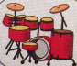




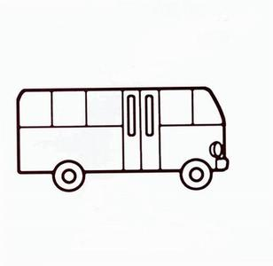
四、听音连线（10分）

1. Daming Dalian


2. Sam Harbin

3. Lingling Beijing 

4. Amy Shanghai

5.Tom zoo 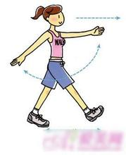

五、听录音选择正确的句子,将答案前的序号写字括号里(10分)
1.（ ）A. I don’t like apples.
B.I don’t like bananas .
2.（ ）A. We eat dumplings at Chinese New Year
B. We eat dumplings at Christmas.
3.（ ） A. Do you like bananas?
B. Do they like bananas?
4.（ ） A. It’s winter. We wear T-shirts and gloves.
B. It’s summer. We wear T-shirts and sunglasses.
- ( ) A.I go to school by bus.
B.I go to school by bike.
笔试部分(40分)
- 读一读下面的字母，根据大小写，写出它们的邻居。(共10分)

Gg Bb Vv

Kk Ss
- 选择最佳答句，把序号写在括号里。(每 题1分，共10分)

（ ）1.I go to Hainan____holiday.
A.in B.on
( )2. ____do you go to the zoo?
A.Where B.How
( )3.____love China.
A.We B..He
( )4.-____you go to Shanghai by plane?
-Yes ,I do .
A.Does B.Do
( ) 5. A present_____you.
A for B on
( ) 6. I go home_____5.
A. in B.at
（ ）7._______ like these shoes.
A.He B.I
( )8.______they like apples?
A.Is B.Do
( )9.They like ______.
A.rice B.rices
( )10.She’s ___a party.
A.on B.at
三、请为下面的问句找到合适的答句，并连线。（10分）

1) Where do you live? I go to school by train.

2) How do you go to school? I live in Dalian.

3) Do you like noodles? He goes swimming in summer.

4) Does he listen to CDs? No, I don’t.

5)What does he do in summer? Yes. he does.

四、读句子，并连线。（10分）

1. I play football in autumn.

2. I go swimming in spring.

3.Amy, here’s a dress for you.

4. We eat dumplings at Chinese New Year.

5.I walk to work.

小学二年级英语期末检测题签

一、听音圈出你所听到的字母
1 Jj 2 Ss 3 Bb 4 Ii 5 Ww 6 Tt 7 Vv 8 Ee 9 SKL 10 PDM
二、听录音给下列单词用数字标号
1 nice 2 cold 3 work 4 wear 5 home 6 bike 7 park 8 their 9 milk 10 spring
三、听句子给图片排序
1 Listen to CDs.
2 play the drums.
3 play football
4 Christmas trees
5 reads books
四、听音连线
1.Daming goes to Dalian by ship.
2. Sam goes to Harbin by plane.
3. Lingling goes to Beijing by bus.
4. Amy goes to Shanghai by train.
5.Tom walks to the zoo.
五、听录音选择正确的句子
1 I don’t like noodles .
2 We eat dumplings at Chinese New Year
3. Do they like bananas?
4. It’s summer. We wear T-shirts and sunglasses.
- I go to school by bus.

