海洋岛学校2014—2015第一学期阶段质量检测 （2014.10）
小学英语 五年级
听力部分( 40分)
听音，选出你所听到的相应信息。（12分，每小题2分）
1、( ) A、bird B、birds C、bench
2、( ) A、clock B、dance C、park
3、( ) A、lot of B、a lot of C、lots of
4、( ) A、helpful B、help C、have
5、( ) A、neighbour B、neighbour’s C、party
6、( ) A、Easter B、Halloween C、east

二、听音，将下列图片排序。 (10分，每小题2分)
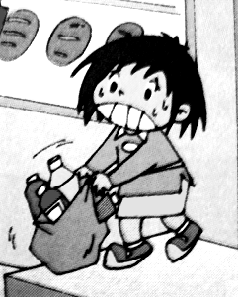
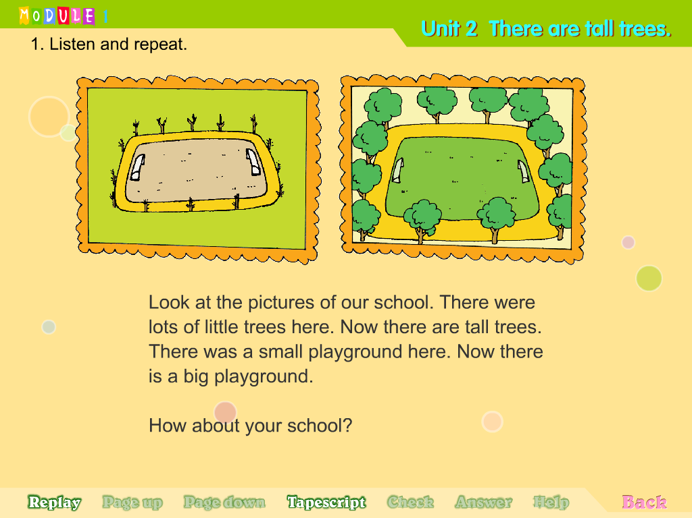
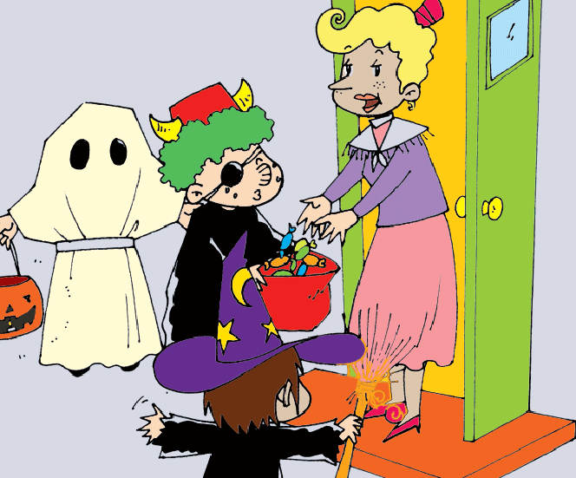
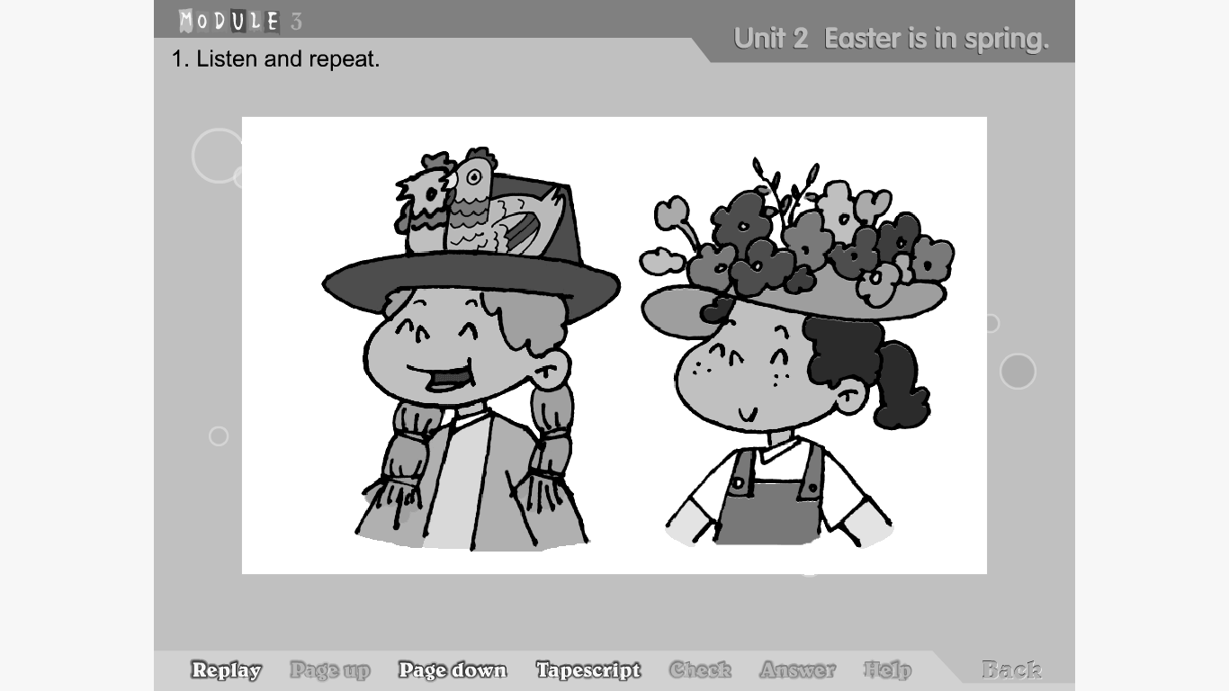
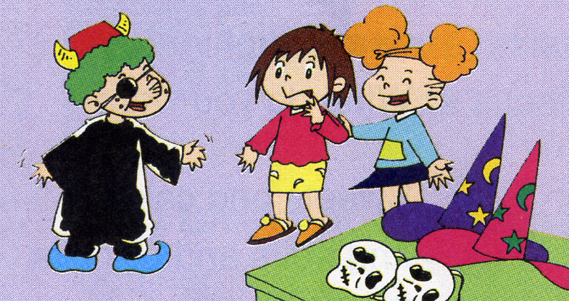

（ ） （ ） （ ） （ ） （ ）
三、根据短文判断对错，在正确的答案前打“√”。（8分，每小题2分）
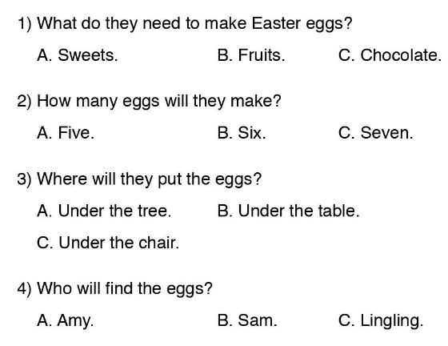

四、听句子,选择正确的答语。(10分，每小题2分)
( ) 1、A、Yes, it does. B、Yes, I do.
( ) 2、A、It’s in spring. B、It’s in autumn.
( ) 3、A、There are two birds.
B、Yes,there are.
( ) 4、A、They wear the scary clothes.
B、They go to the park.
( ) 5、A Yes, I do. B、No, I don’t.
笔试部分（60分）
一、根据中文提示将单词补充完整。（13分，每词1分）
1、You were in China ______ (达)two years.This park is_________(不同的)now.
2、________（有时） there are _________（饭馆） at the supermarket.
3、This one is __________. （重的）.
4、They _______(卖) food from lots of countries.
5、Children go to __________(邻居的) houses at __________(夜晚).
6、_____ (让)me help you.
7、People _____(给) Children some sweets.
8.Some ________(巧克力)eggs are big.
9.There is a big ___________(操场) now.

二、单项选择。（10分，每小题1分）
( )1.They give __________sweets.
A.them B.they C.their
( )2.Halloween is ___ autumn festival.
A.a B.× C.an
( )3.There was a house here______.
A.after B.before C.now
( )4.These bags ___________big.
A.are B.is D.am
( )5.There_____a clock here before.
A.was B.is C.are
( )6.There weren’t____________houses here.
A.some B.any C.something
( )7.You ____in China for two years..
A.was B.are C.were
( )8.Look ___the pictures ___ our school.
A.at in B.to of C.at of
（ ）9. Let’s _____to the supermarket together.
A. to go B. goes C. go
（ ）10.Lingling is in London ____Sam and Amy.
A. in B. with C. on
三、看图完成句子（12分，每空2分）
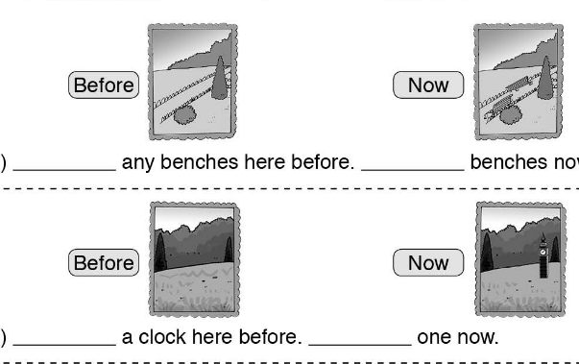
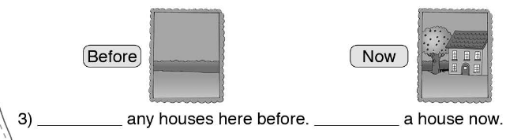
四、情景交际。选择恰当的句子补全对话, 将序号写在横线上。（10分）
A. And there are many sweets, too.
B. Great! Let’s go.
C. I can’t lift it.
D. Oh！What a big supermarket!
E. Let me help you.

Amy: Come on, Lingling. We’re going to go to the supermarket.
Lingling: 1.__________.
Amy: 2. .
Lingling: Yes, it is. There are many biscuits over there.
Amy: 3.____________
Ms Smart: Please help me put the bag in the car.
Lingling: This bag is so big! 4. .
Sam: 5._________
Ms Smart: You are helpful children. Have some sweets.
Amy. Sam, Lingling: Thank you.
五、阅读理解。读短文，判断正误。（10分）
This is a picture of Jim’s classroom. It’s not a big room. In the picture we can see thirty chairs and thirty desks in it. There are fourteen boy-students and sixteen girl-students in his class. They go to school from Monday to Friday. They have Chinese lessons every day. They like school. They’re good students.

根据短文判断对错， 对的划√，错的划×。
( )1. They don’t go to school on Sundays.
( )2. There are sixty students in Jim’s class.
( )3. Jim’s classroom is big.
( )4. Jim is a good student in his class.
( )5. There are thirty students in the class.

六.作文(5分)
要求：万圣节刚刚过去，对于万圣节你都知道哪些风俗?
题目自拟，不少于5句话。

Halloween
___________________________________________________________________________________________________________________________________________________________________________________________________________________________________________________________________________________________________________________________________________________________________________________________________________________________________________________________________________________________________________________________________________________________________________________________________________________________

五年级英语听力题签:
- 听音，选出你所听到的相应信息。（10分，每小题2分）。
1、We can feed the birds.
2、There wasn’t a clock before.
3、There were lots of little trees here.
4、You are helpful children!
5、They go to neighbour’s houses.
6.Easter is in spring in the UK.
二、听音，将下列图片排序。 (10分，每小题2分)
1、What a big playground! 2、This bag is heavy. I can’t lift it.
3、We’re going to have lunch together. 4、Both your red T-shirts are wet.
5、The people give them sweets.
三、根据短文判断对错，在正确的答案前打“√”。（10分，每小题2分）
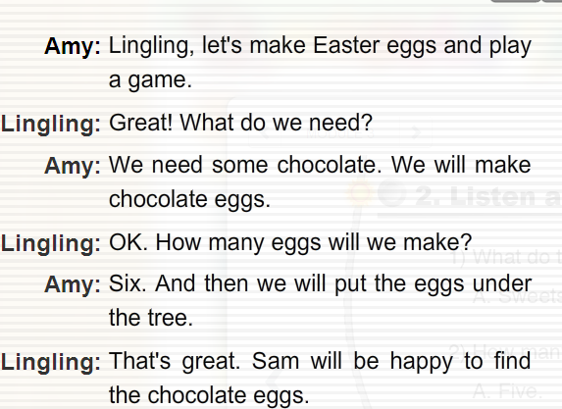

四、听句子,选择正确的答语。（10分，每小题2分）。
1、Does London look different now?
2、When is Easter?
3、How many birds are there?
4、What do the children do at Halloween?

