五年级上册期末综合试题
班级 姓名 学号
一、听音找出句子中含有的单词
（ ）1、 A. mine B. missing C. miss
（ ）2、 A. wall B. well C. water
（ ）3、 A. before B. bored C. break
（ ）4、 A. safe B. library C. laugh
（ ）5、 A. hear B. hers C. dear
（ ）6、 A. pond B. point C. poem
（ ）7、 A. November B. number C. nothing
（ ）8、 A. ready B. reply C. rule
（ ）9、 A. night B. nine C. nice
（ ）10、A. February B. festival C. firefighter
二、听音标号

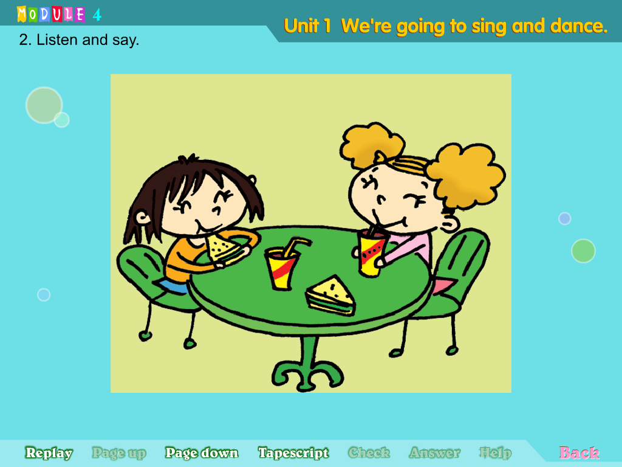
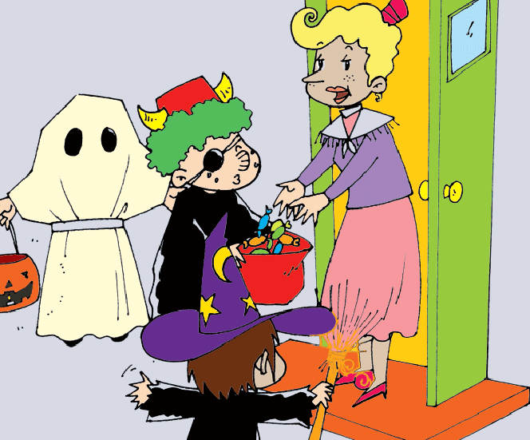
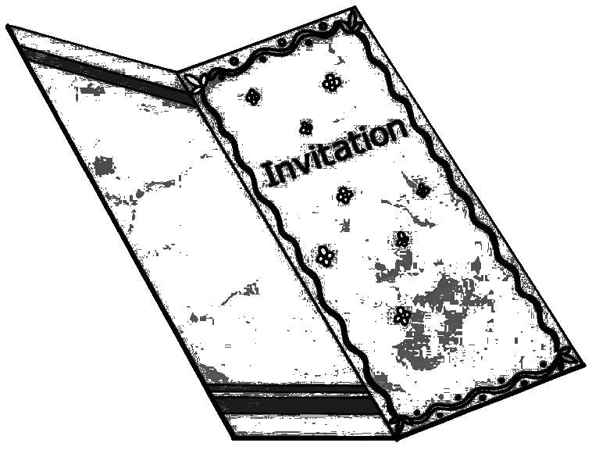
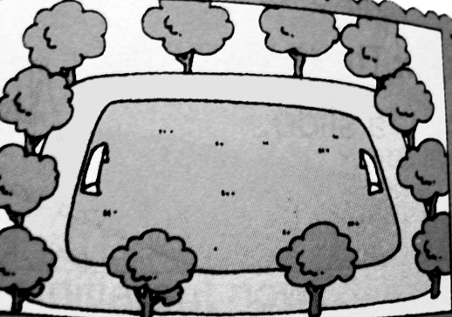
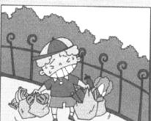

（ ） （ ） ( ) ( ) ( )

三、听短文，判断正误

1. Many English supermarket are not very big.（ ）
2. They sell different things. （ ）
3. They sell food from other countries. （ ）
4. People can’t eat in the restaurants at the supermarket. （ ）
5. Many English families go to the supermarket together. （ ）
笔试部分
一、单项选择。
( )1.--Wow! What ____ big supermarket! --Yes, it is. A. a B. an C. the
( )2. Amy was in China ___ two years. A. in B. for C. with
( )3.Do you want some ___?No,thank you. I’m not thirsty at all.
A.water B.cake C.sweets
( )4. I can’t find my pen. Can I use __ ,Mary? A. you B. your C. yours
( )5. --Daming,which is your favourite TV ___ ?
--Around China. I want to go to different place(地方)in China.
A. show B. rule C. team
( )6. --Why sre you ___? --Because my cat ate my chocolates. My grandma sent them to me. A. happy B. bored C. angry
( )7. --Xiaoyong looks very sad.Do you know ___ ?
--Maybe he misses his mum. She is in America. A whose B why C. what
( )8. Li Yuchun is my favourite singer. She sings very ___.A. high B. well C. fast
( )9. --Sam, you shouldn’t ___the books down.
--I know. Sorry, Mum. A. hold B. put C. take
( )10. --_________ Why are you laughing?
--We’re talking about the basketball game.
A. What’s the matter? B. What’s the weather like? C. What are you laughing?

二、根据提示，用词汇的适当形式完成下列句子
A. 用下列所给单词或短语的适当形式填空。【fire, hers, heavy, have lunch, find】
1. The boy cried and cried. The firefighters could ________ him.
2. Mother likes painting. The pictures on the wall are ___.
3. The elephant was so ____. No one could move(移动) it.
4. There was a ___ inside the house. People ran out of the house.
5. English children usually __________ at school. They eat hamburgers and fruits.
B. 根据句意提示，写出单词的正确形式。（首字母已给出）
1. My mother often tells me some s________. They are very funny.
2. I have nothing to do now. I’m b______ . Can you play games with me?
3. Tony and Dick are good students at school. They s_______ hard.
4. Our school has a big p________. We like playing football on it.
5. W________ skirt is it? It’s Lingling’s.
三、用所给词的填空。 for with about in at
1. I was in the UK _______ three year. 2. How ___________ your school?
3. There’s a TV _____________ my classroom. 4. Lingling is in London_______ Sam and Amy. 5. I’m going to do my homework _______ 6 o’clock.

四、 找出相对应的答句，将序号填入题前括号内。
( )1. What’s the matter? A. Yes, it could.
( )2. Was there a clock here before? B. It’s in autumn.
( )3. When is Halloween? C. At eight o’clock.
( )4. Could it find the people ? D. Nothing. I’m thinking.
( )5. What time does your school start? E. No, there wasn’t.
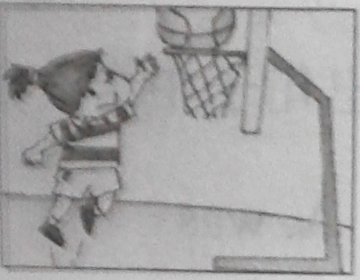
五、根据图文提示，完成句子。
1. ---What ball game can you play?
--__________________________ .

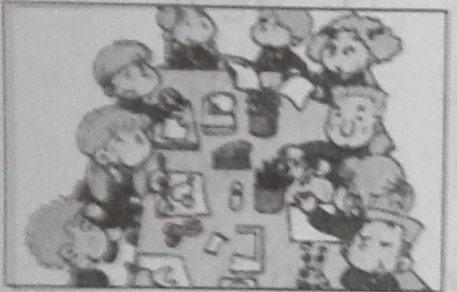
2. ---How do the children in England sit?
---__________________________ .
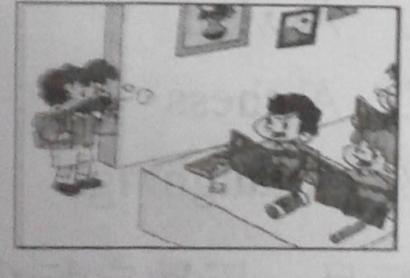

3. Tom was late for school today.
The teacher says,”Tom, ___________________________” .
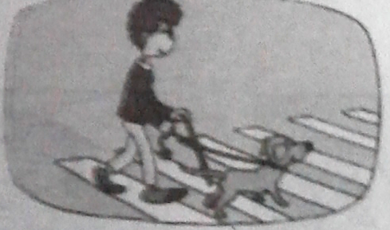
4. ---What does the TV presenter say?
---He says:”This man is blind._______________________________”

5. ---What are you going to do after the party?
---__________________________________________ .收拾房间

六、情景交际。根据对话内容，从下列句子中选择正确选项，将其序号写在横线上A. In China, you start school at 8 o’clock. B. Of course, they do.
C. In China, the children do morning exercises. D. But I really want to go back to China. E. Did you take photos of their school?
A: Hello! Mum. This is Lingling speaking.
B: Hello! Lingling. How are you in England?
A: Very well. Mum, guess what! Yesterday I went to Sam and Amy’s school.
B: Greet! ______1______
A: Yes. I did. Their school is different from mine. The children sing songs together in the morning.
B: That’s true. ________2________
A: In England, they start school at 9 o’clock.
B: Oh! ______3____ Do they do homework every day?
A: _______4_______ They study hard, too.
B: Do you like English school?
A: Yes, I do. ________5_______
七、阅读理解
My school looks different now. There was a small playground before. Now there is a big playground. There weren’t any trees on the playground, and there are lots of trees and flowers now. There was a small river behind our school before. The water was clean. We could swim in it. Now there isn’t a river，there is a pond. Our teacher tell me:” there will be some fishes in the pond. ”
There are no classes on Sundays. We stay at home and watch TV. My father and mother go to shops on Sundays. They all like China.
( ) 1. There are lots of trees and flowers.
( ) 2. There was a big river behind our school before.
( ) 3. Now we can swim in the river.
( ) 4. there will be a pond next year.
( ) 5. In China, the students can stay at home and watch TV on Sundays

八、书面表达。某少儿英文报正在举行正文活动，题目为“I love going to school”。请你根据提示和要求，用英语写一个小短文，积极参加这次活动吧。
提示：1. What time does your school start?
2. What time does it finish?
3. What’s your favourite subject?
4. What do you do at break time?
5. Which teacher do you like?
要求：1、要点齐全，表达准确，语句通顺，书写规范，可适当发挥；
2、词数30词左右。
I love going to school
____________________________________________________________________________________________________________________________________________________________________________________________________________________________________________________________________________________________

