长海县2014~2015学年度第一学期阶段质量检测试卷
小学六年级 英语 完成时间：80分钟
题  号 | 听力部分 |  |  |  | 笔试部分 |  |  |  |  |  | 总分
题  号 | Ⅰ | Ⅱ | Ⅲ | Ⅳ | Ⅴ | Ⅵ | Ⅶ | Ⅷ | Ⅸ | Ⅹ
得
分
听力部分（共四大题，30分）
Ⅰ.听句子，选出你所听到的相应信息。（每题1分，共5分）
C. alone
C. Christmas
C. please
C. thousands
C. delicious
B. along
B. the Spring Festival
B. place
B. presents
B. different
( ) 1. A. long
( ) 2. A. Thanksgiving
( ) 3. A. pleased
( ) 4. A. important
( ) 5. A. difficult



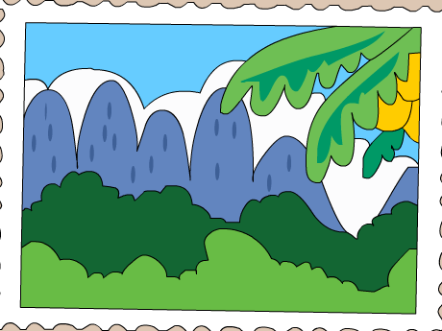
Ⅱ. 听音标号。用数字标出下列图片的先后顺序。（每题1分，共5分）


（ ） （ ） （ ） （ ） （ ）
Ⅲ. 听问句，选答句。将正确答案序号填在括号内。 （每题1分，共8分）
A. 6 kilometres.
B. 50 years.
C. 20 metres.
A. Five-Finger Mountain.
B. They are from Canada.
C. No, I haven’t.
( ) 1. ( ) 2.

A. Yes, I can.
B. Yes, she can.
C. Yes, you can.

A. Yes, I do.
B. No, I haven’t.
C. I like the dragon kite.
( ) 3. ( ) 4.

A. Yes, they do.
B. Yes, they are.
C. Yes, there is.

A. The Spring Festival.
B. National Day.
C. Christmas.
( ) 5. ( ) 6.

A. Dalian.
B. I went there by ship..
C. I helped my mum.

A. I saw a lion dance.
B. I’m sending an email.
C. She will go to Hainan.

( ) 7. ( ) 8.

Ⅳ.听短文，选择填空。将正确答案序号填在括号内。（每题2分，共12分）
( )1. Thanksgiving is important in _______.
A. the UK B. the US
( )2. When is Thanksgiving?
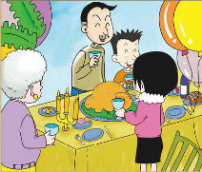
A. In December B. In November
( )3. People have _______ for dinner.
A. a turkey B. fish and chips
( )4.They say “_____ ”for food, family and friends.
A. good luck B. thank you
( )5. What do children do in the streets?
A. They play the guitar.
B. They sing and play the trumpet.
( )6. On Thanksgiving, people always have a ______ time.
A. good B. bad
笔试部分（共六大题，70分）
Ⅴ.单项填空。将正确答案的序号填写在前面的括号里。（每题1分，共15分）
( ) 1. Tell me ______ your city. I want to go there. A. of B. about C. for
( ) 2. We _____ walk all of it. It’s too long. A. are B. can C. can’t
( ) 3. ---______ is the building? --- It’s about two hundred years old..
A. How much B. How old C. How long
( ) 4. I’m going to send emails ______ my friends. A. from B. for C. to
( ) 5. Last Sunday, I ______ a big surprise. A. had B. has C. have
( ) 6. Simon really ______ to visit the Great Wall. A. want B. wants C. go
( ) 7. You don’t send ______ letters. So I haven’t got any stamps.
A. I B. my C. me
( ) 8. ---What are you doing? ---I’m _______ the books.
A. read B. reads C. reading
( ) 9. _______ to music is my hobby. A. Listening B. Listen C. Singing
( ) 10. Do you _______ hear my poem? A.want to B. want C. wants to
( ) 11. The Dragon Boat Festival comes ______ year. A. every B. this C. next
( ) 12. Children’s Day is on _______ 1st of June. A. a B. the C. /
( ) 13. I have got ______ English book. A. a B. an C. /
( ) 14. Will you go shopping _____ go swimming? A. but B. or C. so
( ) 15. Lingling is from China. She is ________ Chinese. A. in B. an C. /
Ⅵ.根据语境提示，用词汇的适当形式补全下列句子。（每空1分，共10分）
1) _________(收集) stamps is my hobby.
2) There are lots of _________ trees (椰子树) in Hainan.
3) My sister can speak __________(法语).
4) There are _________ (灯) everywhere. They’re _________(漂亮的).
5) Changhai is a beautiful ___________(岛屿).
6) Laura ________ _______(写信给) Lingling last weekend.
7) The building is ________ _______(超过) two hundred metres high.
Ⅶ.句子理解。（共2大题，计20分）
A.根据问句，找出相应的答句，将其序号填入题前括号内。（每题2分，共10分）
( ) 1. How tall is your mother? A. He’s from England.
( ) 2. Has Lucy got a beautiful shirt? B.Yes, we can.
( ) 3. Where is he from? C. She’s 167 centimetres tall.
( ) 4. What’s your favourite food? D. Yes, she has.
( ) 5. Can we walk to school? E. Noodles.
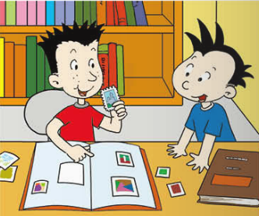
B. 根据图文提示，补全句中所缺单词。（每空1分，共10分）
1. A: What are you doing?
B: I’m _______my stamps into my stamp _______.
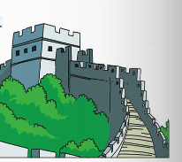
2. A: ______ you got _______ pictures of the Great Wall?
B: Yes, I have.
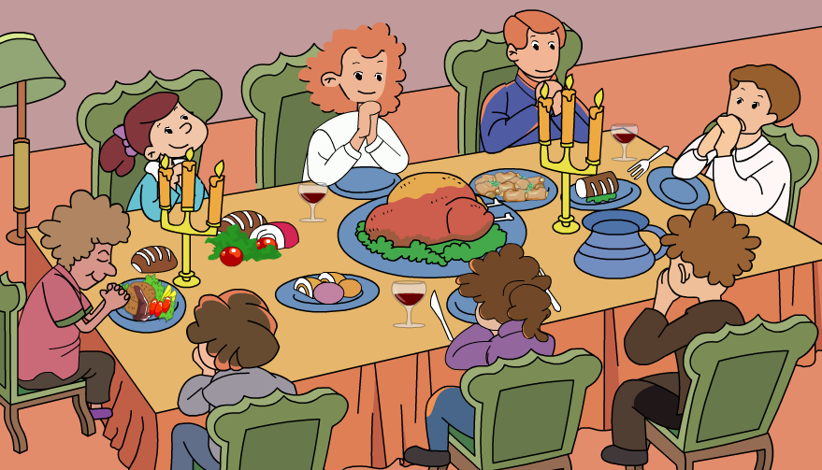
3. A: ______ _______ ______ ______ on Thanksgiving?
B: We always have a big, special dinner.

4. We saw a _______ _________in the street.

Ⅷ.情景交际。选择恰当的句子补全对话, 只填序号。（每题2分，共10分）
A. Why do you like it? B. What’s your favourite festival?
C. What do people do? D. put on new clothes
E. When is it?

A: ____________________________
B: The Spring Festival is my favourite.
A:____________________________
B: Because it’s the most important festival in China.
A: ___________________________
B: It’s in January or February.
A: ___________________________
B: On New Year’s Eve, we have a big family dinner. We make dumlings and watch TV. On New Year’s Day, we____________ and visit friends and relatives(亲戚).
Ⅸ.阅读理解。（每题1分，共10分）

A. 阅读短文，选择正确的答案。
My sister Fangfang has an American pen friend. Her name is Lucy. She lives in Washington D.C. She’s twelve years old. Lucy can’t speak Chinese, but my sister can speak some English, so they write to each other in English. They talk about many things, such as their hobbies, dreams, trips, and their schools. Lucy is good at swimming. And she can sing and dance well, too. But she can’t play ping-pong. In the letter, Lucy said “ I like China very much and I will to to China to learn ping-pong.”
( ) 1. Fangfang’s pen friend comes from_______.
A. America B. China C. England
( ) 2. Lucy is ________ years old.
A. 11 B. 12 C. 13
( ) 3. Lucy ______ speak Chinese, but Fangfang ______ speak some English.
A. can, can’t B. can’t, can C. can, can
( ) 4. They talk about ________ in their letters.
A. bobbies and dreams B. trips and schools C. A and B
( ) 5. Lucy can’t _______ well.
A. play ping-pong B. swim C. sing and dance

B. 阅读故事，判断正误。正确的写“T”，错误的写“F”。
There are lots of different spiders(蜘蛛). There are big ones and small ones, fat ones and thin ones. Some are brown, some are black, some are orange and some are red. Spiders live in webs(网) in houses and schools. They also live in parks and streets.
Spiders have eight legs. They eat insects(昆虫). They make webs. If insects get in the webs, they can’t get out. Then the spiders eat them. Some spiders can hurt you. Some can’t. Be careful of the dangerous spiders!
( ) 1. All the spiders are big and fat.
( ) 2. Spiders have different colours.
( ) 3. Spiders can make webs and they only live in webs.
( )4. Spiders eat insects.
( )5. We can play with the spiders.
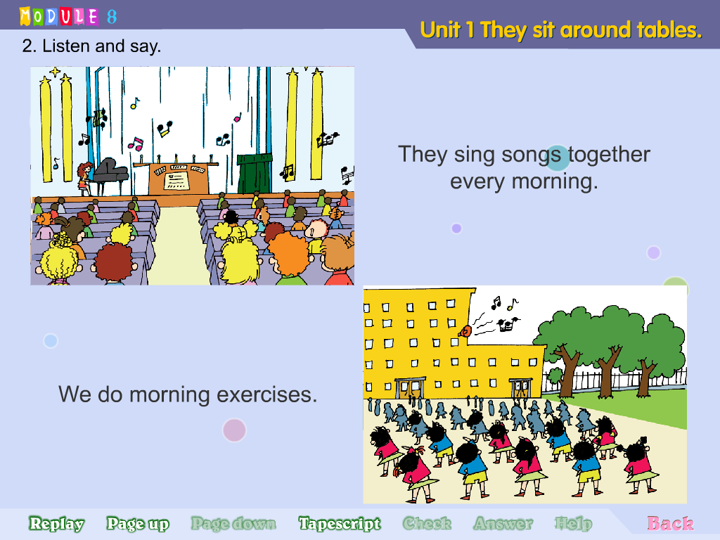
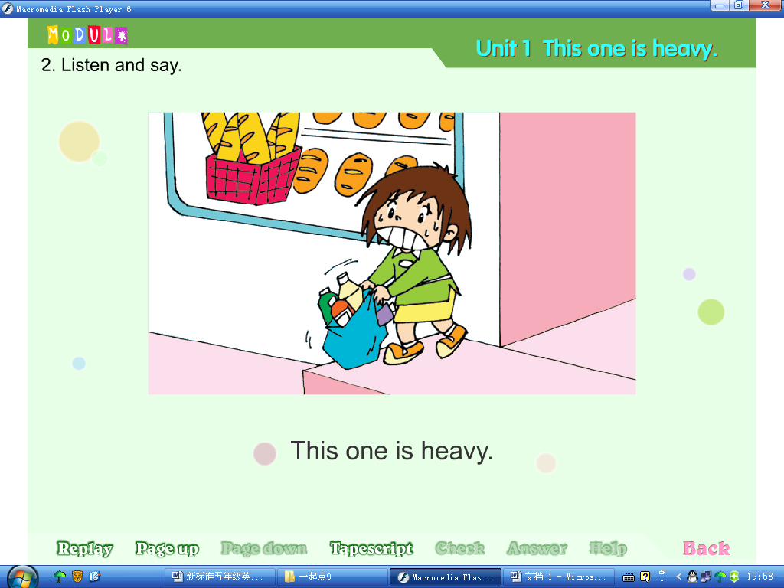
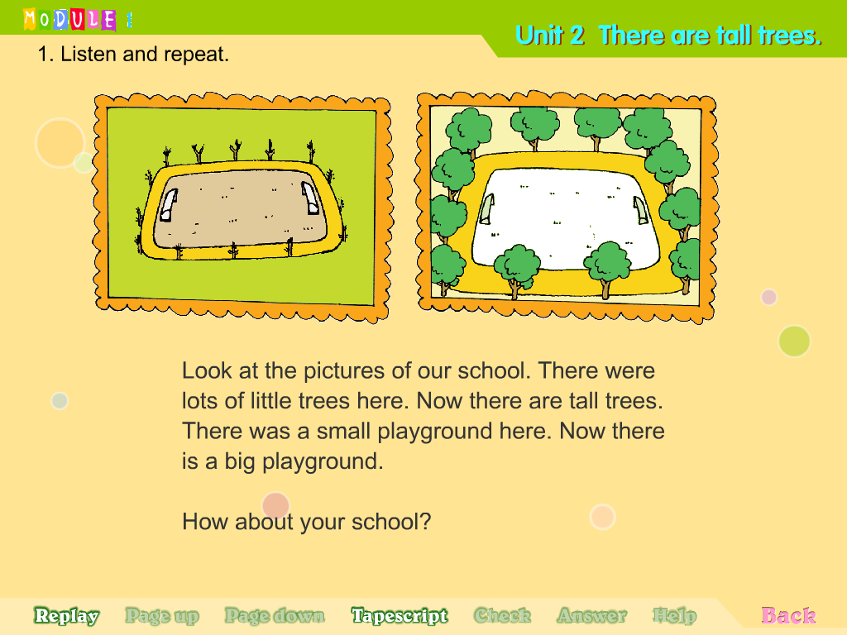
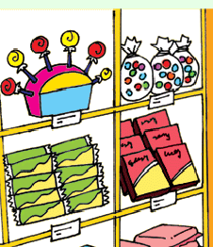
Ⅹ.书面表达。请以＂My Hobby＂为题，介绍并谈论一下你的爱好。（本题共5分）
要求：条理清楚，意思连贯，语句通顺，标点正确，书写规范，40个单词左右。
______________________________________________________________________
______________________________________________________________________
______________________________________________________________________
______________________________________________________________________
______________________________________________________________________
______________________________________________________________________
六年级英语听力题签
注意：每道听力试题读二遍，听力时间控制在15分钟内。

Ⅰ.听句子，选出你所听到的相应信息，将序号写在前面的括号内。
No.1 We can’t walk along all of the Great Wall.
No.2 People put Christmas trees in their homes.
No.3 I’m pleased to be your pen friend.
No.4 On Christmas, people give presents and send cards.
No.5 My hobby is different from hers.

Ⅱ.听音标号。用数字标出下列图片的先后顺序。
No.1 This computer is from the US.
No.2 He’s writing to his cousin.
No.3 The bridge is more than two kilometres long.
No.4 National Day is our favourie day.
No.5 We can see the Five-Finger Mountain and a coconut tree in the stamp.

Ⅲ.听问句，选答句。将正确答案序号填在括号内。
No.1 How old is the school?
No.2 Where are these stamps from?
No.3 Can I write to her?
No.4 Have you got a kite?
No.5 Is there a Chinatown in New York?
No.6 Which festival is in autumn?
No.7 Where did you go last Sunday?
No.8 What are you doing?

Ⅳ. 听短文，选择填空。将正确答案序号填在括号内。
Thanksgiving is a very important festival in the US. It is in November. People always have a big, special dinner. Families enjoy a delicious turkey together. They say “thank you” for food, family and friends. On Thanksgiving, children wear strange clothes and masks. They sing and play the trumpet in the streets. They have a lot of fun.

听力部分到此结束！

六年级英语参考答案及评分标准

听力部分
Ⅰ.(1×5＝5分) 1.B 2.C 3.A 4. B 5. B
Ⅱ. (1×5＝5分) 3—2—1—5----4
Ⅲ. (1×8＝8分) 1.B 2.B 3. C 4. B 5.C 6.B 7.A 8.B
Ⅳ. (2×6＝12分) 1. B 2. B 3. A 4. B 5. B 6. A

笔试部分
Ⅴ. (1×15＝15分) 1.B 2. C 3. B 4.C 5.A 6.B 7. C 8.C
9.A 10. A 11.A 12.B 13. B 14. B 15. C
Ⅵ. (1×10＝10分) 1.Collecting 2.coconut 3.French 4.lights, pretty 5.island 6.wrote to 7. more than
（请注意画线黑体部分，如果没有形式的变化将各扣0.5分，其他单词完全准确方可得1分）
Ⅶ. A. (2×5＝10分) 1. C 2.D 3.A 4.E 5.B
B. (1×10＝10分) 1.putting book 2. Have (0.5分) any
3. What(0.5分) do you do 4. lion dance
（请注意画线黑体部分，其他8空完全准确方可得1分。）
Ⅷ. (2×5＝10分) B A E C D
Ⅸ. (1×10＝10分) A. 1.A 2.B 3.B 4.C 5.A
B. 1.F 2.T 3.F 4.T 5.F
Ⅹ.略。(5分)
备注：卷面满分为100分。（听力30分，笔试70分。）
优秀：90---100
良好：80---89
及格：60---79
不及格：0---59

2014年 10 月 30 日

