长海县2014—2015学年度第一学期阶段质量检测试卷
小学五年级 英 语 完成时间：80分钟
题  号 | 听力部分 |  |  |  | 笔试部分 |  |  |  |  |  |  | 总分
题  号 | Ⅰ | Ⅱ | Ⅲ | Ⅳ | Ⅴ | Ⅵ | Ⅶ | Ⅷ | Ⅸ | Ⅹ | XI
得
分

听力部分（共四大题，30分）
Ⅰ.听音，找出句子中含有的单词，将序号写在前面的括号内。（每题1分，共8分）
C. both
C. December
C. here’s
C. mine
C. different
C. story
C. wall
C. Halloween
B. beach
B. November
B. his
B. my
B. drink
B. sell
B. away
B. whose
( ) 1. A. bench
( ) 2. A. September
( ) 3. A. hers
( ) 4. A. mask
( ) 5. A. difficult
( ) 6. A. still
( ) 7. A. wet
( ) 8. A. heavy

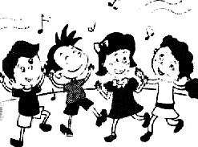
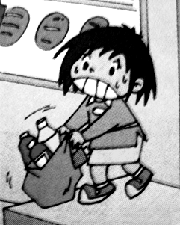
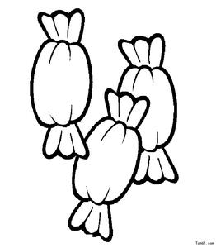
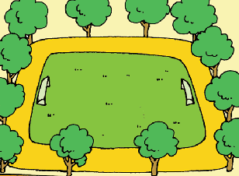
Ⅱ.听音标号。根据所听句子的顺序用数字标出图片的先后顺序。（每题1分，共8分）

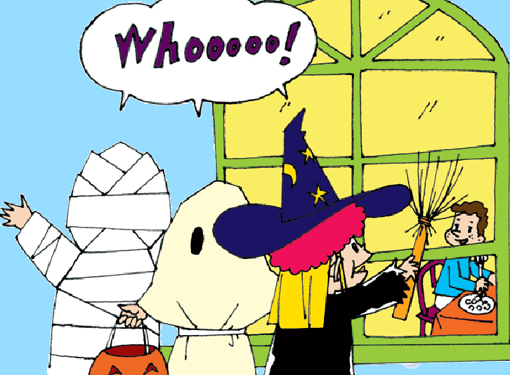
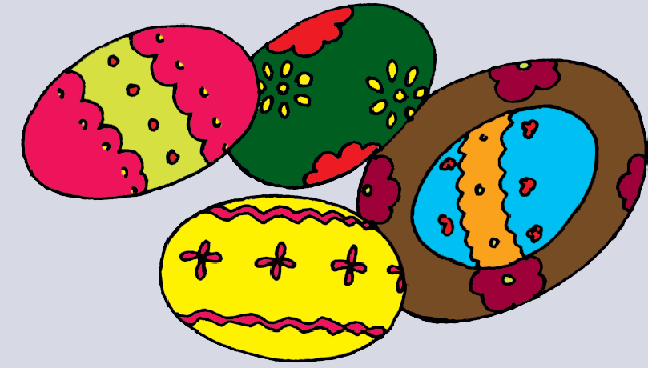
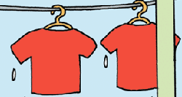
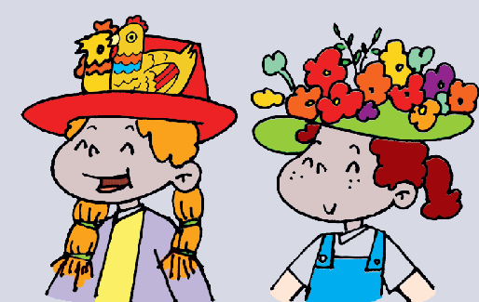
（ ） （ ） （ ） （ ）

（ ） （ ） （ ） （ ）
Ⅲ.听问句，选答句。将正确答案序号填在括号内。 （每题1分，共8分）
A. It’s Halloween.
B. It’s in autumn.
C. It’s really fun.
A. It’s Halloween.
B. It’s Easter.
C. It’s Christmas.
（ ）2.

（ ）1.

A. Some sweets.
B. Some presents.
C. Chocolate eggs.

A. We’re going to sing.
B. We’re having a cake.
C. We went to the park.
（ ）3.

（ ）4.

A. At 12 o’clock.
B. We’re going to dance.
C. In the park.

A: It’s hers.
B: It’s my sister.
C: It’s T-shirt.
（ ）6.

（ ）5.

- It’s mine.
- It’s blue.
- It’s in the desk.

（ ）7.

A. Thank you.
B. Merry Christmas!
C. Trick or treat?

（ ）8.

Ⅳ.听短文，判断正误。正确写“T”, 错误写“F”。（每题1分，共6分）
（ ）1. It’s snowing.
（ ）2. The children are running home.
（ ）3.Lingling’s blue dress is wet.
（ ）4. Amy’s skirt is dirty.
（ ）5. Tom is laughing.
（ ）6. The workers are running home.

笔试部分（共七大题，70分）
Ⅴ. 用词汇的适当形式完成下列句子。（共10分）
- This bag is very _________.(重的)
- _____________(有时) there are restaurants at the supermarket.
- There was a small______________(操场) before.
- The __________(邻居们) _________(给)children some sweets.
- We’re going to tell ______________.(故事)
- ____________(谁的) T-shirt is it? It’s ____________.(她的)
- It’s raining. But the __________(工人) are _________(仍然) working.

Ⅵ.单项选择。将正确的序号填写在前面的括号里。（每题1分，共15分）
( ) 1. ----______is Halloween? ------It’s in autumn.
A. What B. When C. Where
( ) 2. The park is _____3 o’clock _____5 o’clock.
A. to, to B. at, to C. from, to
( ) 3. It isn’t your shirt. It’s_____. A. my B. me C. mine
( ) 4. Mum is going to make a cake me. A. for B. to C. of
( ) 5. You can buy many things_____the supermarket.
A. in B. at C. for
( ) 6.---What a big supermarket! ---_________.
A. Thank you. B. Let’s go C. Yes, it is.
( ) 7.There weren’t _____ trees here before. A .some B.any C. a
( ) 8.There_____ a clock here before. A. was B. were A. is
( ) 9.This bag is too heavy. I _____ carry it.
A. can B. am C. can’t
( )10. Many ________ go to the supermarket together.
A. family B. familys C. families
( )11. We___ going to have lunch together. A. are B. am C. is
( )12.It’s ____invitation to my birthday. A. a B. an C. some
( )13.I’m going to _____ eleven. A. am B. be C. is
( )14. Sam wants to wear _____ T-shirt. A. my B. me C. mine
( )15. We’re going to _____ a party. A. have B. has C. had

Ⅶ.情景反应，请将对应的答句的序号填在括号内。（每题2分，共10分）
( )1.What are we going to do? A. It’s Lingling’s.
( )2.What’s he doing? B.We’re going to have a party.
( )3. When is Halloween? C.Yes, there were.
( )4.Were there lots of trees? D.It’s in autumn.
( )5.Whose eraser is it? E. He is telling a story.

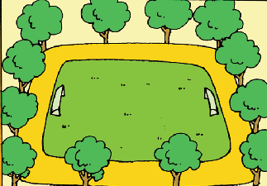
Ⅷ.根据图文提示，写出句子。（每空0.5分，共10分）
- There were little trees before. How about now?
There _______ ________ ________ now.

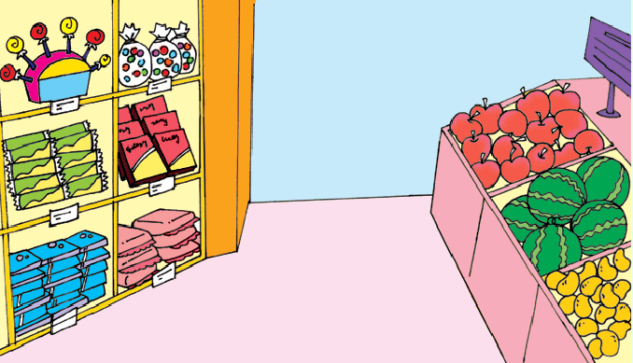
- There are many sweets.
There _____ a ____ ____ ______, too.

- A: What are we going to do ?
B: We’re _____ _____ ______ ______ ________.(一起吃午餐)


- Amy’s blue______ is ______.



5.There wasn’t a ______ here ______.

________ ______ _______ ________.
(现在有一个了。)

Ⅸ.情景交际。选择恰当的句子补全对话, 将序号写在横线上。（每空2分，共10分）
A: Hi, Sam. Where are you going?
B:___________________
A:What are you going to buy?
B:___________ I want to buy a present for her.________________
A:OK. Let’s go. Does your mother like books?
B: No, she doesn’t.
- Can you go with me?
- She likes listening to music.
- That’s a good idea.
- I am going to the supermarket.
- My mother’s birthday is coming.
A:What does your mother like?
B:_______________
A:Let’s buy some CDs for her.
B:______________

X.阅读理解,判断下列句子的正（T）误（F）。 （每题2分，共10分）
Mike and Jack are going to the park at the weekend. They are going there at nine o’clock in the morning. They are going to fly a kite, and they are going to take photos of the flowers. They are going to climb the hill in the park. They are going to go home at eleven. They will be happy.

( )1. Mike is going to the park with Jack.
( )2.They are going to the park in the afternoon.
( )3. They are going to ride bikes.
( )4.They are gong to climb the hill.
( )5. They will be in the park for two hours.

XI.小习作。（ 5分）
请根据所给的提示词，描写万圣节的习俗，要求：题目自拟，不少于5句话。
Autumn, fun, wear, scary, houses, sweets, Trick or treat
______________________________________________________________________________________________________________________________________________________________________________________________________________________________________________________________________________________________________________________________________________________________________________________________________________________________________________________________________________________________________________________________________________________________________________________________
五年级英语听力题签
※注意：每道听力试题读二遍。时间控制在15分钟以内。

Ⅰ.听音，找出句子中含有的单词，将序号写在前面的括号内。（每题1分，共8分）

1.There weren’t any benches here before.
2.Halloween is in November.
3.This T-shirt is hers.
4.This book is mine.
5.Our school is different now.
6.They sell different things.
7.Amy’s blue dress is wet.
8.Whose bag is it?

Ⅱ.听音标号。根据短文叙述的顺序用数字标出图片的先后顺序。（每题1分，共8分）
1.Both your T-shits are there. They are wet.
2.We are going to sing and dance.
3.There are tall trees now.
4.Children wear scary clothes. They go to their neighbours’ houses.
5.There are toy chicks and flowers on the hats.
6.People give children chocolate eggs.
7.There are many sweets.
8.This bag is heavy.

Ⅲ.听问句，选答句。将正确答案序号填在括号内。 （每题1分，共8分）
- When is Halloween?
- Children wear scary clothes. They scare the people. Which festival is it?
- What do people give children at Easter?
- What are you going to do?
- When are we going to dance?
- Whose T-shirt is it?
- What colour is it?
- What do children say at Halloween?

Ⅳ.听短文，判断正误。正确写“T”, 错误写“F”。（每题1分，共6分）
It is raining. The children are running home. Look! Amy’s blue dress is wet. Lingling’s favourite skirt is dirty. Sam’s shoes are wet and dirty. Tom is laughing. Oh, but the workers are still working.

听力部分到此结束！
五年级英语参考答案及评分标准
听力部分(30)
I. (1×8=8 分) A B A C C B A B
II. (1×8=8分) 7 2 8 3 4 5 1 6
III. (1×8＝8分) B A C A A A B C
IV. (1×6＝6分) F T F F T F

笔试部分(70分)
V、(1×10＝10分) (每词一分，没大写，没变化扣减0.5分)
1. heavy 2. Sometimes 3. playground 4 neighbours give
5. stories 6. Whose hers 7. workers still
VI、(1×15＝15分) B C C A B / C B A C C / A B B A A
VII、（2×5=10分） B E D C A
VIII、(0.5×20＝10分) (每空0.5分，完全准确方可得分。)
1. are, tall, trees 2. is , lot, of, fruit 3.going, to, have, lunch, together
4. dress, wet 5. clock, before, There, is, one, now
IX、(2×5＝10分) D E A B C
X、(2×5＝10分) T F F T T
XI、（5分）略
请任教五年级的英语老师批阅作文，并自行把握评分标准,做到心中有数。

备注：卷面满分为100分。（听力30分，笔试70分。）
优秀：90---100
良好：80---89
及格：60---79
不及格：0---59

2014年10月30日

