长海县2014—2015学年度第一学期阶段质量检测试卷
小学四年级 英语 完成时间：60分钟
题  号 | 听力部分 |  |  |  | 笔试部分 |  |  |  |  |  | 总分
题  号 | Ⅰ | Ⅱ | Ⅲ | Ⅳ | Ⅴ | Ⅵ | Ⅶ | Ⅷ | Ⅸ | Ⅹ
得
分

听力部分（共四大题，40分）
Ⅰ. 听音选词。请圈出你所听到的单词。（每题2分，共10分）
1、A. dancing B. music C. computer games
2、A. beside B. between C. in front of
3、A. Mrs B. My C. Mr
4、A. print B. skate C. hurt
5、A. did B. was C. didn’t

Ⅱ.听音标号。用数字标出图片的先后顺序。（每题2分，共10分）
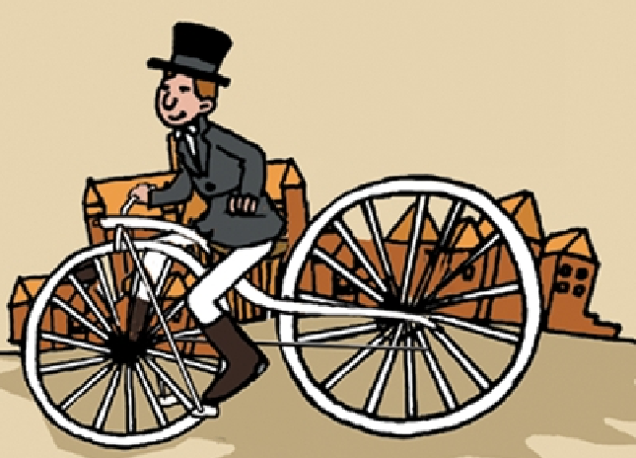
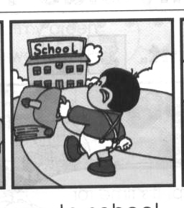
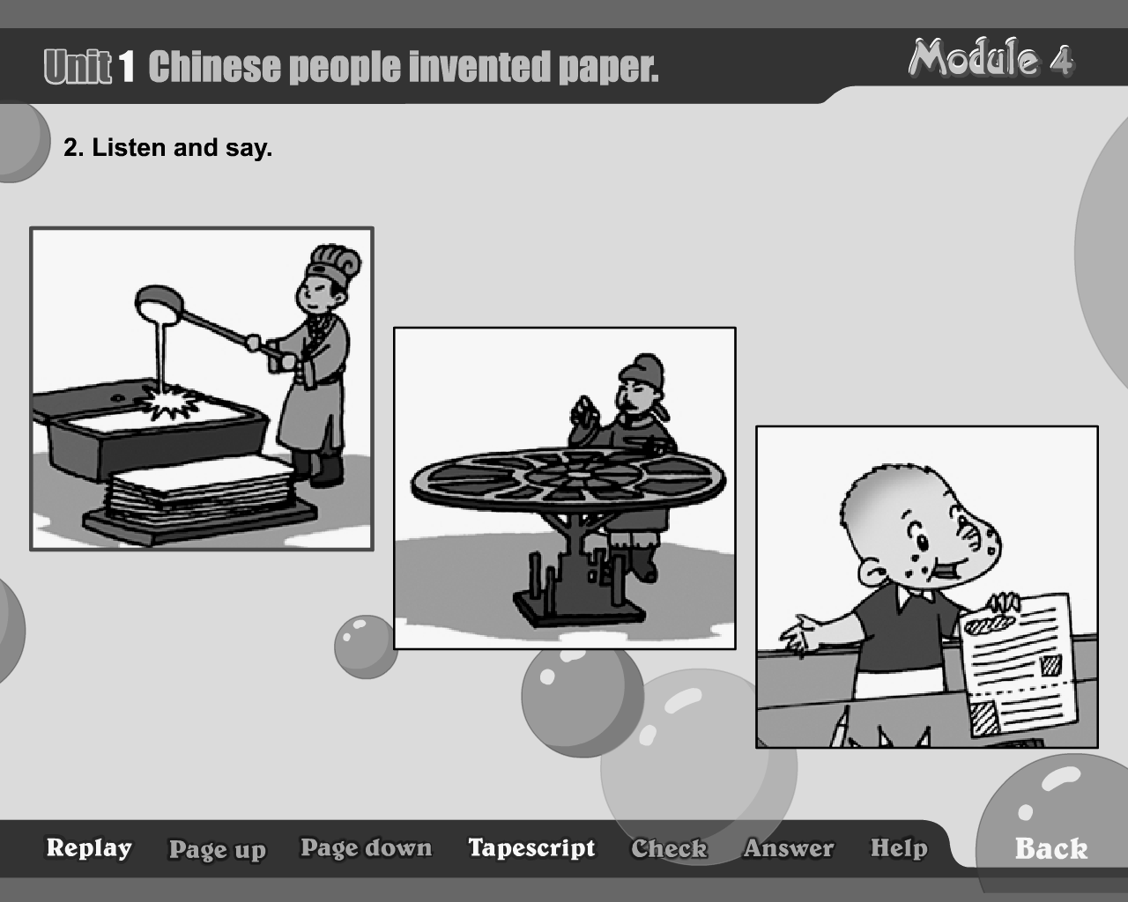
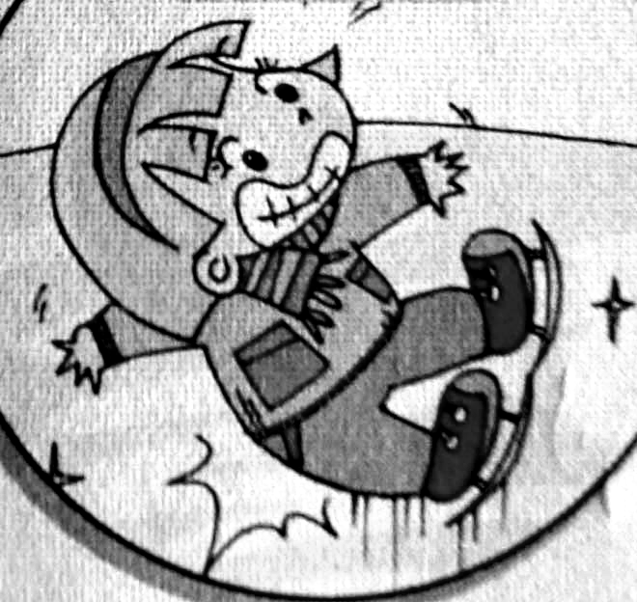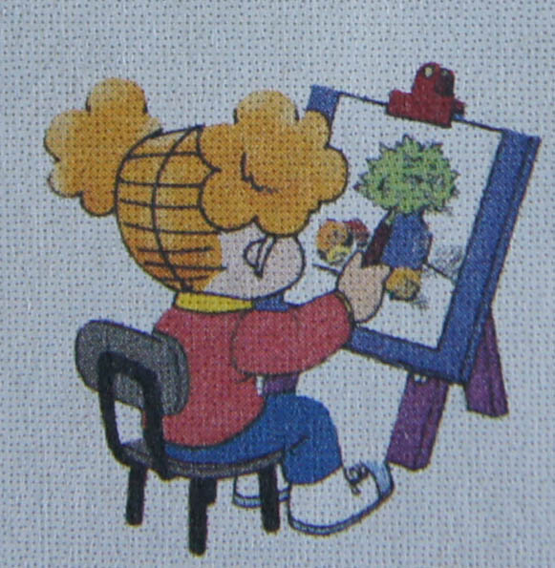
( ) ( ) ( ) ( ) ( )
Ⅲ. 听音选句。把正确的选项填在前面的括号内。（每题2分，共10分）
（ ）1、A. She has got long hair . B. He has got short hair .
（ ）2、A. He went to school on foot. B. We didn’t walk to school.
（ ）3、A. It’s between the two chairs. B. It’s beside the house.
（ ）4、A. What a happy day ! B. What a boring day !
（ ）5、A. I’m very well. B. I can sing well.

Ⅳ. 听音补全句子，填入所缺单词。（每题2分，共10分）
1、A: It’s in front of the cat. B: That’s ________________.
2、My skirt was _______________. I washed it.
3、We ______________ a good time last Sunday.
4、I ______________ our class newspaper yesterday.
5、Look at the ______________. He’s got lots of hats.
笔试部分（共六大题，60分）
Ⅴ.单项填空。（每题1.5分，共15分）
( ) 1. Yesterday I _____ my mum .
A. phone B. help C. helped
( ) 2. My trousers ____ clean. I didn’t wash them.
A. were B. was C. are
( ) 3. Chinese people invented________.
A.printing B. cars C. bicycle
( ) 4. Yesterday Tom didn’t ____ to school. She ___ to the park.
A. went…go B. go… went C. go…goes
( ) 5. It _____ us 50 minutes to climb to the top.
A. take B. took C. taking
( ) 6. A: What did you do yesterday? B: I ___________.
A. watch TV B. have English C. washed my skirt
( ) 7. Children from China are ______.
A. English B. Chinese C. American
( ) 8. I will be eleven________.
A. yesterday B. now C. next year
( ) 9. It was cold. We ______ warm clothes.
A. wear B. wore C. well
( ) 10. A: You are a very good boy, Daming.
B: ______________.
- Thank you. B. You’re welcome. C. Yes!
Ⅵ. 根据所给语境，选择恰当的单词填空。（每题2分，共10分）
ride , finished , was , swim , stayed

On Sundays , I usually _______ my bike to the park. And I usually swim in the pool. But I didn’t ride my bike yesterday. And I didn’t ______. It ______ raining. I ______ at home and ______ my homework. What a boring day !
Ⅶ. 情景反应。（每题2分，共10分）
( ) 1. Where was Lingling? A. I’m fine, thank you .
( ) 2. What did he do ? B. I’m reading a letter.
( ) 3. What are you doing? C. She was beside the two girls.
( ) 4. How are you ? D. I bought a book for you .
( ) 5. What did you buy for me ? E. He cooked noodles.
Ⅷ.情景交际。选择答案的序号填写在空格处。(每题2分，共10分)
John：We went on a school trip yesterday.
A. So, you had a good time.
B. What did you see?
C. We ate candies.
D. we saw some beautiful plants
E. We went to the Great Wall.
Tom: Where did you go?
John:
Tom: ________________
John: We saw lots of mountains.
And ________________.
Tom: What did you eat?
John: .
Tom: ____________________

Ⅸ.短文阅读,判断正(T)误(F)。（每题2分，共10分）
Dear Amy,
How are you ? I’m very well. London is a bit cold now. Is it cold in Beijing , too ?
It was my birthday on Saturday. Now I’m nine. Here is a photo of my birthday party.
The girl in red is my new friend, Zara. She’s got long, black hair. She’s very nice. Here’s another photo of Zara and me. We were at Buckingham Palace. We were very happy.
Write to me soon. Tell me about your friends.
Love,
Lucy
( ) 1. It’s a letter from Amy to Lucy.
( ) 2. Lucy was in Beijing.
( ) 3. It was Lucy’s birthday on Saturday.
( ) 4. Amy had a birthday party.
( ) 5. Zara has got long, black hair.

Ⅹ.想一想，写一写。(共5分）
I’m Daming. Yesterday was Sunday . My mum went shopping.
I ____________my room. And I _______________.We ______ very happy.
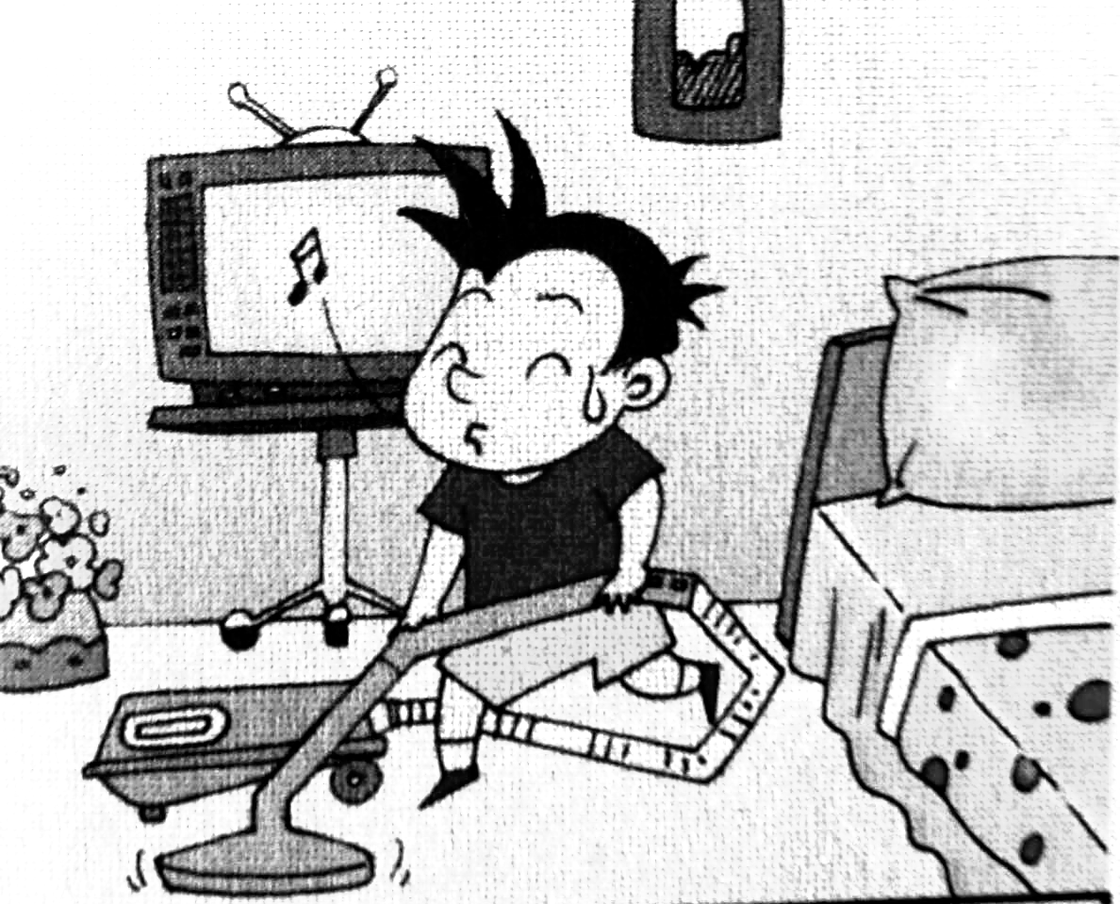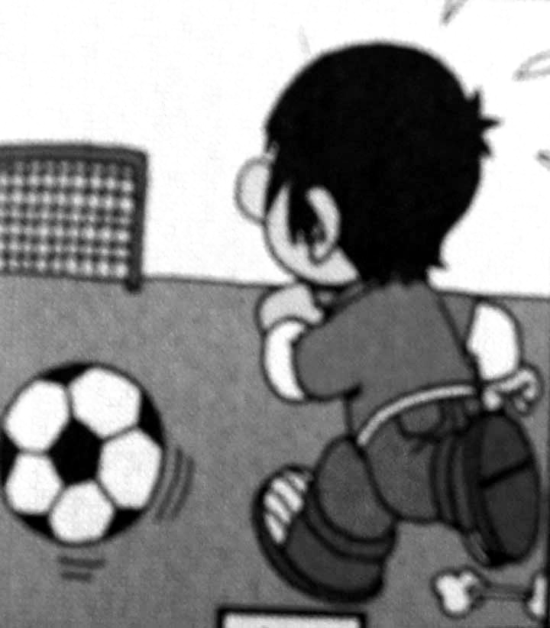

四年级英语听力题签
注意：每道听力试题读二遍，听力时间控制在15分钟内。
Ⅰ. 听音选词。请圈出你所听到的单词。（每题2分，共10分）
1、I like basketball. I love computer games, too.
2、Lingling is between Amy and Sam.
3、Yesterday , Mr Smart cooked noodles.
4、We went skating. The ice was very cold.
5、Lingling usually gets up at 7 on Mondays. But she didn’t get up at 7 yesterday.
Ⅱ.听音标号。用数字标出图片的先后顺序。（每题2分，共10分）
1、Chinese people invented paper.
2、He usually walks to school.
3、She painted a picture yesterday.
4、He invented this bicycle. He was from the UK.
5、She fell over. But it didn’t hurt a lot.
Ⅲ. 听音选句。把正确的选项填在前面的括号内。（每题2分，共10分）
1、She has got long hair .
2、We didn’t walk to school.
3、It’s between the two chairs.
4、What a happy day !
5、I’m very well.
Ⅳ. 听音补全句子，填入所缺单词。（每题2分，共10分）
1、A: It’s in front of the cat. B: That’s ____right________.
2、My skirt was _____dirty_______. I washed it.
3、We _____had______ a good time last Sunday.
4、I ______printed______ our class newspaper yesterday.
5、Look at the ____man________. He’s got lots of hats.

听力部分到此结束！

四年级英语参考答案及评分标准

听力部分
Ⅰ.(2×5＝10分) CBCBC
Ⅱ. (2×5＝10分) 2—-5—-3---4---1
Ⅲ. (2×5＝10分) ABAAA
Ⅳ. (2×5＝10分) right, dirty , had, printed, man（请注意画线黑体部分，如果没有形式的变化将扣1分，其他单词完全准确方可得2分。）

笔试部分
Ⅴ. (1.5×10＝15分) CAABB CBCBA
Ⅵ. (2×5＝10分) ride, swim, was, stayed, finished
（5空单词完全准确方可得2分）
Ⅶ. (2×5＝10分) CEBAD
Ⅷ. (2×5＝10分) EBDCA
Ⅸ. (2×5＝10分) FFTFT
Ⅹ.略。(5分) cleaned(1.5分)， played football (2分), were (1.5分)

备注：卷面满分为100分。（听力40分，笔试60分。）
优秀：90---100
良好：80---89
及格：60---79
不及格：0---59

2014年 10 月 30 日

