教学设计：
一年级起点第十一册（NSE）Module 6
Unit 1 I’ve got some Chinese chopsticks.

【教材分析】]
语言功能：说明自己拥有的物品。
语言结构：have got; has got
教学目标：
- 语言知识目标：全体学生能运用：I’ve got some Chinese chopsticks.;全体学生能理解world, difficult, answer,全体学生能运用：difficult,answer,部分学生能运用world
b.语言技能目标：能够听懂、会说并认读本模块句型，能运用所学语言谈论及询问自己及他人拥有的物品。
c.情感态度目标：乐于感知并积极尝试使用英语。
教学重、难点：
重点：单词world, difficult, answer
功能句I’ve got some Chinese chopsticks.
My brother has got a Chinese kite.
Have you got a book about the US?
难点：能在实际情景中运用have got, has got句型。
【学生分析】
学生已学过have got, has got。本册教材的Module3 也对此句型进行了进一步巩固。所以，学生已经熟悉这个语言结构。
[教学准备]
CD-ROM, word cards, ppt.
【教学过程】
Step1. Warm-up and lead-in
- greetings
- Enjoy some pictures.
T: What are they doing? Do you like reading books? I like reading books. Because books can open our eyes to the world.(teach:world)
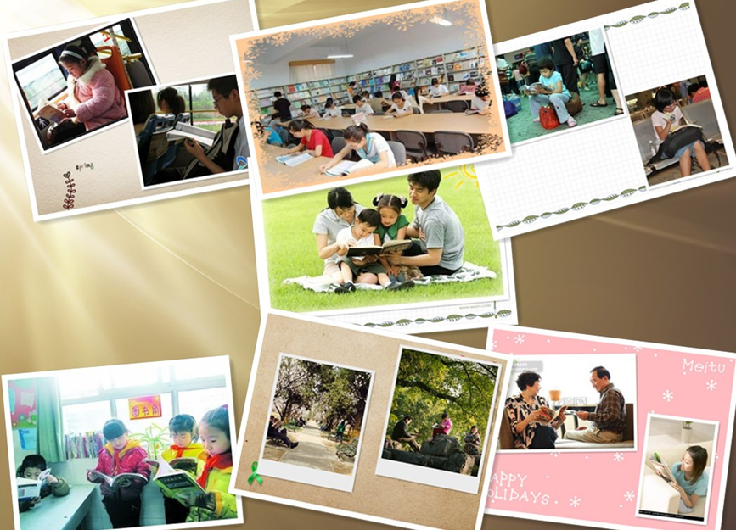
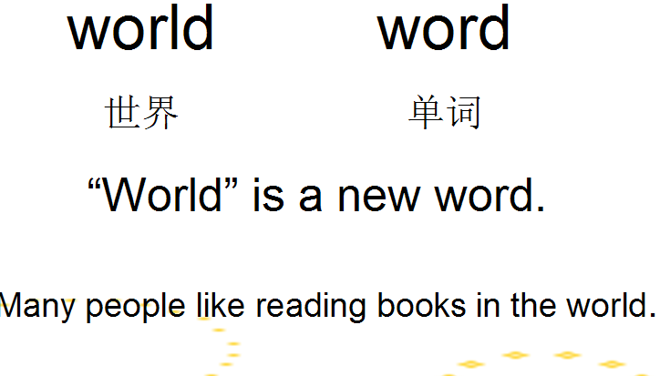

- T: Sam’s friend has got many books. Sam wants to borrow a book from his friend. But what happened?
(放导入部分的课文，再通过几个练习让学生明白什么是“上位概念与下位概念”，之后模仿跟读课文。)

Step2. Task-Presentation
T: Boys and girls , our today’s task is to use “have got, has got” to talk about what kinds of books you have. How to talk about? Now let’s learn M6U1

Step3. Text learning
- T: Lingling has got a letter. Who wrote the letter to Lingling? And what’s the letter about? Let’s watch the CD-ROM and see. OK?
( 看完CD-ROM 之后，让学生回答问题Who wrote the letter to Lingling?;讲授单词answer;回答另一个问题Why does Laura write a letter to Lingling? ----把两个问题的答案写到思维导图上)
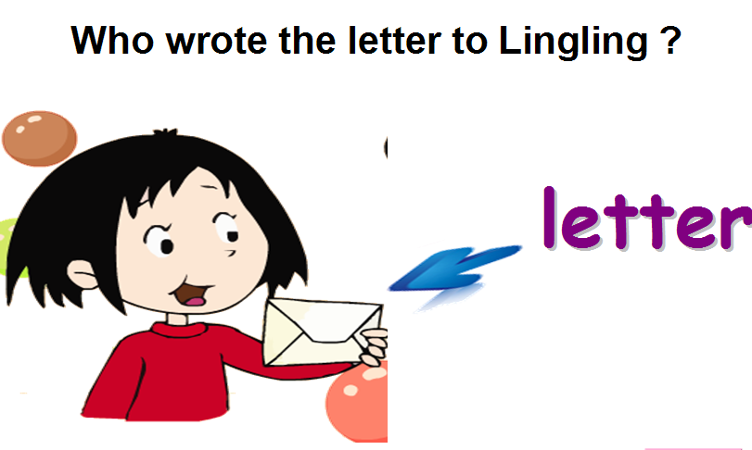
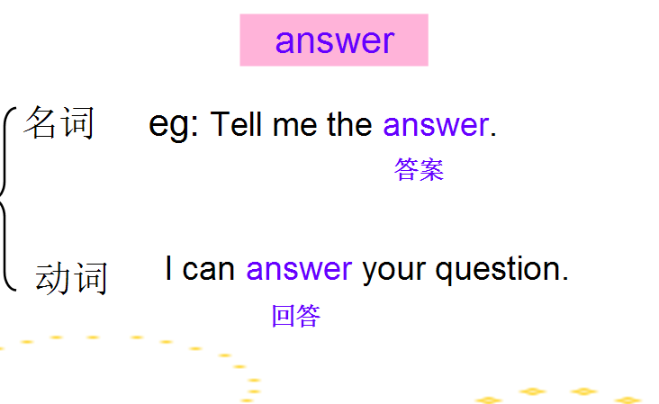

- Watch the CD-ROM again, answer 3 questions
  - Complete the questions
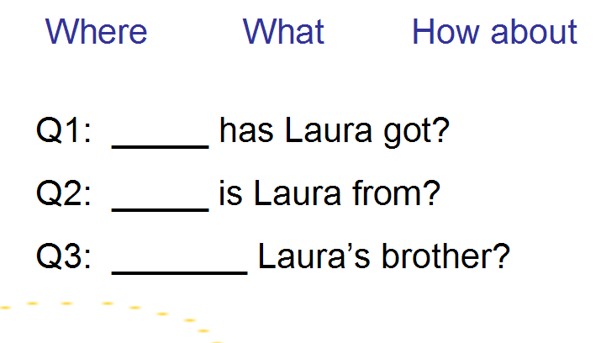

  - Answer the first question: What has Laura got?
(板书思维导图；讲授difficult; 2个描述外貌的guessing game)
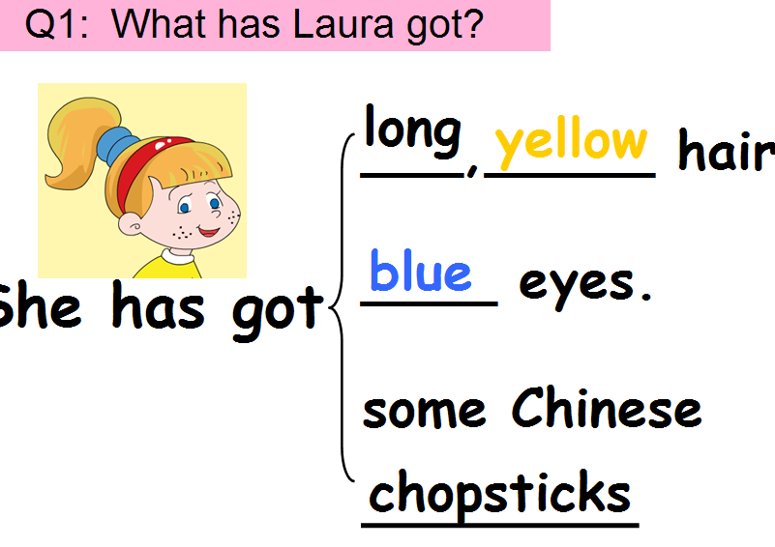
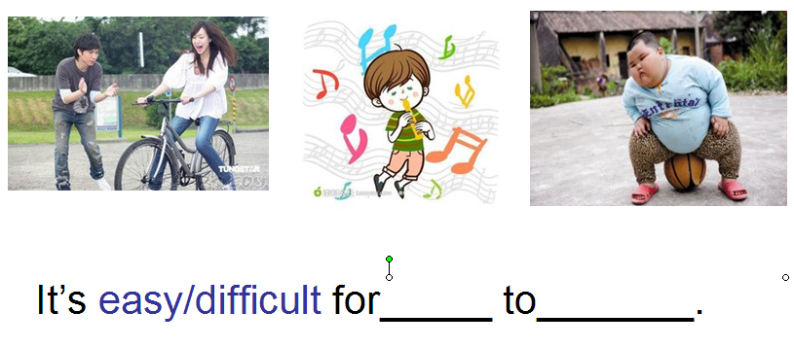

  - Answer the second question: Where is Laura from?
(板书思维导图；找两个学生进行简短对话：Where are you from? How about...?)
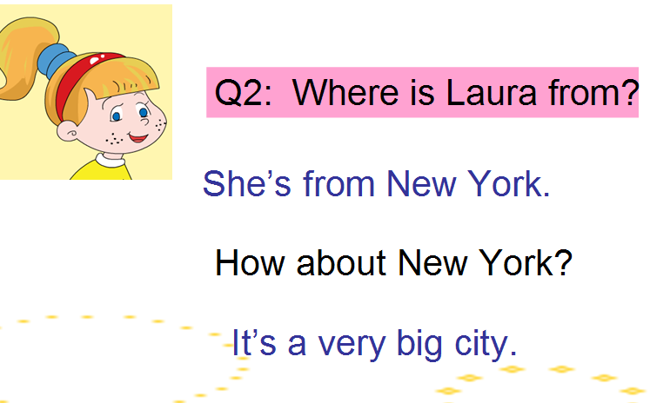

  - Read the text by themselves and answer the third question: How about Laura’s brother?
( 板书思维导图；Discribe some pictures)
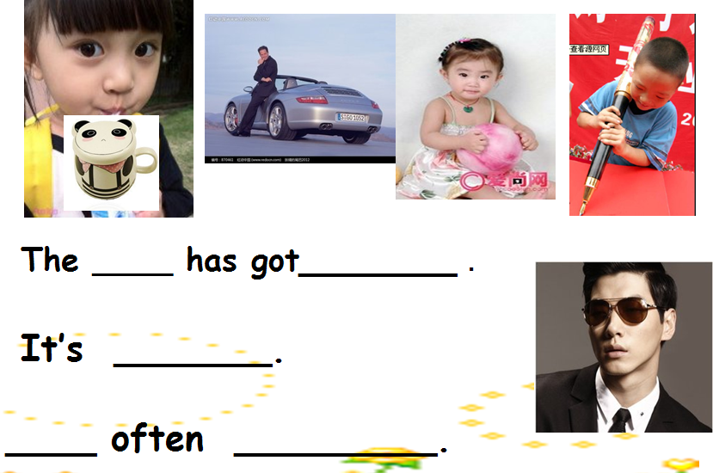
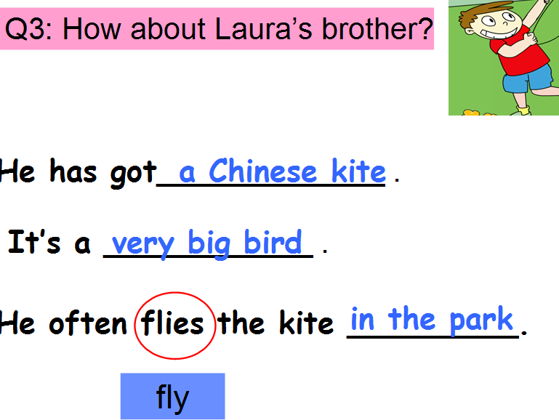
  - Listen and imitate the text.
  - Retell the text
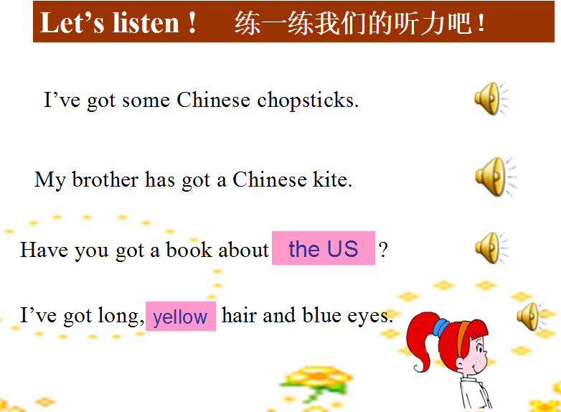
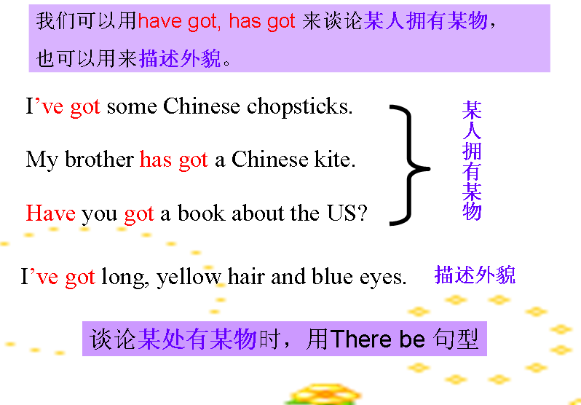
  - 通过听力练习出示4句含有have got, has got 的句子，总结用法，做练习。
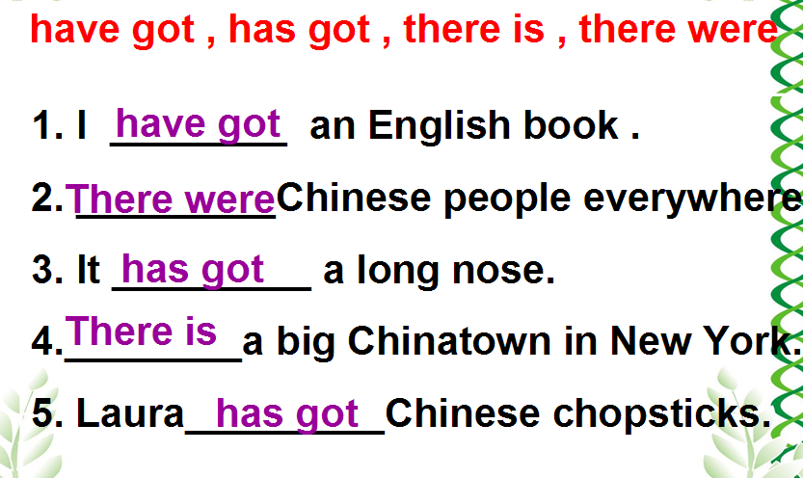

Step 4 Practise
- Part 4
1) read the example 2) ask and answer in pairs.
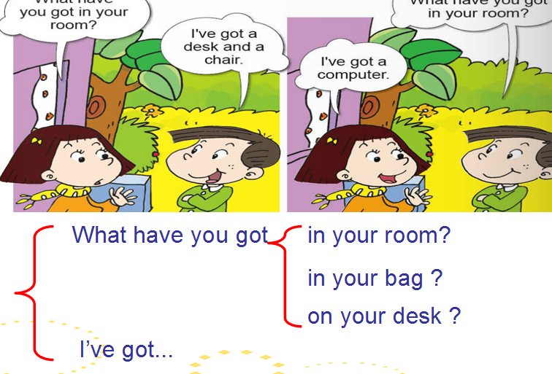
.

- freetalk
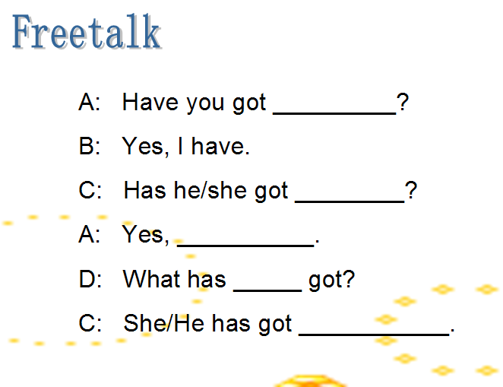

Step 5. Task- completion
- Discuss how to use “have got, has got” to talk about what kinds of books they have in groups. ( I will show some words to help them)
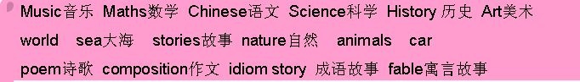
- Choose two students to report.
- Let students listen and see an example.
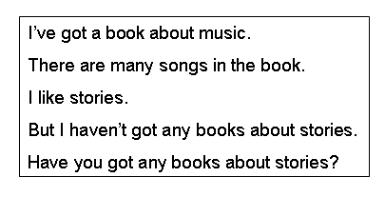

4. Let students write a letter to their friends. Talk about what kinds of books they have. (Give students the task paper)

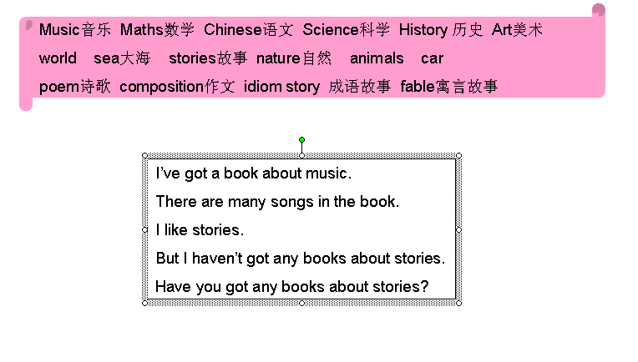
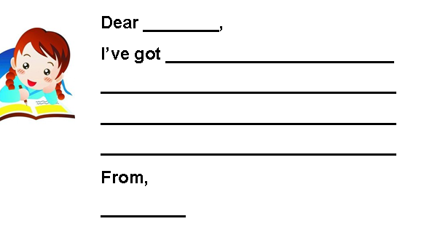

Step 6. Summary and homework
What have we learnt today? We know we can use “have got, has got” to talk about possessions Also we can use them to describe appearance .

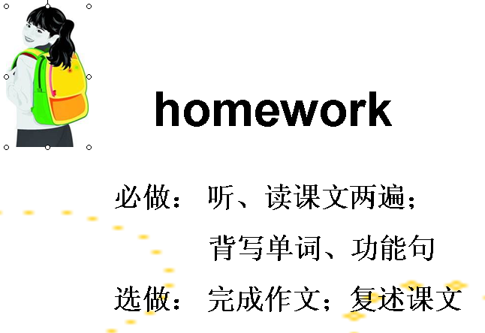

板书：

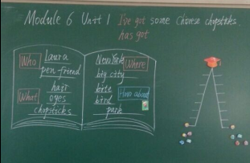

教学设计：
一年级起点第十一册（NSE）Module 6
Unit 2 I haven’t got a book about the US.
【教材分析】
语言功能：说明自己拥有的物品。
语言结构：have got; has got
教学目标：
语言知识目标：全体学生能运用：
- I haven’t got a book about the US.;全体学生能理解Miss全体学生能运用：Miss
b.语言技能目标：能够听懂、会说并认读本模块句型，能运用所学语言谈论及询问自己及他人拥有的物品。
c.情感态度目标：乐于感知并积极尝试使用英语。
教学重、难点：
重点：单词Miss
功能句I haven’t got a book about the US
难点：能在实际情景中运用have got,has got 句型。
【学生分析】
学生已学过have got, has got。本册教材的Module3 也对此句型进行了进一步巩固。所以，学生已经熟悉这个语言结构。
[教学准备]
CD-ROM, word cards
【教学过程】
Step1. Warm-up and lead-in
- Greetings
b.Freetalk: I’ve got some Chinese chopsticks.What have you got ?I’ve got ….
c.Listen and repeat the dialogue
Step2. Task-Presentation
T: Boys and girls, our today’s task is to use “have got, has got” to talk about something you have .Lingling wrote a letter to Laura .Let’s listen .
Step3. Text learning
- T: What’s the letter about? Let’s watch the CD-ROM and see. OK?
2.Watch the CD-ROM again. answer 2questions.
1)Has Lingling got a book about the US?
2)What has Lingling got?
Answer the questions .
She hasn’t got a book about the US.
She has got some photos about New York.
3 Open books Listen again and repeat . .Answer the question
What about Lingling’s school ?
(It starts at eight o’clock .It finishes at half past three ).
4.Learn to say the word“Miss”.
5..Listen and imitate the text.
Step 4 Practise
- Part 3
1) read the example
2) Discuss how to write in pairs and complete the letter 1.
3)Complete the letter two by themselves .
4)Show in class
2.Part 4 Learn to say the chant .
Step 5. Task- completion
Part 5
1)Let studentslook at the pictures and read the example.
2) Let students describe a person to their friends. Guess :Who is he/she ?
Step 6. Summary and homework
What have we learnt today? We know we can use “have got, has got” to talk about possessions Also we can use them to describe appearance .

Homework :
必做：1.Read the text .
2.Write the words and the sentences .
选做：Write a letter .

板书：
Module 6 Unit 2
I haven’t got a book about the US. Miss
She hasn’t got a book about the US.
She has got some photos about New York.
It starts at eight o’clock .
It finishes at half past three

