Module 6 Unit 1 What do you do om Sundays? 教学设计
长海县小长山小学 姜振聪
教学目标：
知识技能目标：
1.全体学生能听懂、能说：What do you do on Sundays? .理解:on,Sunday,park,great,goal,hooray.运用、认读： on,Sunday,park.
2.部分学生能运用、认读： great,goal,hooray.
3.能运用所学句型调查本组同学周末的活动，成立活动小组，邀请更多同伴一起参加。
学习策略目标：

积极运用所学英语进行表达和交流。

情感态度目标：

乐于感知并积极尝试使用英语进行口头交流。
内容分析：

本单元的话题是谈论周末活动安排，重点学习“What do you do on Sundays?”语句结构，围绕着“周末活动安排”这个话题开展多种讨论活动。强化学生对句型的掌握，促进学生语言实际运用的能力的提高。

学情分析：

小学二年级的学生正是玩心重的时候，周末活动安排对他们来说再熟悉不过，由于现在孩子的业余生活很丰富，所以课堂上除了play football,go swimming等dance，play ping-pong也让学生初步用英语感知，并且尽量多准备一些活动和游戏，调动他们积极主动参与学习。使其在活动中主动掌握和运用所学语言。

教具准备：

CD-ROM , PPT ， cards .

教学过程：
OK! Class begins .
Step 1 Warm-up and lead-in
1.Greetings to the students.
2.Show the pictures of(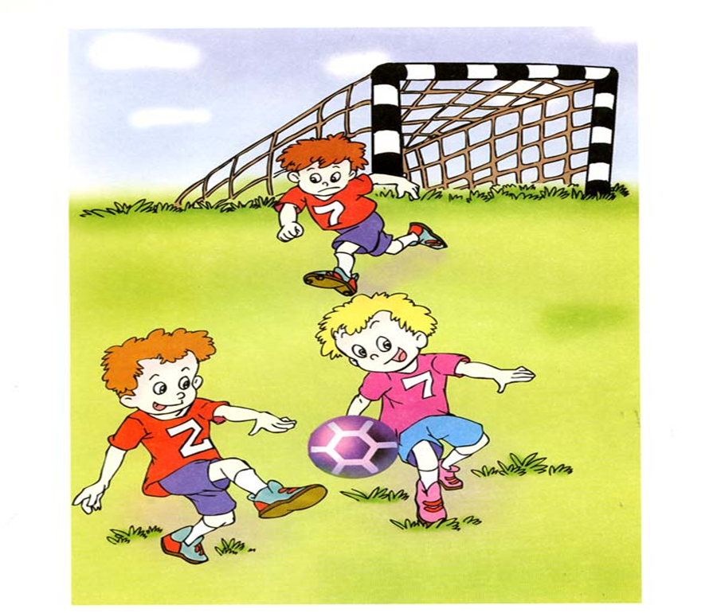...)look at the picture and say the phrase.(Ss:play basketball/play football/go swimming... ”)
3.Show the picture of SB Unite1,take a look and listen and answer the question “Do they like football?”
4.Listen,point and say.
Step 2 Task – presentation
今天我们要跟Sam 和 Daming 一起学习如何介绍自己周末的活动安排并询问他人的安排。学完之后我们要展开调查（Do a survey）找到和自己有相同安排的同学。
Step 3 Text –learning
1.CD-ROM , think over : Do they like football? Sam和Daming喜欢踢足球吗？ (师板书Module6 Unite 1)
SS:…
2. Open the books , listen to the text again , and think over the questions :
What does Sam/Daming do on Sundays? When do they play football?(help them know the meanings )
- Teach the new words and key sentences：on, Sunday（出示日历标明一周七天的英语单词、帮助学生认识理解）, on Sundays,What do you do on Sundays?I ...(师补充板书What do you do on Sundays? I...)
- Do a chant ,work in 3.
S1:On Sundays,I go to the zoo.On Sundays,what do you do? What do you do ?
S2:On Sundays,I go to the zoo,too.
S3:On Sundays,I go to the zoo,too.
Ss:On Sundays,wego to the zoo.We go to the zoo.We go to the zoo.Tweet,moon,coo,roar.（模仿动物叫声）
3. After listening , ask them to answer .
a.Where does Sam play football?
S1 ：At the park.(回答时头戴头饰),
Teach the new words park,great,goal,hooray
- Listen and repeat after the tape.
- Imitate the pronunciation and intonation.
- Practise reading in 2.
Step 4 Practice
- Activity3
Listen to the tape and repeat,then retell the dialogue and act out the dialogue.
2.Part 4
a.Talk about the pictures，pair work.
T: 如果你能说出一幅图，涂一个星； 说2 幅图， 涂二个星； 所有的图片， 涂三个星
b.Act out the dialogue.
Step 5 Task completion
T:Now let’s finish today’s task , let’s do a chant ,try to ask sb“What do you do on Sundays?”and find the same,then make a team and say“let’s ...gother.”
Step6 Summary and Homework
- T: What have we learnt today ?
2. Homework
必做：
- 认读单词
- 听读课文，模仿语音语调。
选做：
询问更多朋友周日的活动安排。

