长海县2013~2014学年度第二学期期末质量抽测试卷
小学四年级 英语 完成时间：60分钟
题  号 | 听力部分 |  |  |  | 笔试部分 |  |  |  |  |  | 总分
题  号 | Ⅰ | Ⅱ | Ⅲ | Ⅳ | Ⅴ | Ⅵ | Ⅶ | Ⅷ | Ⅸ | Ⅹ
得
分
听力部分 (共四大题 40分)

Ⅰ.听音选词。在听到的单词序号上画圈。（每题1分，共8分）

Ⅱ.听音标号。用数字标出图片的先后顺序。（每题1.5分，共12分）
1. | A. hot | B. lot
3. | A. near | B. hear
5. | A. special | B. silence
7. | A. country | B. cousin
2. | A. glass | B. grass
4. | A. lights | B. nights
6. | A. cats | B. hats
8. | A. north | B. south
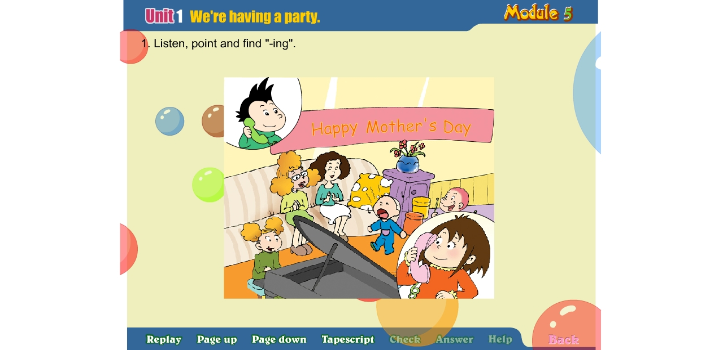 | 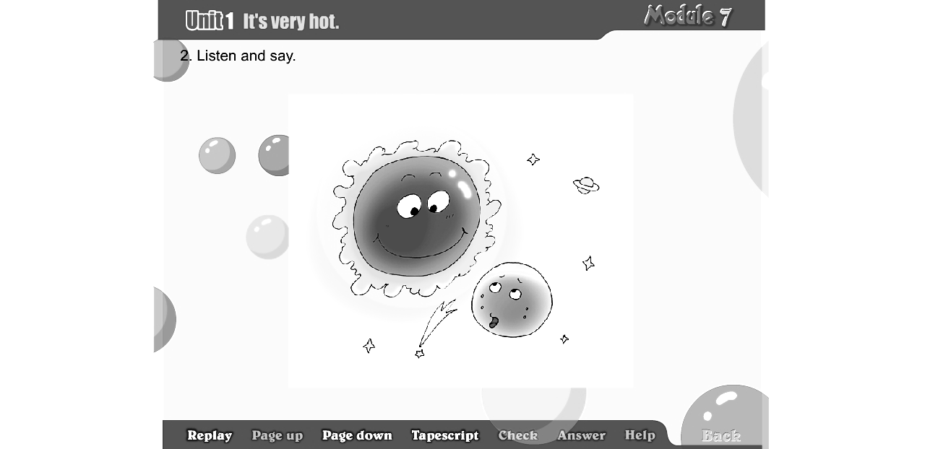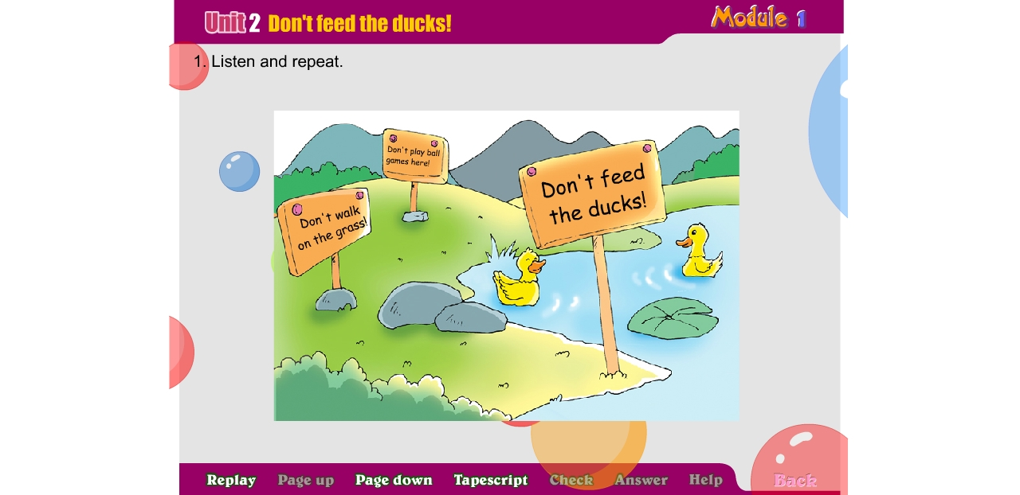 | 
( ) | ( ) ( ) | ( )
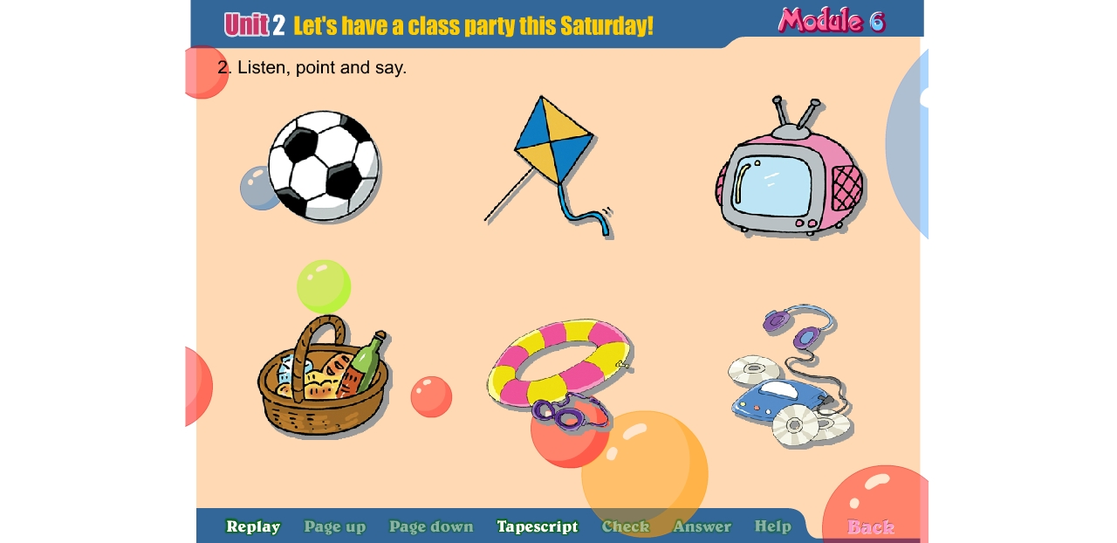  ( ) | 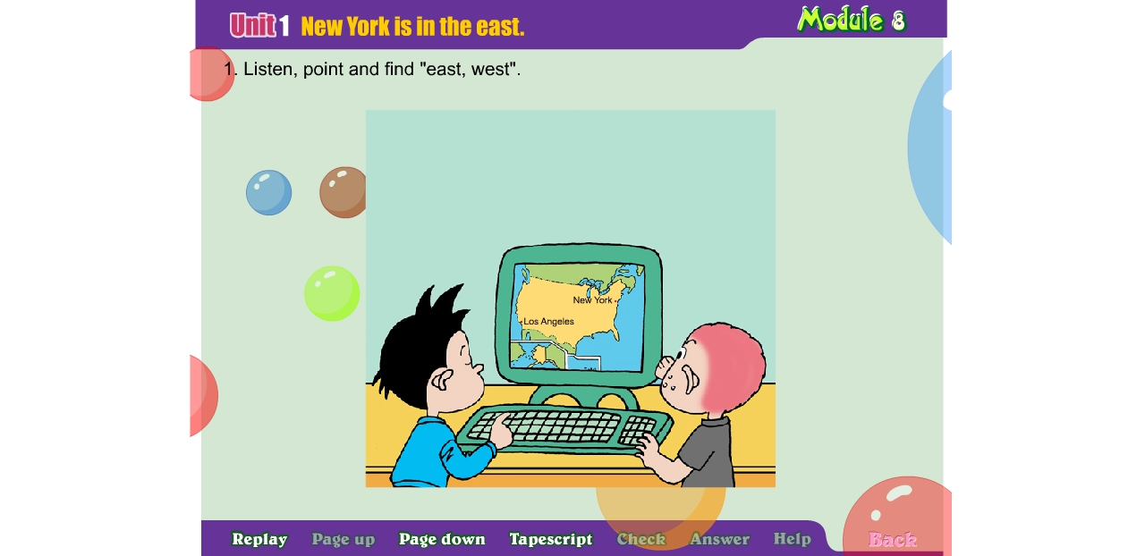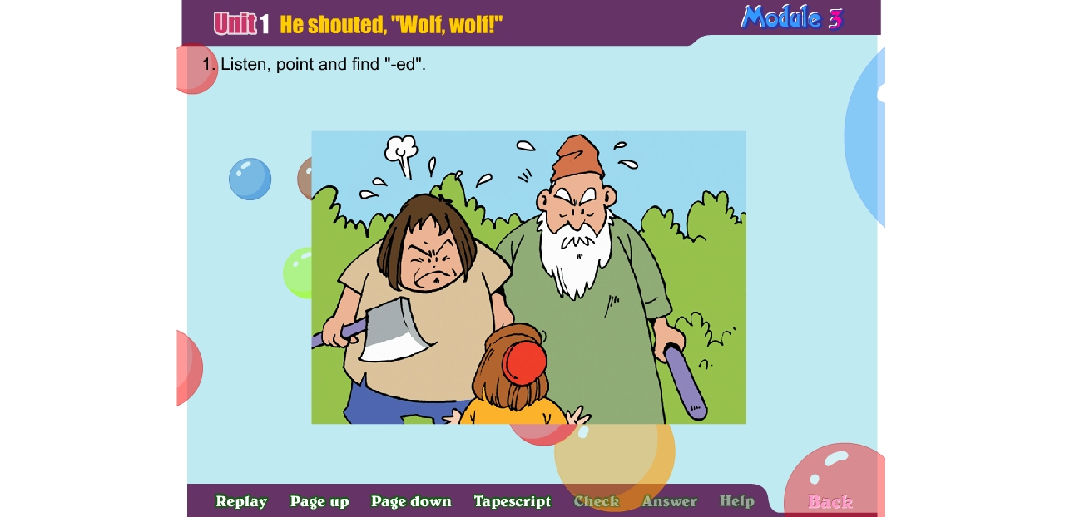  （ ） （ ） | 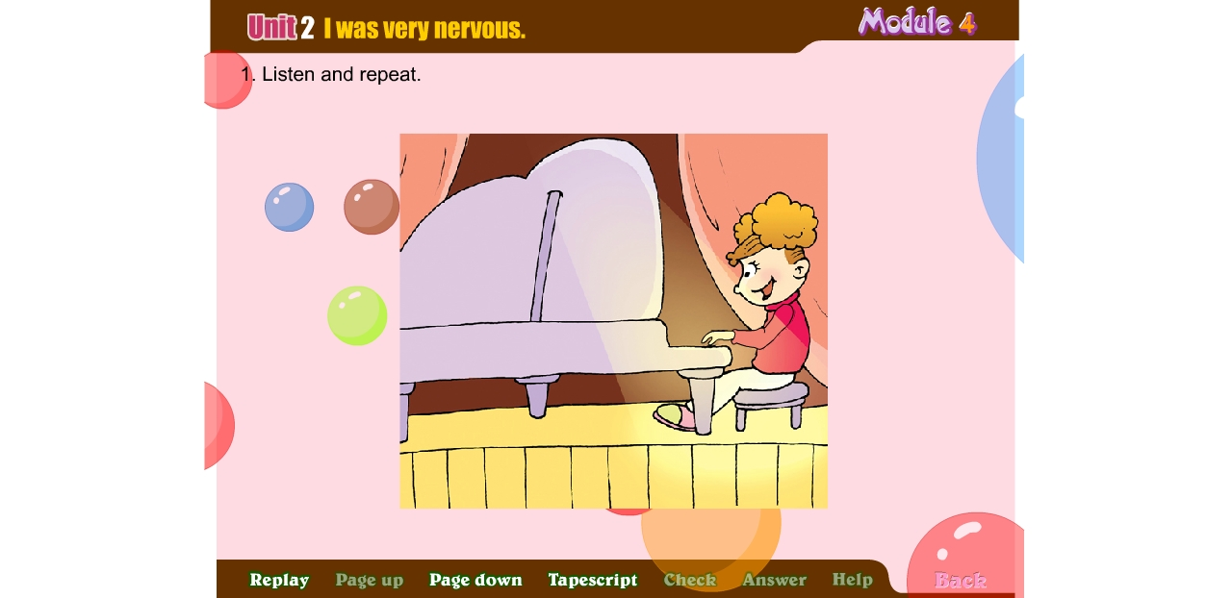  ( )

Ⅲ. 听音选句。把正确的选项填写在前面的括号里。（每题1分，共8分）
( )1. A. Amy played the pipa. B. Amy played the erhu.
( )2. A. This computer is cheap. B. That computer is expensive.
( )3. A. I’m good at English. B. I’m good at Chinese.
( )4. A. The pen costs 1,800 yuan. B. The pen costs 8,100 yuan.
( )5. A. Sam will cut the paper. B. Sam will buy the paper.
( )6. A. Don’t play computer games here. B. Don’t play ball games here.
( )7. A. Lily saw a snake. She was scared. B. Lily saw a cat. She was scared.
( )8. A. I’ll send you a postcard from England.
B. I’ll send you a letter from England.
Ⅳ. 听对话，根据内容判断正误。正确的写T, 错误的写F。（每题2分，共12分）
( ) 1. Amy is singing .
( ) 2. Tom is playing the piano.
( ) 3. Sam is playing the drums now.
( ) 4. They are having a picnic.
( ) 5. Today is Lingling’s mother’s birthday.
( ) 6. It’s a surprise party for Lingling’s mother and Ms Smart.
笔试部分（共六大题，60分）
Ⅴ.单项填空。将正确答案的序号填写在前面的括号里。（每题1.5分，共15分）
( )1. Dalian is near to the sea, so it is very _______ in summer.
A. hot B. cool
( )2. I’ll go back to England this summer. What ______ you, Lingling?
A. about B. with
( )3.Look! This bag ______________ a panda. It’s very funny.
A. looks like B. looks after
( )4. Yesterday Daming went into a shop and _______ some pencils.
A. bought B. ate
( )5. I’m going to ________ an English newspaper. A. making B. make
( )6. I love ________, but they are not good for us. A. crisps B. fruits
( )7.--It’s too hot today. Let’s __________________.
--That’s a great idea!
A. play football B. go swimming
( )8. --____________________ did Tilly run away?
-- Because she saw a cat.
A. Where B. Why
( )9. The boy ______ to the village. “Wolf, wolf,” he shouted.
A. ran B. flew
( )10. --Your English newspaper is fantastic!
--____________________________!
A. That’s a great idea B. Thank you
Ⅵ.词语运用(共2大题，共15分)
A. 用下列方框中所给词语的适当形式填空，使句子完整。（每空1分，共6分）
Mother’s Day, Australia, paint, be good at, west, cute

- East or _________ , home is the best.
- On ____________________, what did you do for your mother?
- Koalas live in __________________. They are very _________________
4. Daming ______________ Art. He will _____________some flowers and birds.
B. 根据语境提示，补全单词完成下列句子。（每题1.5分，共9分）
1. Nice to m_ _ _ (见到)you，sir!
2. Look! The moon tonight looks like a b_ _ _ _ _ （香蕉）.
3. I was very n_ _ _ _ _ _（紧张的）before the concert.
4. Sanya is in the south of China on the m_ _ (地图)of China.
5. At the end of the concert, everyone c_ _ _ _ _ _ (鼓掌) and I was happy.
6. _ _ _ _(等待) for a moment, please!
Ⅶ.情景反应。找出相对应的答句，将序号填入题前括号内。（每题1分，共6分）
( )1. Where are you going to go? A. I looked after my dog.
( )2. What did you do yesterday? B. It’s a Chinese instrument.
( )3. What’s a pipa? C. Because I like Australian animals.
( )4. Why do you like Australia? D. I will go to the shop.
( )5. Where is the supermarket? E. It’s to the east of our school.
( )6. What will you do , Sam? F. I’m going to go to school.
1 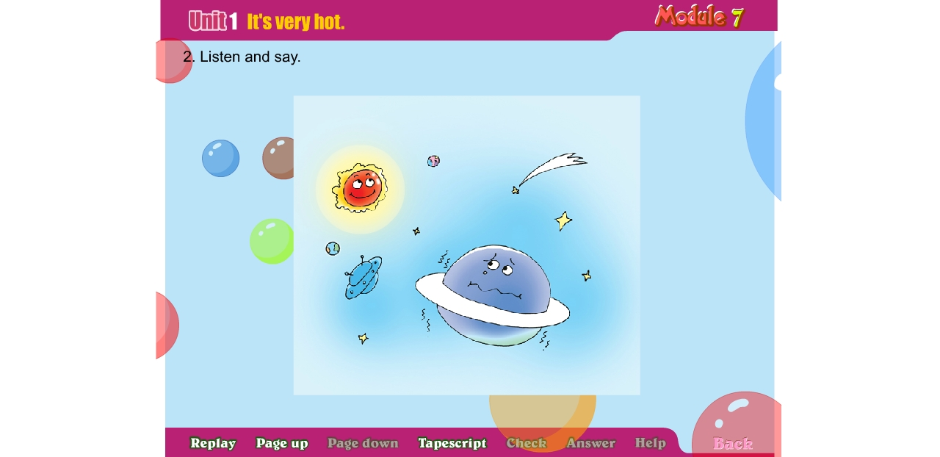
Ⅷ.根据图文提示，完成下列句子。（每题1.5分，共9分）
1. The planet is __________________ the sun , so it is cold.
2 

2. --What will you see in London, Lingling?
-- I will___________________________.
3. --What is Daming doing?
3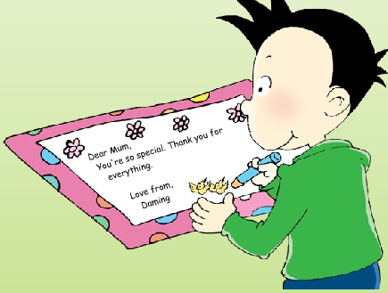
4
--He’s ___________________.
4. --What is the moon like?
5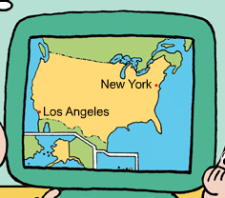
--It’s ___________________________.
5. --Where is New York?
--It’s ___________________of America.
6
6. --Where are you going to go this summer?
-- ________________________________.
Ⅸ.情景交际。选择答案的序号填写在空格处。(每题2分，共10分)
Lingling: I went to a concert yesterday.
Amy: ______________________
A. Dad played the erhu.
B. Was it Chinese music?
C. It looks like a violin.
D. My mum and dad played
in the concert.
E. It looks like a guitar.
Linging: Yes, it was. ____________
Amy: What did they play?
Lingling: _____________________
Amy: What’s an erhu?
Linging: It’s a Chinese instrument
Amy: ___________________
Lingling: And Mum played the pipa.
Amy: ____________________
Ⅹ.阅读短文，选择最佳答案。（每题1分，共5分）
Tomorrow is Saturday, Let’s have a class party. We will go to a park . The park is to the north of school. It’s very big and beautiful . We can play football. We can fly our kite. Sam is going to go skating and Amy will tell us a story(故事), Mr Li , our English teacher will play the guitar. We will go there at nine o’clock.
（ ）1. Tomorrow is _________ A. Sunday B. Saturday
（ ）2. Is the park big? ____ A. Yes, it is. B. No, it isn’t
（ ）3. What will Sam do? He will _______. A. swim B. go skating
（ ）4. Mr Li is our ___________ teacher. A. Chinese B. English
（ ）5. We will go there at _____o’clock A. 9 B. 8

四年级英语听力题签
注意：每道听力试题读二遍，听力时间控制在15分钟内。

Ⅰ.听音选词。在听到的单词序号上画圈。
1. It’ s very hot today.
2. Don’t walk on the grass, please!
3. I can hear the drums.
4. Some nights, there’s no moon at all.
5. The mother kangaroo has a special bag for her baby.
6. I like cats because they’re very cute.
7. My cousin lives in England.
8. Canada is to the north of America.

Ⅱ.听音标号。用数字标出图片的先后顺序。
- It says, “Don’t feed the ducks.”
- This planet is near to the sun. It’s very hot.
- Look! My computer is perfect.
- I like playing football very much.
- There was no wolf. The people were angry.
- The girl played the piano yesterday.
- Daming, listen! We are having a party now.
- I’ll send you a postcard from London.

Ⅲ. 听音选句。把正确的选项填写在前面的括号里。
1. Amy played the pipa.
2. That computer is expensive.
3. I’m good at Chinese.
4. The pen costs one thousand and eight hundred yuan.
5. Sam will cut the paper.
6. Don’t play ball games here!
7. Lily saw a snake. She was scared.
8. I’ll send you a postcard from England.
IV. 听对话，根据内容判断正误。正确写T；错误写F。
Daming: Hi, Lingling! What are you doing ?
Lingling: Hi, Daming.We’re having a party now. Amy is playing the piano.
Daming: What’s happening now?
Lingling: Oh,Tom is singing. Can you hear?
Daming: Yes.
Lingling: And now Sam is playing the drums.
Daming: I can hear the drums. Is it your mother’s birthday?
Lingling: No, it’s Mother’s Day today. It’s a surprise party for Ms Smart and my mother.
Daming: You are great!

听力部分到此结束！

备注：听力题签需要2位英语教师合作录音！

四年级英语参考答案及评分标准
听力部分
Ⅰ.(1×8＝8分) 1.A 2.B 3.B 4. B 5. A 6.A 7. B 8. A
Ⅱ. (1.5×8＝12分) 7- 2- 1- 8 4 -3- 5- 6
Ⅲ. (1×8＝8分) 1.A 2.B 3. B 4. A 5.A 6.B 7.A 8.A
Ⅳ. (2×6＝12分) 1. F 2. F 3. T 4. F 5. F 6. T

笔试部分
Ⅴ. (1.5×10＝15分) 1.B 2. A 3. A 4.A 5.B 6.A 7. B 8.B 9.A 10. B
Ⅵ. A. (1×6＝6分) 1. west 2. Mother’s Day 3. Australia cute
4. is good at （be动词没有变化的扣0.5分） 5. paint

B. (1.5×6＝9分) 1.meet 2. banana 3.nervous 4.map 5. clapped 6. Wait
（请注意画线黑体部分，如果没有形式的变化将各扣0.5分，其他单词完全准确方可得分）
Ⅶ. (1×6＝6分) F A B C E D
Ⅷ. (1.5×6＝9分)
1. far from
2.see Big Ben.
3.painting(drawing)/writing/ painting some pictures /writing a message/making a card…
4. big and round/ very big(round, bright)/big/round/bright…
5. in the east
6. Australia (Sydney/ Sydney Opera House)./ I’m going to (go to )Australia (Sydney/ Sydney Opera House).
(注：大小写、未变形、拼写错误等一处均扣0.5分，扣完为止，不倒扣)
特此说明此题编制意图：伴随着《新课标》，我们取消了以往的连词成句，逐步培养学生的语言思维从中段向高段的过度，能在图文语境的提示下由词到句再到小语篇习作。

Ⅸ. (2×5＝10分) 1.B 2.D 3.A 4.C 5.E
Ⅹ.(1×5＝5分) 1.B 2.A 3.B 4.B 5.A

备注：卷面满分为100分。（听力40分，笔试60分。）
优秀：90---100
良好：80---89
及格：60---79
不及格：0---59

2014年 6 月 30 日

