六年级下册英语期末试卷
听力部分（35分）
一、听音，找出句子中所含的单词.(每题1分)
( ) 1. A hungry B angry C naughty
( ) 2. A hats B caps C cups
( ) 3. A fall B carry C hold
( ) 4. A bookshop B park C supermarket
( ) 5. A interesting B interested C exciting
( ) 6. A spaceship B space C space travel
( )7. A football B baseball C volleyball
( )8. A use B helpful. C useful
( )9. A piano B flute C trumpet
( )10. A March B September C October

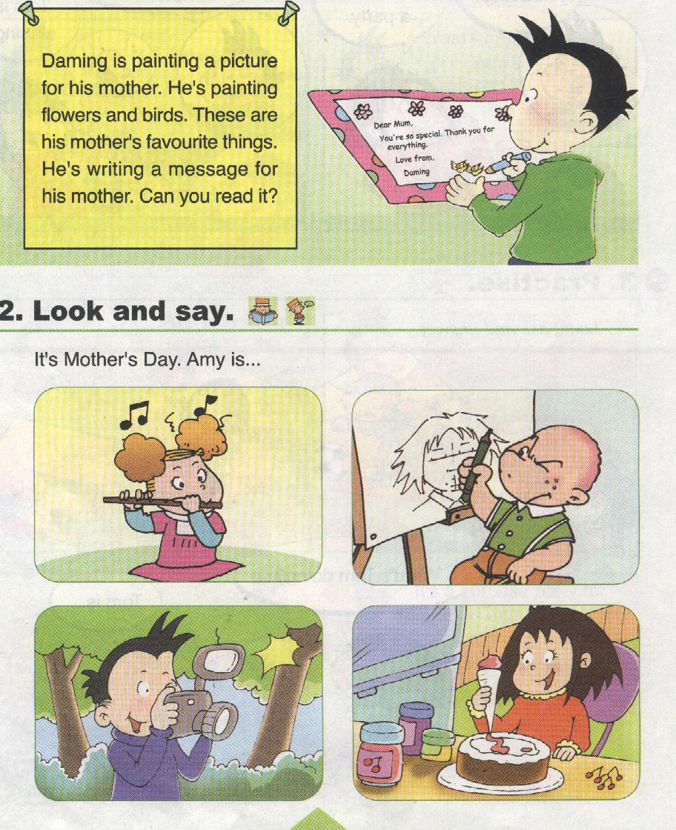
二、听音，标号。（每题1分）
park
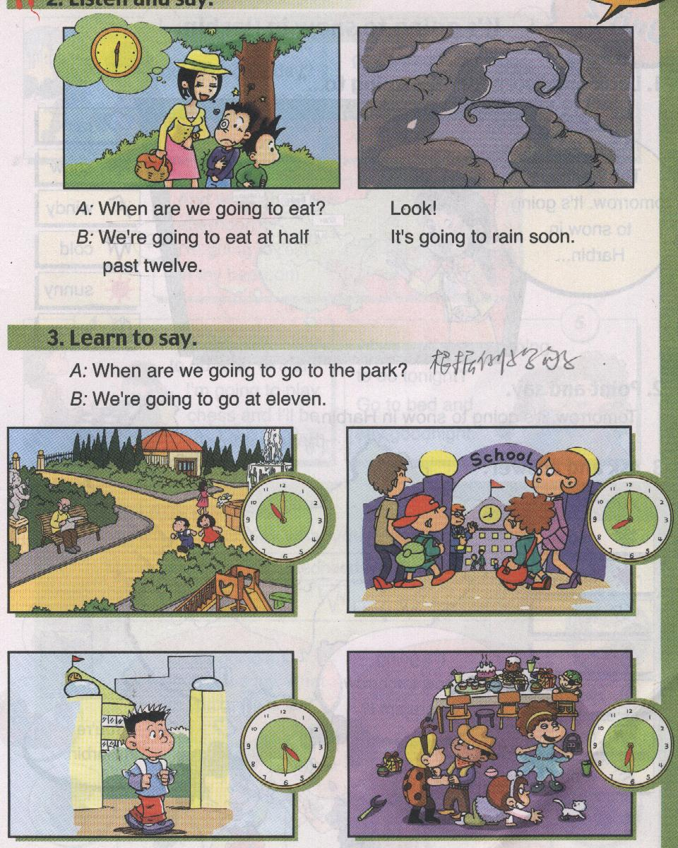
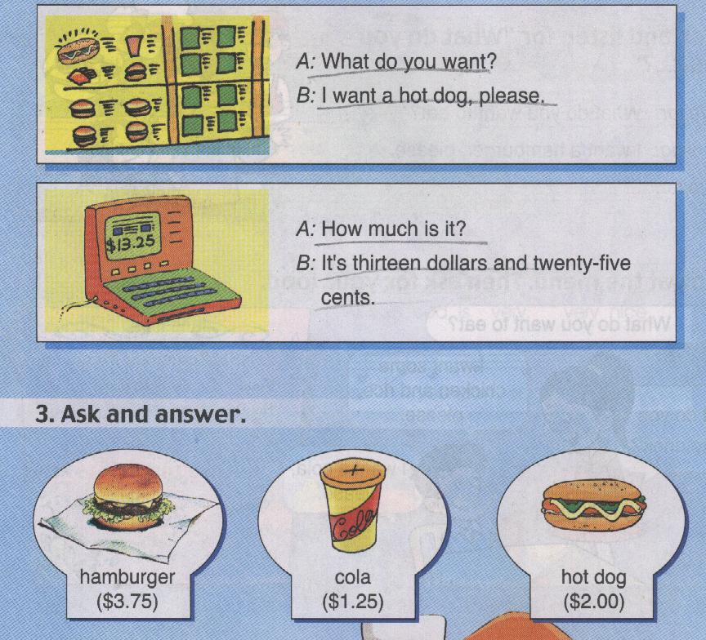
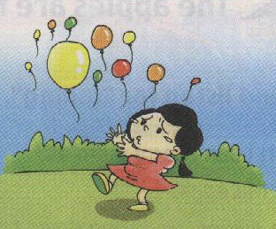
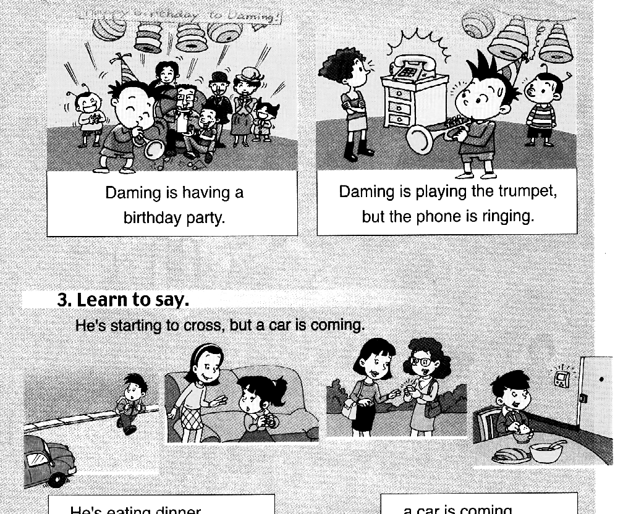
$13.25

.( ) ( ) ( ) ( ) ( )

三、听音，根据问句，选择合适的答句。（每题2分）
( ) 1. A. I will help you.. B. Yes, I can. C. No, I can’t.
( ) 2. A. It’s raining. B. It’s going to be windy. C. It snowed.
( ) 3. A. In the park. B. A hot dog. C. At the park.
( ) 4. A. It two years old. B. It’s hot. C. It’s two dollars.
( ) 5. A. I want a cola. B. I want some fish. C. I want to drink.

四、听短文，选出正确答案。（每题2分）
( )1.When did Shenzhou V fly into space?
A. In 2003. B. In 2005. C. In 2007.
( )2.Who was inside?
A. Liuyang B. Jing Haipeng C. Yang Liwei
( )3.How long did he spend in space?
A. 19 hours B. 20 hours C. 21hours
( )4. Where is he from?
A. Shanghai B. Liaoning C. Henan
( )5.Was his son proud of him?
A. Yes, it is. B. No, it wasn’t. C. Yes, it was.
笔试部分（65分）
一、根据提示补全单词或短语（每空1分）
1. The fish is six d_________ and fifty s__________ in all.
2. In this photo, the sun is _____________（发光） .
3. Let’s go under the tree. It’s _____________（干的）there!
4. The apples are falling down the s_____________.
5. They are a_______ with the ducks.
6.Helen Keller was b______. So she couldn’t see.
7.Yang Liwei __________(度过)21 hours in space.
8. I often make m_________ with English.
9.The book about space__________（旅行） is interesting.
二、单项选择，根据句意， 选择正确的答案。（每题1分）
( )1.Daming is playing the flute, but then a friend _____.
A. arrive B. arrives C. arrived
( )2. She’s buying things _____ her birthday party. A. to B. of C. for
( )3. I’m going to have _____ American birthday this year. A. an B. a C./
( )4. The birds are singing _____ the tree. A. at B. in C. in
( )5. It’s going to ______ tomorrow. A. sunny B. is sunny C. be sunny
( )6.Then we are going to_______ under the tree. A.ate B.eating C.eat
( )7.I am proud _____my son. A to B for C of
( ) 8. I came to this school _______ September 2006. A. on B. in C. at
( ) 9. I have a pen pal. ________ name is Alice. She lives in London.
A. My B. Her C. She
( ) 10. In the photo, the birds _________ in the trees and the ducks are watching us.
A. sing B. are singing C. sang
三、根据问句选择正确的答语，将其序号填在题前括号内。（每题1分）
( )1. Who can help me?
( )2.What’s the weather going to be like?
( )3.What time is it now?
( )4.What do you want to eat?
( )5.What’s the matter?

- It’s half past eleven. .
- I want a hot dog.
C. Sorry, I can’t.
D. I lost my schoolbag.
E. It’s going to be windy
四、根据句意，用词语的适当形式填空（每题2分）
in all fall down take photos have a picnic look out of
1.The oranges are___________________ the stairs
2. I’m in a train. I am _______________________ the window.
3. It’s five dollars and fifty cents, ________________.
4. We’re going to ______________________ in the park.
5. I ________ some ___________ for you yesterday.

五、情景交际（每题2分）
Amy：Who can come out to help me?1._______________
Sam：2._____________I’m washing my clothes.
Mum:3._________________
Amy:4._________________
Mum4: Too late! The cola is falling.
Amy: Oh dear! Look at the apples and the eggs.
Mum: Come on, Sam5._______________
Sam: OK!

A Sorry, I cant.
B We need your help!
C I will help you!
D I can’t carry them all.
E Hold on to the cola, please.

六、阅读文章，根据文章内容选择正确选项, 将选项填入括号中（10分）
I learned about Helen Keller’s story from many books.
Helen Keller was born in a rich family in America in 1880. When she was nineteen months old, she got a high fever. After that, she could not see or speak. It was a sad thing to happen to a child. She was unhappy because she could not talk or share her feelings with others. She could not go to school. She was lonely and had no friends. This lasted for a long time.
Until one day, Helen got her own teacher, Annie Sullivan, who started to teach Helen new things. After a few years, she learnt how to talk. She went on studying and finally finished university. At last, she became a writer and shared her stories with other people in need.
I think that Helen Keller’s story is very encouraging (令人鼓舞的). We should face problems bravely and should never give up.
( )1. Helen Keller was born in ________.
A. America B. Britain C. Australia
( )2. Helen Keller __________ when she was nineteen months old.
A. got a gift B. got a high fever C. got her teacher
( )3. Helen could not go to school, so she had no friends and was ________.
A. happy B. clever C. lonely
( )4. Annie Sullivan taught Helen Keller ____________.
A. to run B. to talk C. to dance
( )5. Helen Keller could ______________.
A. share her stories with other people B. see the world with her eyes C. speak different languages
七、阅读短文，判断正T误F。（每小题1分）
Welcome to the world Zoo. You can see the Australian kangaroos here. The lovely pandas from China are waiting for you. You can ride on an Indian(印度的)elephant. And you can talk to a clever parrot. It’s from Africa(非洲).
Open: Monday to Saturday 8:30—17:00 Sunday 8:00—17：30
Ticket: Adult（成人） $6 8—17 $4 Under 8 $2
Rules: Keep the zoo clean. Don’t feed the animals…
( )1.In the world Zoo, there are many animals from all over the world.
( )2.The zoo opens at 8 o’clock on Saturday.
( )3.The elephants are from Africa.
( )4.If(如果)you ‘re eighteen, you should pay(交付) six dollars for a ticket.
( )5.You can give some bamboo to the panda.
八. 书面表达：（5分）
暑假将至。你打算去哪儿？做些什么？请把你的计划写出来与大家交流一下。
问题提示：1. Where are you going? 2. What are you going to do or what are you going to see there? 3. What’s your feeling? 词数：不少于40词。
My summer holiday plan
________________________________________________________________________
________________________________________________________________________
________________________________________________________________________
________________________________________________________________________
________________________________________________________________________
________________________________________________________________________

