大长山小学2013~2014第二学期质量检测
序号
三年级 英语 完成时间：60分钟
题号 | Ⅰ | Ⅱ | Ⅲ | Ⅳ | Ⅴ | Ⅵ | Ⅶ | Ⅷ | Ⅸ | Ⅹ | Ⅺ | Ⅻ | XIII | 总分
得分
听力部分（60分）
Ⅰ、听音,选出你所听到的单词，将其序号填入括号内。(10分)
( ) 1、 A. fifteen B. fifty C.five
( ) 2、A. peach B. pear C.play
（ ）3. A. say B. try C. high
（ ）4. A. fast B. fruit C. find
( ) 5、 A. twenty B. twelve C. two
（ ）6. A. Tuesday B. Wednesday C. Thursday
( ) 7 、A. drum B. driver C.drive
（ ）8. A. ninety B. ninety-nine C. nineteen
( ) 9、 A. fast B. first C. fun
( ) 10 、A. say B. shy C.speak
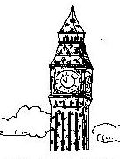
Ⅱ、听音,根据所听顺序用数字(1,2,3,4,5)给下列图片重新排序。（10分）

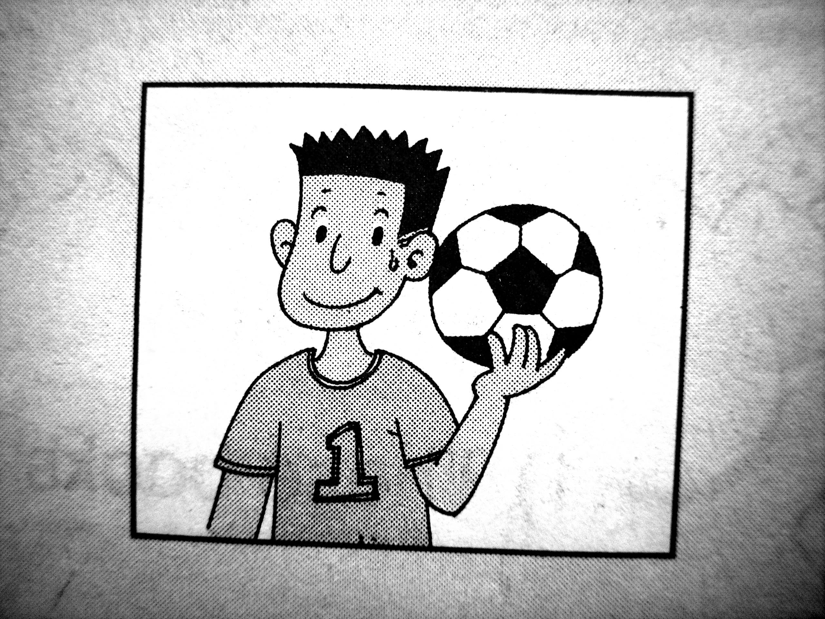
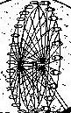


( ) ( ) ( ) ( ) ( )
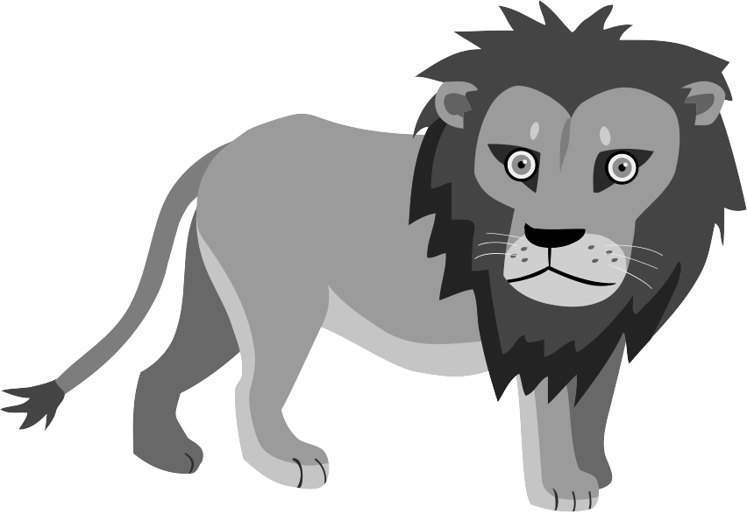
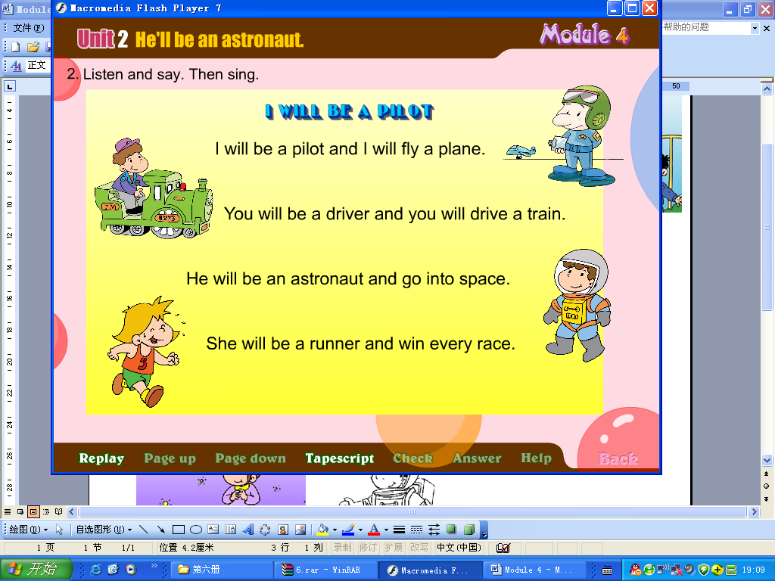
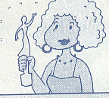
Ⅲ、听一听，选一选，勾一勾(√或ⅹ)。（10分）
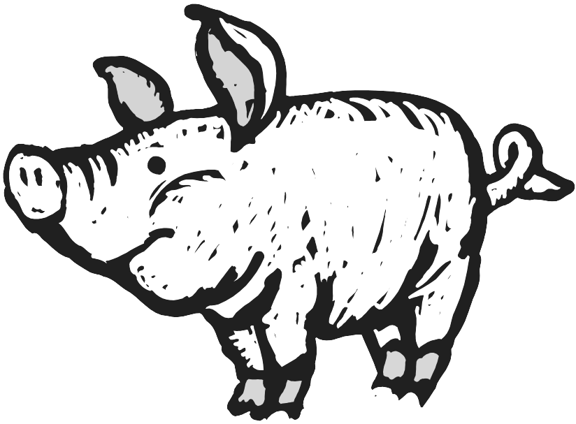
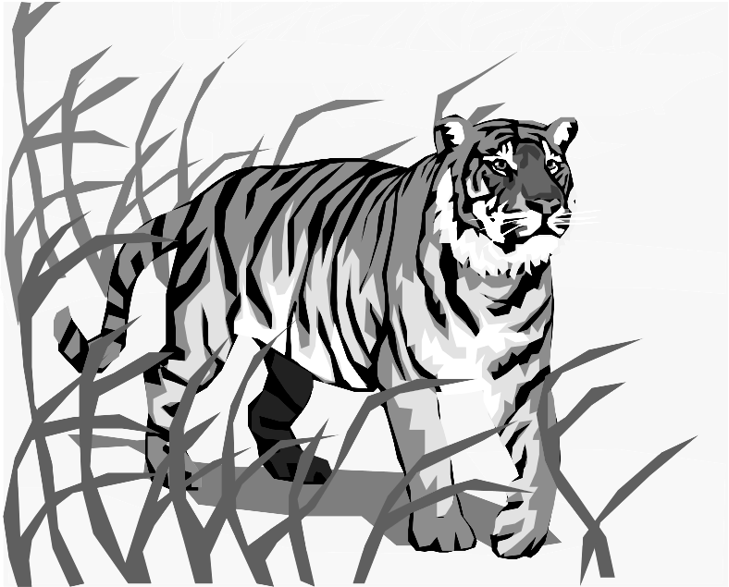

Ⅳ、听音，选择单词补全句子。请将序号写在前面的括号里。（10分）
( ) 1、 Maybe I’ll be a ________. A. writer B. pilot
( ) 2、 Will you play with me _______? A. this afternoon B. this weekend
( ) 3、 Will you take your _______ tomorrow? A. kite B. ball
( ) 4、 They young. A. were B. was
( ) 5、 I’ll see _______. A. The River Thames B. Tower Bridge
Ⅴ、听对话，给下列句子重新排序。(10分)
( ) I don’t know.
( ) What will you see?
( ) What will you do this weekend?
( ) We’ll see lions, tigers and pandas.
( ) Maybe we’ll go to the zoo.
Ⅵ、Listen and write the sentences 旅行团的小伙伴们，快来试着写下你听到的旅游见闻吧。（10分）
1. wide, river is this very .
2. see, Big Ben, will, we . _________
3．you, take, will, your, kite ? ____________
4. will, what, be, you ? ___________
5. nice, she, is, very. _________________________________
笔试部分（40分）
Ⅶ、请写出下列每组字母的左邻右舍。（10分）
1. Pp 2. Yy 3. Gg

4. Kk 5. Ss
Ⅷ、请根据所给语境写出正确的单词。（10分）
1. ____________ ( 桃子) are my favourite fruit.
2. She’s very _____________(友善的).
3. We’ll see lions, (老虎) and pandas in the zoo.
4. We were on the _________ (第一) floor.
5. There are _________ (五十)children in my class.
6. They were very_________ (年轻的).
7. This book is ___________(新的)，but that one is ________( 旧的 ).
8. He __________(学习) hard. He isn’t lazy.
9. A: What day is __________ (在…之后) Tuesday ? B: It’s Wednesday .
Ⅸ、根据问句选答句， 把正确的序号写在题前的括号内。 （12分）
( ) 1. Will you phone me? A. It’s ninety.
( ) 2. How many children? B. There are nineteen.
( ) 3. What will we see? C. I’ll be a film star.
( ) 4. What will you be? D. We’ll see Big Ben.
( ) 5. What’s sixty plus thirty? E. Yes, he will.
( ) 6. Will Sam go, too? F. Yes, I will.
Ⅹ、阅读理解，根据短文内容判断正( T )误( F )。（8分）
I’m Linlin. I’m a quiet girl. I’m eight. I’m short and thin. Look at this photo, they’re my grandparents. They weren’t old then. They were very young. But now they are old. This is their dog. Its hair was short then. Now it’s long. And it’s cute.

( )1. Linlin is a girl and she’s 18.
( )2. Linlin is quiet.
( )3. Her grandparents are very young now.
( )4. They have got a cute dog.

三年级英语听力题签：
注意：每道听力试题读二遍，听力时间控制在25分钟内。
听力部分（60分）
Ⅰ、听音,选出你所听到的单词，将其序号填入括号内。
1. fifteen 2. peach 3.high 4. fruit 5. twenty
6.Wednesday 7. drum 8.ninety--nine 9.first 10. shy
Ⅱ、听音,根据所听顺序用数字(1,2,3,4,5)给下列图片重新排序。
1. This house is very old.
2. The London Eye goes round and round.
3. He’ll be a footballer in the future.
4. Big Ben is very tall. It’s a very old clock.
5. I’ll read some books. I won’t watch TV.
Ⅲ、听一听，选一选，勾一勾(√或ⅹ)。（10分）
1.Maybe I’ll be a driver.
2.This lion is big.
3. Maybe I’ll be a filmstar.
4. This bird is small.
5.. This panda is fat.

Ⅳ、听音，选择单词补全句子。请将序号写在前面的括号里。
1. Maybe I’ll be a pilot.
2. Will you play with me this weekend?
3. Will you take your kite tomorrow?
4. They were young.
5. I’ll see Tower Bridge.
Ⅴ.听对话，给下列句子重新排序。
---What will you do this weekend? ---I don’t know. Maybe we’ll go to the zoo. ---What will you see?---We’ll see lions, tigers and pandas.
Ⅵ、Listen and write the sentences 旅行团的小伙伴们，快来试着写下你听到的旅游见闻吧。（10分）
1. This river is very wide.
2. We will see Big Ben .
3．will you take your kite ?
4. what will you be?
5.She is very nice.

