小长山小学六年级下期末试卷
听力部分( 30分)
Ⅰ、 听辨单词，选出你所听到的句子中的单词。（5分）
( ) 1. A. study B. student C. stairs
( ) 2. A. spend B. space C.shine
( ) 3. A. scared B. scary C. stairs
( ) 4. A. interested B. interesting C. inside
( ) 5. A. around B. arrive C. away

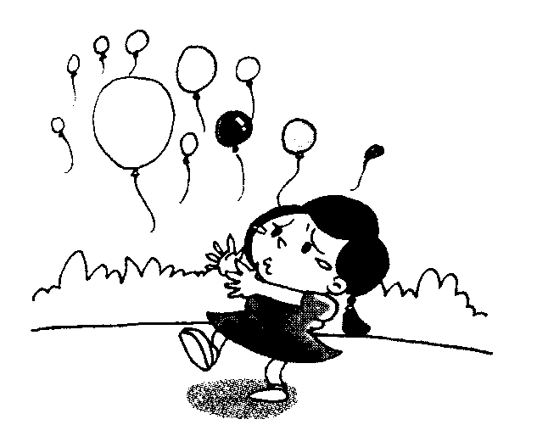
Ⅱ、听句子选图片，根据所听顺序将其序号填写在相应的横线上.（5分）
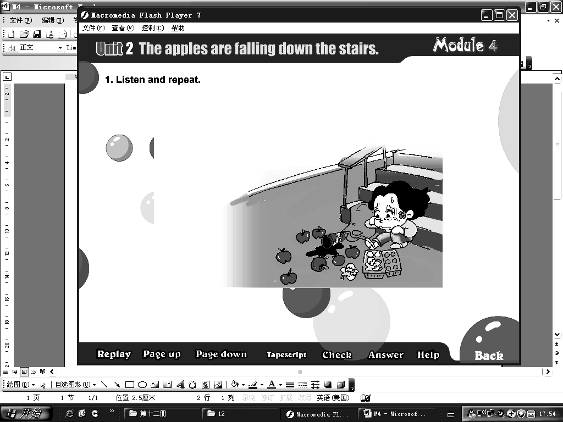
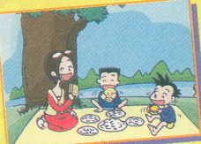
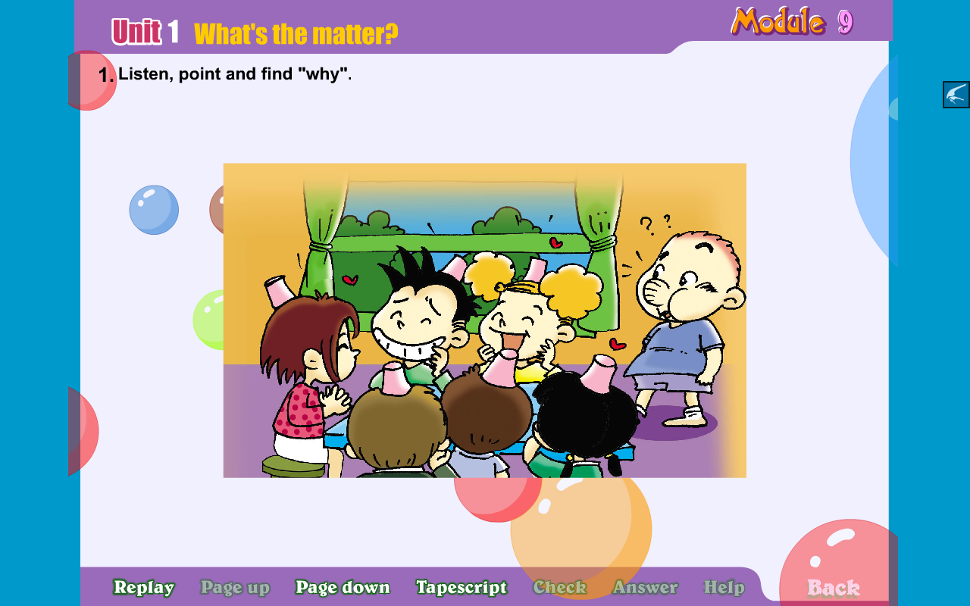

A B C D E

1. ________ 2. ________ 3. ________ 4. _______ 5. _______

Ⅲ、听问句选答语，将其序号填写在前面的括号里。（10分）
( ) 1. A. I want a cola. B. I want a hot dog.
( ) 2. A. We are singing. B. We’re going to sing.
( ) 3. A. It’s going to rain. B. It’s sunny.
( ) 4. A.Because I am happy. B. I’m reading.
( ) 5. A. I can write. B. I could read.

Ⅳ、听短文，判断正(T)误(F)。(10分）
( ) 1. Helen could learn.
( ) 2. “Hand” was Helen’s first word.
( ) 3. Helen’s friend put Helen’s hand in some water.
( ) 4. Helen’s friend wrote in Helen’s hand.
( ) 5. Her friend could talk to her.

笔试部分（共70分）
Ⅴ、选择。（10分）
( )1. I will go to Beijing ______ train.
A. in B. on C. by
( )2. We often make mistakes ________ English.
A. to B. for C. with
( )3. This question is difficult_______ me.
A. for B. with C. to
( )4. She is singing, but then the baby____________.
A .cry B. crying C. cries
( )5. Daming is ______ a model spaceship.
A. making B. made C. make
( )6. It’s going to be________ tomorrow.
A. hot B. rain C. snow
( )7. I want _______ some meat.
A. eat B. to eat C eating
( )8. Helen Keller couldn’t _________.
A. look B see C saw
( )9. I’m very interested _______ English.
A. in B. to C. speak
( )10. He ________21 hours in space in 2003.
A spend B spent C spending

Ⅵ、请根据所给语境，正确补全下列句子。(10分）
1. Everyone is listening and _____________.（鼓掌）
2. We are hungry and __________(生气的）with the ducks.
3. What’s the ___________?(麻烦事） I am ___________(恐惧的）.
4. The ducks are very _____________.(淘气的）
5. We are going to__________(walk) around the lake .
6. In this photo, the sun is _____________.(shine)
7. Tom_________ ( take) some photos yesterday.
8. Now the cola is ______________(fall).
9. He is playing the flute, but then the telephone ___________.(ring)

Ⅶ、情景反应, 请将序号填入题前的括号内。（5分）
( ) 1.What do you want? A. Because I am happy.
( ) 2. What are you going to do? B. I want a hamburger.
( ) 3. What are you doing? C. Sorry, I can’t.
( ) 4. Who can help me ? D. I am eating.
( ) 5. Why are you lauging? E. I’m going to fly a kite.

VIII、情景交际，补全对话,填入正确的序号即可。(10分）
Simon’s mum: Here’s your present. I bought a book for you.
Daming: _______________.
Simon’s mum: ______________. It’s all about space travel.
Daming: I’m very interested in that!
Simon: What a great book! Who gave it to you?
Daming: _______________. We can read it together.
Simon: Look, there are space ships from America and Russia.
Daming:______________.
Simon: China?
Daming:Yes. China sent a man into space, too.
Simon: Really? I want to read about that.
Daming: OK ._______________.

- You’re welcome.
- Then we can make a paper Chinese spaceship.
- Thank you.
- Your mum gave it to you.
- And China too!
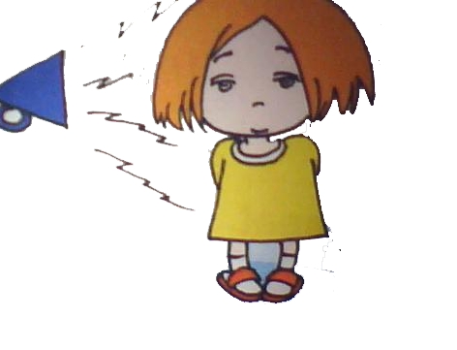
Ⅸ、把下面的句子补充完整。（10分）

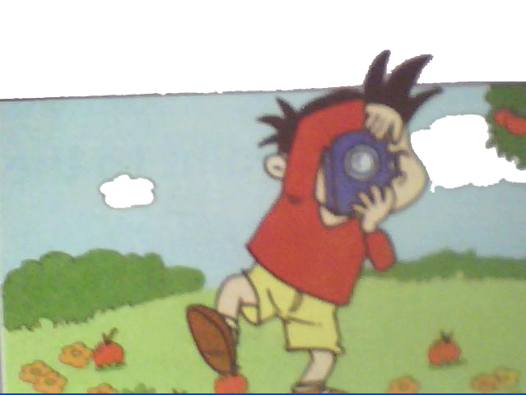
1. She was deaf._____________________________.

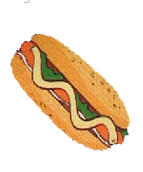
2. Yesterday______________________________.

3. A: ____________________________?
B:I want a hot dog, please.

4. eat / we/ going / to/ are /half/ twelve/ past/ at (连词成句）
________________________________________________________
- in/ he/ spent/ 21 hours/ about/ space (连词成句）
________________________________________________________

Ⅹ、完形填空。根据语境从括号里选择恰当的选项写在横线上。（10分）
I am in a train. I am looking out 1 the window. It is 2 .The pigs
3 sleeping under the tree. People are carrying umbrellas. A man4 wearing
a big hat and boots. 5 are jumping 6 the water. Then the train goes 7
a tunnel. It is very dark. Then we come 8 of the tunnel.It is raining. The sun is 9 . Children are playing in a park. Then the train arrives 10 the station.
1. A. at B.of C.in 2. A. raining B.rained C.rained
3. A. am C.is C.are 4. A.are B.is C.am
5. A.Child B.children C.Achild 6. A.in B.on C.at
7. A.into B.in C.on 8.A.out B.to C.on
9. A.shining B.shineing C.shined 10. A.to B.in C .at

Ⅺ、阅读理解。正确的写T,错误的写F。（10分）
Tom and Fred are students. They are both twelve years old, and they are in the same class in their school.
Last Friday afternoon they have a fight（吵架） in class, and their teacher is very angry. He says to both of them, “ Stay here after the lessons this afternoon, and write your names a hundred times.”
After the last lesson, all the other boys go home, but Tom and Fred stay in the classroom with their teacher.
They begin writing their names. The teacher looks at him and says, “ Why are you crying, Fred?”
“Because his name is Tommy, and my name is very very long. My name is Frederick Hollingsworth.” Fred says.
( )1. Tom and Fred are classmates（同学）.
( )2. Last Friday Fred and Tom have a fight in class, and their teacher is very happy.
( )3. All the other boys go home after school.
( )4. Tom and Fred do not go home. They stay in the classroom and write their teacher’s name.
( )5. Fred begins crying, because he can’t write his name.
Ⅻ、写作园地。（5分）
同学们，你们马上就要上中学了，请介绍一下你要去的新学校和即将开始的学校生活吧。要求语句通顺，条理清晰，标点正确，书写规范, 不少于50个单词。
_____________________________________________________________________________________________________________________________________________________________________________________________________________________
____________________________________________________________________________________________________________________________________________________________________________________________________________________
六年级英语听力题签:
※注意：每道听力试题读二遍。时间控制在15分钟以内。

Ⅰ、 听辨单词，选出你所听到的句子中的单词。（5分）
- We are going to study History, Science, Geography....lots of new things.
- In October 2003, Shenzhou V flew into space.
- Why are you scared?
- This book is very interesting.
5. My parents arrive at 10 o’clock.
Ⅱ、听句子选图片，根据所听顺序将其序号填写在相应的横线上.（5分）
1. It’s going to rain soon.
2. What’s the matter? Why are you laughing?
3. They are having a picnic.
4. Look!The apples are falling down the stairs.
5. All the balloons are flying away.
Ⅲ、听问句选答语，将其序号填写在前面的括号里。（10分）
1.What are you going to eat?
2. What are you going to do?
3. What’s the weather like?
4.Why are you laughing?
5. What can you do?
Ⅳ、听短文，判断正(T)误(F)。(10分）
How did Helen Keller learn to read and write?
One day, Helen’s friend wrote the word “water” in Helen’s hand with her finger. Then she put Helen’s hand in some water. “Water” was Helen’s first word. Helen was very happy. Now her friends could talk to her. They wrote in her hand.

