小长山小学四年级下期末试卷
听力部分（40分）
Ⅰ、听音，选出你所听到的单词，将其序号填入括号内。（10分）
（ ）1、 A. space B. special （ ）6、 A. meet B. moon
（ ）2、 A. cousin B. capital （ ）7、 A. banana B. because
（ ）3、 A. powerful B. perfect ( ）8、 A. south B. north
（ ）4、 A. postcard B. potato （ ）9、 A. grass B. glasses
（ ）5、 A. choose B. cheap （ ）10、A. concert B. country
Ⅱ、听音，根据所听顺序用数字(1,2,3,4,5)给下列图片重新排序。（5分）
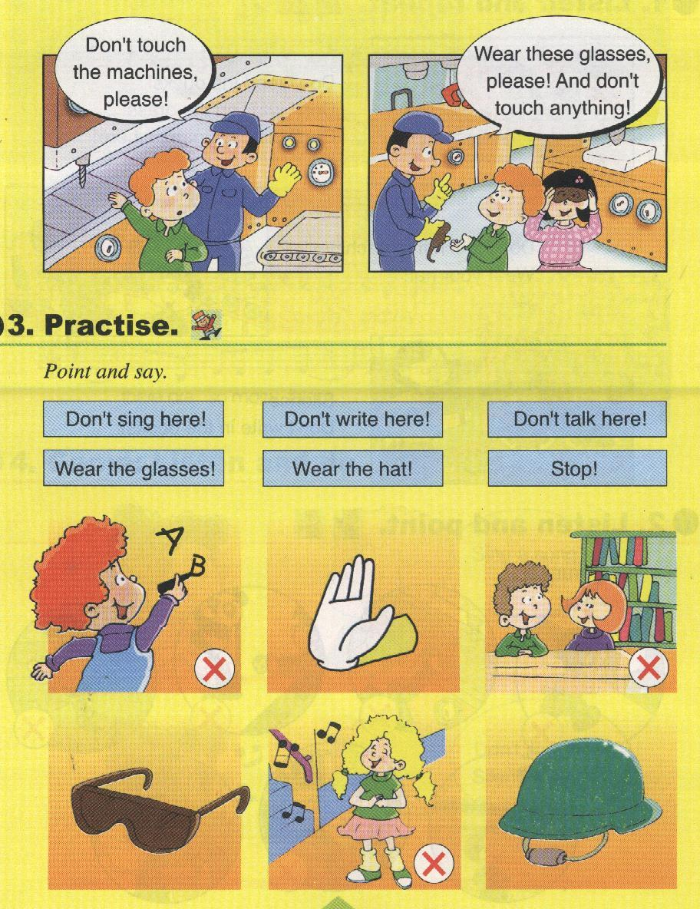

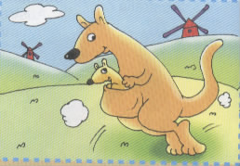
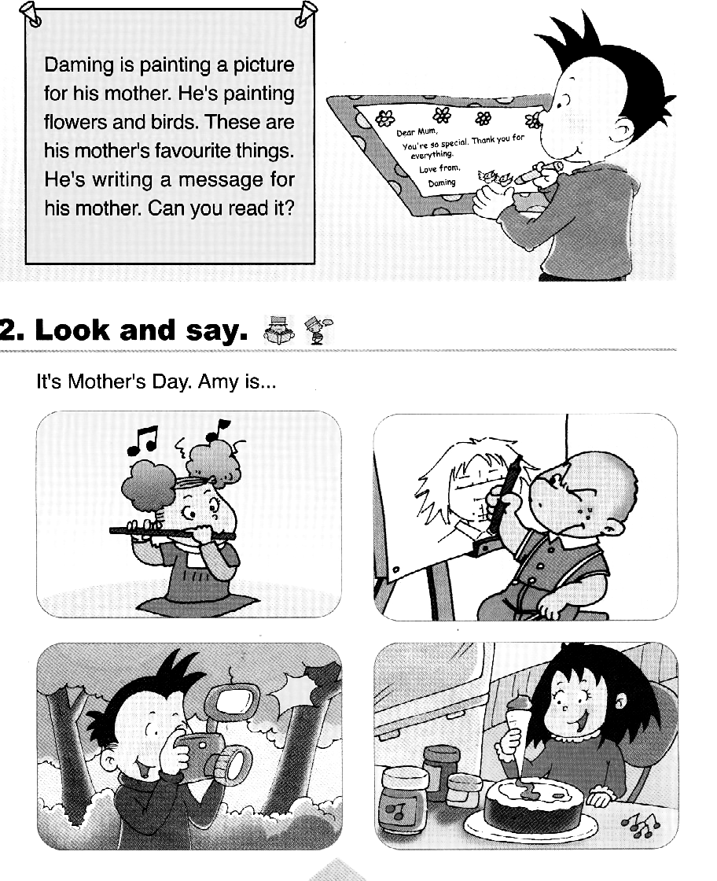

（ ） （ ） （ ） （ ） （ ）
Ⅲ、听音，判断图片是否正确，正确打“√ ”，错误画 “×”。（10分）
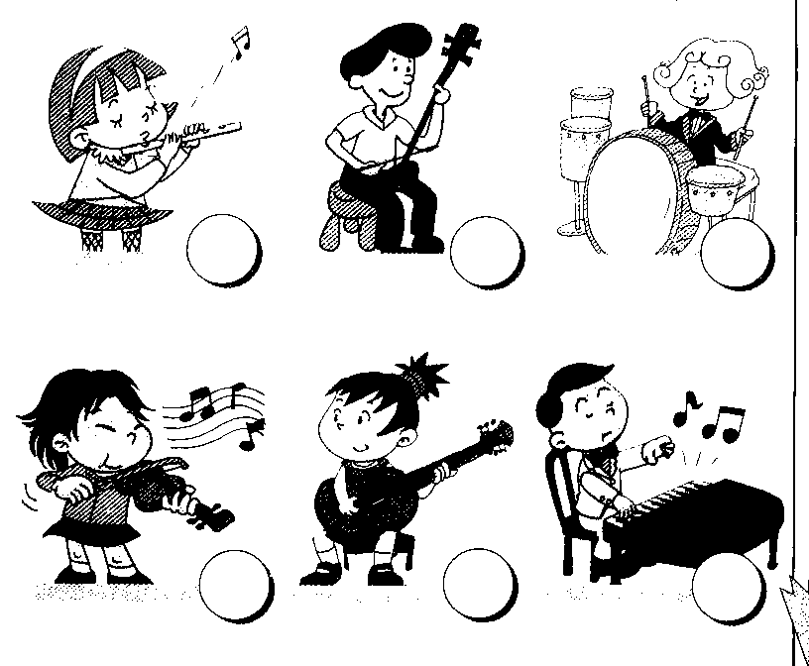
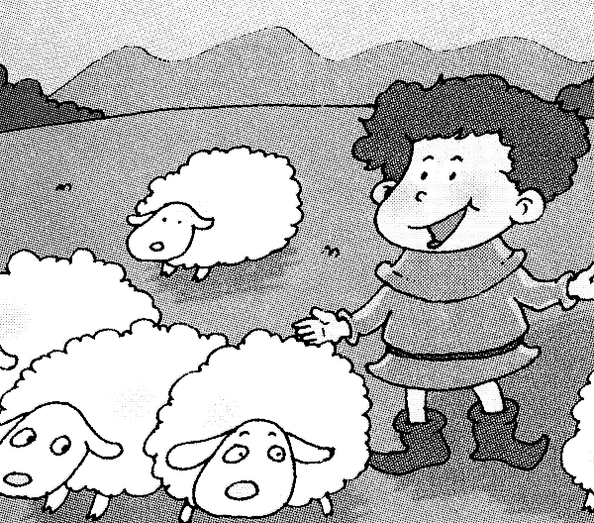
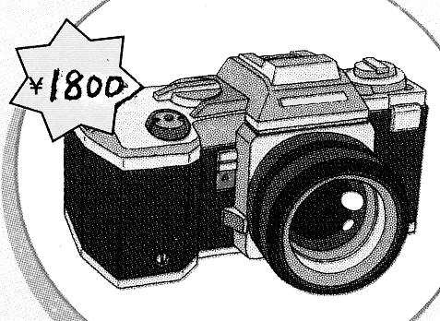
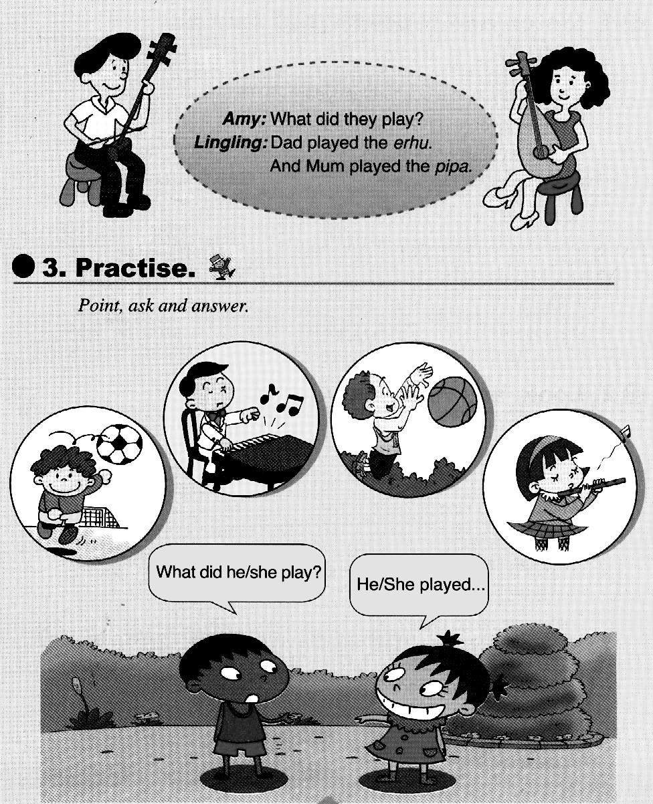
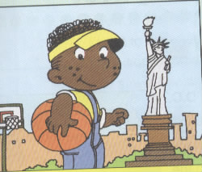

1.( ) 2.( ) 3.( ) 4.( ) 5.( )
Ⅳ、听音，选出你所听到的句子，并把序号写在题前的括号内。（5分）
（ ）1、A. I’m going to go back to England.
B. I’m going to go back to China.
（ ）2、A. New York is in the east. B. New York is in the west.
（ ）3、A. This computer is powerful. B. This computer is cheap.
（ ）4、A.We’re having a party. B. We’re going to have a party.
（ ）5、A. The boy ran to the village. B. The people ran to the field.
Ⅴ、听短文，连一连。（10分）
Amy draw the pictures
Lingling stick the newspaper together
Sam cut the paper
Daming read the newspaper
Teacher write the reports

笔试部分（60分）
Ⅵ、根据语境用“——”画出句中正确的单词。（5分）
1. I like (Australia / Australian) animals .
2. This computer is beautiful, ( and / but) it isn’t powerful.
3. It ( cost / costs) three thousand yuan.
4. We are ( eat / eating) a cake.
5. This planet is near to the sun, it’s very ( hot / cold).
Ⅶ、根据语境补全句子中的单词。（10分）
1、I was very _____________(紧张的) before the concert.
2、I am a Chinese, I am very __________.(自豪的）
3、The kangaroos jump on their__________(后面的）legs.
4、_____________( 安静 ), please ! Don’t talk here !
5、The boy_______________(呼喊), “Wolf, wolf!”
6、Don’t touch ________________.(任何东西）
7、I have nothing to do, I’m very _____________（无聊的）.
8、What’s _______________(发生）now?
9、The boy ran to the ________________.(村庄）
10、I like ______________(中国的）music.
Ⅷ、选择填空，将序号填在括号里。（15分）
（ ）1、Don’t walk _______ the grass !
A. in B. on C. to
（ ）2、So many computers. It’s difficult _______ choose.
A. in B. to C. for
（ ）3、This planet is far _________ the sun.
A. for B. to C. from
( ) 4、She went _______a shop.
A. in B. for C. into
( ) 5、My mum played______ pipa.
A. / B. the C. one
( ) 6、 We______ playing football.
A. is B.are C. am
( ) 7、 ________ read in the sun. It’s bad for your eyes.
A. Please B. \ C. Don’t
（ ）8、She ______ painting a picture.
A. is B. am C. are
（ ）9、Beijing is the capital_______ China.
A. of B. to C. in
（ ）10、Canada is ______ the north of America.
A. of B. in C. to
( )11、Look! The boys are laughing and _______________.
A. claping B. clap C. clapping
( )12、I will _______ you a present.
A. send B. sent C. sending
( )13、Lingling is _______ TV.
- watch B. watches C. watching
( )14、I’m going to _________ to Dalian.
A. go B. going C. went
( )15、I ________ to a concert yesterday.
A. go B. going C. went
Ⅸ、根据问句选答句，将序号写在前面的括号里。(5分）
（ ）1、Where’s will she go? A. Because they are very cute.
（ ）2、Why do you love koalas? B. She will go to Shanghai.
（ ）3、What will you do? C. They played football.
（ ）4、What did they play? D. We’re having a party.
（ ）5、What are you doing? E. I’ll cut the paper.
Ⅹ、 根据语境选词填空, 将序号填写在下面的横线上。（5分）
A. end B. before C.concert D. proud E. clapped

I played in a _______ last year. I played the piano. I was very nervous _________ the concert. At the _______, everyone _________. I was happy. And I was very ___________.

Ⅺ、 连词成句。（10分）
1. computer/ this / beautiful/ is（.）
2. is / he /painting / flowers （.）
3．party / a / let’s / have/ class/ Satrday/ this ( . ) _______________________________________________________
4.Australia/ like/ do / why/ you( ?) ___________________________________
5. feed / the / don’t / pandas ( ! ) _____________________________________

Ⅻ、阅读理解。（10分）
This is Lily and Lucy's bedroom. It is a nice room. They have one desk and two chairs. Their clock, books and pencil-boxes are on the desk. Their schoolbags are on the chairs. There are some nice flowers on the desk. Look, near the flowers, there is a kite. There's a family photo on the wall. The bedroom is very nice.

( )1. We can see ______desk in the room.
A. one B. two C. three
( )2. Where is the kite?
A. It's near the flowers. B. It's on the wall. C. It's on the bed.
( )3. We can find ______on the wall.
A. flowers B. kite C. a family photo
( )4. Some ______are on the chairs.
A. books B. pencil-boxes C. schoolbags
( )5. Whose bedroom is it?
A. Lily's B. Lucy's B. Lily and Lucy's

四年级英语听力题签:
※注意：每道听力试题读二遍。时间控制在20分钟以内。
I、听音，选出你所听到的单词，将其序号填入括号内。（10分）
- This is space.
- The capital of America is WashingtongD.C.
- This computer is powerful.
- I’ll send you a postcard from England.
- This computer is perfect and it’s cheap.
- Let’s meet in the park.
- Some nights,the moon looks like a banana.
- Kaikou is in the south of China.
- Please wear these glasses.
- This country is America.
Ⅱ、听音，根据所听顺序用数字(1,2,3,4,5)给下列图片重新排序。（5分）
- He is painting a picture.
- The sun is very big and very hot.
- Kangaroos jump on their back legs.
- Don’t talk in the library!
- Don’t write here!
Ⅲ、听音，判断图片是否正确，正确打“√ ”，错误画 “×”。（10分）
1. Dad played the pipa.
- Once upon a time, there was a boy, he looked after sheep.
- It costs 1 hundred yuan. It’s very cheap.
- He is from America.
- She played the flute.
Ⅳ、听音，选出你所听到的句子，并把序号写在题前的括号内。（5分）
1、 I’m going to go back to England.
2、A. New York is in the east.
3、A. This computer is powerful.
4、 We’re going to have a party.
5、 The people ran to the field.
Ⅴ、听短文，连一连。（10分）
We are going to make an English newspaper. It can be about our school. Daming will draw the pictrures. He is good at Art. Amy will write the reports. She’s good at English. Sam will cut the paper. And Lingling will stick the newspaper together. Wow! Our English newspaper is fantastic! Our teacher will read the newspaper.

